# **Hubble's Law as Photon Velocity**

Mike Helland

Seattle, WA USA

[mike@mikehelland.com](mailto:mike@mikehelland.com)

## Abstract

The expansion of space causes a delay in a photon’s journey from a distant galaxy that correlates with the photon’s redshift. It is discovered that these time delays can be reproduced by a novel application of Hubble’s law to the motion of an individual photon. The hypothesis developed is shown to produce the observed cosmological redshifts, producing less redshift than the standard model over time, eliminating the need for a dynamic Hubble’s constant. The hypothesis also allows for communication between Hubble volumes

## **1. Introduction**

One effect of an expanding universe is that delays are introduced in the journey of light from one galaxy to another. To demonstrate, let's model a single photon that passes a series of targets placed 100 million light years apart.

In a simple universe, the photon will reach the first target in 100 million years, the second target in 200 million light years, and so on.

In an expanding universe, objects move away from each other at v = HD as per Hubble's Law, and thus the targets take longer and longer to reach.

The same delays can be produced if the photon simply lost speed HD, as seen in Figure 1. (The code for these models is provided at the end of this document.)

As you can see, the model where the entire universe is in motion produces the same output as a single decelerating photon. The hypothesis is that the velocity v of a photon is a function of the distance D it has traveled:



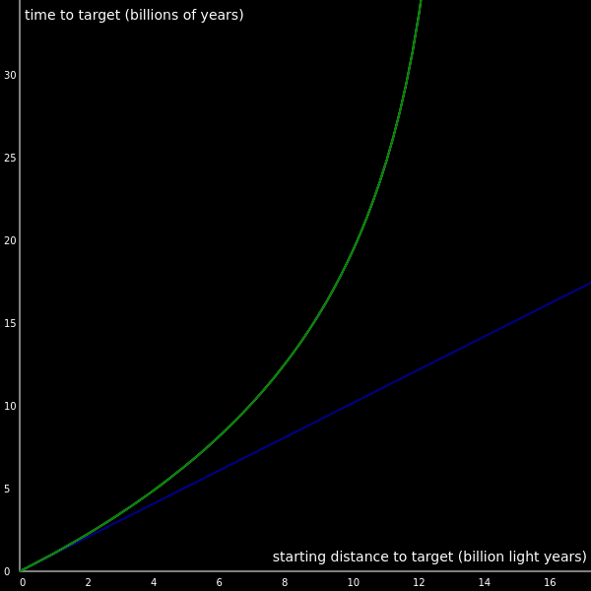

Figure 1. Static model (blue) shows no time delays. The expanding universe and decelerating photon hypothesis (green) produce the same time delays

While I found this interesting, non-expanding theories of the universe have some immediate fatal flaws:

* This is the Tired Light Theory, which is discredited
* Redshifts indicate an expanding universe
* The CMB indicates a hot past
* The farthest galaxies are younger than nearby galaxies, indicating a beginning of time
* The Tolman surface brightness test indicates an expanding universe
* Time dilation in supernovae light curves indicate an expanding universe

To add to these problems, the idea of a decelerating photon violates both relativity and the first law of motion.

More than a decade has passed since first considering the decelerating photon hypothesis, and much has happened in cosmology:

* Measurements of Hubble's constant don't match measurements of the CMB[[1][2][3][4]](https://mikehelland.github.io/hubbles-law/#sources)
* WMAP and Planck show anomalies in the CMB[[5][6]](https://mikehelland.github.io/hubbles-law/#sources)
* Observing mature galaxies in the early universe has become a regular occurence[[7][8][9][10][11][12][13][14][15][16][17][18]](https://mikehelland.github.io/hubbles-law/#sources)
* More objects that surpass the theoretical size limit have been observed [[19][20][21][22][23][24]](https://mikehelland.github.io/hubbles-law/#sources)

These new observations run counter to the standard model, and the state of cosmology has officially been declared a crisis[[25]](https://mikehelland.github.io/hubbles-law/#sources).

Yet these observations pose no threat to the decelerating photon hypothesis. Without expanding space, there would be no beginning of time, and objects in the universe would not be restricted in age or size. There would also be no ancient heat that could be used to determine Hubble's constant.

Given these new observations and the issues they pose for the standard model of cosmology, the remainder of this paper will attempt to address the issues of the decelerating photon hypothesis and propose some ways to test it.

## **2. Tired Light**

The expanding model has been challenged by hundreds of non-expanding theories, and all of them have failed.[[26]](https://mikehelland.github.io/hubbles-law/#sources) These theories propose different ways light can interact with matter or other forces to reduce the light's energy, and they are known as tired light theories.

Light loses energy in the tired light theories, but it never loses speed as the theories are consistent with Newton's first law of motion and special relativity. Because tired light moves at c, there are no time delays in a photon's journey like there are in the expanding model or the decelerating photon hypothesis. Tired light photons match the arrival time of the simple static model (blue in Figure 1), while the decelerating photon hypothesis (green) has time delays that match the expanding model (white, hidden behind green).

In general, tired light theories have the following in common:

* Photons lose energy as they travel
* There are no delays in light's journey, matching a simple static model
* Some other phenomenon causes the redshifts
* Light travels at c

The decelerating photon hypothesis is different:

* Photons lose energy and speed as they travel
* There are delays in light's journey, matching the expanding model
* Nothing causes the redshifts, they are as fundamental to nature as inertia
* Light travels at c-HD

In this hypothesis, one could say light *does* get "tired", but it does so in a way that is conceptually and mathematically unique to the established tired light theories.

## **3. Big Bang Cosmology**

### **3.1 Redshifts indicate an expanding universe**

The redshift-distance relation is the observational foundation of an expanding universe. The expansion of space stretches a photon's wavelength as it travels, producing the observed redshifts.

A photon redshifts when its wavelength increases. But a photon also redshifts when its frequency decreases. If we calculate the velocity of a photon with a decreased frequency using the wave speed equation, v = frequency × wavelength, the result is a decrease in velocity. A redshift interpreted this way correlates to a decrease in photon velocity.

We can update the computer model for the decelerating photon to calculate a new frequency from its decreased speed.

photon.v = c - H * photon.d

photon.d += photon.v

photon.f = (photon.v * 299792458 / photon.w)

We can apply the standard method of calculating redshift to the new frequencies:



When we graph the z's predicted by both the expanding model and the decelerating photon hypothesis, we find again they match exactly.

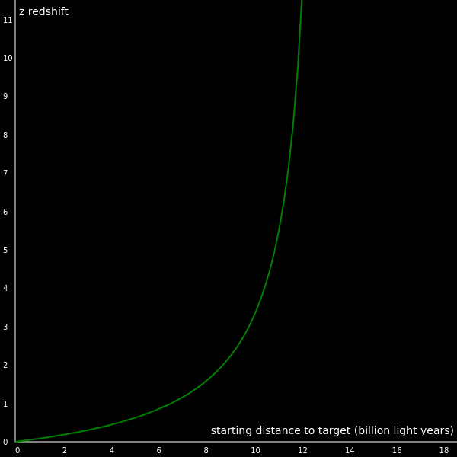

Figure 2. The z redshifts for the expanding model and decelerating photon hypothesis

The redshifts predicted by the expanding model and the decelerating photon hypothesis are identical.

### **3.2 The CMB indicates a hot past**

The Cosmic Microwave Background was predicted by the big bang theory as a remnant of the fiery conditions at the beginning of the universe, and its discovery is an important piece of evidence for the theory.

If the decelerating photon hypothesis is correct, the CMB must have some other explanation. Considering the following facts:

1. Photons lose energy proportional with distance
2. There is energy coming from all directions as microwave background radiation

The energy lost through redshifting and the energy of the CMB might be more closely related than we currently think. If the energy lost by redshifting is discarded into space it would start to pile up.

If space is filling up with the energy discarded by redshifting photons, when the energy in a volume of space is greater than the energy equivalent of the temperature of its surroundings, that volume of space should start emitting radiation to cool to equilibrium.

This might take the form of a "background" field that receives the energy lost by redshifting photons and returns the energy to the EM field as photons to reach a thermal equilibrium.

Early 20th century astronomers calculated that the minimum temperature to which a black body in our galaxy would cool is 2.8 K well before the CMB was discovered.[[26]](https://mikehelland.github.io/hubbles-law/#sources)

The CMB was discovered in 1964 at 3 K, which has been refined to 2.725 K.

In the expanding model, the similarity between the predicted effective temperature of our galaxy and the temperature of the CMB is a coincidence.

In the decelerating photon hypothesis, the temperature of the CMB is an effect of the background field cooling to the effective temperature of the galaxy.

### **3.3 Age of the universe**

If the universe started with a Big Bang, as we look back in space and time, we should be seeing fewer and fewer mature galaxies and eventually only young galaxies. In the 21st century observations show that's not true:

* A cold, massive, rotating disk galaxy 1.5 billion years after the Big Bang [[7]](https://mikehelland.github.io/hubbles-law/#sources) The existence of such a massive, rotationally supported, cold disk galaxy when the Universe was only 1.5 billion years old favours formation through either cold-mode accretion or mergers, although its large rotational velocity and large content of cold gas remain challenging to reproduce with most numerical simulations.
* A dynamically cold disk galaxy in the early Universe[[8]](https://mikehelland.github.io/hubbles-law/#sources) Interferometric imaging at a spatial resolution of about 60 pc reveals a ratio of rotational-to-random motions of V/σ = 9.7 ± 0.4, which is at least four times larger than expected from any galaxy evolution model at this epoch, but similar to the ratios of spiral galaxies in the local Universe.
* How Can a Star Be Older Than the Universe? [[9]](https://mikehelland.github.io/hubbles-law/#sources) Bond and his collaborators estimated HD 140283's age to be 14.46 billion years — a significant reduction on the 16 billion previously claimed. That was, however, still more than the age of the universe itself, but the scientists posed a residual uncertainty of 800 million years, which Bond said made the star's age compatible with the age of the universe, even though it wasn't entirely perfect.
* A dominant population of optically invisible massive galaxies in the early Universe [[10]](https://mikehelland.github.io/hubbles-law/#sources)Such a high abundance of massive and dusty galaxies in the early Universe challenges our understanding of massive-galaxy formation.
* Earliest giant galaxies: The birth of monsters [[11]](https://mikehelland.github.io/hubbles-law/#sources) "To complicate things further, if massive galaxies are unexpectedly dustier in the early Universe than astronomers predict then even UltraVISTA wouldn't be able to detect them. If this is indeed the case, the currently-held picture of how galaxies formed in the early Universe may also require a complete overhaul."
* Lyman α Emission from a Luminous z = 8.68 Galaxy: Implications for Galaxies as Tracers of Cosmic Reionization [[12]](https://mikehelland.github.io/hubbles-law/#sources) "If you look at the galaxies in the early universe, there is a lot of neutral hydrogen that is not transparent to this emission," says Zitrin. "We expect that most of the radiation from this galaxy would be absorbed by the hydrogen in the intervening space. Yet still we see Lyman-alpha from this galaxy."
* A dusty, normal galaxy in the epoch of reionization [[13]](https://mikehelland.github.io/hubbles-law/#sources) The galaxy is highly evolved: it has a large stellar mass, and is heavily enriched in dust, with a dust-to-gas ratio close to that of the Milky Way. Dusty, evolved galaxies are thus present among the fainter star-forming population at z > 7, in spite of the very short time since they first appeared.
* Some galaxies in the early universe grew up quickly [[14]](https://mikehelland.github.io/hubbles-law/#sources) Fifteen mature galaxies were found at a record-breaking average distance of 12 billion light years, when the universe was just 1.6 billion years old. Their existence at such an early time raises new questions about what forced them to grow up so quickly
* Galaxy Zoo: CANDELS Barred Disks and Bar Fractions [[15]](https://mikehelland.github.io/hubbles-law/#sources) The newly classified galaxies are striking in that they look a lot like those in today's universe, with disks, bars and spiral arms. But theorists predict that these should have taken another 2 billion years to begin to form, so things seem to have been settling down a lot earlier than expected.
* Spitzer Splash Project Dives Deep for Galaxies [[16]](https://mikehelland.github.io/hubbles-law/#sources) "The findings cast doubt on current models of galaxy formation, which struggle to explain how these remote and young galaxies grew so big so fast."
* Oldest Alien Planets Found—Born at Dawn of Universe [[17]](https://mikehelland.github.io/hubbles-law/#sources) "The idea of planets springing from such a stellar makeup runs counter to a widely accepted theory called the accretion model, which says that heavy elements are needed to form planets."
* Web of the giant: Spectroscopic confirmation of a large-scale structure around the z = 6.31 quasar SDSS J1030+0524 [[18]](https://mikehelland.github.io/hubbles-law/#sources) “This research was mainly driven by the desire to understand some of the most challenging astronomical objects — supermassive black holes in the early Universe. These are extreme systems and to date we have had no good explanation for their existence,”

In a universe that expands, there is a race against the clock for the universe to take shape, and lately the clock has been winning. A universe that doesn't expand, on the other hand, has no discernible age or hurried time schedules for galaxy formation to squeeze into.

### **3.4 Size of the universe**

The things we observe in the universe don't seem to be constrained in size by what we assume are the theoretical limits they could reach. [[19][20][20][21][22][23][24]](https://mikehelland.github.io/hubbles-law/#sources):

Year Structure name Max. dimension (in light-years)  
2014 Hercules-Corona Borealis Great Wall 9,700,000,000  
2015 Giant GRB Ring 5,600,000,000  
2012 Huge-LQG 4,000,000,000  
2011 U1.11 LQG 2,500,000,000   
1991 Clowes–Campusano LQG 2,000,000,000  
2003 Sloan Great Wall 1,380,000,000  
2020 South Pole Wall) 1,370,000,000  
(Theoretical limit 1,200,000,000

In the decelerating photon hypothesis, the size and age of the universe are indefinite and there is no cosmic size limit.

### **3.5 Tolman Surface Brightness Test**

The Tolman Surface Brightness Test is meant to distinguish a static universe from an expanding one.

In the decelerating photon hypothesis, a photon experiences the same delays in the journey as a photon would in expanding space. But successive photons in an expanding universe would experience higher delays, whereas each successive photon in the decelerating photon hypothesis experiences the same delay as the first photon.

An expanding universe predicts an extra factor of dimming, due to the photons arriving at a lower rate due to the galaxy's motion away from us. Based on observations, it predicts one factor too many[[27]](https://mikehelland.github.io/hubbles-law/#sources):

"The exponent found is not 4 as expected in the simplest expanding model, but 2.6 or 3.4, depending on the frequency band."

The decelerating photon hypothesis predicts one fewer factor than the expanding universe, matching observations.

### **3.6 Time Dilation in Supernovae Light Curves**

Due to the expanding universe, a nearby event that lasts for 20 days, such as a supernova, would appear to last longer when the event takes place far away. That is because of the same reason that an expanding universe predicts a fourth dimming factor in the surface brightness test: the galaxy is farther away each time it emits light. This is known as time dilation, and it is observed in the light curves of distant supernovae. The more dilated the duration of the event, the farther away it must be.

In the decelerating photon hypothesis, space is not expanding, and thus it cannot stretch the time it takes for an event to occur. The only way the decelerating photon hypothesis could be true then, is if the longer supernovae observed are not time dilated, but actually much bigger supernovae than we assume they are.

This is the position argued by Jensen[[28]](https://mikehelland.github.io/hubbles-law/#sources), page 5:

On the other hand, the Delta(15) values seem to indicate the opposite trend, the light curves and therefore the supernovae themselves are actually getting smaller with increasing redshift! Why would this be true? Why would we find smaller supernova with increasing redshift? Unless the morphology of supernova are changing, and the spectra indicate that they are not, we should expect the size of the supernova we actually observe to increase slightly with distance, a predictable Malmquist type II bias of about 4%.

And page 6:

This same argument can be made with the most basic piece of statistical data: Supernovae rise times: In the local universe, the average rise time is 20 days, but in the redshifted universe; it is 17.5 days, which again, would tend to indicate more distant supernova are smaller (Li). If this time dilation factor is removed, the high redshift sample has an average rise time of about 25 days. This is too long for normal Ia, but not if the distance modulus and the corresponding attenuation factor are underestimated. In this case, the higher redshifted SNe Ia would indeed be over-represented by very high magnitude ‘peculiar’ Ia, or hypernova. Credence is given to this conjecture by the fact the number of supernova actually found in high redshift surveys represent only a small fraction (~4%) of the expected yield (Tonry).

Jensen argues that the farther we look into space and the larger our sample size becomes, the smaller the average supernova appears to be, contrary to expectations. He advocates adjusting for a Malmquist type II bias, meaning the farther into space we look, the lower the fraction of the galaxy's light will reach us, altering our measurements. These particularly long lasting supernovae are then not only larger events than we think they are, they are also farther away than we think.

## **4. Established Laws of Physics**

### **4.1 Newton's First Law of Motion**

An object in motion remains in motion at a constant velocity. Does this hold true to infinity? Even if a photon could travel at c to infinity, Hubble's law would place a limit on how far it can effectively travel.

To illustrate, remember those models of photons from the Introduction? The decelerating photon burned out long ago, but the photon in expanding space is still traveling, ever faster and farther. It hasn't hit a target for hundreds of trillions of years, and it never will.

The photons in the expanding universe that approach the Hubble limit just cruise forever in rapidly increasing space. Alternatively, energy that is redshifted away in the decelerating photon hypothesis gets recycled back into the universe. The expanding universe is almost comically inefficient by comparison.

That said, the hypothesis v=c-HD needs a D, which is the distance the particle has traveled since it was emitted. This would not apply to a Newtonian object.

### **4.2 Special Relativity**

The second postulate of special relativity is that the speed of light in a vacuum is always c. And like Newtonian inertia, it is implied that this holds to infinite distance.

The decelerating photon hypothesis directly contradicts that by saying the velocity of a photon is determined by its distance, v = c - HD. In the domain where cosmological redshifts aren't observed HD = 0, so v = c - HD becomes v = c, and there is no conflict. The hypothesis is consistent with special relativity where it is experimentally confirmed.

Testing the constancy of the speed of light from very distant sources is a topic in a later section of this paper.

But cosmological redshifts are the domain of general relativity.

### **4.3 General Relativity**

Recall the graph of the time delays from the introduction. If that graph were to include a second photon headed in the opposite direction, it would produce a reflected image, like this:

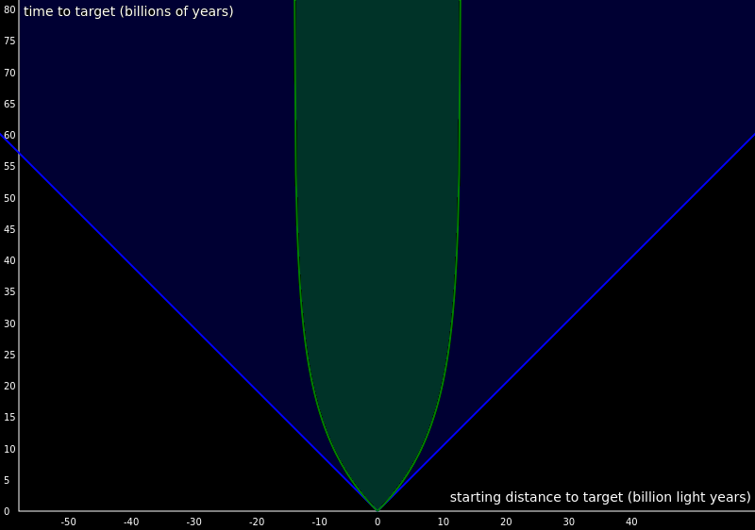

Figure 3. Light cone in special relativity (blue) with the expanding universe and decelerating photon hypothesis in green

The straight (blue) lines that make the traditional light cone represent special relativity. The curved (green) lines that make the upside down bell shape represent Hubble's law, both as the expansion of space and as the decelerating photon hypothesis. The green shaded area represents the Hubble volume.

To accommodate the observed redshifts, the light cone in relativity must be curved in a way that exactly matches the decelerating photon hypothesis.

But there is a very big difference between the two. In general relativity, space expands the null geodesic for all photons. All photons stick to the same geodesic at the same speed.

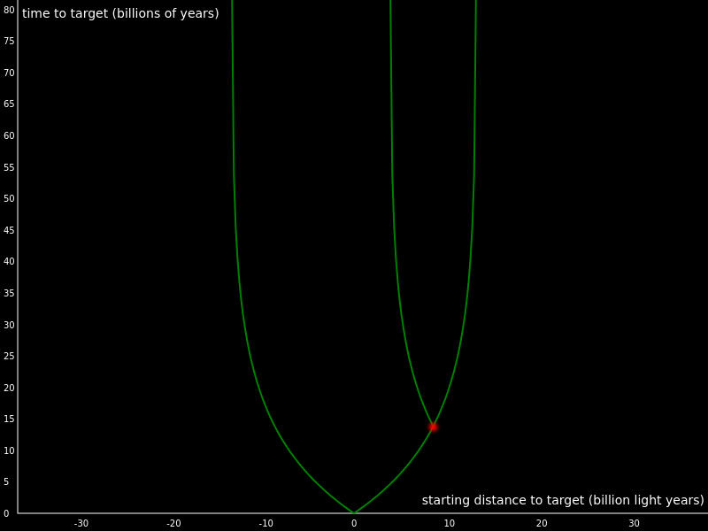

Figure 4. Two photons in expanding space

In the decelerating photon hypothesis, each photon begins on the null geodesic, but then diverges according to v=c-HD along its own individual geodesic. The length of each photon geodesic has a maximum range of c/H, Hubble's length. Put another way, Hubble's law would be removed as the scale factor and reapplied in the geodesic equation.

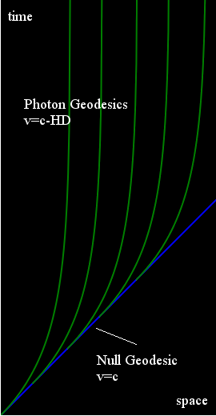

Figure 5. A new class of geodesics for photons in general relativity

These extra individual paths that diverge from the common path can be seen as time dilations localized to an individual photon.

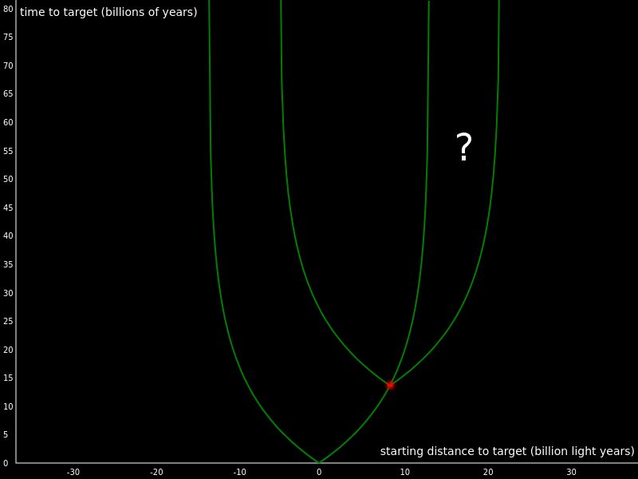

Figure 6. Two decelerating photons

This actually allows for different Hubble volumes to communicate between relays. Information can be sent from one galaxy to a distant one within range. That signal can be received and retransmitted with fresh photons, eventually leaving the original broadcaster's Hubble volume.

Given an indefinitely old universe, the ability to communicate between Hubble volumes avoids any issues posed by the horizon problem, which says different parts of the sky should not have reached temperature because there is too little time since the big bang and they are causally separated by the Hubble limit of their respective Hubble volumes.

### **4.4 Quantum Mechanics**

There is nothing in quantum mechanics that resembles anything discussed in this paper. No known interaction will cause the photon to redshift in the manner needed by the decelerating photon hypothesis. So the following Fenyman diagram is proposed:

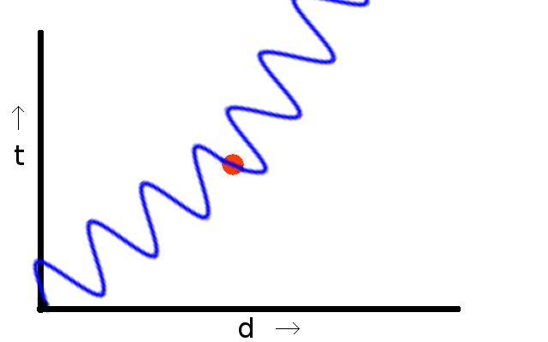

Figure 7. A Feynman diagram for a photon redshifting

Here is a photon cruising along, and then it discards some energy, and also decelerates.

As mentioned in the section on the CMB, this action could be thought of as transferring energy from the photon to the "background" field.

## **5. Photons**

The electromagnetic force holds our atoms together and brings us heat and light from the universe. As our ability to observe has progressed, it was assumed the photon would always be there, no matter the distance. Some physicists are dismayed by the idea that the photon cannot travel to infinity. But for everything else the photon does, we owe it some gratitude.

With that out of the way, a photon's distance from where it was emitted is crucial to keep in mind at all times. Consider light that has traveled billions of years to reach your telescope. The light enters the lens, gets focused to the eyepiece, and then into your eyeball.

Seems pretty straightforward. But at some level, some type of interaction with the light and the lens must be focusing the light. At the quantum level, the photon will have been absorbed by atoms in the lens. Then it is re-emitted (or an entirely new photon is emitted), and focused to your telescope's eyepiece.

The photon may have traveled great distances from its source before it encountered your telescope, but the light inside the telescope will be very close to its source: the lens that focused it. The distance to the source of the photons in the telescope will be less than a meter, not millions of light years.

In that case the refreshed photon will be traveling at c, which now results in an elongated wavelength when calculated.

## **6. Tests**

### **6.1 Measure the speed of a cosmologically redshifted photon**

This is the first obvious test of the hypothesis.

But it would take thousands or millions of years to perform a fully controlled experiment where light is emitted with a known energy at a known time and travels across a known distance to see the effects of redshift.

Using light that has already traveled millions of years seems to be the only choice.

But interacting with the photon will cause it to reset its distance and speed, as mentioned in the previous section. The task then is to come up with a clever way to measure the speed of ancient light without disturbing the photon.

Consider a long tube in space with a telescope at one end and an open shutter at the other. The telescope has a nearby galaxy and a highly redshifted galaxy in its sight.

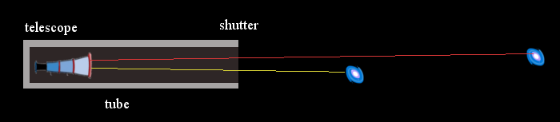

Figure 8. A test for slow photons

What happens when the shutter is closed?

**Prediction:** Because the red light is moving slower than the yellow light, first the nearby galaxy will disappear from view, then the distant one.

### **6.2 Extra doppler shifts from high z galaxies**

Because photons from high z galaxies should be moving slower than c, their relative velocity to Earth should be detectable by the Hubble Space Telescope as Doppler effects.

**Prediction:** Observing a high z galaxy on Earth's horizon, when Earth is on opposite sides of the sun, should produce more redshift when the Earth is moving away from the distant galaxy than when the Earth is moving toward the galaxy, to a degree more exaggerated than for nearby galaxies.

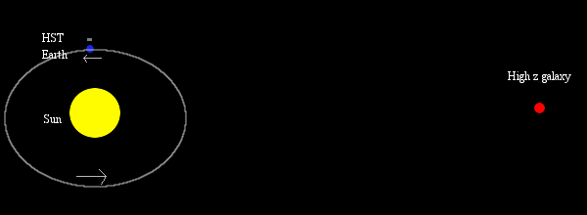

Figure 9. Another test for slow photons looking for extra Doppler effects

### **6.3 Deviations from the standard model**

The decelerating photon hypothesis is identical to a simple expanding model. However, the expanding model provided here is much simpler than the standard model of cosmology, with its dark matter and dark energy components.

To compare the hypothesis with the standard model, Table 1. was made using WolframAlpha for the standard model of z, lookback time, and co-moving distance using a Hubble constant of 74 km/s/Mpc.

In the expanding model, the lookback time refers to how long ago the light was emitted, and the co-moving distance refers to how far away the light source is now given that space has expanded since the light was emitted.

In the decelerating photon hypothesis, the time it takes to make the journey increases due to the photon slowing down. A distant light source won't have moved from expansion between then and now (though it may have its own particular motion). In this case distance and duration trade places. The lookback time correlates with the distance of the target, and the co-moving distance correlates with the time it takes to reach the target.

[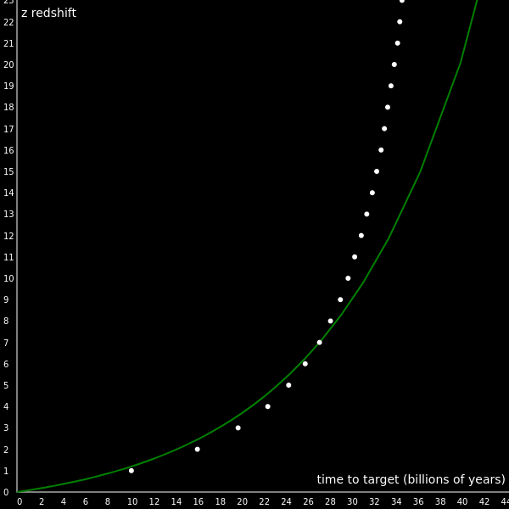](https://mikehelland.github.io/hubbles-law/img/z_time.png)

Figure 9. The hypothesis (green) predicts less redshift than the standard model (white dots)

At about z=8.0, the hypothesis starts to go off the path of the standard model, predicting a slower rise in z over time. In other words, this hypothesis predicts more redshift nearby and less far away than the standard model, giving it the illusion that the effect is currently accelerating compared to the expectations of the standard model.

**Prediction**: A new telescope such as JWST should show the galaxy population extending indefinitely, distributed evenly by lookback time (which, in the decelerating photon hypothesis, is the galaxy's distance) rather than by co-moving distance (which represents the time required to reach the galaxy).

## **7. Conclusion**

*We seem to face, as once before in the days of Copernicus, a choice between a small, finite universe, and a universe indefinitely large plus a new principle of nature.* - Edwin Hubble

Cosmological redshifts have been a known, observed fact since 1929.

We could assume the redshifts indicate expansion, which means:

* there are age and size limits to the universe
* the universe inflated in the first nanosecond
* it is dominated by dark matter and dark energy
* it's currently accelerating

Or we could assume the redshifts are themselves a new feature of the universe, which means:

* light doesn't travel to infinity at a constant speed
* what we can see is an insignificant sample of an indefinitely large and old universe

When interpreting the redshifts as Doppler effects in the 20th century, astronomers didn't know this idea would lead to inflation or dark energy. In fact, they chose the velocity-shift interpretation because it was known and familiar and didn't require new laws of physics.

In retrospect, it should come as no surprise to us that when telescopes could show us what's beyond the Milky Way, they would also reveal a new fundamental law of nature.

If dark energy is in the consideration as a possible fundamental ingredient of nature despite having never been observed, then the actual observations that led to its conjecture, cosmological redshift, should be considered as well.

## **8. Declarations**

**Funding** Not Applicable

**Conflicts of interest/Competing interests** Not Applicable

**Availability of data and material** Included at bottom

**Code availability** Included at bottom

## 

## 

## **9. Sources**

1. A. G. Riess et al. "Large Magellanic Cloud Cepheid Standards Provide a 1% Foundation for the Determination of the Hubble Constant and Stronger Evidence for Physics Beyond LambdaCDM" [arXiv:1903.07603](https://arxiv.org/abs/1903.07603), (2019).
2. N. Aghanim et al., *“Planck 2018 results. VI. Cosmological parameters*, (2018)
3. A. G. Riess et al., "Cosmic Distances Calibrated to 1% Precision with Gaia EDR3 Parallaxes and Hubble Space Telescope Photometry of 75 Milky Way Cepheids Confirm Tension with LambdaCDM" [arXiv:2012.08534 [astro-ph.CO]](https://arxiv.org/abs/2012.08534) *ApJ.*, 116, 1009 (2020).
4. Blakeslee, J.P. et al,. "The Hubble Constant from Infrared Surface Brightness Fluctuation Distances" [arXiv:2101.02221](https://arxiv.org/abs/2101.02221) (2021)
5. Cruz, M.; Martinez-Gonzalez, E.; Vielva, P.; Cayon, L. "Detection of a non-Gaussian Spot in WMAP". *Monthly Notices of the Royal Astronomical Society*. **356** (1): 29–40. (2005)  [arXiv](https://mikehelland.github.io/wiki/ArXiv_(identifier)):[astro-ph/0405341](https://arxiv.org/abs/astro-ph/0405341). [Bibcode](https://mikehelland.github.io/wiki/Bibcode_(identifier)):[2005MNRAS.356...29C](https://ui.adsabs.harvard.edu/abs/2005MNRAS.356...29C). [doi](https://mikehelland.github.io/wiki/Doi_(identifier)):[10.1111/j.1365-2966.2004.08419.x](https://doi.org/10.1111%2Fj.1365-2966.2004.08419.x).
6. Ade, P. A. R.; et al. (Planck Collaboration) (2013). "Planck 2013 results. XXIII. Isotropy and statistics of the CMB". *Astronomy & Astrophysics*. **571**: A23. [arXiv](https://mikehelland.github.io/wiki/ArXiv_(identifier)):[1303.5083](https://arxiv.org/abs/1303.5083). [Bibcode](https://mikehelland.github.io/wiki/Bibcode_(identifier)):[2014A&A...571A..23P](https://ui.adsabs.harvard.edu/abs/2014A&A...571A..23P). [doi](https://mikehelland.github.io/wiki/Doi_(identifier)):[10.1051/0004-6361/201321534](https://doi.org/10.1051%2F0004-6361%2F201321534).
7. Neeleman, M., Prochaska, J.X., Kanekar, N. et al. A cold, massive, rotating disk galaxy 1.5 billion years after the Big Bang. Nature 581, 269–272<https://doi.org/10.1038/s41586-020-2276-y> [2005.09661](https://arxiv.org/pdf/2005.09661) (2020)
8. Rizzo, F., Vegetti, S., Powell, D. et al. A dynamically cold disk galaxy in the early Universe. Nature 584, 201–204 (2020).<https://doi.org/10.1038/s41586-020-2572-6>
9. Don A. VandenBerg et al 2014 ApJ 792 110<http://dx.doi.org/10.1088/0004-637X/792/2/110>
10. Wang, T., Schreiber, C., Elbaz, D. et al. A dominant population of optically invisible massive galaxies in the early Universe. Nature 572, 211–214 (2019).<https://doi.org/10.1038/s41586-019-1452-4>
11. K. Caputi et al., “Spitzer Bright, UltraVISTA Faint Sources in COSMOS: The Contribution to the Overall Population of Massive Galaxies at z = 3-7”, Astrophysical Journal.
12. Adi Zitrin et al, ApJL 810 L12 (2015)<https://iopscience.iop.org/article/10.1088/2041-8205/810/1/L12>
13. Watson, D., Christensen, L., Knudsen, K. et al. A dusty, normal galaxy in the epoch of reionization. Nature 519, 327–330 (2015).<https://doi.org/10.1038/nature14164>
14. Straatman, Caroline MS, et al. "A substantial population of massive quiescent galaxies at z∼ 4 from ZFOURGE." The Astrophysical Journal Letters 783.1 (2014): L14.<https://arxiv.org/abs/1312.4952>
15. B. D. Simmons et al. Galaxy Zoo: CANDELS Barred Disks and Bar Fractions. Monthly Notices of the Royal Astronomical Society, 2014 DOI: 10.1093/mnras/stu1817
16. Charles L. Steinhardt et al 2014 ApJL 791 L25<https://iopscience.iop.org/article/10.1088/2041-8205/791/2/L25>
17. J. Setiawan, et al., Planetary companions around the metal-poor star HIP 11952, A&A 540 A141 (2012) DOI: 10.1051/0004-6361/201117826
18. Marco Mignoli, et al., A&A 642 L1 (2020) DOI: 10.1051/0004-6361/202039045 Web of the giant: Spectroscopic confirmation of a large-scale structure around the z = 6.31 quasar SDSS J1030+0524
19. Daniel Pomarède et al 2020 ApJ 897 133<https://iopscience.iop.org/article/10.3847/1538-4357/ab9952>
20. Gott, J. Richard, III; et al. (May 2005), "A Map of the Universe", *The Astrophysical Journal*, **624** (2): 463–484, [arXiv](https://mikehelland.github.io/wiki/ArXiv_(identifier)):[astro-ph/0310571](https://arxiv.org/abs/astro-ph/0310571), [Bibcode](https://mikehelland.github.io/wiki/Bibcode_(identifier)):[2005ApJ...624..463G](https://ui.adsabs.harvard.edu/abs/2005ApJ...624..463G), [doi](https://mikehelland.github.io/wiki/Doi_(identifier)):[10.1086/428890](https://doi.org/10.1086%2F428890)
21. Clowes, Roger; Luis E. Campusano; Matthew J. Graham & Ilona K. S¨ochting (2012). "Two close Large Quasar Groups of size ∼ 350 Mpc at z ∼ 1.2". *Monthly Notices of the Royal Astronomical Society*. **419** (1): 556. [arXiv](https://mikehelland.github.io/wiki/ArXiv_(identifier)):[1108.6221](https://arxiv.org/abs/1108.6221). [Bibcode](https://mikehelland.github.io/wiki/Bibcode_(identifier)):[2012MNRAS.419..556C](https://ui.adsabs.harvard.edu/abs/2012MNRAS.419..556C). [doi](https://mikehelland.github.io/wiki/Doi_(identifier)):[10.1111/j.1365-2966.2011.19719.x](https://doi.org/10.1111%2Fj.1365-2966.2011.19719.x).
22. Clowes, Roger G.; Harris, Kathryn A.; Raghunathan, Srinivasan; Campusano, Luis E.; Söchting, Ilona K.; Graham, Matthew J. (2013-01-11). ["A structure in the early Universe at z ∼ 1.3 that exceeds the homogeneity scale of the R-W concordance cosmology"](http://mnras.oxfordjournals.org/content/early/2013/01/07/mnras.sts497.full). *Monthly Notices of the Royal Astronomical Society*. **1211** (4): 6256. [arXiv](https://mikehelland.github.io/wiki/ArXiv_(identifier)):[1211.6256](https://arxiv.org/abs/1211.6256). [Bibcode](https://mikehelland.github.io/wiki/Bibcode_(identifier)):[2013MNRAS.429.2910C](https://ui.adsabs.harvard.edu/abs/2013MNRAS.429.2910C). [doi](https://mikehelland.github.io/wiki/Doi_(identifier)):[10.1093/mnras/sts497](https://doi.org/10.1093%2Fmnras%2Fsts497). [S2CID](https://mikehelland.github.io/wiki/S2CID_(identifier)) [486490](https://api.semanticscholar.org/CorpusID:486490). Retrieved 14 January 2013.
23. Balazs, L.G.; Bagoly, Z.; Hakkila, J.E.; Horvath, I.; Kobori, J.; Racz, I.I.; Toth, L.V. (2015-08-05). ["A giant ring-like structure at 0.78 < z < 0.86 displayed by GRBs"](http://mnras.oxfordjournals.org/content/452/3/2236.abstract). *Monthly Notices of the Royal Astronomical Society*. **452** (3): 2236–2246. [arXiv](https://mikehelland.github.io/wiki/ArXiv_(identifier)):[1507.00675](https://arxiv.org/abs/1507.00675). [Bibcode](https://mikehelland.github.io/wiki/Bibcode_(identifier)):[2015MNRAS.452.2236B](https://ui.adsabs.harvard.edu/abs/2015MNRAS.452.2236B). [doi](https://mikehelland.github.io/wiki/Doi_(identifier)):[10.1093/mnras/stv1421](https://doi.org/10.1093%2Fmnras%2Fstv1421). [S2CID](https://mikehelland.github.io/wiki/S2CID_(identifier)) [109936564](https://api.semanticscholar.org/CorpusID:109936564). Retrieved 5 August 2015.
24. Horvath, Istvan; Bagoly, Zsolt; Hakkila, Jon; Tóth, L. Viktor (2014). "Anomalies in the GRB spatial distribution". *Proceedings of Science*: 78. [arXiv](https://mikehelland.github.io/wiki/ArXiv_(identifier)):[1507.05528](https://arxiv.org/abs/1507.05528). [Bibcode](https://mikehelland.github.io/wiki/Bibcode_(identifier)):[2014styd.confE..78H](https://ui.adsabs.harvard.edu/abs/2014styd.confE..78H).
25. Jones, David, "Crisis in Cosmology: Measuring The Local Value of the Hubble Constant" APS April Meeting 2018 63,4 [APR18-2018-000816](http://meetings.aps.org/Meeting/APR18/Session/H07.1) (2018)
26. Assis, A. K. T.; Neves, M. C. D., Astrophysics and Space Science, Volume 227, Issue 1-2, pp. 13-24 (1995)
27. Lubin, L. M.; Sandage, A., "The Tolman Surface Brightness Test for the Reality of the Expansion. IV. A Measurement of the Tolman Signal and the Luminosity Evolution of Early-Type Galaxies," Astronomical Journal, 122 (2001): 1084-1103.
28. Jensen, J. W., "Supernovae Light Curves: An Argument for a New Distance Modulus" [arXiv:astro-ph/0404207](https://arxiv.org/abs/astro-ph/0404207) (2004)
29. H.J. Reboul, [*Astron. Astrophys. Supp. Ser.*](https://ui.adsabs.harvard.edu/abs/1981A%26AS...45..129R/abstract) 45, 129--144 (1981).
30. J. Magueijo, *Reports on Progress in Physics*, Vol. 66, Iss. 11, 2025-2068 (2003).
31. E. Hubble, in [*The Observational Approach to Cosmology*](https://ned.ipac.caltech.edu/level5/Sept04/Hubble/paper.pdf), p22, (1937)

Table 1.

z lookback time (By) co-moving distance (Bly)

-----------------------------------------------------

1 7.4 10.4

2 9.8 16.4

3 11.0 20.1

4 11.6 22.8

5 11.9 24.7

6 12.2 26.2

7 12.3 27.5

8 12.4 28.5

9 12.5 29.4

10 12.6 30.1

11 12.7 30.7

12 12.7 31.3

13 12.7 31.8

14 12.8 32.3

15 12.8 32.7

16 12.8 33.1

17 12.8 33.4

18 12.9 33.7

19 12.9 34.0

20 12.9 34.3

21 12.9 34.6

22 12.9 34.8

23 12.9 35.0

24 12.9 35.2

25 12.9 35.4

https://www.wolframalpha.com/input/?i=galaxy+with+redshift+z%3D+1+hubble+parameter+%3D+74

Source Code for models

var simple = {

photon: {d: 0},

next: function () {

this.photon.d += c

}

}

var expanding = {

photon: {d: 0},

next: function () {

// photon and targets move at H × D

this.photon.d += c + H * this.photon.d

for (var target of this.targets)

target.d += H * target.d

}

}

var hypothesis = {

photon: {d: 0},

next: function () {

this.photon.d += c - H * this.photon.d

}

}

// time units: 1 million years

// distance units: 1 million light years

// the speed of light 1 million light years / million years

const c = 1

function run(model) {

// create targets at distance (d) 200 million light years apart

model.targets = []

for (var i = 200; i <= 30000; i+=200)

model.targets.push({d: i, start: i})

var t = 0

var nextTarget = 0

// start the loop

while (model.targets[nextTarget]) {

//advance the model 1 million years

t += 1

model.next()

// if we hit a target record the time

if (model.photon.d >= model.targets[nextTarget].d) {

console.log("Target reached", t)

model.targets[nextTarget].hit = t

nextTarget += 1

}

}

}