Show Shell Books

Overview
There are three CMS apps that can be used to display literacy content that is in Paratext. Each produces a report designed for one or more specific purposes. They are combined in one help file because they have similar options. The apps are as follows:
Show Shellbooks Text – This App will produce a report in plain text showing one or more shell books or original stories without SFM markers (\ codes). This app can be used for the following purposes:
- To quickly see which books/stories that have been translated
- To produce a quick printout for work sessions.
Show Shellbooks Link Index – This app will display a chapter-verse index of shellbooks or original stories in a Paratext window. If you double-click on an item in the list, Paratext will jump to that chapter and verse. This app makes it easy to navigate to various shellbooks or stories.
Shellbooks to Publisher – This app will produce a report to showing one or more Shell Books formatted specifically for copying and pasting text into Publisher shells. It has been optimized for pasting text into Publisher’s linked text boxes by replacing page numbers in the report with page breaks recognizable by Publisher. The app does not copy the text into Publisher for you. It just makes the task easier. See Brief instructions for copying from the report to Publisher near the end of this document.

Instructions
The instructions for each of the apps is very similar.

Opening Screen
Input Project – Choose the Paratext project. Most of the time, the correct project will already be showing.
Current Book and Choose Books – these function the same way they in other Paratext windows. For shellbooks and original stories, Extra Book (XXA) is the most likely choice.
Options – Click the options button for additional options. Descriptions are following.

Options
In the Options window, under Option Name, select each option one at a time, read the Description for the option at the right, and type a choice in the Value text box. Following are descriptions of the options.
Shell book filter – This option is used to select which shellbooks or stories to show. Type the filter into the text box:
- Enter ALL to show all the shell books,
- Enter a two letter category (ex. AS) to show all the stories in one category
- Enter a book number (ex. AG0005) to show a specific shell book.
Show empty shell books – Use this option to specify whether or not empty shell books will be displayed.
- Enter NO to show only shell books containing vernacular text,
- Enter YES to show books with just shells along with books containg vernacular text.
Hide Page Numbers – The mark up of shell books includes page numbers for Publisher (p.##). Use this option to specify whether to display these page numbers in the report
- Enter YES To hide page numbers (p.##) at the beginning of a story page
- Enter NO to show page numbers.
Recognize traditional page numbers – The Standard for Literacy Content in Paratext specifies that page numbers be formatted with “p.” followed by the page number (p.##). Shellbooks authored before the Standard was written may use a traditional number format for page numbers consisting of a number followed by a period (##.). This option will tell the app whether to treat traditionally formatted numbers as page boundaries.
- Enter YES and this app will recognize traditional page numbers (##.) as well as standard page numbers (p.##) to specify the beginning of a story page.
- Enter NO and the app will not treat traditional page numbers as page numbers or page boundaries.

Brief instructions for copying from the report to Publisher
The app Shellbooks to Publisher produces a report formatted for ease of copying to MS publisher. The report looks something like this:
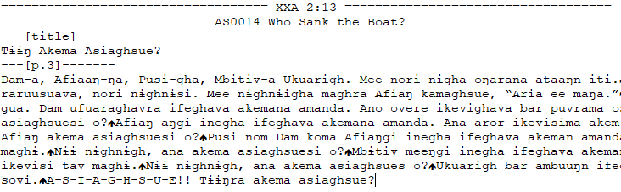
- Open the shell book shell in Publisher into which you want to import text.
- In the text editor showing the report:
  - You should see two or more headers like “---[title]-------“ and “---[p.3]-------“. Each header is followed by vernacular text. (If the entire text of the story appears on one line, turn on word wrap.)
  - Under the header “---[title]-------“, select the vernacular title (in this example it is “Tɨɨŋ Akema Asiaghsue?”), and copy it.
  - In the Publisher shell book, paste the vernacular title into the title text boxes. Normally there are two title text boxes—one on the cover and one on the title page.
  - In the text editor following the vernacular title, there is a page header that looks something like this, “---[p.3]-------“, indicating the following text starts on the indicated page (normally this is 3).
  - Select the entire vernacular text following the page header. In this example, select from the beginning of “Dam-a” to the end of “asiaghsue?” Copy the text.
  - Paste the vernacular text into the first text box on the page shown in the page header (normally 3). The text should automatically flow into the linked text boxes on following pages
  - If there are additional page headers, repeat steps d. thru f.
- Save the Publisher file.

