Airline Pilot Retention Analysis

Mike Hickey

2025-06-04

Table of Contents

–RESEARCH QUESTION ANALYSES– 1

Why Records Were Excluded

| exclusion_reason | n |
| --- | --- |
| did_not_finish | 35 |
| included | 76 |
| not_air_carrier | 2 |

## **Total records in file:** 113 \n\n**Records kept for analysis:** 76 \n\n**Records excluded:** 37

write_csv(included_data, here("data/retention_cleaned.csv"))

#{r preview-clean, echo = FALSE} #knitr::kable(head(included_data), caption = "Preview of Cleaned Data") #

Descriptive Statistics for Age

| n | min_age | q1_age | median_age | mean_age | q3_age | max_age | sd_age | iqr_age | skew_age | kurt_age |
| --- | --- | --- | --- | --- | --- | --- | --- | --- | --- | --- |
| 76 | 21 | 26 | 29 | 32.41 | 35 | 63 | 9.91 | 9 | 1.46 | 1.48 |

##   
## Shapiro–Wilk normality test p‑value: 0

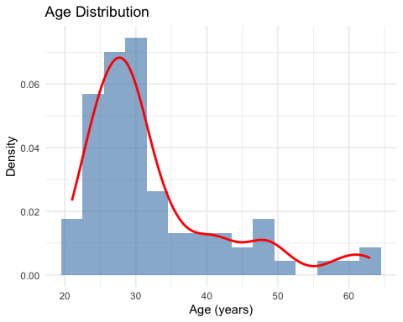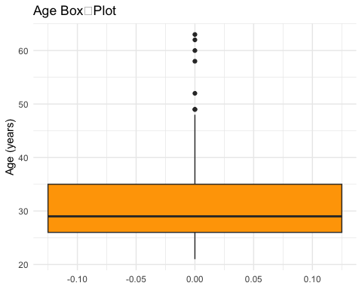

Age Distribution: ≤ 35 vs > 35

| Age Group | n | % |
| --- | --- | --- |
| ≤ 35 | 58 | 76.3 |
| > 35 | 18 | 23.7 |

Descriptive Statistics for Years of Experience

| n | min_exp | q1_exp | median_exp | mean_exp | q3_exp | max_exp | sd_exp | iqr_exp | skew_exp | kurt_exp |
| --- | --- | --- | --- | --- | --- | --- | --- | --- | --- | --- |
| 76 | 1 | 2 | 3 | 5.78 | 7 | 30 | 6.55 | 5 | 2.21 | 4.74 |

##   
## Shapiro–Wilk normality test p‑value: 3.131e-11

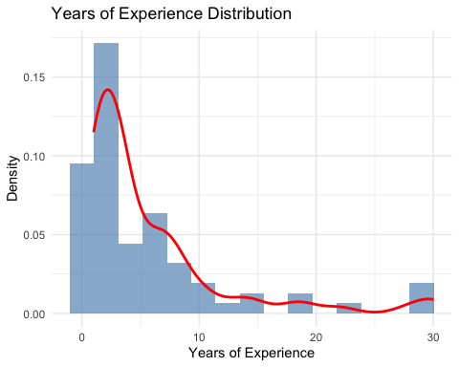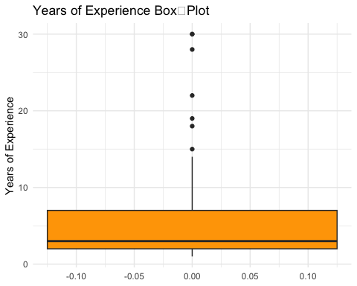

Descriptive Statistics for Total Flying Hours

| n | min_hours | q1_hours | median_hours | mean_hours | q3_hours | max_hours | sd_hours | iqr_hours | skew_hours | kurt_hours |
| --- | --- | --- | --- | --- | --- | --- | --- | --- | --- | --- |
| 76 | 840 | 2015 | 2900 | 4532.13 | 4500 | 22000 | 4490.88 | 2485 | 2.41 | 5.48 |

##   
## Shapiro–Wilk normality test p‑value: 3.991e-12

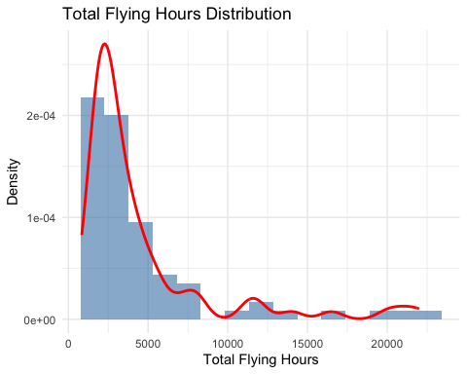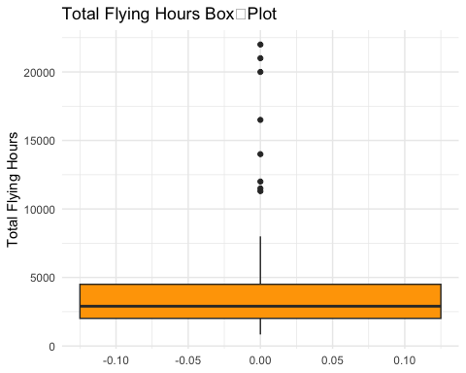

Gender Distribution

| gender | n | percent |
| --- | --- | --- |
| Female | 8 | 10.5% |
| Male | 67 | 88.2% |
| Prefer not to say | 1 | 1.3% |
| Total | 76 | 100.0% |

##   
## Missing / blank gender responses: 0

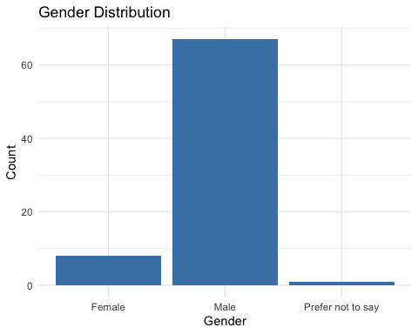

Air‑Carrier Type Distribution

| air_carrier_type | n | percent |
| --- | --- | --- |
| Charter/Fractional (Part 135/91K) | 2 | 2.6% |
| Freight/Cargo Carrier | 1 | 1.3% |
| Legacy/Mainline Part 121 Airline | 11 | 14.5% |
| Low Cost Carrier | 5 | 6.6% |
| Regional Airline | 57 | 75.0% |
| Total | 76 | 100.0% |

##   
## Missing / blank carrier‑type responses: 0

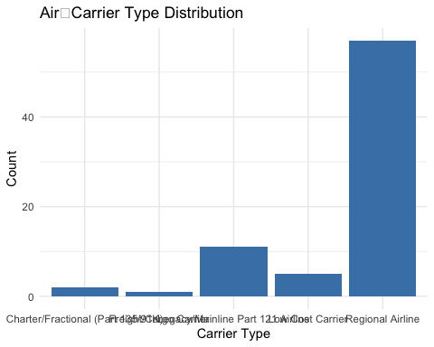

Flight‑Deck Position Distribution

| position_position | n | percent |
| --- | --- | --- |
| Captain | 26 | 34.2% |
| First Officer | 50 | 65.8% |
| Total | 76 | 100.0% |

##   
## Missing / blank position responses: 0

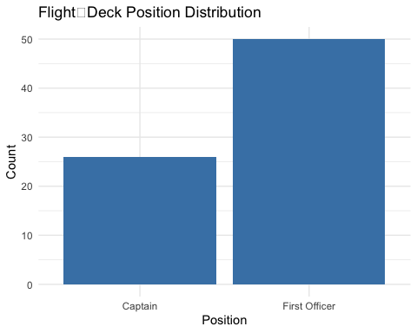

Military Experience Distribution (Yes / No)

| military_bg | n | percent |
| --- | --- | --- |
| No | 69 | 90.8% |
| Yes | 7 | 9.2% |
| Total | 76 | 100.0% |

##   
## Missing military‑experience responses: 0

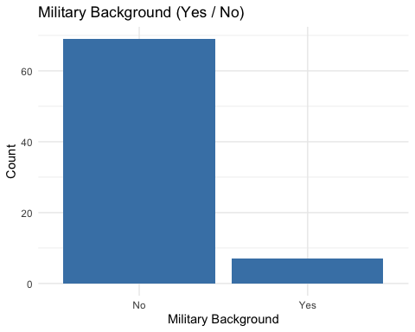

Nationality – Full Country Breakdown

| nationality | n | percent |
| --- | --- | --- |
| United States of America | 70 | 92.1% |
| Ethiopia | 1 | 1.3% |
| Germany | 1 | 1.3% |
| India | 1 | 1.3% |
| Lao People’s Democratic Republic | 1 | 1.3% |
| Mexico | 1 | 1.3% |
| New Zealand | 1 | 1.3% |

Nationality Re‑coded to US vs Foreign

| us_vs_foreign | n | percent |
| --- | --- | --- |
| Foreign | 6 | 7.9% |
| US | 70 | 92.1% |
| Total | 76 | 100.0% |

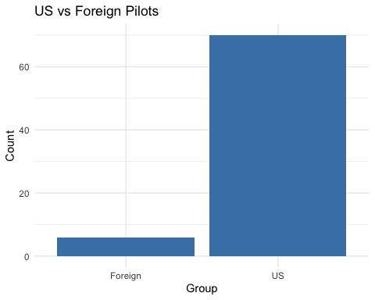

### –RESEARCH QUESTION ANALYSES–

Table 1 Rank Summary for General Retention Factors

| factor | n | median | iqr |
| --- | --- | --- | --- |
| financial | 76 | NA | 2 |
| lifestyle | 76 | NA | 2 |
| operational | 76 | NA | 1 |
| professional | 76 | NA | 1 |
| recognition | 76 | NA | 1 |
| schedule | 76 | NA | 1 |

Table 2 Number (and %) of Pilots Ranking Each Factor #1

| factor | n | percent |
| --- | --- | --- |
| lifestyle | 34 | 44.7 |
| financial | 25 | 32.9 |
| schedule | 13 | 17.1 |
| professional | 3 | 3.9 |
| operational | 1 | 1.3 |

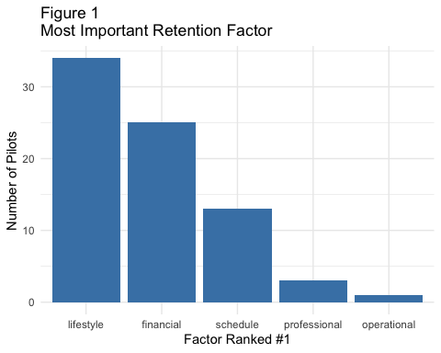

## # A tibble: 1 × 6  
## .y. n statistic df p method   
## * <chr> <int> <dbl> <dbl> <dbl> <chr>   
## 1 rank 76 234. 5 1.27e-48 Friedman test

Table 3 Pairwise Wilcoxon Tests Between General Factors (Bonferroni‑adjusted p‑values)

| comparison | p.sig |
| --- | --- |
| financial vs lifestyle | 1 |
| financial vs operational | < .001 |
| financial vs professional | < .001 |
| financial vs recognition | < .001 |
| financial vs schedule | 1 |
| lifestyle vs operational | < .001 |
| lifestyle vs professional | < .001 |
| lifestyle vs recognition | < .001 |
| lifestyle vs schedule | 0.232 |
| operational vs professional | 1 |
| operational vs recognition | < .001 |
| operational vs schedule | < .001 |
| professional vs recognition | < .001 |
| professional vs schedule | < .001 |
| recognition vs schedule | < .001 |

Table 4 Mann‑Whitney U Tests: Age Groups (≤ 35 vs > 35) on General‑Factor Ranks

| Factor | n ≤35 | Median ≤35 | n >35 | Median >35 | p (Bonferroni) |
| --- | --- | --- | --- | --- | --- |
| lifestyle | 58 | 1 | 18 | 2.5 | 0.05 |
| financial | 58 | 2 | 18 | 2.0 | 1.00 |
| operational | 58 | 4 | 18 | 4.0 | 1.00 |
| professional | 58 | 5 | 18 | 4.0 | 1.00 |
| recognition | 58 | 6 | 18 | 6.0 | 1.00 |
| schedule | 58 | 2 | 18 | 2.0 | 1.00 |

Table 5 Median Rank of General Factors by Experience Quartile

| factor | Q1 (least)_n | Q2_n | Q3_n | Q4 (most)_n | Q1 (least)_median | Q2_median | Q3_median | Q4 (most)_median |
| --- | --- | --- | --- | --- | --- | --- | --- | --- |
| financial | 19 | 19 | 19 | 19 | 2 | 2 | 2 | 2 |
| lifestyle | 19 | 19 | 19 | 19 | 1 | 2 | 2 | 2 |
| operational | 19 | 19 | 19 | 19 | 5 | 4 | 4 | 4 |
| professional | 19 | 19 | 19 | 19 | 4 | 5 | 5 | 5 |
| recognition | 19 | 19 | 19 | 19 | 6 | 6 | 6 | 6 |
| schedule | 19 | 19 | 19 | 19 | 3 | 2 | 2 | 2 |

Table 6 Kruskal–Wallis Tests for Experience Quartiles (Bonferroni‑adjusted p)

| factor | statistic | df | p_adj |
| --- | --- | --- | --- |
| financial | 0.551 | 3 | 1 |
| lifestyle | 3.854 | 3 | 1 |
| operational | 1.364 | 3 | 1 |
| professional | 1.015 | 3 | 1 |
| recognition | 4.639 | 3 | 1 |
| schedule | 2.619 | 3 | 1 |

## Gender counts:

##   
## Female Male <NA>   
## 8 67 1

Table 7 Median Rank of General Factors by Gender

| factor | Female_n | Male_n | Female_median | Male_median |
| --- | --- | --- | --- | --- |
| financial | 8 | 67 | 3 | 2 |
| lifestyle | 8 | 67 | 1 | 2 |
| operational | 8 | 67 | 4 | 5 |
| professional | 8 | 67 | 5 | 5 |
| recognition | 8 | 67 | 6 | 6 |
| schedule | 8 | 67 | 2 | 2 |

Table 8 Mann‑Whitney U Tests: Male vs Female (Bonferroni‑adjusted p)

| factor | p_adj |
| --- | --- |
| financial | 0.504 |
| lifestyle | 1.000 |
| operational | 0.280 |
| professional | 1.000 |
| recognition | 0.364 |
| schedule | 1.000 |

## Military background counts:

##   
## Yes No   
## 7 69

Table 9 Median Rank of General Factors by Military Background

| factor | Yes_n | No_n | Yes_median | No_median |
| --- | --- | --- | --- | --- |
| financial | 7 | 69 | 2 | 2 |
| lifestyle | 7 | 69 | 2 | 2 |
| operational | 7 | 69 | 5 | 4 |
| professional | 7 | 69 | 4 | 5 |
| recognition | 7 | 69 | 6 | 6 |
| schedule | 7 | 69 | 2 | 2 |

Table 10 Mann‑Whitney U Tests: Military vs Civilian (Bonferroni‑adjusted p)

| factor | p_adj |
| --- | --- |
| financial | 1 |
| lifestyle | 1 |
| operational | 1 |
| professional | 1 |
| recognition | 1 |
| schedule | 1 |

## Carrier group counts:

##   
## LCC Major Other Regional   
## 5 11 3 57

Table 11 Median Rank of General Factors by Carrier Group

| factor | LCC_n | Major_n | Other_n | Regional_n | LCC_median | Major_median | Other_median | Regional_median |
| --- | --- | --- | --- | --- | --- | --- | --- | --- |
| financial | 5 | 11 | 3 | 57 | 3 | 2 | 1 | 2 |
| lifestyle | 5 | 11 | 3 | 57 | 2 | 1 | 2 | 2 |
| operational | 5 | 11 | 3 | 57 | 4 | 4 | 4 | 4 |
| professional | 5 | 11 | 3 | 57 | 5 | 5 | 4 | 5 |
| recognition | 5 | 11 | 3 | 57 | 6 | 6 | 6 | 6 |
| schedule | 5 | 11 | 3 | 57 | 1 | 3 | 3 | 2 |

Table 12 Kruskal–Wallis Tests Across Carrier Groups (Bonferroni‑adjusted p)

| factor | statistic | df | p_adj |
| --- | --- | --- | --- |
| financial | 5.451 | 3 | 0.852 |
| lifestyle | 1.479 | 3 | 1.000 |
| operational | 2.792 | 3 | 1.000 |
| professional | 2.304 | 3 | 1.000 |
| recognition | 2.102 | 3 | 1.000 |
| schedule | 9.233 | 3 | 0.158 |

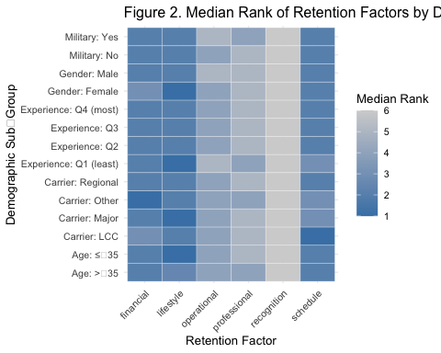

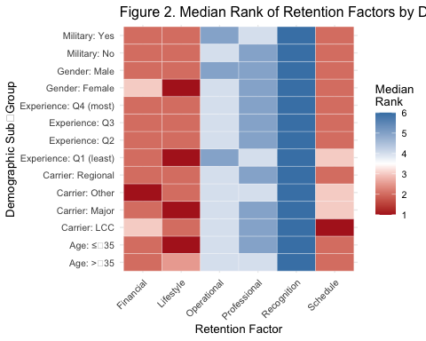

## Position counts:

##   
## Captain First Officer   
## 26 50

Table X1 Median Rank of General Factors by Flight‑Deck Position

| factor | Captain_n | First Officer_n | Captain_median | First Officer_median |
| --- | --- | --- | --- | --- |
| financial | 26 | 50 | 2 | 2 |
| lifestyle | 26 | 50 | 2 | 2 |
| operational | 26 | 50 | 5 | 4 |
| professional | 26 | 50 | 4 | 5 |
| recognition | 26 | 50 | 6 | 6 |
| schedule | 26 | 50 | 2 | 2 |

Table X2 Mann‑Whitney U Tests: Captain vs First Officer (Bonferroni‑adjusted p)

| factor | p_adj |
| --- | --- |
| financial | 0.400 |
| lifestyle | 1.000 |
| operational | 0.082 |
| professional | 1.000 |
| recognition | 1.000 |
| schedule | 1.000 |

