U.S. Airline Pilot Retention Analysis
  - General Factor Rankings and Subfactor Priorities
Michael J. Hickey
Marina Efthymiou
James Higgins
Aman Gupta
Robert Walton
2025-11-21
Table of contents

1. Overview
Repository: https://github.com/mikehickey2/US-Airline-Pilot-Retention-Analysis
This analysis examines pilot retention priorities from a survey of U.S. airline pilots (n = 76). The analysis has two parts:
- General Retention Factors - Rankings of six broad retention constructs and demographic comparisons
- Subfactor Analysis - Within-construct priorities for 31 specific retention elements
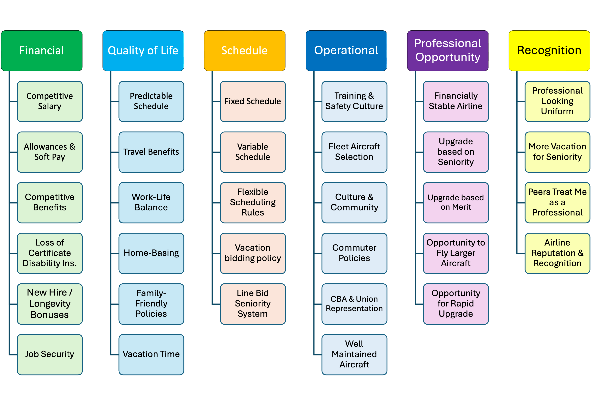
Figure 1: Factors of Pilot Retention in U.S. Airlines

2. Statistical Methods

2.1 Sample and Data Collection
Survey data was collected from U.S. airline pilots in May 2025. After exclusions for incomplete responses and non-air carrier pilots, n = 76 valid responses remained for analysis.

2.2 Statistical Tests
All ranking data is ordinal; therefore, non-parametric tests are used throughout:
- Friedman Test: Within-subjects comparison of factor rankings
- Mann-Whitney U: Between-groups comparison for binary demographics
- Kruskal-Wallis H: Between-groups comparison for multi-level demographics

2.3 Multiple Testing Correction
This quantitative study employs a hierarchical false discovery rate (FDR) control procedure:
General Factor Analysis (30 tests): Benjamini-Hochberg FDR at q = 0.10 applied across all demographic comparisons.
Subfactor Analysis (155 tests): Two-step hierarchical procedure:
- Screening: For each construct, compute minimum p-value across demographics. Apply BH-FDR at q = 0.10 to these 6 screening p-values.
- Within-construct testing: For constructs passing screening, apply Holm’s procedure at alpha = 0.05 to demographic comparisons.
Rationale: Standard Bonferroni correction (alpha/155 = 0.0003) is overly conservative for exploratory research, causing 50-70% Type II error rates. FDR control at q = 0.10 balances discovery against false positives appropriately for hypothesis generation.

2.4 Effect Sizes
- Mann-Whitney U: Rank-biserial correlation r (small < .3, medium .3-.5, large > .5)
- Kruskal-Wallis: Eta-squared (small < .01, medium .01-.06, large > .06)

2.5 Software
Analysis conducted in R 4.5.1 using: tidyverse, rstatix, coin, DescTools, knitr, janitor.
Code Availability: The complete analysis code is available at scripts/analysis/unified_retention_analysis.qmd in the GitHub repository: https://github.com/mikehickey2/US-Airline-Pilot-Retention-Analysis

3. Setup

4. Data Loading and Preprocessing
Data Exclusion Summary
exclusion_reason | n
did_not_finish | 35
included | 76
not_air_carrier | 2
Table 1: Sample Demographic Summary
Demographic | Category | n
Age Group | ≤ 35 years | 58
 | > 35 years | 18
Experience | Q1 (least) | 19
 | Q2 | 19
 | Q3 | 19
 | Q4 (most) | 19
Gender | Male | 67
 | Female | 8
 | Other/NA | 1
Military Background | Yes | 7
 | No | 69
Position | Captain | 26
 | First Officer | 50
Carrier Type | Regional | 57
 | Major | 11
 | LCC | 5
 | Other | 3

Final sample: 76 pilots included in analysis.

5. Part 1: General Retention Factor Analysis
This section analyzes the rankings of six broad retention constructs:
- Financial (salary, benefits, bonuses)
- Quality of Life/Lifestyle (schedule, family, work-life balance)
- Professional Opportunity (stability, upgrade, aircraft type)
- Recognition (uniform, respect, awards)
- Schedule (fixed vs variable, bidding systems)
- Operational (SOPs, training, equipment, pilot skill)

5.1 Descriptive Statistics
Table 1: Rank Summary for General Retention Factors
factor | n | median | iqr | mean | sd
financial | 76 | 2 | 2 | 2.22 | 1.10
lifestyle | 76 | 2 | 2 | 1.99 | 1.16
schedule | 76 | 2 | 1 | 2.46 | 1.01
operational | 76 | 4 | 1 | 4.41 | 1.07
professional | 76 | 5 | 1 | 4.37 | 1.16
recognition | 76 | 6 | 1 | 5.55 | 0.84
Table 2: Number (and %) of Pilots Ranking Each Factor #1
factor | n | percent
lifestyle | 34 | 44.7
financial | 25 | 32.9
schedule | 13 | 17.1
professional | 3 | 3.9
operational | 1 | 1.3
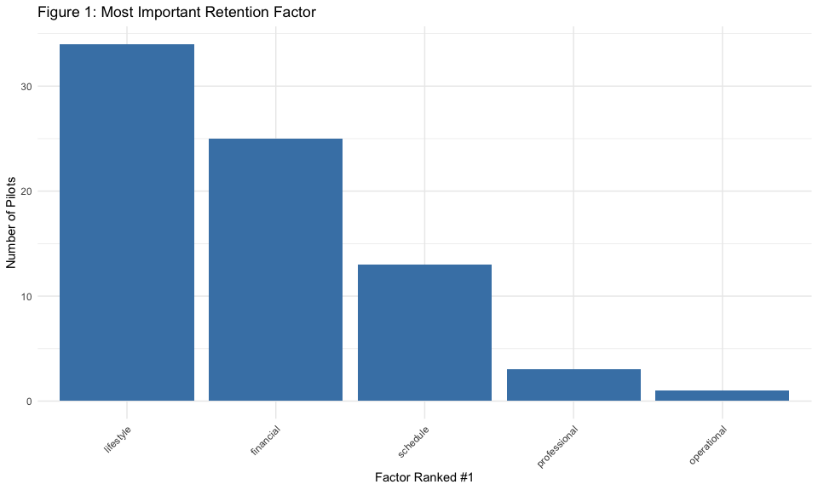

5.2 Friedman Test: Overall Factor Rankings
Friedman Test: Overall Difference in Factor Rankings
.y. | n | statistic | df | p | method
rank | 76 | 234.316 | 5 | 0 | Friedman test
Table 3: Pairwise Wilcoxon Tests Between General Factors (Holm-adjusted)
comparison | statistic | p | p.adj | sig
financial vs lifestyle | 1700.5 | 0.209 | 0.426
financial vs operational | 206.5 | 0.000 | 0.000 | *
financial vs professional | 173.0 | 0.000 | 0.000 | *
financial vs recognition | 10.5 | 0.000 | 0.000 | *
financial vs schedule | 1187.0 | 0.142 | 0.426
lifestyle vs operational | 104.0 | 0.000 | 0.000 | *
lifestyle vs professional | 149.5 | 0.000 | 0.000 | *
lifestyle vs recognition | 45.0 | 0.000 | 0.000 | *
lifestyle vs schedule | 1009.0 | 0.016 | 0.062
operational vs professional | 1437.0 | 0.892 | 0.892
operational vs recognition | 477.0 | 0.000 | 0.000 | *
operational vs schedule | 2793.0 | 0.000 | 0.000 | *
professional vs recognition | 427.0 | 0.000 | 0.000 | *
professional vs schedule | 2667.0 | 0.000 | 0.000 | *
recognition vs schedule | 2905.5 | 0.000 | 0.000 | *

5.3 Demographic Comparisons

5.3.1 Age Groups (≤35 vs >35)
Table 4: Mann-Whitney U Tests - Age Groups (≤35 vs >35)
factor | > 35_n | ≤ 35_n | > 35_median | ≤ 35_median | statistic | p_raw | p_adj_fdr | sig_fdr10 | n1 | n2
lifestyle | 18 | 58 | 2.5 | 1 | 726.0 | 0.008 | 0.049 | * | 18 | 58
financial | 18 | 58 | 2.0 | 2 | 436.0 | 0.276 | 0.736 |  | 18 | 58
schedule | 18 | 58 | 2.0 | 2 | 466.0 | 0.477 | 0.736 |  | 18 | 58
professional | 18 | 58 | 4.0 | 5 | 479.0 | 0.584 | 0.736 |  | 18 | 58
recognition | 18 | 58 | 6.0 | 6 | 488.5 | 0.613 | 0.736 |  | 18 | 58
operational | 18 | 58 | 4.0 | 4 | 505.0 | 0.832 | 0.832 |  | 18 | 58

5.3.2 Experience Quartiles
Table 5: Median Rank of General Factors by Experience Quartile
factor | Q1 (least)_n | Q2_n | Q3_n | Q4 (most)_n | Q1 (least)_median | Q2_median | Q3_median | Q4 (most)_median
financial | 19 | 19 | 19 | 19 | 2 | 2 | 2 | 2
lifestyle | 19 | 19 | 19 | 19 | 1 | 2 | 2 | 2
operational | 19 | 19 | 19 | 19 | 5 | 4 | 4 | 4
professional | 19 | 19 | 19 | 19 | 4 | 5 | 5 | 5
recognition | 19 | 19 | 19 | 19 | 6 | 6 | 6 | 6
schedule | 19 | 19 | 19 | 19 | 3 | 2 | 2 | 2
Table 6: Kruskal-Wallis Tests for Experience Quartiles (FDR-adjusted)
factor | statistic | df | p_raw | p_adj_fdr | sig_fdr10
financial | 0.551 | 3 | 0.908 | 0.908
lifestyle | 3.854 | 3 | 0.278 | 0.834
operational | 1.364 | 3 | 0.714 | 0.908
professional | 1.015 | 3 | 0.798 | 0.908
recognition | 4.639 | 3 | 0.200 | 0.834
schedule | 2.619 | 3 | 0.454 | 0.908

5.3.3 Gender (Male vs Female)
Table 7: Median Rank of General Factors by Gender
factor | Female_n | Male_n | Female_median | Male_median
financial | 8 | 67 | 3 | 2
lifestyle | 8 | 67 | 1 | 2
operational | 8 | 67 | 4 | 5
professional | 8 | 67 | 5 | 5
recognition | 8 | 67 | 6 | 6
schedule | 8 | 67 | 2 | 2
Table 8: Mann-Whitney U Tests - Male vs Female (Exact test, FDR-adjusted)
factor | statistic | p_raw | p_adj_fdr | sig_fdr10 | n1 | n2
financial | 365 | 0.084 | 0.168 |  | 8 | 67
lifestyle | 212 | 0.312 | 0.353 |  | 8 | 67
operational | 157 | 0.047 | 0.168 |  | 8 | 67
professional | 320 | 0.353 | 0.353 |  | 8 | 67
recognition | 356 | 0.061 | 0.168 |  | 8 | 67
schedule | 192 | 0.174 | 0.261 |  | 8 | 67

 Note
Note on Gender Comparisons: With only 8 female respondents, statistical power for detecting gender differences is limited. Results should be interpreted cautiously.

5.3.4 Military Background
Table 9: Median Rank of General Factors by Military Background
factor | No_n | Yes_n | No_median | Yes_median
financial | 69 | 7 | 2 | 2
lifestyle | 69 | 7 | 2 | 2
operational | 69 | 7 | 4 | 5
professional | 69 | 7 | 5 | 4
recognition | 69 | 7 | 6 | 6
schedule | 69 | 7 | 2 | 2
Table 10: Mann-Whitney U Tests - Military vs Civilian (FDR-adjusted)
factor | statistic | p_raw | p_adj_fdr | sig_fdr10 | n1 | n2
financial | 220.5 | 0.701 | 0.841 |  | 69 | 7
lifestyle | 251.5 | 0.856 | 0.856 |  | 69 | 7
operational | 211.5 | 0.578 | 0.841 |  | 69 | 7
professional | 277.5 | 0.502 | 0.841 |  | 69 | 7
recognition | 198.5 | 0.338 | 0.841 |  | 69 | 7
schedule | 284.5 | 0.423 | 0.841 |  | 69 | 7

5.3.5 Flight-Deck Position (Captain vs First Officer)
Table 11: Median Rank of General Factors by Flight-Deck Position
factor | Captain_n | First Officer_n | Captain_median | First Officer_median
financial | 26 | 50 | 2 | 2
lifestyle | 26 | 50 | 2 | 2
operational | 26 | 50 | 5 | 4
professional | 26 | 50 | 4 | 5
recognition | 26 | 50 | 6 | 6
schedule | 26 | 50 | 2 | 2
Table 12: Mann-Whitney U Tests - Captain vs First Officer (FDR-adjusted)
factor | statistic | p_raw | p_adj_fdr | sig_fdr10 | n1 | n2
financial | 489.0 | 0.067 | 0.200 |  | 26 | 50
lifestyle | 723.0 | 0.398 | 0.478 |  | 26 | 50
operational | 865.0 | 0.014 | 0.082 | * | 26 | 50
professional | 543.0 | 0.219 | 0.438 |  | 26 | 50
recognition | 573.5 | 0.296 | 0.444 |  | 26 | 50
schedule | 669.0 | 0.832 | 0.832 |  | 26 | 50

5.3.6 Carrier Type
Table 13: Median Rank of General Factors by Carrier Type
factor | LCC_n | Major_n | Other_n | Regional_n | LCC_median | Major_median | Other_median | Regional_median
financial | 5 | 11 | 3 | 57 | 3 | 2 | 1 | 2
lifestyle | 5 | 11 | 3 | 57 | 2 | 1 | 2 | 2
operational | 5 | 11 | 3 | 57 | 4 | 4 | 4 | 4
professional | 5 | 11 | 3 | 57 | 5 | 5 | 4 | 5
recognition | 5 | 11 | 3 | 57 | 6 | 6 | 6 | 6
schedule | 5 | 11 | 3 | 57 | 1 | 3 | 3 | 2
Table 14: Kruskal-Wallis Tests Across Carrier Types (FDR-adjusted)
factor | statistic | df | p_raw | p_adj_fdr | sig_fdr10
financial | 5.451 | 3 | 0.142 | 0.426
lifestyle | 1.479 | 3 | 0.687 | 0.687
operational | 2.792 | 3 | 0.425 | 0.661
professional | 2.304 | 3 | 0.512 | 0.661
recognition | 2.102 | 3 | 0.551 | 0.661
schedule | 9.233 | 3 | 0.026 | 0.158

5.4 Summary: General Factor Results
Summary: General Factor Demographic Comparisons (BH-FDR at q=0.10)
Demographic | Tests | Min_p_raw | Min_p_adj | Significant_q10
Age (≤35 vs >35) | 6 | 0.0081 | 0.0488 | 1
Experience Quartiles | 6 | 0.2000 | 0.8340 | 0
Gender (Male vs Female) | 6 | 0.0466 | 0.1680 | 0
Military Background | 6 | 0.3380 | 0.8412 | 0
Flight-Deck Position | 6 | 0.0136 | 0.0816 | 1
Carrier Type | 6 | 0.0264 | 0.1584 | 0
General Factor Analysis Summary:
- Total demographic comparisons: 36
- Significant at FDR q=0.10: 2
- Discovery rate: 5.6%

6. Part 2: Subfactor Analysis
This section examines the 31 subfactors within each retention construct and tests for demographic differences in within-construct priorities.

6.1 Financial Subfactors
Financial Subfactors - Descriptive Statistics
item | n | median | mean | sd | pct_rank1
Competitive salary | 76 | 2.0 | 1.64 | 0.74 | 47.37
Allowances and soft pay | 76 | 4.0 | 3.96 | 1.24 | 1.32
Benefits package | 76 | 3.0 | 3.36 | 1.14 | 5.26
Disability insurance | 76 | 4.5 | 4.41 | 1.05 | 1.32
Job security | 76 | 2.0 | 2.09 | 1.28 | 44.74
New hire/longevity bonuses | 76 | 6.0 | 5.54 | 0.92 | 0.00
Financial: Friedman Test
.y. | n | statistic | df | p | method
rank | 76 | 231.06 | 5 | 0 | Friedman test
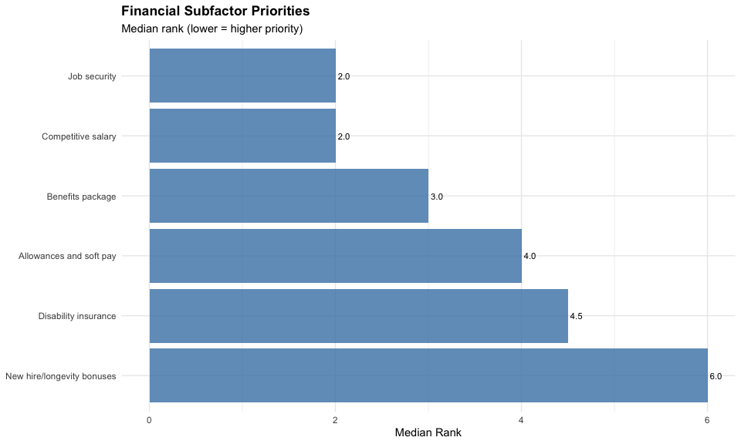
Financial: Age Group Comparisons
item | statistic | p | p_adj_holm | p.adj.signif | effsize | magnitude
Competitive salary | 460.5 | 0.406 | 1.000 | ns | 0.096 | small
Allowances and soft pay | 502.0 | 0.806 | 1.000 | ns | 0.029 | small
Benefits package | 583.0 | 0.444 | 1.000 | ns | 0.088 | small
Disability insurance | 515.0 | 0.934 | 1.000 | ns | 0.010 | small
Job security | 516.5 | 0.948 | 1.000 | ns | 0.008 | small
New hire/longevity bonuses | 619.0 | 0.127 | 0.762 | ns | 0.176 | small
Financial: Gender Comparisons
item | statistic | p | p_adj_holm | p.adj.signif | effsize | magnitude
Competitive salary | 363.0 | 0.069 | 0.415 | ns | 0.211 | small
Allowances and soft pay | 332.5 | 0.258 | 1.000 | ns | 0.132 | small
Benefits package | 204.0 | 0.259 | 1.000 | ns | 0.131 | small
Disability insurance | 174.0 | 0.093 | 0.464 | ns | 0.195 | small
Job security | 205.0 | 0.255 | 1.000 | ns | 0.133 | small
New hire/longevity bonuses | 311.0 | 0.339 | 1.000 | ns | 0.112 | small
Financial: Position Comparisons
item | statistic | p | p_adj_holm | p.adj.signif | effsize | magnitude
Competitive salary | 603.5 | 0.574 | 1.000 | ns | 0.065 | small
Allowances and soft pay | 596.0 | 0.547 | 1.000 | ns | 0.070 | small
Benefits package | 646.5 | 0.973 | 1.000 | ns | 0.005 | small
Disability insurance | 730.0 | 0.362 | 1.000 | ns | 0.105 | small
Job security | 674.5 | 0.781 | 1.000 | ns | 0.033 | small
New hire/longevity bonuses | 755.5 | 0.137 | 0.822 | ns | 0.171 | small
Financial: Military Comparisons
item | statistic | p | p_adj_holm | p.adj.signif | effsize | magnitude
Competitive salary | 311.5 | 0.164 | 0.984 | ns | 0.161 | small
Allowances and soft pay | 233.5 | 0.890 | 1.000 | ns | 0.017 | small
Benefits package | 264.5 | 0.676 | 1.000 | ns | 0.049 | small
Disability insurance | 229.0 | 0.821 | 1.000 | ns | 0.027 | small
Job security | 169.5 | 0.173 | 0.984 | ns | 0.157 | small
New hire/longevity bonuses | 246.0 | 0.926 | 1.000 | ns | 0.012 | small
Financial: Experience Comparisons
item | statistic | df | p | p_adj_holm | p.adj.signif | effsize | magnitude
Competitive salary | 1.885 | 3 | 0.597 | 1 | ns | -0.015 | small
Allowances and soft pay | 3.862 | 3 | 0.277 | 1 | ns | 0.012 | small
Benefits package | 3.708 | 3 | 0.295 | 1 | ns | 0.010 | small
Disability insurance | 4.724 | 3 | 0.193 | 1 | ns | 0.024 | small
Job security | 2.263 | 3 | 0.520 | 1 | ns | -0.010 | small
New hire/longevity bonuses | 4.884 | 3 | 0.181 | 1 | ns | 0.026 | small

6.2 Quality of Life Subfactors
Quality of Life Subfactors - Descriptive Statistics
item | n | median | mean | sd | pct_rank1
Predictable schedule | 76 | 2 | 2.51 | 1.13 | 19.74
Vacation time | 76 | 4 | 4.12 | 1.18 | 1.32
Family-friendly policies | 76 | 5 | 4.53 | 1.28 | 1.32
Possibility of being based at home | 76 | 2 | 2.70 | 1.87 | 39.47
Travel benefits | 76 | 5 | 4.87 | 1.20 | 1.32
Work-life balance | 76 | 2 | 2.28 | 1.41 | 36.84
Quality of Life: Friedman Test
.y. | n | statistic | df | p | method
rank | 76 | 139.489 | 5 | 0 | Friedman test
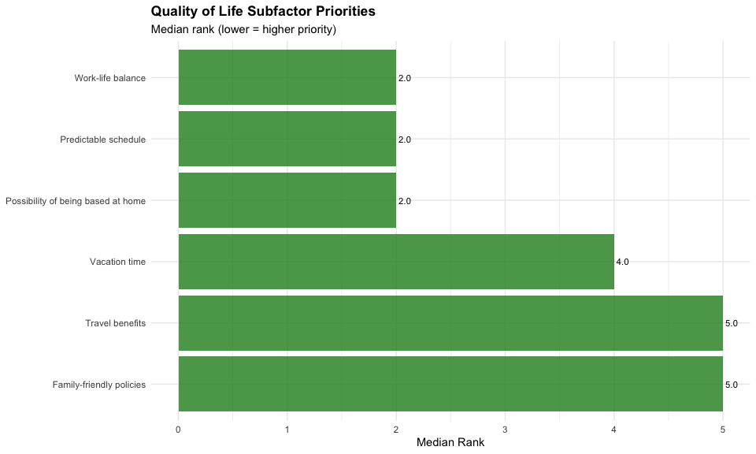
Quality of Life: Age Group Comparisons
item | statistic | p | p_adj_holm | p.adj.signif | effsize | magnitude
Predictable schedule | 329.5 | 0.015 | 0.088 | ns | 0.281 | small
Vacation time | 544.5 | 0.780 | 1.000 | ns | 0.033 | small
Family-friendly policies | 481.0 | 0.610 | 1.000 | ns | 0.059 | small
Possibility of being based at home | 529.5 | 0.929 | 1.000 | ns | 0.011 | small
Travel benefits | 570.0 | 0.543 | 1.000 | ns | 0.071 | small
Work-life balance | 640.0 | 0.134 | 0.670 | ns | 0.173 | small
Quality of Life: Gender Comparisons
item | statistic | p | p_adj_holm | p.adj.signif | effsize | magnitude
Predictable schedule | 197.5 | 0.212 | 1.000 | ns | 0.145 | small
Vacation time | 253.5 | 0.803 | 1.000 | ns | 0.030 | small
Family-friendly policies | 265.5 | 0.972 | 1.000 | ns | 0.005 | small
Possibility of being based at home | 259.0 | 0.880 | 1.000 | ns | 0.019 | small
Travel benefits | 359.5 | 0.102 | 0.612 | ns | 0.190 | small
Work-life balance | 290.5 | 0.693 | 1.000 | ns | 0.047 | small
Quality of Life: Position Comparisons
item | statistic | p | p_adj_holm | p.adj.signif | effsize | magnitude
Predictable schedule | 722.0 | 0.415 | 1 | ns | 0.094 | small
Vacation time | 604.0 | 0.605 | 1 | ns | 0.060 | small
Family-friendly policies | 739.5 | 0.315 | 1 | ns | 0.116 | small
Possibility of being based at home | 556.0 | 0.287 | 1 | ns | 0.123 | small
Travel benefits | 576.5 | 0.402 | 1 | ns | 0.097 | small
Work-life balance | 711.5 | 0.485 | 1 | ns | 0.081 | small
Quality of Life: Military Comparisons
item | statistic | p | p_adj_holm | p.adj.signif | effsize | magnitude
Predictable schedule | 193.5 | 0.375 | 1.000 | ns | 0.103 | small
Vacation time | 216.0 | 0.641 | 1.000 | ns | 0.055 | small
Family-friendly policies | 200.5 | 0.453 | 1.000 | ns | 0.087 | small
Possibility of being based at home | 357.5 | 0.031 | 0.186 | ns | 0.249 | small
Travel benefits | 236.5 | 0.932 | 1.000 | ns | 0.011 | small
Work-life balance | 198.0 | 0.420 | 1.000 | ns | 0.094 | small
Quality of Life: Experience Comparisons
item | statistic | df | p | p_adj_holm | p.adj.signif | effsize | magnitude
Predictable schedule | 7.452 | 3 | 0.059 | 0.353 | ns | 0.062 | moderate
Vacation time | 5.189 | 3 | 0.158 | 0.790 | ns | 0.030 | small
Family-friendly policies | 4.905 | 3 | 0.179 | 0.790 | ns | 0.026 | small
Possibility of being based at home | 2.634 | 3 | 0.451 | 1.000 | ns | -0.005 | small
Travel benefits | 1.214 | 3 | 0.750 | 1.000 | ns | -0.025 | small
Work-life balance | 1.712 | 3 | 0.634 | 1.000 | ns | -0.018 | small

6.3 Professional Opportunity Subfactors
Professional Subfactors - Descriptive Statistics
item | n | median | mean | sd | pct_rank1
Financially stable airline | 76 | 1 | 1.18 | 0.42 | 82.89
Opportunity for rapid upgrade | 76 | 3 | 3.45 | 1.09 | 1.32
Opportunity to fly larger aircraft | 76 | 3 | 3.26 | 1.43 | 10.53
Promotion/upgrade based on merit | 76 | 3 | 3.45 | 1.24 | 5.26
Upgrade based on length of service | 76 | 4 | 3.66 | 0.97 | 0.00
Professional: Friedman Test
.y. | n | statistic | df | p | method
rank | 76 | 127.663 | 4 | 0 | Friedman test
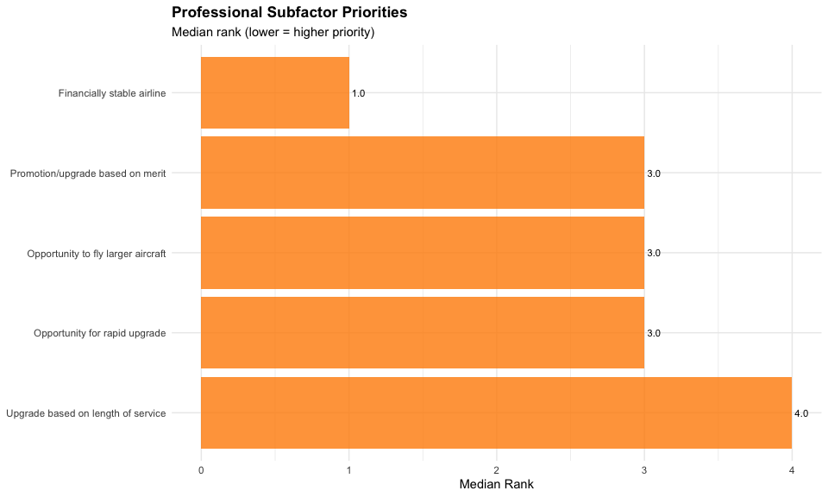
Professional: Age Group Comparisons
item | statistic | p | p_adj_holm | p.adj.signif | effsize | magnitude
Financially stable airline | 442.5 | 0.139 | 0.695 | ns | 0.171 | small
Opportunity for rapid upgrade | 560.0 | 0.636 | 1.000 | ns | 0.055 | small
Opportunity to fly larger aircraft | 558.5 | 0.650 | 1.000 | ns | 0.053 | small
Promotion/upgrade based on merit | 495.0 | 0.739 | 1.000 | ns | 0.039 | small
Upgrade based on length of service | 498.5 | 0.769 | 1.000 | ns | 0.034 | small
Professional: Gender Comparisons
item | statistic | p | p_adj_holm | p.adj.signif | effsize | magnitude
Financially stable airline | 253.0 | 0.705 | 1.000 | ns | 0.045 | small
Opportunity for rapid upgrade | 316.5 | 0.394 | 1.000 | ns | 0.099 | small
Opportunity to fly larger aircraft | 355.5 | 0.123 | 0.492 | ns | 0.179 | small
Promotion/upgrade based on merit | 173.5 | 0.097 | 0.484 | ns | 0.193 | small
Upgrade based on length of service | 216.5 | 0.360 | 1.000 | ns | 0.107 | small
Professional: Position Comparisons
item | statistic | p | p_adj_holm | p.adj.signif | effsize | magnitude
Financially stable airline | 593.5 | 0.348 | 1 | ns | 0.109 | small
Opportunity for rapid upgrade | 696.5 | 0.603 | 1 | ns | 0.060 | small
Opportunity to fly larger aircraft | 679.5 | 0.743 | 1 | ns | 0.038 | small
Promotion/upgrade based on merit | 645.0 | 0.960 | 1 | ns | 0.006 | small
Upgrade based on length of service | 578.0 | 0.414 | 1 | ns | 0.094 | small
Professional: Military Comparisons
item | statistic | p | p_adj_holm | p.adj.signif | effsize | magnitude
Financially stable airline | 287.0 | 0.216 | 0.648 | ns | 0.144 | small
Opportunity for rapid upgrade | 323.5 | 0.130 | 0.520 | ns | 0.175 | small
Opportunity to fly larger aircraft | 135.0 | 0.049 | 0.246 | ns | 0.227 | small
Promotion/upgrade based on merit | 229.0 | 0.824 | 0.824 | ns | 0.027 | small
Upgrade based on length of service | 303.0 | 0.253 | 0.648 | ns | 0.132 | small
Professional: Experience Comparisons
item | statistic | df | p | p_adj_holm | p.adj.signif | effsize | magnitude
Financially stable airline | 1.667 | 3 | 0.644 | 1.000 | ns | -0.019 | small
Opportunity for rapid upgrade | 2.979 | 3 | 0.395 | 1.000 | ns | 0.000 | small
Opportunity to fly larger aircraft | 0.302 | 3 | 0.960 | 1.000 | ns | -0.037 | small
Promotion/upgrade based on merit | 2.428 | 3 | 0.488 | 1.000 | ns | -0.008 | small
Upgrade based on length of service | 6.135 | 3 | 0.105 | 0.525 | ns | 0.044 | small

6.4 Recognition Subfactors
Recognition Subfactors - Descriptive Statistics
item | n | median | mean | sd | pct_rank1
Professional-looking uniforms | 76 | 3 | 2.80 | 0.97 | 14.47
Additional vacation for long service | 76 | 2 | 2.04 | 1.01 | 36.84
Recognition as a professional | 76 | 2 | 1.78 | 0.84 | 44.74
Airline recognition | 76 | 4 | 3.38 | 0.88 | 3.95
Recognition: Friedman Test
.y. | n | statistic | df | p | method
rank | 76 | 73.168 | 3 | 0 | Friedman test
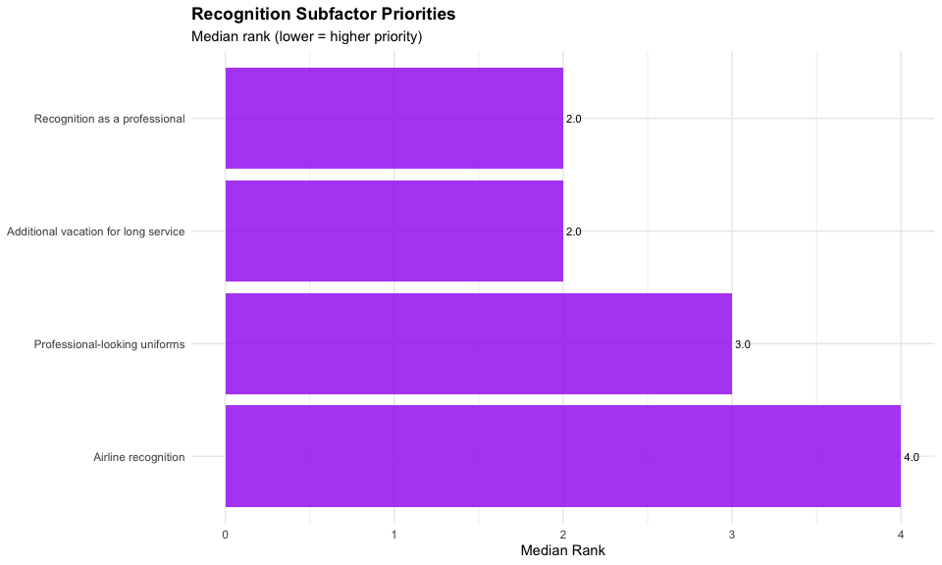
Recognition: Age Group Comparisons
item | statistic | p | p_adj_holm | p.adj.signif | effsize | magnitude
Professional-looking uniforms | 577 | 0.476 | 0.900 | ns | 0.082 | small
Additional vacation for long service | 345 | 0.023 | 0.093 | ns | 0.261 | small
Recognition as a professional | 601 | 0.300 | 0.900 | ns | 0.120 | small
Airline recognition | 579 | 0.430 | 0.900 | ns | 0.091 | small
Recognition: Gender Comparisons
item | statistic | p | p_adj_holm | p.adj.signif | effsize | magnitude
Professional-looking uniforms | 183.0 | 0.120 | 0.360 | ns | 0.180 | small
Additional vacation for long service | 247.5 | 0.718 | 1.000 | ns | 0.043 | small
Recognition as a professional | 264.0 | 0.948 | 1.000 | ns | 0.009 | small
Airline recognition | 384.0 | 0.023 | 0.091 | ns | 0.264 | small
Recognition: Position Comparisons
item | statistic | p | p_adj_holm | p.adj.signif | effsize | magnitude
Professional-looking uniforms | 767.5 | 0.171 | 0.513 | ns | 0.158 | small
Additional vacation for long service | 496.5 | 0.078 | 0.312 | ns | 0.203 | small
Recognition as a professional | 724.0 | 0.385 | 0.770 | ns | 0.100 | small
Airline recognition | 618.0 | 0.694 | 0.770 | ns | 0.046 | small
Recognition: Military Comparisons
item | statistic | p | p_adj_holm | p.adj.signif | effsize | magnitude
Professional-looking uniforms | 119.5 | 0.020 | 0.078 | ns | 0.269 | small
Additional vacation for long service | 355.5 | 0.032 | 0.096 | ns | 0.247 | small
Recognition as a professional | 214.0 | 0.600 | 1.000 | ns | 0.061 | small
Airline recognition | 274.0 | 0.511 | 1.000 | ns | 0.077 | small
Recognition: Experience Comparisons
item | statistic | df | p | p_adj_holm | p.adj.signif | effsize | magnitude
Professional-looking uniforms | 4.887 | 3 | 0.180 | 0.540 | ns | 0.026 | small
Additional vacation for long service | 8.274 | 3 | 0.041 | 0.163 | ns | 0.073 | moderate
Recognition as a professional | 1.184 | 3 | 0.757 | 1.000 | ns | -0.025 | small
Airline recognition | 0.637 | 3 | 0.888 | 1.000 | ns | -0.033 | small

6.5 Schedule Subfactors
Schedule Subfactors - Descriptive Statistics
item | n | median | mean | sd | pct_rank1
Fixed schedule | 76 | 3.5 | 3.18 | 1.64 | 25.00
Variable schedule | 76 | 3.0 | 3.39 | 1.39 | 14.47
Flexible work rules | 76 | 2.0 | 2.12 | 1.31 | 42.11
Bid line seniority system | 76 | 3.0 | 2.82 | 1.27 | 18.42
Vacation bidding rules | 76 | 3.0 | 3.49 | 0.97 | 0.00
Schedule: Friedman Test
.y. | n | statistic | df | p | method
rank | 76 | 37.632 | 4 | 0 | Friedman test
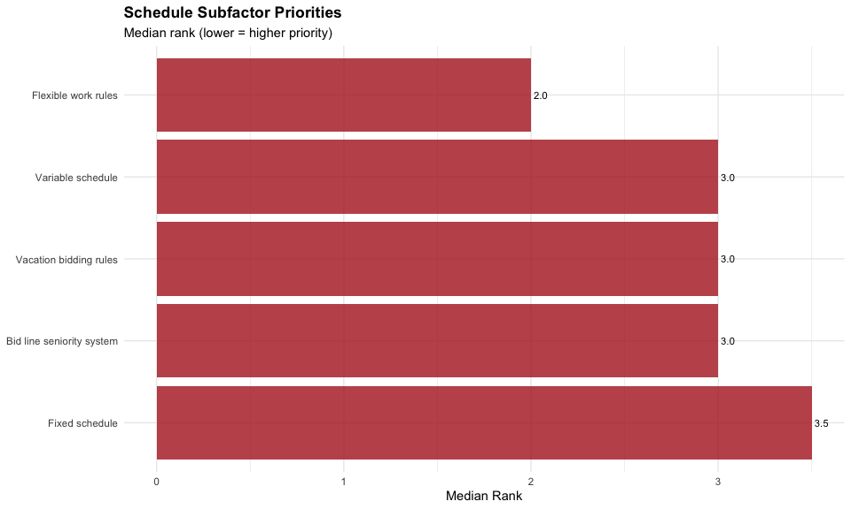
Schedule: Age Group Comparisons
item | statistic | p | p_adj_holm | p.adj.signif | effsize | magnitude
Fixed schedule | 464.5 | 0.472 | 1.00 | ns | 0.083 | small
Variable schedule | 493.5 | 0.724 | 1.00 | ns | 0.041 | small
Flexible work rules | 669.0 | 0.058 | 0.29 | ns | 0.218 | small
Bid line seniority system | 574.5 | 0.514 | 1.00 | ns | 0.076 | small
Vacation bidding rules | 479.0 | 0.588 | 1.00 | ns | 0.063 | small
Schedule: Gender Comparisons
item | statistic | p | p_adj_holm | p.adj.signif | effsize | magnitude
Fixed schedule | 202.5 | 0.248 | 0.992 | ns | 0.134 | small
Variable schedule | 387.0 | 0.036 | 0.180 | ns | 0.243 | small
Flexible work rules | 229.5 | 0.489 | 0.992 | ns | 0.081 | small
Bid line seniority system | 270.5 | 0.972 | 0.992 | ns | 0.005 | small
Vacation bidding rules | 204.0 | 0.256 | 0.992 | ns | 0.132 | small
Schedule: Position Comparisons
item | statistic | p | p_adj_holm | p.adj.signif | effsize | magnitude
Fixed schedule | 606.0 | 0.622 | 1 | ns | 0.057 | small
Variable schedule | 647.0 | 0.977 | 1 | ns | 0.004 | small
Flexible work rules | 714.0 | 0.462 | 1 | ns | 0.085 | small
Bid line seniority system | 747.5 | 0.276 | 1 | ns | 0.126 | small
Vacation bidding rules | 551.5 | 0.263 | 1 | ns | 0.129 | small
Schedule: Military Comparisons
item | statistic | p | p_adj_holm | p.adj.signif | effsize | magnitude
Fixed schedule | 177.0 | 0.235 | 1 | ns | 0.137 | small
Variable schedule | 286.5 | 0.410 | 1 | ns | 0.096 | small
Flexible work rules | 227.5 | 0.797 | 1 | ns | 0.031 | small
Bid line seniority system | 216.0 | 0.645 | 1 | ns | 0.054 | small
Vacation bidding rules | 257.0 | 0.779 | 1 | ns | 0.033 | small
Schedule: Experience Comparisons
item | statistic | df | p | p_adj_holm | p.adj.signif | effsize | magnitude
Fixed schedule | 1.454 | 3 | 0.693 | 1.000 | ns | -0.021 | small
Variable schedule | 0.483 | 3 | 0.923 | 1.000 | ns | -0.035 | small
Flexible work rules | 4.079 | 3 | 0.253 | 0.968 | ns | 0.015 | small
Bid line seniority system | 4.188 | 3 | 0.242 | 0.968 | ns | 0.016 | small
Vacation bidding rules | 5.826 | 3 | 0.120 | 0.600 | ns | 0.039 | small

6.6 Operational Subfactors
Operational Subfactors - Descriptive Statistics
item | n | median | mean | sd | pct_rank1
Unambiguous SOPs | 76 | 3 | 3.07 | 1.59 | 28.95
Proactive training environment | 76 | 3 | 2.84 | 1.17 | 11.84
Well-maintained aircraft | 76 | 2 | 2.25 | 1.16 | 35.53
Well-equipped aircraft | 76 | 5 | 4.13 | 1.18 | 1.32
Highly skilled fellow pilots | 76 | 3 | 2.71 | 1.24 | 22.37
Operational: Friedman Test
.y. | n | statistic | df | p | method
rank | 76 | 59.463 | 4 | 0 | Friedman test
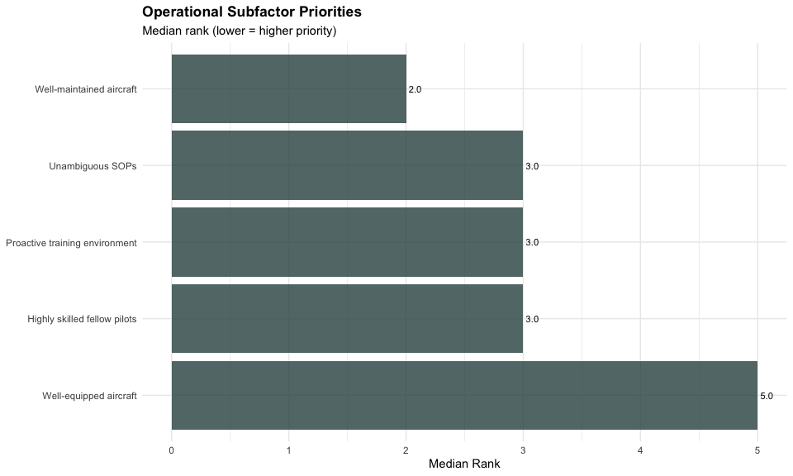
Operational: Age Group Comparisons
item | statistic | p | p_adj_holm | p.adj.signif | effsize | magnitude
Unambiguous SOPs | 486.0 | 0.655 | 1.000 | ns | 0.052 | small
Proactive training environment | 406.0 | 0.145 | 0.725 | ns | 0.168 | small
Well-maintained aircraft | 556.0 | 0.671 | 1.000 | ns | 0.050 | small
Well-equipped aircraft | 551.5 | 0.692 | 1.000 | ns | 0.046 | small
Highly skilled fellow pilots | 608.0 | 0.283 | 1.000 | ns | 0.124 | small
Operational: Gender Comparisons
item | statistic | p | p_adj_holm | p.adj.signif | effsize | magnitude
Unambiguous SOPs | 255.0 | 0.825 | 1 | ns | 0.027 | small
Proactive training environment | 240.0 | 0.626 | 1 | ns | 0.057 | small
Well-maintained aircraft | 237.0 | 0.586 | 1 | ns | 0.064 | small
Well-equipped aircraft | 328.5 | 0.247 | 1 | ns | 0.135 | small
Highly skilled fellow pilots | 290.0 | 0.705 | 1 | ns | 0.045 | small
Operational: Position Comparisons
item | statistic | p | p_adj_holm | p.adj.signif | effsize | magnitude
Unambiguous SOPs | 620.0 | 0.740 | 1 | ns | 0.039 | small
Proactive training environment | 722.5 | 0.416 | 1 | ns | 0.094 | small
Well-maintained aircraft | 618.0 | 0.720 | 1 | ns | 0.042 | small
Well-equipped aircraft | 637.5 | 0.883 | 1 | ns | 0.018 | small
Highly skilled fellow pilots | 655.5 | 0.955 | 1 | ns | 0.007 | small
Operational: Military Comparisons
item | statistic | p | p_adj_holm | p.adj.signif | effsize | magnitude
Unambiguous SOPs | 287.0 | 0.405 | 1 | ns | 0.096 | small
Proactive training environment | 280.0 | 0.481 | 1 | ns | 0.082 | small
Well-maintained aircraft | 218.0 | 0.668 | 1 | ns | 0.050 | small
Well-equipped aircraft | 204.5 | 0.463 | 1 | ns | 0.085 | small
Highly skilled fellow pilots | 225.0 | 0.768 | 1 | ns | 0.035 | small
Operational: Experience Comparisons
item | statistic | df | p | p_adj_holm | p.adj.signif | effsize | magnitude
Unambiguous SOPs | 4.274 | 3 | 0.233 | 0.932 | ns | 0.018 | small
Proactive training environment | 0.476 | 3 | 0.924 | 1.000 | ns | -0.035 | small
Well-maintained aircraft | 1.985 | 3 | 0.575 | 1.000 | ns | -0.014 | small
Well-equipped aircraft | 0.326 | 3 | 0.955 | 1.000 | ns | -0.037 | small
Highly skilled fellow pilots | 5.161 | 3 | 0.160 | 0.800 | ns | 0.030 | small

6.7 Hierarchical FDR Screening Results
Construct-Level Screening: Benjamini-Hochberg FDR (q=0.10)
construct | n_subfactors | min_p | rank | p_adj_fdr | passes_screen | decision
Quality of Life | 6 | 0.0147 | 1 | 0.0588 | TRUE | Proceed to detailed testing
Recognition | 4 | 0.0196 | 2 | 0.0588 | TRUE | Proceed to detailed testing
Schedule | 5 | 0.0359 | 3 | 0.0718 | TRUE | Proceed to detailed testing
Professional | 5 | 0.0493 | 4 | 0.0739 | TRUE | Proceed to detailed testing
Financial | 6 | 0.0691 | 5 | 0.0829 | TRUE | Proceed to detailed testing
Operational | 5 | 0.1450 | 6 | 0.1450 | FALSE | No demographic differences detected
Screening Summary:
- Constructs passing FDR screen (p_adj < 0.10): 5 of 6
Note
For constructs passing screening, demographic comparisons have been adjusted using Holm’s procedure. Tests with p_adj_holm < 0.05 indicate significant demographic differences in subfactor prioritization.

7. Combined Results Summary
Combined Analysis Summary: Multiple Testing Approach
Analysis | Total_Tests | FDR_Method | Significant_FDR | Note
General Factors | 36 | BH q=0.10 | 2 | 6 factors × 5 demographics (no Position analysis)
Subfactor Analysis | 155 | Hierarchical: BH screening + Holm within | 5 | 5 of 6 constructs pass screening

7.1 Summary
General Retention Factors (Part 1):
- Total demographic comparisons: 36
- Significant at FDR q=0.10: 2
Subfactor Analysis (Part 2):
- Constructs analyzed: 6
- Total subfactors: 31
- Constructs passing FDR screening: 5
- Constructs with demographic differences: Quality of Life, Recognition, Schedule, Professional, Financial
 Interpretation
The hierarchical FDR procedure controls for the 155 subfactor tests by:
- Screening at construct level (BH-FDR q=0.10 on 6 tests)
- Applying Holm correction within constructs that pass screening
This approach maintains family-wise error rate control while preserving power to detect genuine demographic differences.

8. Limitations
 Statistical Power Considerations
With n = 76, this study has limited statistical power. Non-significant results should not be interpreted as evidence of no effect. Many analyses may be underpowered to detect small-to-medium effects.

This analysis has several important limitations:

8.1 Sample Size and Power
The total sample of n = 76 provides adequate power only for detecting large effects (Cohen’s d > 0.8 or r > 0.5). For demographic comparisons:
Comparison | Group Sizes | Detectable Effect (80% power)
Age groups | ~40 vs ~36 | Medium (r ≈ 0.35)
Experience | ~19 per quartile | Large (eta² > 0.10)
Gender | 67 vs 8 | Very large only (r > 0.6)
Military | ~35 vs ~40 | Medium (r ≈ 0.35)
Position | ~45 vs ~30 | Medium (r ≈ 0.35)
Gender comparisons warrant particular caution: With only 8 female respondents, the analysis has approximately 20% power to detect medium effects - meaning 80% of true medium-sized gender differences would go undetected.

8.2 Additional Limitations
- Multiple Testing Burden: Despite FDR control, the large number of tests (155 in subfactor analysis) increases false discovery risk; the expected number of false discoveries at q=0.10 is approximately 10% of significant findings
- Self-Selection Bias: Survey respondents may not represent all U.S. airline pilots; those with strong opinions about retention may be overrepresented
- Cross-Sectional Design: Retention priorities may change over career stage; this snapshot cannot capture temporal dynamics
- Ranking Methodology: Forced rankings prevent assessment of absolute importance; factors ranked low may still be important in absolute terms

9. References

9.1 Primary Sources
Hickey, M. J. (2025). Rethinking pilot retention in the United States: An analysis of key factors [Master’s thesis, University of North Dakota]. ProQuest Dissertations & Theses. https://www.proquest.com/docview/3246414757
Efthymiou, M., Njoya, E. T., Lo, P. L., Papatheodorou, A., & Randall, D. (2020). The factors influencing entry level airline pilot retention: An empirical study of Ryanair. Journal of Air Transport Management, 91, 101997. https://doi.org/10.1016/j.jairtraman.2020.101997

9.2 Statistical Methods
Benjamini, Y., & Hochberg, Y. (1995). Controlling the false discovery rate: A practical and powerful approach to multiple testing. Journal of the Royal Statistical Society: Series B, 57(1), 289-300.
Bender, R., & Lange, S. (1999). Multiple test procedures other than Bonferroni’s deserve wider use. BMJ, 318(7183), 600-601.
Armstrong, R. A. (2014). When to use the Bonferroni correction. Ophthalmic and Physiological Optics, 34(5), 502-508.
Li, J., & Ghosh, J. K. (2014). A two-step hierarchical hypothesis set testing framework. BMC Bioinformatics, 15, 108.

