Airline Pilot Retention Analysis
Michael J. Hickey
2025-11-11
Table of contents

Why Records Were Excluded
exclusion_reason | n
did_not_finish | 35
included | 76
not_air_carrier | 2
**Total records in file:** 113 \n\n**Records kept for analysis:** 76 \n\n**Records excluded:** 37
write_csv(included_data, here("data/processed/retention_cleaned.csv"))

Statistical Methods

Multiple Testing Correction
This exploratory analysis of general retention factor rankings (6 factors × 5 demographics = 30 tests) employs Benjamini-Hochberg false discovery rate (FDR) control at q=0.10.
Rationale: For pilot studies with exploratory aims, FDR provides appropriate balance between detecting genuine demographic differences (avoiding Type II errors) and controlling false discoveries. Standard Bonferroni correction (α = 0.05/30 ≈ 0.0017) is overly conservative for hypothesis generation, increasing Type II error rates to 40-60% and causing researchers to miss important effects worthy of follow-up investigation.
FDR at q=0.10 means we accept that approximately 10% of significant findings may be false positives, while ensuring we identify 90% of true demographic differences. This error balance is appropriate when findings prompt further research rather than immediate policy decisions.
Within-Subjects Testing: Friedman test assesses whether the six retention factors differ in importance. Post-hoc pairwise comparisons use Wilcoxon signed-rank tests with Holm’s sequentially rejective procedure. Holm is used rather than BH-FDR because repeated-measures comparisons are strongly dependent (same participants in all comparisons), and BH-FDR could inflate false positive rates under such dependence. Holm maintains family-wise error rate control for dependent tests while being more powerful than Bonferroni.
Small Sample Adjustments: Gender comparisons use exact Mann-Whitney U tests (rather than asymptotic approximations) due to small female subsample (n=8). Exact tests provide valid inference with samples below n=10 where asymptotic assumptions fail. Exact tests require the coin package for computation.
References: Benjamini & Hochberg (1995); Bender & Lange (1999); Armstrong (2014).
#{r preview-clean, echo = FALSE} #knitr::kable(head(included_data), caption = "Preview of Cleaned Data") #
Descriptive Statistics for Age
n | min_age | q1_age | median_age | mean_age | q3_age | max_age | sd_age | iqr_age | skew_age | kurt_age
76 | 21 | 26 | 29 | 32.41 | 35 | 63 | 9.91 | 9 | 1.46 | 1.48
Shapiro–Wilk normality test p‑value: 0
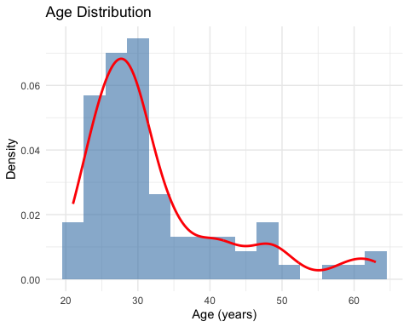
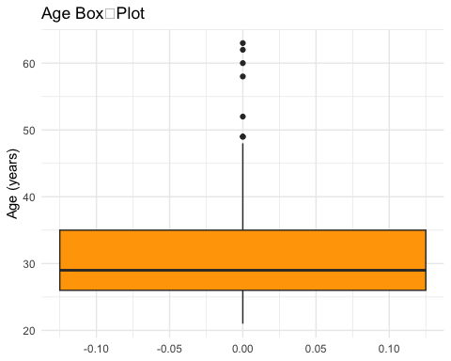

Age Distribution: ≤ 35 vs > 35
Age Group | n | %
≤ 35 | 58 | 76.3
> 35 | 18 | 23.7

Descriptive Statistics for Years of Experience
n | min_exp | q1_exp | median_exp | mean_exp | q3_exp | max_exp | sd_exp | iqr_exp | skew_exp | kurt_exp
76 | 1 | 2 | 3 | 5.78 | 7 | 30 | 6.55 | 5 | 2.21 | 4.74
Shapiro–Wilk normality test p‑value: 3.131e-11
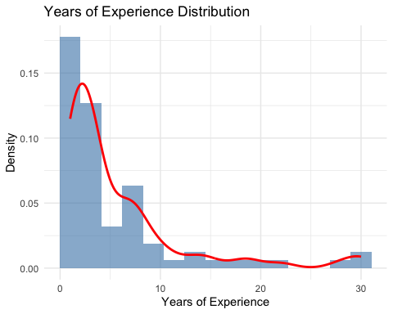
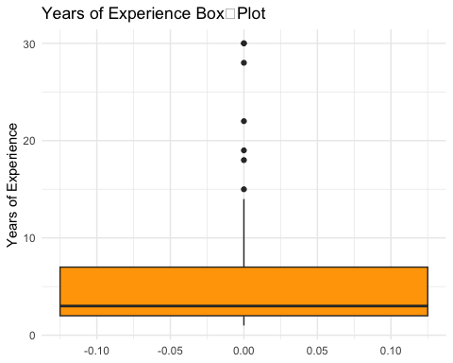

Descriptive Statistics for Total Flying Hours
n | min_hours | q1_hours | median_hours | mean_hours | q3_hours | max_hours | sd_hours | iqr_hours | skew_hours | kurt_hours
76 | 840 | 2015 | 2900 | 4532.13 | 4500 | 22000 | 4490.88 | 2485 | 2.41 | 5.48
Shapiro–Wilk normality test p‑value: 3.991e-12
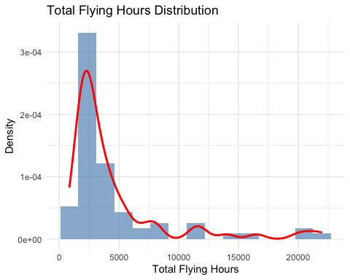
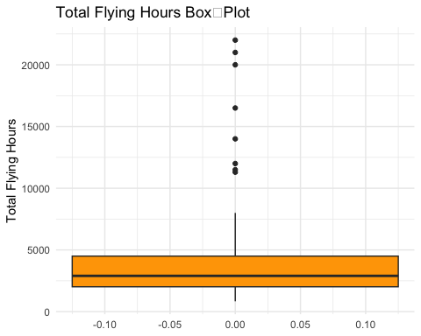

Gender Distribution
gender | n | percent
Female | 8 | 10.5%
Male | 67 | 88.2%
Prefer not to say | 1 | 1.3%
Total | 76 | 100.0%
Missing / blank gender responses: 0
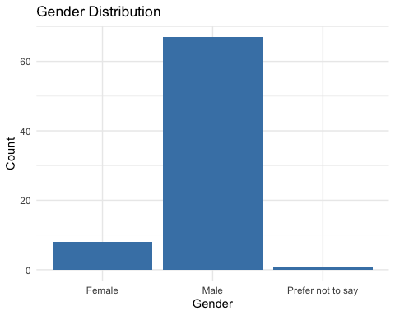

Air‑Carrier Type Distribution
air_carrier_type | n | percent
Charter/Fractional (Part 135/91K) | 2 | 2.6%
Freight/Cargo Carrier | 1 | 1.3%
Legacy/Mainline Part 121 Airline | 11 | 14.5%
Low Cost Carrier | 5 | 6.6%
Regional Airline | 57 | 75.0%
Total | 76 | 100.0%
Missing / blank carrier‑type responses: 0
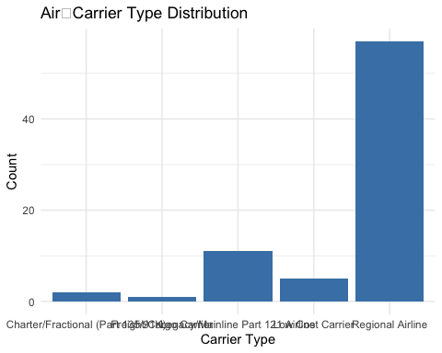

Flight‑Deck Position Distribution
position_position | n | percent
Captain | 26 | 34.2%
First Officer | 50 | 65.8%
Total | 76 | 100.0%
Missing / blank position responses: 0
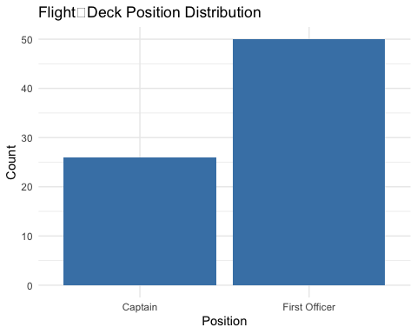

Military Experience Distribution (Yes / No)
military_bg | n | percent
No | 69 | 90.8%
Yes | 7 | 9.2%
Total | 76 | 100.0%
Missing military‑experience responses: 0
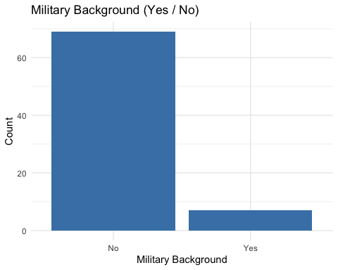

Nationality – Full Country Breakdown
nationality | n | percent
United States of America | 70 | 92.1%
Ethiopia | 1 | 1.3%
Germany | 1 | 1.3%
India | 1 | 1.3%
Lao People’s Democratic Republic | 1 | 1.3%
Mexico | 1 | 1.3%
New Zealand | 1 | 1.3%
Nationality Re‑coded to US vs Foreign
us_vs_foreign | n | percent
Foreign | 6 | 7.9%
US | 70 | 92.1%
Total | 76 | 100.0%
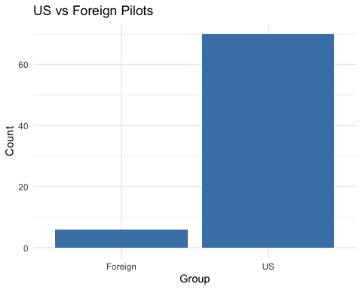

–RESEARCH QUESTION ANALYSES–
Table 1 Rank Summary for General Retention Factors
factor | n | median | iqr
financial | 76 | NA | 2
lifestyle | 76 | NA | 2
operational | 76 | NA | 1
professional | 76 | NA | 1
recognition | 76 | NA | 1
schedule | 76 | NA | 1
Table 2 Number (and %) of Pilots Ranking Each Factor #1
factor | n | percent
lifestyle | 34 | 44.7
financial | 25 | 32.9
schedule | 13 | 17.1
professional | 3 | 3.9
operational | 1 | 1.3
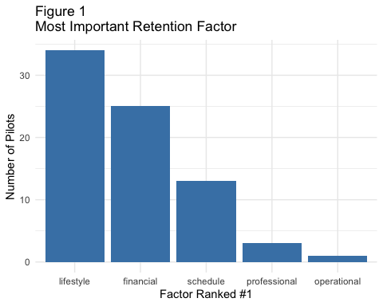
# A tibble: 1 × 6
.y. n statistic df p method
* <chr> <int> <dbl> <dbl> <dbl> <chr>
1 rank 76 234. 5 1.27e-48 Friedman test

Table 3 Pairwise Wilcoxon Tests Between General Factors (Holm‑adjusted p‑values)
comparison | p.sig
financial vs lifestyle | 0.426
financial vs operational | < .001
financial vs professional | < .001
financial vs recognition | < .001
financial vs schedule | 0.426
lifestyle vs operational | < .001
lifestyle vs professional | < .001
lifestyle vs recognition | < .001
lifestyle vs schedule | 0.062
operational vs professional | 0.892
operational vs recognition | < .001
operational vs schedule | < .001
professional vs recognition | < .001
professional vs schedule | < .001
recognition vs schedule | < .001

Table 4 Mann‑Whitney U Tests: Age Groups (≤ 35 vs > 35) on General‑Factor Ranks
Factor | n ≤35 | Median ≤35 | n >35 | Median >35 | Statistic | p (raw) | p (FDR) | Sig (q=0.10) | n1 | n2
lifestyle | 58 | 1 | 18 | 2.5 | 726.0 | 0.008 | 0.049 | TRUE | 18 | 58
financial | 58 | 2 | 18 | 2.0 | 436.0 | 0.276 | 0.736 | FALSE | 18 | 58
schedule | 58 | 2 | 18 | 2.0 | 466.0 | 0.477 | 0.736 | FALSE | 18 | 58
professional | 58 | 5 | 18 | 4.0 | 479.0 | 0.584 | 0.736 | FALSE | 18 | 58
recognition | 58 | 6 | 18 | 6.0 | 488.5 | 0.613 | 0.736 | FALSE | 18 | 58
operational | 58 | 4 | 18 | 4.0 | 505.0 | 0.832 | 0.832 | FALSE | 18 | 58

Table 5 Median Rank of General Factors by Experience Quartile
factor | Q1 (least)_n | Q2_n | Q3_n | Q4 (most)_n | Q1 (least)_median | Q2_median | Q3_median | Q4 (most)_median
financial | 19 | 19 | 19 | 19 | 2 | 2 | 2 | 2
lifestyle | 19 | 19 | 19 | 19 | 1 | 2 | 2 | 2
operational | 19 | 19 | 19 | 19 | 5 | 4 | 4 | 4
professional | 19 | 19 | 19 | 19 | 4 | 5 | 5 | 5
recognition | 19 | 19 | 19 | 19 | 6 | 6 | 6 | 6
schedule | 19 | 19 | 19 | 19 | 3 | 2 | 2 | 2
Table 6 Kruskal–Wallis Tests for Experience Quartiles (FDR‑adjusted p)
Factor | Statistic | df | p (raw) | p (FDR) | Sig (q=0.10)
financial | 0.551 | 3 | 0.908 | 0.908 | FALSE
lifestyle | 3.854 | 3 | 0.278 | 0.834 | FALSE
operational | 1.364 | 3 | 0.714 | 0.908 | FALSE
professional | 1.015 | 3 | 0.798 | 0.908 | FALSE
recognition | 4.639 | 3 | 0.200 | 0.834 | FALSE
schedule | 2.619 | 3 | 0.454 | 0.908 | FALSE

Gender counts:
Female Male <NA>
8 67 1
Table 7 Median Rank of General Factors by Gender
factor | Female_n | Male_n | Female_median | Male_median
financial | 8 | 67 | 3 | 2
lifestyle | 8 | 67 | 1 | 2
operational | 8 | 67 | 4 | 5
professional | 8 | 67 | 5 | 5
recognition | 8 | 67 | 6 | 6
schedule | 8 | 67 | 2 | 2
Table 8 Mann‑Whitney U Tests: Male vs Female (Exact test; FDR‑adjusted p)
Factor | Statistic | p (raw) | p (FDR) | Sig (q=0.10) | n1 | n2
financial | 365 | 0.084 | 0.168 | FALSE | 8 | 67
lifestyle | 212 | 0.312 | 0.353 | FALSE | 8 | 67
operational | 157 | 0.047 | 0.168 | FALSE | 8 | 67
professional | 320 | 0.353 | 0.353 | FALSE | 8 | 67
recognition | 356 | 0.061 | 0.168 | FALSE | 8 | 67
schedule | 192 | 0.174 | 0.261 | FALSE | 8 | 67

Military background counts:
Yes No
7 69
Table 9 Median Rank of General Factors by Military Background
factor | Yes_n | No_n | Yes_median | No_median
financial | 7 | 69 | 2 | 2
lifestyle | 7 | 69 | 2 | 2
operational | 7 | 69 | 5 | 4
professional | 7 | 69 | 4 | 5
recognition | 7 | 69 | 6 | 6
schedule | 7 | 69 | 2 | 2
Table 10 Mann‑Whitney U Tests: Military vs Civilian (FDR‑adjusted p)
Factor | Statistic | p (raw) | p (FDR) | Sig (q=0.10) | n1 | n2
financial | 262.5 | 0.701 | 0.841 | FALSE | 7 | 69
lifestyle | 231.5 | 0.856 | 0.856 | FALSE | 7 | 69
operational | 271.5 | 0.578 | 0.841 | FALSE | 7 | 69
professional | 205.5 | 0.502 | 0.841 | FALSE | 7 | 69
recognition | 284.5 | 0.338 | 0.841 | FALSE | 7 | 69
schedule | 198.5 | 0.423 | 0.841 | FALSE | 7 | 69

Carrier group counts:
LCC Major Other Regional
5 11 3 57
Table 11 Median Rank of General Factors by Carrier Group
factor | LCC_n | Major_n | Other_n | Regional_n | LCC_median | Major_median | Other_median | Regional_median
financial | 5 | 11 | 3 | 57 | 3 | 2 | 1 | 2
lifestyle | 5 | 11 | 3 | 57 | 2 | 1 | 2 | 2
operational | 5 | 11 | 3 | 57 | 4 | 4 | 4 | 4
professional | 5 | 11 | 3 | 57 | 5 | 5 | 4 | 5
recognition | 5 | 11 | 3 | 57 | 6 | 6 | 6 | 6
schedule | 5 | 11 | 3 | 57 | 1 | 3 | 3 | 2
Table 12 Kruskal–Wallis Tests Across Carrier Groups (FDR‑adjusted p)
Factor | Statistic | df | p (raw) | p (FDR) | Sig (q=0.10)
financial | 5.451 | 3 | 0.142 | 0.426 | FALSE
lifestyle | 1.479 | 3 | 0.687 | 0.687 | FALSE
operational | 2.792 | 3 | 0.425 | 0.661 | FALSE
professional | 2.304 | 3 | 0.512 | 0.661 | FALSE
recognition | 2.102 | 3 | 0.551 | 0.661 | FALSE
schedule | 9.233 | 3 | 0.026 | 0.158 | FALSE
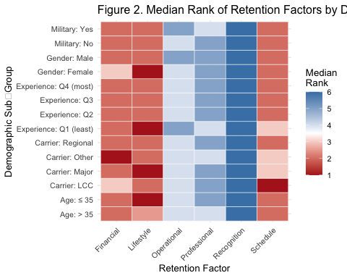

Results Summary
Summary of BH-FDR Results Across Demographic Comparisons
Demographic | Tests | Min_p_raw | Min_p_adj | Significant_q10
Age (≤35 vs >35) | 6 | 0.0081 | 0.0488 | 1
Experience Quartiles | 6 | 0.2000 | 0.8340 | 0
Gender (Male vs Female) | 6 | 0.0466 | 0.1680 | 0
Military Background | 6 | 0.3380 | 0.8412 | 0
Flight-Deck Position | 0 | NA | NA | NA
Carrier Type | 6 | 0.0264 | 0.1584 | 0

Position counts:
Captain First Officer
26 50
Table X1 Median Rank of General Factors by Flight‑Deck Position
factor | Captain_n | First Officer_n | Captain_median | First Officer_median
financial | 26 | 50 | 2 | 2
lifestyle | 26 | 50 | 2 | 2
operational | 26 | 50 | 5 | 4
professional | 26 | 50 | 4 | 5
recognition | 26 | 50 | 6 | 6
schedule | 26 | 50 | 2 | 2
Table X2 Mann‑Whitney U Tests: Captain vs First Officer (FDR‑adjusted p)
Factor | Statistic | p (raw) | p (FDR) | Sig (q=0.10) | n1 | n2
financial | 489.0 | 0.067 | 0.200 | FALSE | 26 | 50
lifestyle | 723.0 | 0.398 | 0.478 | FALSE | 26 | 50
operational | 865.0 | 0.014 | 0.082 | TRUE | 26 | 50
professional | 543.0 | 0.219 | 0.438 | FALSE | 26 | 50
recognition | 573.5 | 0.296 | 0.444 | FALSE | 26 | 50
schedule | 669.0 | 0.832 | 0.832 | FALSE | 26 | 50
