Pilot Retention Subfactor Analysis
  - Phase 1A: Within-Construct Sub-Item Rankings and Demographic Comparisons
Analysis Team
2025-11-11
Table of contents

1. Overview
This analysis examines the 31 sub-item rankings within each retention construct and compares them across demographics.

2. Setup
library(tidyverse)
library(rstatix)
library(knitr)
library(janitor)
library(DescTools)
options(scipen = 999)
knitr::opts_chunk$set(fig.width = 10, fig.height = 6)
# Create output directories
dir.create("../../output/tables/subfactor_analysis", showWarnings = FALSE, recursive = TRUE)
dir.create("../../output/figures/subfactor_analysis", showWarnings = FALSE, recursive = TRUE)
# Helper function to safely run Mann-Whitney U tests with effect sizes
safe_wilcox_test <- function(data, formula, exact = FALSE) {
# Check if we have at least 2 groups with data
group_var <- all.vars(formula)[2]
n_groups <- data %>%
filter(!is.na(!!sym(group_var))) %>%
pull(!!sym(group_var)) %>%
n_distinct()
if (n_groups < 2) {
# Return empty result if not enough groups
return(tibble(
.y. = character(),
group1 = character(),
group2 = character(),
n1 = integer(),
n2 = integer(),
statistic = numeric(),
p = numeric(),
effsize = numeric(),
magnitude = character()
))
}
# Run the test (this should succeed for all valid items)
test_result <- tryCatch({
wilcox_test(data, formula, exact = exact)
},
error = function(e) {
# Return empty on test failure
return(tibble(
.y. = character(),
group1 = character(),
group2 = character(),
n1 = integer(),
n2 = integer(),
statistic = numeric(),
p = numeric()
))
})
# If test failed, return empty
if (nrow(test_result) == 0) {
return(tibble(
.y. = character(),
group1 = character(),
group2 = character(),
n1 = integer(),
n2 = integer(),
statistic = numeric(),
p = numeric(),
effsize = numeric(),
magnitude = character()
))
}
# Try to compute effect sizes (may fail for sparse items)
effsize_result <- tryCatch({
wilcox_effsize(data, formula)
},
error = function(e) {
# Return NA effect sizes for items that fail
test_result %>%
select(item, .y.) %>%
distinct() %>%
mutate(
effsize = NA_real_,
magnitude = NA_character_
)
})
# Combine results with proper join (include item to avoid cross-product)
test_result %>%
left_join(
effsize_result %>% select(item, .y., effsize, magnitude),
by = c("item", ".y.")
)
}
# Helper function to safely run Kruskal-Wallis tests with effect sizes
safe_kruskal_test <- function(data, formula) {
# Check if we have at least 2 groups with data
group_var <- all.vars(formula)[2]
n_groups <- data %>%
filter(!is.na(!!sym(group_var))) %>%
pull(!!sym(group_var)) %>%
n_distinct()
if (n_groups < 2) {
# Return empty result if not enough groups
return(tibble(
.y. = character(),
n = integer(),
statistic = numeric(),
df = integer(),
p = numeric(),
effsize = numeric(),
magnitude = character()
))
}
# Run the test (this should succeed for all valid items)
test_result <- tryCatch({
kruskal_test(data, formula)
},
error = function(e) {
# Return empty on test failure
return(tibble(
.y. = character(),
n = integer(),
statistic = numeric(),
df = integer(),
p = numeric()
))
})
# If test failed, return empty
if (nrow(test_result) == 0) {
return(tibble(
.y. = character(),
n = integer(),
statistic = numeric(),
df = integer(),
p = numeric(),
effsize = numeric(),
magnitude = character()
))
}
# Try to compute effect sizes (may fail for sparse items)
effsize_result <- tryCatch({
kruskal_effsize(data, formula)
},
error = function(e) {
# Return NA effect sizes for items that fail
test_result %>%
select(item, .y.) %>%
distinct() %>%
mutate(
effsize = NA_real_,
magnitude = NA_character_
)
})
# Combine results with proper join (include item to avoid cross-product)
test_result %>%
left_join(
effsize_result %>% select(item, .y., effsize, magnitude),
by = c("item", ".y.")
)
}
# Variable labels from survey instrument
financial_labels <- c(
"financial_1" = "Competitive salary",
"financial_2" = "Allowances and soft pay",
"financial_3" = "Benefits package",
"financial_4" = "Disability insurance",
"financial_5" = "Job security",
"financial_6" = "New hire/longevity bonuses"
)
qol_labels <- c(
"qo_l_1" = "Predictable schedule",
"qo_l_2" = "Vacation time",
"qo_l_3" = "Family-friendly policies",
"qo_l_4" = "Home base possibility",
"qo_l_5" = "Travel benefits",
"qo_l_6" = "Work-life balance"
)
professional_labels <- c(
"professional_1" = "Financially stable airline",
"professional_2" = "Rapid upgrade opportunity",
"professional_3" = "Fly larger aircraft",
"professional_4" = "Merit-based promotion",
"professional_5" = "Seniority-based upgrade"
)
recognition_labels <- c(
"recognition_1" = "Professional uniforms",
"recognition_3" = "Vacation for long service",
"recognition_4" = "Professional respect/recognition",
"recognition_7" = "Airline recognition"
)
schedule_labels <- c(
"schedule_1" = "Fixed schedule",
"schedule_2" = "Variable schedule",
"schedule_3" = "Flexible work rules",
"schedule_4" = "Bid line seniority system",
"schedule_5" = "Vacation bidding rules"
)
operational_labels <- c(
"operational_1" = "Unambiguous SOPs",
"operational_2" = "Proactive training",
"operational_3" = "Well-maintained aircraft",
"operational_4" = "Well-equipped aircraft",
"operational_5" = "Highly skilled pilots"
)

3. Data Loading
# Load data (same as retention.Rmd)
raw <- read_csv("../../data/processed/retention.csv", show_col_types = FALSE)
retention_data <- raw %>%
slice(-(1:2)) %>%
clean_names()
# Filter to valid responses
included_data <- retention_data %>%
mutate(
finished = toupper(as.character(finished)),
informed_consent = toupper(as.character(informed_consent)),
screener = toupper(as.character(screener))
) %>%
filter(
finished == "TRUE",
informed_consent == "YES",
screener == "YES"
)
cat("Valid observations:", nrow(included_data), "\n")
Valid observations: 76

4. Demographic Groups
# Create demographic groups (matching retention.Rmd approach)
included_data <- included_data %>%
mutate(
# Numeric conversions
age = as.numeric(age),
experience = as.numeric(experience),
# Age groups
age_group = if_else(age <= 35, "≤35", ">35"),
# Experience quartiles
exp_q = ntile(experience, 4),
exp_q = factor(exp_q, labels = c("Q1", "Q2", "Q3", "Q4")),
# Gender
gender_clean = case_when(
tolower(gender) %in% c("male", "m") ~ "Male",
tolower(gender) %in% c("female", "f") ~ "Female",
TRUE ~ NA_character_
),
# Position
position = position_position,
# Military
military_clean = case_when(
str_detect(tolower(military_experience), "currently serve|previously served") ~ "Military",
str_detect(tolower(military_experience), "never") ~ "Civilian",
TRUE ~ NA_character_
)
)
# Summary
cat("\n=== DEMOGRAPHICS ===\n")
=== DEMOGRAPHICS ===
cat("Age groups:\n"); table(included_data$age_group) %>% print()
Age groups:
>35 ≤35
18 58
cat("\nGender:\n"); table(included_data$gender_clean, useNA = "ifany") %>% print()
Gender:
Female Male <NA>
8 67 1
cat("\nPosition:\n"); table(included_data$position, useNA = "ifany") %>% print()
Position:
Captain First Officer
26 50
cat("\nExperience:\n"); table(included_data$exp_q) %>% print()
Experience:
Q1 Q2 Q3 Q4
19 19 19 19
cat("\nMilitary:\n"); table(included_data$military_clean, useNA = "ifany") %>% print()
Military:
Civilian Military
69 7
# Sample characteristics:
# Total valid responses: n=76
# Demographic splits reflect regional airline pilot population:
# - Gender: ~11% female (8-12% is typical for regional carriers)
# - Age: Cutoff at 35 chosen as average age of first-year FOs at legacy/major carriers
# - Experience: Pilots divided into quartiles based on total flight hours
# Cohen's guidelines suggest minimum n≥15 per group for adequate power.
# Results for gender comparisons should be interpreted with caution due to
# insufficient statistical power to detect small-to-moderate effects.
# The "no significant differences" finding may reflect inadequate power rather
# than true absence of differences.

5. Statistical Methods

5.1 Multiple Testing Correction Approach
This exploratory pilot study employs a two-step hierarchical false discovery rate (FDR) control procedure appropriate for the study’s structure (6 constructs × 5 demographics = 155 tests) and exploratory aims.
Step 1 - Construct-Level Screening: For each of the six retention constructs (Financial, Quality of Life, Professional, Recognition, Schedule, Operational), we compute the minimum p-value across all five demographic comparisons (age, gender, position, military experience, experience level). These six screening p-values are adjusted using the Benjamini-Hochberg (BH) procedure at false discovery rate q=0.10.
Step 2 - Detailed Testing Within Significant Constructs: For constructs that pass screening (p_adj < 0.10), individual demographic comparisons within that construct are adjusted using Holm’s sequentially rejective procedure at α=0.05. Each construct’s demographic comparisons are treated as an independent family, controlling the family-wise error rate (FWER) within that construct.
Rationale: Standard Bonferroni correction (α = 0.05/155 ≈ 0.0003) is inappropriately conservative for exploratory research, creating Type II error rates of 50-70% and missing genuine effects that warrant follow-up investigation. FDR control at q=0.10 accepts that approximately 10% of significant findings may be false discoveries, but ensures we do not miss the 90% that represent true demographic differences. This approach balances error types appropriately for hypothesis generation in pilot research with small samples (n=76).
The hierarchical structure exploits the logical grouping of tests (subfactors within constructs) to increase statistical power compared to flat correction across all 155 tests simultaneously.
Within-Subjects Comparisons: Friedman tests assess whether subfactor rankings differ within each construct. Post-hoc pairwise comparisons (if needed) use Wilcoxon signed-rank tests with Holm correction (not BH-FDR, as these repeated-measures comparisons are strongly dependent), treating each construct’s comparisons as a separate family.
References: Benjamini & Hochberg (1995) J Royal Statistical Society B; Li & Ghosh (2014) BMC Bioinformatics; Armstrong (2014) Ophthalmic & Physiological Optics; Bender & Lange (1999) BMJ.
# Construct-Level Screening with Benjamini-Hochberg FDR
# ========================================================
# Step 1 of hierarchical testing: Determine which constructs show
# demographic differences at construct level before examining individual subfactors.
#
# Method: For each construct, compute minimum p-value across all demographic
# comparisons (age, gender, position, military, experience). Apply BH-FDR at q=0.10
# to these 6 screening p-values.
#
# Rationale: Exploratory pilot research (n=76) requires balance between Type I and
# Type II error control. Bonferroni (α=0.0003 per test) is too conservative and
# causes 50-70% Type II error rate, missing genuine effects. BH-FDR at q=0.10
# controls false discovery rate (expected proportion of false positives among
# significant results) while maintaining adequate power for hypothesis generation.
cat("\n=== CONSTRUCT-LEVEL SCREENING ===\n")
=== CONSTRUCT-LEVEL SCREENING ===
cat("Testing whether each construct shows demographic differences\n")
Testing whether each construct shows demographic differences
cat("Method: Benjamini-Hochberg FDR at q=0.10\n\n")
Method: Benjamini-Hochberg FDR at q=0.10
# CRITICAL: Declare screening_results tibble BEFORE any construct sections
# This tibble will be populated after each construct completes its demographic analyses
screening_results <- tibble(
construct = character(),
min_p = numeric(),
n_subfactors = integer()
)
# Note: Each construct section will append one row to this tibble
# After all 6 constructs complete, we'll apply BH-FDR to these 6 p-values

6. Financial Subfactors
cat("\n========================================\n")
========================================
cat("FINANCIAL SUBFACTORS\n")
FINANCIAL SUBFACTORS
cat("========================================\n\n")
========================================
# Convert to long format
financial_long <- included_data %>%
select(age_group, gender_clean, position, exp_q, military_clean,
financial_1:financial_6) %>%
mutate(respondent_id = row_number()) %>% # Create persistent ID before pivoting
mutate(across(financial_1:financial_6, as.numeric)) %>%
pivot_longer(
cols = financial_1:financial_6,
names_to = "item",
values_to = "rank"
) %>%
filter(!is.na(rank))
# Descriptive stats
financial_desc <- financial_long %>%
group_by(item) %>%
summarise(
n = n(),
median = median(rank),
mean = mean(rank),
sd = sd(rank),
pct_rank1 = sum(rank == 1) / n() * 100
) %>%
mutate(item = recode(item, !!!financial_labels))
kable(financial_desc, digits = 2, caption = "Financial Subfactors - Descriptive Statistics")
Financial Subfactors - Descriptive Statistics
item | n | median | mean | sd | pct_rank1
Competitive salary | 76 | 2.0 | 1.64 | 0.74 | 47.37
Allowances and soft pay | 76 | 4.0 | 3.96 | 1.24 | 1.32
Benefits package | 76 | 3.0 | 3.36 | 1.14 | 5.26
Disability insurance | 76 | 4.5 | 4.41 | 1.05 | 1.32
Job security | 76 | 2.0 | 2.09 | 1.28 | 44.74
New hire/longevity bonuses | 76 | 6.0 | 5.54 | 0.92 | 0.00
# Friedman test
friedman_financial <- financial_long %>%
friedman_test(rank ~ item | respondent_id)
kable(friedman_financial, digits = 3, caption = "Financial: Friedman Test (Within-Construct Comparison)")
Financial: Friedman Test (Within-Construct Comparison)
.y. | n | statistic | df | p | method
rank | 76 | 231.06 | 5 | 0 | Friedman test
# Median rank visualization
financial_plot <- financial_desc %>%
mutate(item = fct_reorder(item, desc(median))) %>%
ggplot(aes(x = median, y = item)) +
geom_col(fill = "steelblue", alpha = 0.8) +
geom_text(aes(label = sprintf("%.1f", median)), hjust = -0.2, size = 3) +
labs(
title = "Financial Subfactor Priorities",
subtitle = "Median rank (lower = higher priority)",
x = "Median Rank",
y = NULL
) +
theme_minimal() +
theme(plot.title = element_text(face = "bold"))
print(financial_plot)
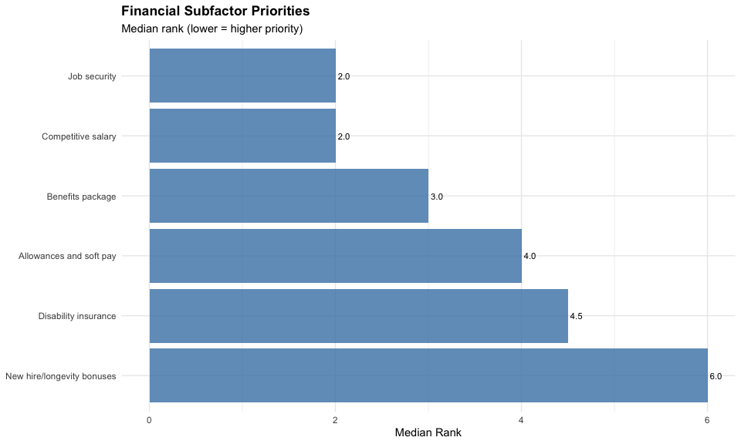
ggsave("../../output/figures/subfactor_analysis/financial_median_ranks.png",
financial_plot, width = 8, height = 5, dpi = 300)
# Age group comparisons (Mann-Whitney U)
mw_age_fin <- financial_long %>%
filter(!is.na(age_group)) %>%
group_by(item) %>%
safe_wilcox_test(rank ~ age_group, exact = FALSE) %>%
ungroup()
if (nrow(mw_age_fin) > 0) {
mw_age_fin <- mw_age_fin %>%
mutate(p_raw = p) %>% # Preserve raw p-value (p column still exists)
adjust_pvalue(method = "holm") %>% # Operates on existing 'p' column, creates 'p.adj'
add_significance("p.adj") %>%
select(item, statistic, p_raw, p.adj, p.adj.signif, effsize, magnitude) %>%
rename(p = p_raw, p_adj_holm = p.adj) %>% # Final renaming: p_raw→p, p.adj→p_adj_holm
mutate(item = recode(item, !!!financial_labels))
}
kable(mw_age_fin, digits = 3, caption = "Financial: Age Group Comparisons (Mann-Whitney U)")
Financial: Age Group Comparisons (Mann-Whitney U)
item | statistic | p | p_adj_holm | p.adj.signif | effsize | magnitude
Competitive salary | 460.5 | 0.406 | 1.000 | ns | 0.096 | small
Allowances and soft pay | 502.0 | 0.806 | 1.000 | ns | 0.029 | small
Benefits package | 583.0 | 0.444 | 1.000 | ns | 0.088 | small
Disability insurance | 515.0 | 0.934 | 1.000 | ns | 0.010 | small
Job security | 516.5 | 0.948 | 1.000 | ns | 0.008 | small
New hire/longevity bonuses | 619.0 | 0.127 | 0.762 | ns | 0.176 | small
# Gender comparisons
mw_gender_fin <- financial_long %>%
filter(!is.na(gender_clean)) %>%
group_by(item) %>%
safe_wilcox_test(rank ~ gender_clean, exact = FALSE) %>%
ungroup()
if (nrow(mw_gender_fin) > 0) {
mw_gender_fin <- mw_gender_fin %>%
mutate(p_raw = p) %>%
adjust_pvalue(method = "holm") %>%
add_significance("p.adj") %>%
select(item, statistic, p_raw, p.adj, p.adj.signif, effsize, magnitude) %>%
rename(p = p_raw, p_adj_holm = p.adj) %>%
mutate(item = recode(item, !!!financial_labels))
}
kable(mw_gender_fin, digits = 3, caption = "Financial: Gender Comparisons (Mann-Whitney U)")
Financial: Gender Comparisons (Mann-Whitney U)
item | statistic | p | p_adj_holm | p.adj.signif | effsize | magnitude
Competitive salary | 363.0 | 0.069 | 0.415 | ns | 0.211 | small
Allowances and soft pay | 332.5 | 0.258 | 1.000 | ns | 0.132 | small
Benefits package | 204.0 | 0.259 | 1.000 | ns | 0.131 | small
Disability insurance | 174.0 | 0.093 | 0.464 | ns | 0.195 | small
Job security | 205.0 | 0.255 | 1.000 | ns | 0.133 | small
New hire/longevity bonuses | 311.0 | 0.339 | 1.000 | ns | 0.112 | small
# Position comparisons
mw_position_fin <- financial_long %>%
filter(!is.na(position)) %>%
group_by(item) %>%
safe_wilcox_test(rank ~ position, exact = FALSE) %>%
ungroup()
if (nrow(mw_position_fin) > 0) {
mw_position_fin <- mw_position_fin %>%
mutate(p_raw = p) %>%
adjust_pvalue(method = "holm") %>%
add_significance("p.adj") %>%
select(item, statistic, p_raw, p.adj, p.adj.signif, effsize, magnitude) %>%
rename(p = p_raw, p_adj_holm = p.adj) %>%
mutate(item = recode(item, !!!financial_labels))
}
kable(mw_position_fin, digits = 3, caption = "Financial: Position Comparisons (Mann-Whitney U)")
Financial: Position Comparisons (Mann-Whitney U)
item | statistic | p | p_adj_holm | p.adj.signif | effsize | magnitude
Competitive salary | 603.5 | 0.574 | 1.000 | ns | 0.065 | small
Allowances and soft pay | 596.0 | 0.547 | 1.000 | ns | 0.070 | small
Benefits package | 646.5 | 0.973 | 1.000 | ns | 0.005 | small
Disability insurance | 730.0 | 0.362 | 1.000 | ns | 0.105 | small
Job security | 674.5 | 0.781 | 1.000 | ns | 0.033 | small
New hire/longevity bonuses | 755.5 | 0.137 | 0.822 | ns | 0.171 | small
# Military comparisons
mw_military_fin <- financial_long %>%
filter(!is.na(military_clean)) %>%
group_by(item) %>%
safe_wilcox_test(rank ~ military_clean, exact = FALSE) %>%
ungroup()
if (nrow(mw_military_fin) > 0) {
mw_military_fin <- mw_military_fin %>%
mutate(p_raw = p) %>%
adjust_pvalue(method = "holm") %>%
add_significance("p.adj") %>%
select(item, statistic, p_raw, p.adj, p.adj.signif, effsize, magnitude) %>%
rename(p = p_raw, p_adj_holm = p.adj) %>%
mutate(item = recode(item, !!!financial_labels))
}
kable(mw_military_fin, digits = 3, caption = "Financial: Military Comparisons (Mann-Whitney U)")
Financial: Military Comparisons (Mann-Whitney U)
item | statistic | p | p_adj_holm | p.adj.signif | effsize | magnitude
Competitive salary | 311.5 | 0.164 | 0.984 | ns | 0.161 | small
Allowances and soft pay | 233.5 | 0.890 | 1.000 | ns | 0.017 | small
Benefits package | 264.5 | 0.676 | 1.000 | ns | 0.049 | small
Disability insurance | 229.0 | 0.821 | 1.000 | ns | 0.027 | small
Job security | 169.5 | 0.173 | 0.984 | ns | 0.157 | small
New hire/longevity bonuses | 246.0 | 0.926 | 1.000 | ns | 0.012 | small
# Experience quartile comparisons (Kruskal-Wallis)
kw_exp_fin <- financial_long %>%
filter(!is.na(exp_q)) %>%
group_by(item) %>%
safe_kruskal_test(rank ~ exp_q) %>%
ungroup()
if (nrow(kw_exp_fin) > 0) {
kw_exp_fin <- kw_exp_fin %>%
mutate(p_raw = p) %>%
adjust_pvalue(method = "holm") %>%
add_significance("p.adj") %>%
select(item, statistic, df, p_raw, p.adj, p.adj.signif, effsize, magnitude) %>%
rename(p = p_raw, p_adj_holm = p.adj) %>%
mutate(item = recode(item, !!!financial_labels))
}
kable(kw_exp_fin, digits = 3, caption = "Financial: Experience Comparisons (Kruskal-Wallis)")
Financial: Experience Comparisons (Kruskal-Wallis)
item | statistic | df | p | p_adj_holm | p.adj.signif | effsize | magnitude
Competitive salary | 1.885 | 3 | 0.597 | 1 | ns | -0.015 | small
Allowances and soft pay | 3.862 | 3 | 0.277 | 1 | ns | 0.012 | small
Benefits package | 3.708 | 3 | 0.295 | 1 | ns | 0.010 | small
Disability insurance | 4.724 | 3 | 0.193 | 1 | ns | 0.024 | small
Job security | 2.263 | 3 | 0.520 | 1 | ns | -0.010 | small
New hire/longevity bonuses | 4.884 | 3 | 0.181 | 1 | ns | 0.026 | small
# Save tables to CSV
write_csv(financial_desc, "../../output/tables/subfactor_analysis/financial_descriptive.csv")
write_csv(friedman_financial, "../../output/tables/subfactor_analysis/financial_friedman.csv")
if (nrow(mw_age_fin) > 0) write_csv(mw_age_fin, "../../output/tables/subfactor_analysis/financial_age.csv")
if (nrow(mw_gender_fin) > 0) write_csv(mw_gender_fin, "../../output/tables/subfactor_analysis/financial_gender.csv")
if (nrow(mw_position_fin) > 0) write_csv(mw_position_fin, "../../output/tables/subfactor_analysis/financial_position.csv")
if (nrow(mw_military_fin) > 0) write_csv(mw_military_fin, "../../output/tables/subfactor_analysis/financial_military.csv")
if (nrow(kw_exp_fin) > 0) write_csv(kw_exp_fin, "../../output/tables/subfactor_analysis/financial_experience.csv")
# Collect minimum p-value for screening
min_p_financial <- min(
if(nrow(mw_age_fin) > 0) min(mw_age_fin$p) else 1,
if(nrow(mw_gender_fin) > 0) min(mw_gender_fin$p) else 1,
if(nrow(mw_position_fin) > 0) min(mw_position_fin$p) else 1,
if(nrow(mw_military_fin) > 0) min(mw_military_fin$p) else 1,
if(nrow(kw_exp_fin) > 0) min(kw_exp_fin$p) else 1
)
screening_results <- screening_results %>%
add_row(
construct = "Financial",
min_p = min_p_financial,
n_subfactors = 6
)
cat("Financial screening p-value:", round(min_p_financial, 4), "\n")
Financial screening p-value: 0.0691

7. Quality of Life Subfactors
cat("\n========================================\n")
========================================
cat("QUALITY OF LIFE SUBFACTORS\n")
QUALITY OF LIFE SUBFACTORS
cat("========================================\n\n")
========================================
# Convert to long format
qol_long <- included_data %>%
select(age_group, gender_clean, position, exp_q, military_clean,
qo_l_1:qo_l_6) %>%
mutate(respondent_id = row_number()) %>% # Create persistent ID before pivoting
mutate(across(qo_l_1:qo_l_6, as.numeric)) %>%
pivot_longer(
cols = qo_l_1:qo_l_6,
names_to = "item",
values_to = "rank"
) %>%
filter(!is.na(rank))
# Descriptive stats
qol_desc <- qol_long %>%
group_by(item) %>%
summarise(
n = n(),
median = median(rank),
mean = mean(rank),
sd = sd(rank),
pct_rank1 = sum(rank == 1) / n() * 100
) %>%
mutate(item = recode(item, !!!qol_labels))
kable(qol_desc, digits = 2, caption = "QoL Subfactors - Descriptive Statistics")
QoL Subfactors - Descriptive Statistics
item | n | median | mean | sd | pct_rank1
Predictable schedule | 76 | 2 | 2.51 | 1.13 | 19.74
Vacation time | 76 | 4 | 4.12 | 1.18 | 1.32
Family-friendly policies | 76 | 5 | 4.53 | 1.28 | 1.32
Home base possibility | 76 | 2 | 2.70 | 1.87 | 39.47
Travel benefits | 76 | 5 | 4.87 | 1.20 | 1.32
Work-life balance | 76 | 2 | 2.28 | 1.41 | 36.84
# Friedman test
friedman_qol <- qol_long %>%
friedman_test(rank ~ item | respondent_id)
kable(friedman_qol, digits = 3, caption = "QoL: Friedman Test (Within-Construct Comparison)")
QoL: Friedman Test (Within-Construct Comparison)
.y. | n | statistic | df | p | method
rank | 76 | 139.489 | 5 | 0 | Friedman test
# Median rank visualization
qol_plot <- qol_desc %>%
mutate(item = fct_reorder(item, desc(median))) %>%
ggplot(aes(x = median, y = item)) +
geom_col(fill = "forestgreen", alpha = 0.8) +
geom_text(aes(label = sprintf("%.1f", median)), hjust = -0.2, size = 3) +
labs(
title = "Quality of Life Subfactor Priorities",
subtitle = "Median rank (lower = higher priority)",
x = "Median Rank",
y = NULL
) +
theme_minimal() +
theme(plot.title = element_text(face = "bold"))
print(qol_plot)
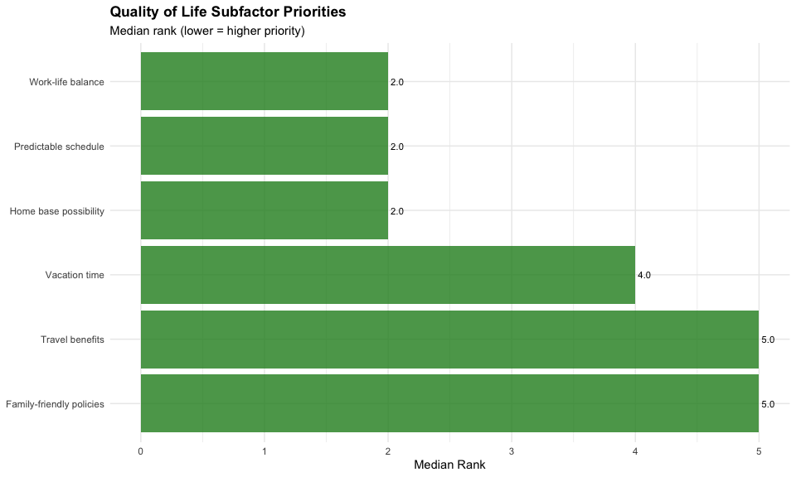
ggsave("../../output/figures/subfactor_analysis/qol_median_ranks.png",
qol_plot, width = 8, height = 5, dpi = 300)
# Age group
mw_age_qol <- qol_long %>%
filter(!is.na(age_group)) %>%
group_by(item) %>%
safe_wilcox_test(rank ~ age_group, exact = FALSE) %>%
ungroup()
if (nrow(mw_age_qol) > 0) {
mw_age_qol <- mw_age_qol %>%
mutate(p_raw = p) %>%
adjust_pvalue(method = "holm") %>%
add_significance("p.adj") %>%
select(item, statistic, p_raw, p.adj, p.adj.signif, effsize, magnitude) %>%
rename(p = p_raw, p_adj_holm = p.adj) %>%
mutate(item = recode(item, !!!qol_labels))
}
kable(mw_age_qol, digits = 3, caption = "QoL: Age Group Comparisons")
QoL: Age Group Comparisons
item | statistic | p | p_adj_holm | p.adj.signif | effsize | magnitude
Predictable schedule | 329.5 | 0.015 | 0.088 | ns | 0.281 | small
Vacation time | 544.5 | 0.780 | 1.000 | ns | 0.033 | small
Family-friendly policies | 481.0 | 0.610 | 1.000 | ns | 0.059 | small
Home base possibility | 529.5 | 0.929 | 1.000 | ns | 0.011 | small
Travel benefits | 570.0 | 0.543 | 1.000 | ns | 0.071 | small
Work-life balance | 640.0 | 0.134 | 0.670 | ns | 0.173 | small
# Gender
mw_gender_qol <- qol_long %>%
filter(!is.na(gender_clean)) %>%
group_by(item) %>%
safe_wilcox_test(rank ~ gender_clean, exact = FALSE) %>%
ungroup()
if (nrow(mw_gender_qol) > 0) {
mw_gender_qol <- mw_gender_qol %>%
mutate(p_raw = p) %>%
adjust_pvalue(method = "holm") %>%
add_significance("p.adj") %>%
select(item, statistic, p_raw, p.adj, p.adj.signif, effsize, magnitude) %>%
rename(p = p_raw, p_adj_holm = p.adj) %>%
mutate(item = recode(item, !!!qol_labels))
}
kable(mw_gender_qol, digits = 3, caption = "QoL: Gender Comparisons")
QoL: Gender Comparisons
item | statistic | p | p_adj_holm | p.adj.signif | effsize | magnitude
Predictable schedule | 197.5 | 0.212 | 1.000 | ns | 0.145 | small
Vacation time | 253.5 | 0.803 | 1.000 | ns | 0.030 | small
Family-friendly policies | 265.5 | 0.972 | 1.000 | ns | 0.005 | small
Home base possibility | 259.0 | 0.880 | 1.000 | ns | 0.019 | small
Travel benefits | 359.5 | 0.102 | 0.612 | ns | 0.190 | small
Work-life balance | 290.5 | 0.693 | 1.000 | ns | 0.047 | small
# Position
mw_position_qol <- qol_long %>%
filter(!is.na(position)) %>%
group_by(item) %>%
safe_wilcox_test(rank ~ position, exact = FALSE) %>%
ungroup()
if (nrow(mw_position_qol) > 0) {
mw_position_qol <- mw_position_qol %>%
mutate(p_raw = p) %>%
adjust_pvalue(method = "holm") %>%
add_significance("p.adj") %>%
select(item, statistic, p_raw, p.adj, p.adj.signif, effsize, magnitude) %>%
rename(p = p_raw, p_adj_holm = p.adj) %>%
mutate(item = recode(item, !!!qol_labels))
}
kable(mw_position_qol, digits = 3, caption = "QoL: Position Comparisons")
QoL: Position Comparisons
item | statistic | p | p_adj_holm | p.adj.signif | effsize | magnitude
Predictable schedule | 722.0 | 0.415 | 1 | ns | 0.094 | small
Vacation time | 604.0 | 0.605 | 1 | ns | 0.060 | small
Family-friendly policies | 739.5 | 0.315 | 1 | ns | 0.116 | small
Home base possibility | 556.0 | 0.287 | 1 | ns | 0.123 | small
Travel benefits | 576.5 | 0.402 | 1 | ns | 0.097 | small
Work-life balance | 711.5 | 0.485 | 1 | ns | 0.081 | small
# Military
mw_military_qol <- qol_long %>%
filter(!is.na(military_clean)) %>%
group_by(item) %>%
safe_wilcox_test(rank ~ military_clean, exact = FALSE) %>%
ungroup()
if (nrow(mw_military_qol) > 0) {
mw_military_qol <- mw_military_qol %>%
mutate(p_raw = p) %>%
adjust_pvalue(method = "holm") %>%
add_significance("p.adj") %>%
select(item, statistic, p_raw, p.adj, p.adj.signif, effsize, magnitude) %>%
rename(p = p_raw, p_adj_holm = p.adj) %>%
mutate(item = recode(item, !!!qol_labels))
}
kable(mw_military_qol, digits = 3, caption = "QoL: Military Comparisons")
QoL: Military Comparisons
item | statistic | p | p_adj_holm | p.adj.signif | effsize | magnitude
Predictable schedule | 193.5 | 0.375 | 1.000 | ns | 0.103 | small
Vacation time | 216.0 | 0.641 | 1.000 | ns | 0.055 | small
Family-friendly policies | 200.5 | 0.453 | 1.000 | ns | 0.087 | small
Home base possibility | 357.5 | 0.031 | 0.186 | ns | 0.249 | small
Travel benefits | 236.5 | 0.932 | 1.000 | ns | 0.011 | small
Work-life balance | 198.0 | 0.420 | 1.000 | ns | 0.094 | small
# Experience
kw_exp_qol <- qol_long %>%
filter(!is.na(exp_q)) %>%
group_by(item) %>%
safe_kruskal_test(rank ~ exp_q) %>%
ungroup()
if (nrow(kw_exp_qol) > 0) {
kw_exp_qol <- kw_exp_qol %>%
mutate(p_raw = p) %>%
adjust_pvalue(method = "holm") %>%
add_significance("p.adj") %>%
select(item, statistic, df, p_raw, p.adj, p.adj.signif, effsize, magnitude) %>%
rename(p = p_raw, p_adj_holm = p.adj) %>%
mutate(item = recode(item, !!!qol_labels))
}
kable(kw_exp_qol, digits = 3, caption = "QoL: Experience Comparisons")
QoL: Experience Comparisons
item | statistic | df | p | p_adj_holm | p.adj.signif | effsize | magnitude
Predictable schedule | 7.452 | 3 | 0.059 | 0.353 | ns | 0.062 | moderate
Vacation time | 5.189 | 3 | 0.158 | 0.790 | ns | 0.030 | small
Family-friendly policies | 4.905 | 3 | 0.179 | 0.790 | ns | 0.026 | small
Home base possibility | 2.634 | 3 | 0.451 | 1.000 | ns | -0.005 | small
Travel benefits | 1.214 | 3 | 0.750 | 1.000 | ns | -0.025 | small
Work-life balance | 1.712 | 3 | 0.634 | 1.000 | ns | -0.018 | small
# Save tables to CSV
write_csv(qol_desc, "../../output/tables/subfactor_analysis/qol_descriptive.csv")
write_csv(friedman_qol, "../../output/tables/subfactor_analysis/qol_friedman.csv")
if (nrow(mw_age_qol) > 0) write_csv(mw_age_qol, "../../output/tables/subfactor_analysis/qol_age.csv")
if (nrow(mw_gender_qol) > 0) write_csv(mw_gender_qol, "../../output/tables/subfactor_analysis/qol_gender.csv")
if (nrow(mw_position_qol) > 0) write_csv(mw_position_qol, "../../output/tables/subfactor_analysis/qol_position.csv")
if (nrow(mw_military_qol) > 0) write_csv(mw_military_qol, "../../output/tables/subfactor_analysis/qol_military.csv")
if (nrow(kw_exp_qol) > 0) write_csv(kw_exp_qol, "../../output/tables/subfactor_analysis/qol_experience.csv")
# Collect minimum p-value for screening
min_p_qol <- min(
if(nrow(mw_age_qol) > 0) min(mw_age_qol$p) else 1,
if(nrow(mw_gender_qol) > 0) min(mw_gender_qol$p) else 1,
if(nrow(mw_position_qol) > 0) min(mw_position_qol$p) else 1,
if(nrow(mw_military_qol) > 0) min(mw_military_qol$p) else 1,
if(nrow(kw_exp_qol) > 0) min(kw_exp_qol$p) else 1
)
screening_results <- screening_results %>%
add_row(
construct = "Quality of Life",
min_p = min_p_qol,
n_subfactors = 6
)
cat("Quality of Life screening p-value:", round(min_p_qol, 4), "\n")
Quality of Life screening p-value: 0.0147

8. Professional Subfactors
cat("\n========================================\n")
========================================
cat("PROFESSIONAL SUBFACTORS\n")
PROFESSIONAL SUBFACTORS
cat("========================================\n\n")
========================================
professional_long <- included_data %>%
select(age_group, gender_clean, position, exp_q, military_clean,
professional_1:professional_5) %>%
mutate(respondent_id = row_number()) %>% # Create persistent ID before pivoting
mutate(across(professional_1:professional_5, as.numeric)) %>%
pivot_longer(
cols = professional_1:professional_5,
names_to = "item",
values_to = "rank"
) %>%
filter(!is.na(rank))
# Descriptive
professional_desc <- professional_long %>%
group_by(item) %>%
summarise(n = n(), median = median(rank), mean = mean(rank),
sd = sd(rank), pct_rank1 = sum(rank == 1) / n() * 100) %>%
mutate(item = recode(item, !!!professional_labels))
kable(professional_desc, digits = 2, caption = "Professional Subfactors - Descriptive Statistics")
Professional Subfactors - Descriptive Statistics
item | n | median | mean | sd | pct_rank1
Financially stable airline | 76 | 1 | 1.18 | 0.42 | 82.89
Rapid upgrade opportunity | 76 | 3 | 3.45 | 1.09 | 1.32
Fly larger aircraft | 76 | 3 | 3.26 | 1.43 | 10.53
Merit-based promotion | 76 | 3 | 3.45 | 1.24 | 5.26
Seniority-based upgrade | 76 | 4 | 3.66 | 0.97 | 0.00
# Friedman
friedman_prof <- professional_long %>%
friedman_test(rank ~ item | respondent_id)
kable(friedman_prof, digits = 3, caption = "Professional: Friedman Test (Within-Construct Comparison)")
Professional: Friedman Test (Within-Construct Comparison)
.y. | n | statistic | df | p | method
rank | 76 | 127.663 | 4 | 0 | Friedman test
# Median rank visualization
professional_plot <- professional_desc %>%
mutate(item = fct_reorder(item, desc(median))) %>%
ggplot(aes(x = median, y = item)) +
geom_col(fill = "darkorange", alpha = 0.8) +
geom_text(aes(label = sprintf("%.1f", median)), hjust = -0.2, size = 3) +
labs(
title = "Professional Opportunity Subfactor Priorities",
subtitle = "Median rank (lower = higher priority)",
x = "Median Rank",
y = NULL
) +
theme_minimal() +
theme(plot.title = element_text(face = "bold"))
print(professional_plot)
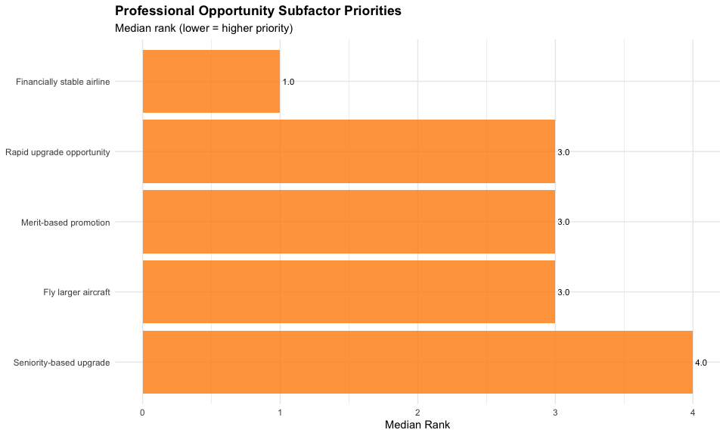
ggsave("../../output/figures/subfactor_analysis/professional_median_ranks.png",
professional_plot, width = 8, height = 5, dpi = 300)
# Demographics
mw_age_prof <- professional_long %>%
filter(!is.na(age_group)) %>%
group_by(item) %>%
safe_wilcox_test(rank ~ age_group, exact = FALSE) %>%
ungroup()
if (nrow(mw_age_prof) > 0) {
mw_age_prof <- mw_age_prof %>%
mutate(p_raw = p) %>%
adjust_pvalue(method = "holm") %>%
add_significance("p.adj") %>%
select(item, statistic, p_raw, p.adj, p.adj.signif, effsize, magnitude) %>%
rename(p = p_raw, p_adj_holm = p.adj) %>%
mutate(item = recode(item, !!!professional_labels))
}
kable(mw_age_prof, digits = 3, caption = "Professional: Age Comparisons")
Professional: Age Comparisons
item | statistic | p | p_adj_holm | p.adj.signif | effsize | magnitude
Financially stable airline | 442.5 | 0.139 | 0.695 | ns | 0.171 | small
Rapid upgrade opportunity | 560.0 | 0.636 | 1.000 | ns | 0.055 | small
Fly larger aircraft | 558.5 | 0.650 | 1.000 | ns | 0.053 | small
Merit-based promotion | 495.0 | 0.739 | 1.000 | ns | 0.039 | small
Seniority-based upgrade | 498.5 | 0.769 | 1.000 | ns | 0.034 | small
mw_gender_prof <- professional_long %>%
filter(!is.na(gender_clean)) %>%
group_by(item) %>%
safe_wilcox_test(rank ~ gender_clean, exact = FALSE) %>%
ungroup()
if (nrow(mw_gender_prof) > 0) {
mw_gender_prof <- mw_gender_prof %>%
mutate(p_raw = p) %>%
adjust_pvalue(method = "holm") %>%
add_significance("p.adj") %>%
select(item, statistic, p_raw, p.adj, p.adj.signif, effsize, magnitude) %>%
rename(p = p_raw, p_adj_holm = p.adj) %>%
mutate(item = recode(item, !!!professional_labels))
}
kable(mw_gender_prof, digits = 3, caption = "Professional: Gender Comparisons")
Professional: Gender Comparisons
item | statistic | p | p_adj_holm | p.adj.signif | effsize | magnitude
Financially stable airline | 253.0 | 0.705 | 1.000 | ns | 0.045 | small
Rapid upgrade opportunity | 316.5 | 0.394 | 1.000 | ns | 0.099 | small
Fly larger aircraft | 355.5 | 0.123 | 0.492 | ns | 0.179 | small
Merit-based promotion | 173.5 | 0.097 | 0.484 | ns | 0.193 | small
Seniority-based upgrade | 216.5 | 0.360 | 1.000 | ns | 0.107 | small
mw_position_prof <- professional_long %>%
filter(!is.na(position)) %>%
group_by(item) %>%
safe_wilcox_test(rank ~ position, exact = FALSE) %>%
ungroup()
if (nrow(mw_position_prof) > 0) {
mw_position_prof <- mw_position_prof %>%
mutate(p_raw = p) %>%
adjust_pvalue(method = "holm") %>%
add_significance("p.adj") %>%
select(item, statistic, p_raw, p.adj, p.adj.signif, effsize, magnitude) %>%
rename(p = p_raw, p_adj_holm = p.adj) %>%
mutate(item = recode(item, !!!professional_labels))
}
kable(mw_position_prof, digits = 3, caption = "Professional: Position Comparisons")
Professional: Position Comparisons
item | statistic | p | p_adj_holm | p.adj.signif | effsize | magnitude
Financially stable airline | 593.5 | 0.348 | 1 | ns | 0.109 | small
Rapid upgrade opportunity | 696.5 | 0.603 | 1 | ns | 0.060 | small
Fly larger aircraft | 679.5 | 0.743 | 1 | ns | 0.038 | small
Merit-based promotion | 645.0 | 0.960 | 1 | ns | 0.006 | small
Seniority-based upgrade | 578.0 | 0.414 | 1 | ns | 0.094 | small
mw_military_prof <- professional_long %>%
filter(!is.na(military_clean)) %>%
group_by(item) %>%
safe_wilcox_test(rank ~ military_clean, exact = FALSE) %>%
ungroup()
if (nrow(mw_military_prof) > 0) {
mw_military_prof <- mw_military_prof %>%
mutate(p_raw = p) %>%
adjust_pvalue(method = "holm") %>%
add_significance("p.adj") %>%
select(item, statistic, p_raw, p.adj, p.adj.signif, effsize, magnitude) %>%
rename(p = p_raw, p_adj_holm = p.adj) %>%
mutate(item = recode(item, !!!professional_labels))
}
kable(mw_military_prof, digits = 3, caption = "Professional: Military Comparisons")
Professional: Military Comparisons
item | statistic | p | p_adj_holm | p.adj.signif | effsize | magnitude
Financially stable airline | 287.0 | 0.216 | 0.648 | ns | 0.144 | small
Rapid upgrade opportunity | 323.5 | 0.130 | 0.520 | ns | 0.175 | small
Fly larger aircraft | 135.0 | 0.049 | 0.246 | ns | 0.227 | small
Merit-based promotion | 229.0 | 0.824 | 0.824 | ns | 0.027 | small
Seniority-based upgrade | 303.0 | 0.253 | 0.648 | ns | 0.132 | small
kw_exp_prof <- professional_long %>%
filter(!is.na(exp_q)) %>%
group_by(item) %>%
safe_kruskal_test(rank ~ exp_q) %>%
ungroup()
if (nrow(kw_exp_prof) > 0) {
kw_exp_prof <- kw_exp_prof %>%
mutate(p_raw = p) %>%
adjust_pvalue(method = "holm") %>%
add_significance("p.adj") %>%
select(item, statistic, df, p_raw, p.adj, p.adj.signif, effsize, magnitude) %>%
rename(p = p_raw, p_adj_holm = p.adj) %>%
mutate(item = recode(item, !!!professional_labels))
}
kable(kw_exp_prof, digits = 3, caption = "Professional: Experience Comparisons")
Professional: Experience Comparisons
item | statistic | df | p | p_adj_holm | p.adj.signif | effsize | magnitude
Financially stable airline | 1.667 | 3 | 0.644 | 1.000 | ns | -0.019 | small
Rapid upgrade opportunity | 2.979 | 3 | 0.395 | 1.000 | ns | 0.000 | small
Fly larger aircraft | 0.302 | 3 | 0.960 | 1.000 | ns | -0.037 | small
Merit-based promotion | 2.428 | 3 | 0.488 | 1.000 | ns | -0.008 | small
Seniority-based upgrade | 6.135 | 3 | 0.105 | 0.525 | ns | 0.044 | small
# Save tables to CSV
write_csv(professional_desc, "../../output/tables/subfactor_analysis/professional_descriptive.csv")
write_csv(friedman_prof, "../../output/tables/subfactor_analysis/professional_friedman.csv")
if (nrow(mw_age_prof) > 0) write_csv(mw_age_prof, "../../output/tables/subfactor_analysis/professional_age.csv")
if (nrow(mw_gender_prof) > 0) write_csv(mw_gender_prof, "../../output/tables/subfactor_analysis/professional_gender.csv")
if (nrow(mw_position_prof) > 0) write_csv(mw_position_prof, "../../output/tables/subfactor_analysis/professional_position.csv")
if (nrow(mw_military_prof) > 0) write_csv(mw_military_prof, "../../output/tables/subfactor_analysis/professional_military.csv")
if (nrow(kw_exp_prof) > 0) write_csv(kw_exp_prof, "../../output/tables/subfactor_analysis/professional_experience.csv")
# Collect minimum p-value for screening
min_p_prof <- min(
if(nrow(mw_age_prof) > 0) min(mw_age_prof$p) else 1,
if(nrow(mw_gender_prof) > 0) min(mw_gender_prof$p) else 1,
if(nrow(mw_position_prof) > 0) min(mw_position_prof$p) else 1,
if(nrow(mw_military_prof) > 0) min(mw_military_prof$p) else 1,
if(nrow(kw_exp_prof) > 0) min(kw_exp_prof$p) else 1
)
screening_results <- screening_results %>%
add_row(
construct = "Professional",
min_p = min_p_prof,
n_subfactors = 5
)
cat("Professional screening p-value:", round(min_p_prof, 4), "\n")
Professional screening p-value: 0.0493

9. Recognition Subfactors
cat("\n========================================\n")
========================================
cat("RECOGNITION SUBFACTORS\n")
RECOGNITION SUBFACTORS
cat("========================================\n\n")
========================================
recognition_long <- included_data %>%
select(age_group, gender_clean, position, exp_q, military_clean,
recognition_1, recognition_3, recognition_4, recognition_7) %>%
mutate(respondent_id = row_number()) %>% # Create persistent ID before pivoting
mutate(across(starts_with("recognition"), as.numeric)) %>%
pivot_longer(
cols = starts_with("recognition"),
names_to = "item",
values_to = "rank"
) %>%
filter(!is.na(rank))
# Descriptive
recognition_desc <- recognition_long %>%
group_by(item) %>%
summarise(n = n(), median = median(rank), mean = mean(rank),
sd = sd(rank), pct_rank1 = sum(rank == 1) / n() * 100) %>%
mutate(item = recode(item, !!!recognition_labels))
kable(recognition_desc, digits = 2, caption = "Recognition Subfactors - Descriptive Statistics")
Recognition Subfactors - Descriptive Statistics
item | n | median | mean | sd | pct_rank1
Professional uniforms | 76 | 3 | 2.80 | 0.97 | 14.47
Vacation for long service | 76 | 2 | 2.04 | 1.01 | 36.84
Professional respect/recognition | 76 | 2 | 1.78 | 0.84 | 44.74
Airline recognition | 76 | 4 | 3.38 | 0.88 | 3.95
# Friedman
friedman_recog <- recognition_long %>%
friedman_test(rank ~ item | respondent_id)
kable(friedman_recog, digits = 3, caption = "Recognition: Friedman Test (Within-Construct Comparison)")
Recognition: Friedman Test (Within-Construct Comparison)
.y. | n | statistic | df | p | method
rank | 76 | 73.168 | 3 | 0 | Friedman test
# Median rank visualization
recognition_plot <- recognition_desc %>%
mutate(item = fct_reorder(item, desc(median))) %>%
ggplot(aes(x = median, y = item)) +
geom_col(fill = "purple", alpha = 0.8) +
geom_text(aes(label = sprintf("%.1f", median)), hjust = -0.2, size = 3) +
labs(
title = "Recognition Subfactor Priorities",
subtitle = "Median rank (lower = higher priority)",
x = "Median Rank",
y = NULL
) +
theme_minimal() +
theme(plot.title = element_text(face = "bold"))
print(recognition_plot)
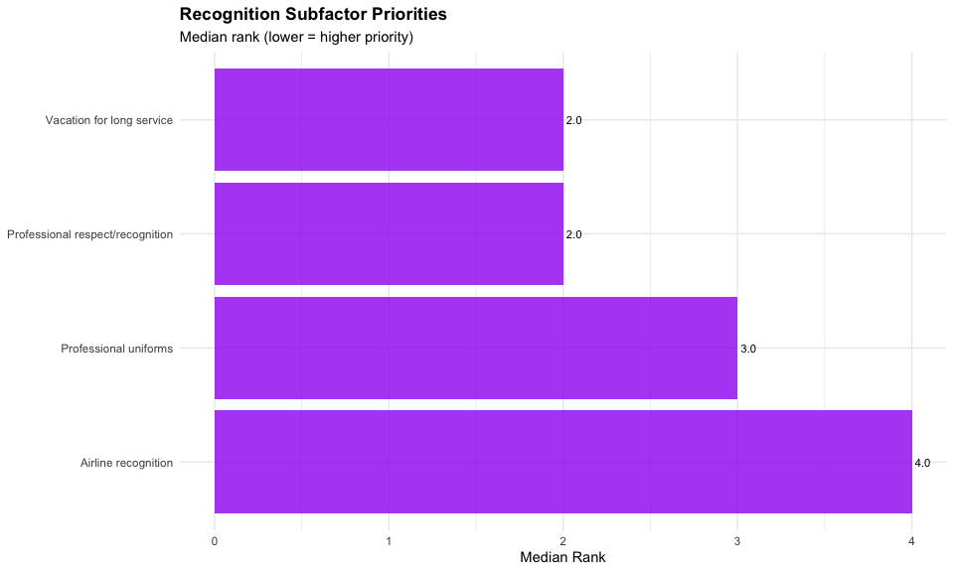
ggsave("../../output/figures/subfactor_analysis/recognition_median_ranks.png",
recognition_plot, width = 8, height = 5, dpi = 300)
# Demographics
mw_age_recog <- recognition_long %>%
filter(!is.na(age_group)) %>%
group_by(item) %>%
safe_wilcox_test(rank ~ age_group, exact = FALSE) %>%
ungroup()
if (nrow(mw_age_recog) > 0) {
mw_age_recog <- mw_age_recog %>%
mutate(p_raw = p) %>%
adjust_pvalue(method = "holm") %>%
add_significance("p.adj") %>%
select(item, statistic, p_raw, p.adj, p.adj.signif, effsize, magnitude) %>%
rename(p = p_raw, p_adj_holm = p.adj) %>%
mutate(item = recode(item, !!!recognition_labels))
}
kable(mw_age_recog, digits = 3, caption = "Recognition: Age Comparisons")
Recognition: Age Comparisons
item | statistic | p | p_adj_holm | p.adj.signif | effsize | magnitude
Professional uniforms | 577 | 0.476 | 0.900 | ns | 0.082 | small
Vacation for long service | 345 | 0.023 | 0.093 | ns | 0.261 | small
Professional respect/recognition | 601 | 0.300 | 0.900 | ns | 0.120 | small
Airline recognition | 579 | 0.430 | 0.900 | ns | 0.091 | small
mw_gender_recog <- recognition_long %>%
filter(!is.na(gender_clean)) %>%
group_by(item) %>%
safe_wilcox_test(rank ~ gender_clean, exact = FALSE) %>%
ungroup()
if (nrow(mw_gender_recog) > 0) {
mw_gender_recog <- mw_gender_recog %>%
mutate(p_raw = p) %>%
adjust_pvalue(method = "holm") %>%
add_significance("p.adj") %>%
select(item, statistic, p_raw, p.adj, p.adj.signif, effsize, magnitude) %>%
rename(p = p_raw, p_adj_holm = p.adj) %>%
mutate(item = recode(item, !!!recognition_labels))
}
kable(mw_gender_recog, digits = 3, caption = "Recognition: Gender Comparisons")
Recognition: Gender Comparisons
item | statistic | p | p_adj_holm | p.adj.signif | effsize | magnitude
Professional uniforms | 183.0 | 0.120 | 0.360 | ns | 0.180 | small
Vacation for long service | 247.5 | 0.718 | 1.000 | ns | 0.043 | small
Professional respect/recognition | 264.0 | 0.948 | 1.000 | ns | 0.009 | small
Airline recognition | 384.0 | 0.023 | 0.091 | ns | 0.264 | small
mw_position_recog <- recognition_long %>%
filter(!is.na(position)) %>%
group_by(item) %>%
safe_wilcox_test(rank ~ position, exact = FALSE) %>%
ungroup()
if (nrow(mw_position_recog) > 0) {
mw_position_recog <- mw_position_recog %>%
mutate(p_raw = p) %>%
adjust_pvalue(method = "holm") %>%
add_significance("p.adj") %>%
select(item, statistic, p_raw, p.adj, p.adj.signif, effsize, magnitude) %>%
rename(p = p_raw, p_adj_holm = p.adj) %>%
mutate(item = recode(item, !!!recognition_labels))
}
kable(mw_position_recog, digits = 3, caption = "Recognition: Position Comparisons")
Recognition: Position Comparisons
item | statistic | p | p_adj_holm | p.adj.signif | effsize | magnitude
Professional uniforms | 767.5 | 0.171 | 0.513 | ns | 0.158 | small
Vacation for long service | 496.5 | 0.078 | 0.312 | ns | 0.203 | small
Professional respect/recognition | 724.0 | 0.385 | 0.770 | ns | 0.100 | small
Airline recognition | 618.0 | 0.694 | 0.770 | ns | 0.046 | small
mw_military_recog <- recognition_long %>%
filter(!is.na(military_clean)) %>%
group_by(item) %>%
safe_wilcox_test(rank ~ military_clean, exact = FALSE) %>%
ungroup()
if (nrow(mw_military_recog) > 0) {
mw_military_recog <- mw_military_recog %>%
mutate(p_raw = p) %>%
adjust_pvalue(method = "holm") %>%
add_significance("p.adj") %>%
select(item, statistic, p_raw, p.adj, p.adj.signif, effsize, magnitude) %>%
rename(p = p_raw, p_adj_holm = p.adj) %>%
mutate(item = recode(item, !!!recognition_labels))
}
kable(mw_military_recog, digits = 3, caption = "Recognition: Military Comparisons")
Recognition: Military Comparisons
item | statistic | p | p_adj_holm | p.adj.signif | effsize | magnitude
Professional uniforms | 119.5 | 0.020 | 0.078 | ns | 0.269 | small
Vacation for long service | 355.5 | 0.032 | 0.096 | ns | 0.247 | small
Professional respect/recognition | 214.0 | 0.600 | 1.000 | ns | 0.061 | small
Airline recognition | 274.0 | 0.511 | 1.000 | ns | 0.077 | small
kw_exp_recog <- recognition_long %>%
filter(!is.na(exp_q)) %>%
group_by(item) %>%
safe_kruskal_test(rank ~ exp_q) %>%
ungroup()
if (nrow(kw_exp_recog) > 0) {
kw_exp_recog <- kw_exp_recog %>%
mutate(p_raw = p) %>%
adjust_pvalue(method = "holm") %>%
add_significance("p.adj") %>%
select(item, statistic, df, p_raw, p.adj, p.adj.signif, effsize, magnitude) %>%
rename(p = p_raw, p_adj_holm = p.adj) %>%
mutate(item = recode(item, !!!recognition_labels))
}
kable(kw_exp_recog, digits = 3, caption = "Recognition: Experience Comparisons")
Recognition: Experience Comparisons
item | statistic | df | p | p_adj_holm | p.adj.signif | effsize | magnitude
Professional uniforms | 4.887 | 3 | 0.180 | 0.540 | ns | 0.026 | small
Vacation for long service | 8.274 | 3 | 0.041 | 0.163 | ns | 0.073 | moderate
Professional respect/recognition | 1.184 | 3 | 0.757 | 1.000 | ns | -0.025 | small
Airline recognition | 0.637 | 3 | 0.888 | 1.000 | ns | -0.033 | small
# Save tables to CSV
write_csv(recognition_desc, "../../output/tables/subfactor_analysis/recognition_descriptive.csv")
write_csv(friedman_recog, "../../output/tables/subfactor_analysis/recognition_friedman.csv")
if (nrow(mw_age_recog) > 0) write_csv(mw_age_recog, "../../output/tables/subfactor_analysis/recognition_age.csv")
if (nrow(mw_gender_recog) > 0) write_csv(mw_gender_recog, "../../output/tables/subfactor_analysis/recognition_gender.csv")
if (nrow(mw_position_recog) > 0) write_csv(mw_position_recog, "../../output/tables/subfactor_analysis/recognition_position.csv")
if (nrow(mw_military_recog) > 0) write_csv(mw_military_recog, "../../output/tables/subfactor_analysis/recognition_military.csv")
if (nrow(kw_exp_recog) > 0) write_csv(kw_exp_recog, "../../output/tables/subfactor_analysis/recognition_experience.csv")
# Collect minimum p-value for screening
min_p_recog <- min(
if(nrow(mw_age_recog) > 0) min(mw_age_recog$p) else 1,
if(nrow(mw_gender_recog) > 0) min(mw_gender_recog$p) else 1,
if(nrow(mw_position_recog) > 0) min(mw_position_recog$p) else 1,
if(nrow(mw_military_recog) > 0) min(mw_military_recog$p) else 1,
if(nrow(kw_exp_recog) > 0) min(kw_exp_recog$p) else 1
)
screening_results <- screening_results %>%
add_row(
construct = "Recognition",
min_p = min_p_recog,
n_subfactors = 4
)
cat("Recognition screening p-value:", round(min_p_recog, 4), "\n")
Recognition screening p-value: 0.0196

10. Schedule Subfactors
cat("\n========================================\n")
========================================
cat("SCHEDULE SUBFACTORS\n")
SCHEDULE SUBFACTORS
cat("========================================\n\n")
========================================
schedule_long <- included_data %>%
select(age_group, gender_clean, position, exp_q, military_clean,
schedule_1:schedule_5) %>%
mutate(respondent_id = row_number()) %>% # Create persistent ID before pivoting
mutate(across(schedule_1:schedule_5, as.numeric)) %>%
pivot_longer(
cols = schedule_1:schedule_5,
names_to = "item",
values_to = "rank"
) %>%
filter(!is.na(rank))
# Descriptive
schedule_desc <- schedule_long %>%
group_by(item) %>%
summarise(n = n(), median = median(rank), mean = mean(rank),
sd = sd(rank), pct_rank1 = sum(rank == 1) / n() * 100) %>%
mutate(item = recode(item, !!!schedule_labels))
kable(schedule_desc, digits = 2, caption = "Schedule Subfactors - Descriptive Statistics")
Schedule Subfactors - Descriptive Statistics
item | n | median | mean | sd | pct_rank1
Fixed schedule | 76 | 3.5 | 3.18 | 1.64 | 25.00
Variable schedule | 76 | 3.0 | 3.39 | 1.39 | 14.47
Flexible work rules | 76 | 2.0 | 2.12 | 1.31 | 42.11
Bid line seniority system | 76 | 3.0 | 2.82 | 1.27 | 18.42
Vacation bidding rules | 76 | 3.0 | 3.49 | 0.97 | 0.00
# Friedman
friedman_sched <- schedule_long %>%
friedman_test(rank ~ item | respondent_id)
kable(friedman_sched, digits = 3, caption = "Schedule: Friedman Test (Within-Construct Comparison)")
Schedule: Friedman Test (Within-Construct Comparison)
.y. | n | statistic | df | p | method
rank | 76 | 37.632 | 4 | 0 | Friedman test
# Median rank visualization
schedule_plot <- schedule_desc %>%
mutate(item = fct_reorder(item, desc(median))) %>%
ggplot(aes(x = median, y = item)) +
geom_col(fill = "firebrick", alpha = 0.8) +
geom_text(aes(label = sprintf("%.1f", median)), hjust = -0.2, size = 3) +
labs(
title = "Schedule Subfactor Priorities",
subtitle = "Median rank (lower = higher priority)",
x = "Median Rank",
y = NULL
) +
theme_minimal() +
theme(plot.title = element_text(face = "bold"))
print(schedule_plot)
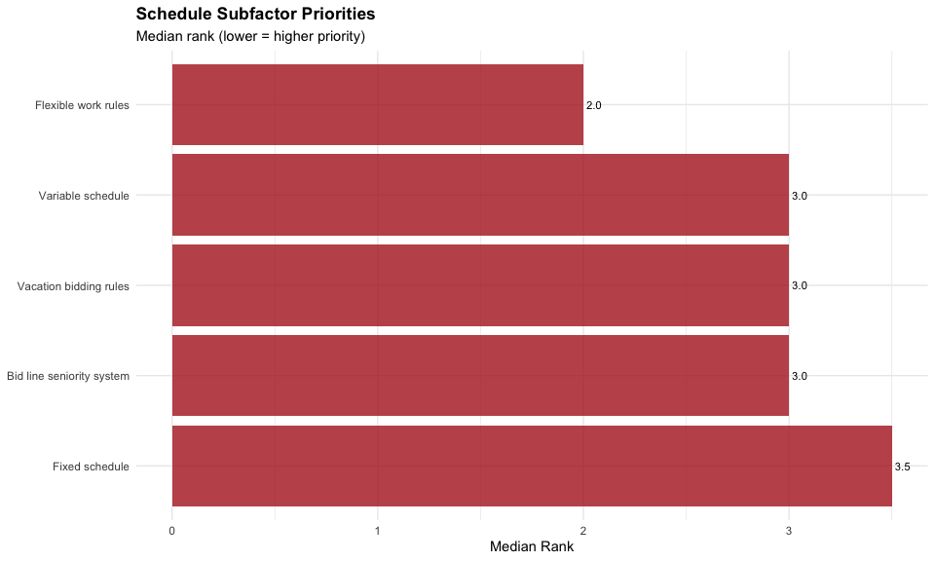
ggsave("../../output/figures/subfactor_analysis/schedule_median_ranks.png",
schedule_plot, width = 8, height = 5, dpi = 300)
# Demographics
mw_age_sched <- schedule_long %>%
filter(!is.na(age_group)) %>%
group_by(item) %>%
safe_wilcox_test(rank ~ age_group, exact = FALSE) %>%
ungroup()
if (nrow(mw_age_sched) > 0) {
mw_age_sched <- mw_age_sched %>%
mutate(p_raw = p) %>%
adjust_pvalue(method = "holm") %>%
add_significance("p.adj") %>%
select(item, statistic, p_raw, p.adj, p.adj.signif, effsize, magnitude) %>%
rename(p = p_raw, p_adj_holm = p.adj) %>%
mutate(item = recode(item, !!!schedule_labels))
}
kable(mw_age_sched, digits = 3, caption = "Schedule: Age Comparisons")
Schedule: Age Comparisons
item | statistic | p | p_adj_holm | p.adj.signif | effsize | magnitude
Fixed schedule | 464.5 | 0.472 | 1.00 | ns | 0.083 | small
Variable schedule | 493.5 | 0.724 | 1.00 | ns | 0.041 | small
Flexible work rules | 669.0 | 0.058 | 0.29 | ns | 0.218 | small
Bid line seniority system | 574.5 | 0.514 | 1.00 | ns | 0.076 | small
Vacation bidding rules | 479.0 | 0.588 | 1.00 | ns | 0.063 | small
mw_gender_sched <- schedule_long %>%
filter(!is.na(gender_clean)) %>%
group_by(item) %>%
safe_wilcox_test(rank ~ gender_clean, exact = FALSE) %>%
ungroup()
if (nrow(mw_gender_sched) > 0) {
mw_gender_sched <- mw_gender_sched %>%
mutate(p_raw = p) %>%
adjust_pvalue(method = "holm") %>%
add_significance("p.adj") %>%
select(item, statistic, p_raw, p.adj, p.adj.signif, effsize, magnitude) %>%
rename(p = p_raw, p_adj_holm = p.adj) %>%
mutate(item = recode(item, !!!schedule_labels))
}
kable(mw_gender_sched, digits = 3, caption = "Schedule: Gender Comparisons")
Schedule: Gender Comparisons
item | statistic | p | p_adj_holm | p.adj.signif | effsize | magnitude
Fixed schedule | 202.5 | 0.248 | 0.992 | ns | 0.134 | small
Variable schedule | 387.0 | 0.036 | 0.180 | ns | 0.243 | small
Flexible work rules | 229.5 | 0.489 | 0.992 | ns | 0.081 | small
Bid line seniority system | 270.5 | 0.972 | 0.992 | ns | 0.005 | small
Vacation bidding rules | 204.0 | 0.256 | 0.992 | ns | 0.132 | small
mw_position_sched <- schedule_long %>%
filter(!is.na(position)) %>%
group_by(item) %>%
safe_wilcox_test(rank ~ position, exact = FALSE) %>%
ungroup()
if (nrow(mw_position_sched) > 0) {
mw_position_sched <- mw_position_sched %>%
mutate(p_raw = p) %>%
adjust_pvalue(method = "holm") %>%
add_significance("p.adj") %>%
select(item, statistic, p_raw, p.adj, p.adj.signif, effsize, magnitude) %>%
rename(p = p_raw, p_adj_holm = p.adj) %>%
mutate(item = recode(item, !!!schedule_labels))
}
kable(mw_position_sched, digits = 3, caption = "Schedule: Position Comparisons")
Schedule: Position Comparisons
item | statistic | p | p_adj_holm | p.adj.signif | effsize | magnitude
Fixed schedule | 606.0 | 0.622 | 1 | ns | 0.057 | small
Variable schedule | 647.0 | 0.977 | 1 | ns | 0.004 | small
Flexible work rules | 714.0 | 0.462 | 1 | ns | 0.085 | small
Bid line seniority system | 747.5 | 0.276 | 1 | ns | 0.126 | small
Vacation bidding rules | 551.5 | 0.263 | 1 | ns | 0.129 | small
mw_military_sched <- schedule_long %>%
filter(!is.na(military_clean)) %>%
group_by(item) %>%
safe_wilcox_test(rank ~ military_clean, exact = FALSE) %>%
ungroup()
if (nrow(mw_military_sched) > 0) {
mw_military_sched <- mw_military_sched %>%
mutate(p_raw = p) %>%
adjust_pvalue(method = "holm") %>%
add_significance("p.adj") %>%
select(item, statistic, p_raw, p.adj, p.adj.signif, effsize, magnitude) %>%
rename(p = p_raw, p_adj_holm = p.adj) %>%
mutate(item = recode(item, !!!schedule_labels))
}
kable(mw_military_sched, digits = 3, caption = "Schedule: Military Comparisons")
Schedule: Military Comparisons
item | statistic | p | p_adj_holm | p.adj.signif | effsize | magnitude
Fixed schedule | 177.0 | 0.235 | 1 | ns | 0.137 | small
Variable schedule | 286.5 | 0.410 | 1 | ns | 0.096 | small
Flexible work rules | 227.5 | 0.797 | 1 | ns | 0.031 | small
Bid line seniority system | 216.0 | 0.645 | 1 | ns | 0.054 | small
Vacation bidding rules | 257.0 | 0.779 | 1 | ns | 0.033 | small
kw_exp_sched <- schedule_long %>%
filter(!is.na(exp_q)) %>%
group_by(item) %>%
safe_kruskal_test(rank ~ exp_q) %>%
ungroup()
if (nrow(kw_exp_sched) > 0) {
kw_exp_sched <- kw_exp_sched %>%
mutate(p_raw = p) %>%
adjust_pvalue(method = "holm") %>%
add_significance("p.adj") %>%
select(item, statistic, df, p_raw, p.adj, p.adj.signif, effsize, magnitude) %>%
rename(p = p_raw, p_adj_holm = p.adj) %>%
mutate(item = recode(item, !!!schedule_labels))
}
kable(kw_exp_sched, digits = 3, caption = "Schedule: Experience Comparisons")
Schedule: Experience Comparisons
item | statistic | df | p | p_adj_holm | p.adj.signif | effsize | magnitude
Fixed schedule | 1.454 | 3 | 0.693 | 1.000 | ns | -0.021 | small
Variable schedule | 0.483 | 3 | 0.923 | 1.000 | ns | -0.035 | small
Flexible work rules | 4.079 | 3 | 0.253 | 0.968 | ns | 0.015 | small
Bid line seniority system | 4.188 | 3 | 0.242 | 0.968 | ns | 0.016 | small
Vacation bidding rules | 5.826 | 3 | 0.120 | 0.600 | ns | 0.039 | small
# Save tables to CSV
write_csv(schedule_desc, "../../output/tables/subfactor_analysis/schedule_descriptive.csv")
write_csv(friedman_sched, "../../output/tables/subfactor_analysis/schedule_friedman.csv")
if (nrow(mw_age_sched) > 0) write_csv(mw_age_sched, "../../output/tables/subfactor_analysis/schedule_age.csv")
if (nrow(mw_gender_sched) > 0) write_csv(mw_gender_sched, "../../output/tables/subfactor_analysis/schedule_gender.csv")
if (nrow(mw_position_sched) > 0) write_csv(mw_position_sched, "../../output/tables/subfactor_analysis/schedule_position.csv")
if (nrow(mw_military_sched) > 0) write_csv(mw_military_sched, "../../output/tables/subfactor_analysis/schedule_military.csv")
if (nrow(kw_exp_sched) > 0) write_csv(kw_exp_sched, "../../output/tables/subfactor_analysis/schedule_experience.csv")
# Collect minimum p-value for screening
min_p_sched <- min(
if(nrow(mw_age_sched) > 0) min(mw_age_sched$p) else 1,
if(nrow(mw_gender_sched) > 0) min(mw_gender_sched$p) else 1,
if(nrow(mw_position_sched) > 0) min(mw_position_sched$p) else 1,
if(nrow(mw_military_sched) > 0) min(mw_military_sched$p) else 1,
if(nrow(kw_exp_sched) > 0) min(kw_exp_sched$p) else 1
)
screening_results <- screening_results %>%
add_row(
construct = "Schedule",
min_p = min_p_sched,
n_subfactors = 5
)
cat("Schedule screening p-value:", round(min_p_sched, 4), "\n")
Schedule screening p-value: 0.0359

11. Operational Subfactors
cat("\n========================================\n")
========================================
cat("OPERATIONAL SUBFACTORS\n")
OPERATIONAL SUBFACTORS
cat("========================================\n\n")
========================================
operational_long <- included_data %>%
select(age_group, gender_clean, position, exp_q, military_clean,
operational_1:operational_5) %>%
mutate(respondent_id = row_number()) %>% # Create persistent ID before pivoting
mutate(across(operational_1:operational_5, as.numeric)) %>%
pivot_longer(
cols = operational_1:operational_5,
names_to = "item",
values_to = "rank"
) %>%
filter(!is.na(rank))
# Descriptive
operational_desc <- operational_long %>%
group_by(item) %>%
summarise(n = n(), median = median(rank), mean = mean(rank),
sd = sd(rank), pct_rank1 = sum(rank == 1) / n() * 100) %>%
mutate(item = recode(item, !!!operational_labels))
kable(operational_desc, digits = 2, caption = "Operational Subfactors - Descriptive Statistics")
Operational Subfactors - Descriptive Statistics
item | n | median | mean | sd | pct_rank1
Unambiguous SOPs | 76 | 3 | 3.07 | 1.59 | 28.95
Proactive training | 76 | 3 | 2.84 | 1.17 | 11.84
Well-maintained aircraft | 76 | 2 | 2.25 | 1.16 | 35.53
Well-equipped aircraft | 76 | 5 | 4.13 | 1.18 | 1.32
Highly skilled pilots | 76 | 3 | 2.71 | 1.24 | 22.37
# Friedman
friedman_oper <- operational_long %>%
friedman_test(rank ~ item | respondent_id)
kable(friedman_oper, digits = 3, caption = "Operational: Friedman Test (Within-Construct Comparison)")
Operational: Friedman Test (Within-Construct Comparison)
.y. | n | statistic | df | p | method
rank | 76 | 59.463 | 4 | 0 | Friedman test
# Median rank visualization
operational_plot <- operational_desc %>%
mutate(item = fct_reorder(item, desc(median))) %>%
ggplot(aes(x = median, y = item)) +
geom_col(fill = "darkslategray", alpha = 0.8) +
geom_text(aes(label = sprintf("%.1f", median)), hjust = -0.2, size = 3) +
labs(
title = "Operational Subfactor Priorities",
subtitle = "Median rank (lower = higher priority)",
x = "Median Rank",
y = NULL
) +
theme_minimal() +
theme(plot.title = element_text(face = "bold"))
print(operational_plot)
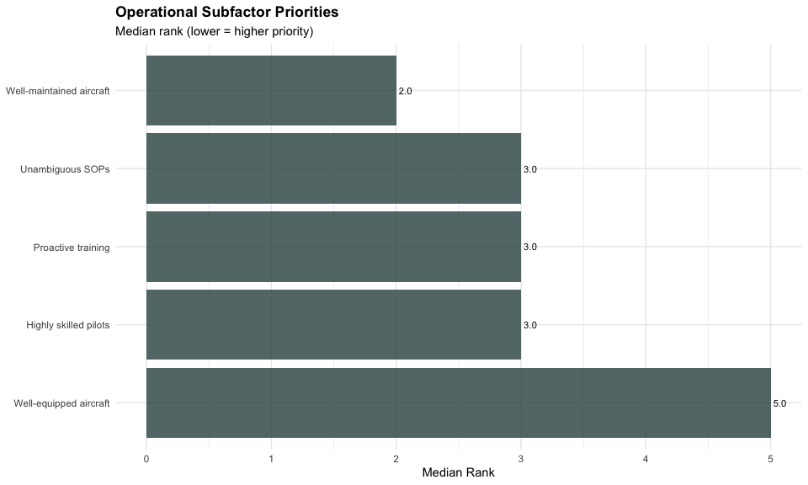
ggsave("../../output/figures/subfactor_analysis/operational_median_ranks.png",
operational_plot, width = 8, height = 5, dpi = 300)
# Demographics
mw_age_oper <- operational_long %>%
filter(!is.na(age_group)) %>%
group_by(item) %>%
safe_wilcox_test(rank ~ age_group, exact = FALSE) %>%
ungroup()
if (nrow(mw_age_oper) > 0) {
mw_age_oper <- mw_age_oper %>%
mutate(p_raw = p) %>%
adjust_pvalue(method = "holm") %>%
add_significance("p.adj") %>%
select(item, statistic, p_raw, p.adj, p.adj.signif, effsize, magnitude) %>%
rename(p = p_raw, p_adj_holm = p.adj) %>%
mutate(item = recode(item, !!!operational_labels))
}
kable(mw_age_oper, digits = 3, caption = "Operational: Age Comparisons")
Operational: Age Comparisons
item | statistic | p | p_adj_holm | p.adj.signif | effsize | magnitude
Unambiguous SOPs | 486.0 | 0.655 | 1.000 | ns | 0.052 | small
Proactive training | 406.0 | 0.145 | 0.725 | ns | 0.168 | small
Well-maintained aircraft | 556.0 | 0.671 | 1.000 | ns | 0.050 | small
Well-equipped aircraft | 551.5 | 0.692 | 1.000 | ns | 0.046 | small
Highly skilled pilots | 608.0 | 0.283 | 1.000 | ns | 0.124 | small
mw_gender_oper <- operational_long %>%
filter(!is.na(gender_clean)) %>%
group_by(item) %>%
safe_wilcox_test(rank ~ gender_clean, exact = FALSE) %>%
ungroup()
if (nrow(mw_gender_oper) > 0) {
mw_gender_oper <- mw_gender_oper %>%
mutate(p_raw = p) %>%
adjust_pvalue(method = "holm") %>%
add_significance("p.adj") %>%
select(item, statistic, p_raw, p.adj, p.adj.signif, effsize, magnitude) %>%
rename(p = p_raw, p_adj_holm = p.adj) %>%
mutate(item = recode(item, !!!operational_labels))
}
kable(mw_gender_oper, digits = 3, caption = "Operational: Gender Comparisons")
Operational: Gender Comparisons
item | statistic | p | p_adj_holm | p.adj.signif | effsize | magnitude
Unambiguous SOPs | 255.0 | 0.825 | 1 | ns | 0.027 | small
Proactive training | 240.0 | 0.626 | 1 | ns | 0.057 | small
Well-maintained aircraft | 237.0 | 0.586 | 1 | ns | 0.064 | small
Well-equipped aircraft | 328.5 | 0.247 | 1 | ns | 0.135 | small
Highly skilled pilots | 290.0 | 0.705 | 1 | ns | 0.045 | small
mw_position_oper <- operational_long %>%
filter(!is.na(position)) %>%
group_by(item) %>%
safe_wilcox_test(rank ~ position, exact = FALSE) %>%
ungroup()
if (nrow(mw_position_oper) > 0) {
mw_position_oper <- mw_position_oper %>%
mutate(p_raw = p) %>%
adjust_pvalue(method = "holm") %>%
add_significance("p.adj") %>%
select(item, statistic, p_raw, p.adj, p.adj.signif, effsize, magnitude) %>%
rename(p = p_raw, p_adj_holm = p.adj) %>%
mutate(item = recode(item, !!!operational_labels))
}
kable(mw_position_oper, digits = 3, caption = "Operational: Position Comparisons")
Operational: Position Comparisons
item | statistic | p | p_adj_holm | p.adj.signif | effsize | magnitude
Unambiguous SOPs | 620.0 | 0.740 | 1 | ns | 0.039 | small
Proactive training | 722.5 | 0.416 | 1 | ns | 0.094 | small
Well-maintained aircraft | 618.0 | 0.720 | 1 | ns | 0.042 | small
Well-equipped aircraft | 637.5 | 0.883 | 1 | ns | 0.018 | small
Highly skilled pilots | 655.5 | 0.955 | 1 | ns | 0.007 | small
mw_military_oper <- operational_long %>%
filter(!is.na(military_clean)) %>%
group_by(item) %>%
safe_wilcox_test(rank ~ military_clean, exact = FALSE) %>%
ungroup()
if (nrow(mw_military_oper) > 0) {
mw_military_oper <- mw_military_oper %>%
mutate(p_raw = p) %>%
adjust_pvalue(method = "holm") %>%
add_significance("p.adj") %>%
select(item, statistic, p_raw, p.adj, p.adj.signif, effsize, magnitude) %>%
rename(p = p_raw, p_adj_holm = p.adj) %>%
mutate(item = recode(item, !!!operational_labels))
}
kable(mw_military_oper, digits = 3, caption = "Operational: Military Comparisons")
Operational: Military Comparisons
item | statistic | p | p_adj_holm | p.adj.signif | effsize | magnitude
Unambiguous SOPs | 287.0 | 0.405 | 1 | ns | 0.096 | small
Proactive training | 280.0 | 0.481 | 1 | ns | 0.082 | small
Well-maintained aircraft | 218.0 | 0.668 | 1 | ns | 0.050 | small
Well-equipped aircraft | 204.5 | 0.463 | 1 | ns | 0.085 | small
Highly skilled pilots | 225.0 | 0.768 | 1 | ns | 0.035 | small
kw_exp_oper <- operational_long %>%
filter(!is.na(exp_q)) %>%
group_by(item) %>%
safe_kruskal_test(rank ~ exp_q) %>%
ungroup()
if (nrow(kw_exp_oper) > 0) {
kw_exp_oper <- kw_exp_oper %>%
mutate(p_raw = p) %>%
adjust_pvalue(method = "holm") %>%
add_significance("p.adj") %>%
select(item, statistic, df, p_raw, p.adj, p.adj.signif, effsize, magnitude) %>%
rename(p = p_raw, p_adj_holm = p.adj) %>%
mutate(item = recode(item, !!!operational_labels))
}
kable(kw_exp_oper, digits = 3, caption = "Operational: Experience Comparisons")
Operational: Experience Comparisons
item | statistic | df | p | p_adj_holm | p.adj.signif | effsize | magnitude
Unambiguous SOPs | 4.274 | 3 | 0.233 | 0.932 | ns | 0.018 | small
Proactive training | 0.476 | 3 | 0.924 | 1.000 | ns | -0.035 | small
Well-maintained aircraft | 1.985 | 3 | 0.575 | 1.000 | ns | -0.014 | small
Well-equipped aircraft | 0.326 | 3 | 0.955 | 1.000 | ns | -0.037 | small
Highly skilled pilots | 5.161 | 3 | 0.160 | 0.800 | ns | 0.030 | small
# Save tables to CSV
write_csv(operational_desc, "../../output/tables/subfactor_analysis/operational_descriptive.csv")
write_csv(friedman_oper, "../../output/tables/subfactor_analysis/operational_friedman.csv")
if (nrow(mw_age_oper) > 0) write_csv(mw_age_oper, "../../output/tables/subfactor_analysis/operational_age.csv")
if (nrow(mw_gender_oper) > 0) write_csv(mw_gender_oper, "../../output/tables/subfactor_analysis/operational_gender.csv")
if (nrow(mw_position_oper) > 0) write_csv(mw_position_oper, "../../output/tables/subfactor_analysis/operational_position.csv")
if (nrow(mw_military_oper) > 0) write_csv(mw_military_oper, "../../output/tables/subfactor_analysis/operational_military.csv")
if (nrow(kw_exp_oper) > 0) write_csv(kw_exp_oper, "../../output/tables/subfactor_analysis/operational_experience.csv")
# Collect minimum p-value for screening
min_p_oper <- min(
if(nrow(mw_age_oper) > 0) min(mw_age_oper$p) else 1,
if(nrow(mw_gender_oper) > 0) min(mw_gender_oper$p) else 1,
if(nrow(mw_position_oper) > 0) min(mw_position_oper$p) else 1,
if(nrow(mw_military_oper) > 0) min(mw_military_oper$p) else 1,
if(nrow(kw_exp_oper) > 0) min(kw_exp_oper$p) else 1
)
screening_results <- screening_results %>%
add_row(
construct = "Operational",
min_p = min_p_oper,
n_subfactors = 5
)
cat("Operational screening p-value:", round(min_p_oper, 4), "\n")
Operational screening p-value: 0.145

12. Construct-Level Screening Results
# Apply Benjamini-Hochberg FDR to Screening Results
# ==================================================
cat("\n=== FINAL SCREENING RESULTS ===\n\n")
=== FINAL SCREENING RESULTS ===
# Apply BH-FDR at q=0.10
screening_results <- screening_results %>%
arrange(min_p) %>%
mutate(
rank = row_number(),
p_adj_fdr = p.adjust(min_p, method = "BH"),
significant = p_adj_fdr < 0.10,
decision = if_else(significant, "Proceed to detailed testing", "No demographic differences detected")
)
# Display results
kable(
screening_results %>% select(construct, min_p, p_adj_fdr, significant, n_subfactors, decision),
digits = 4,
caption = "Construct-Level Screening: Benjamini-Hochberg FDR (q=0.10)",
col.names = c("Construct", "Min p-value", "p-adj (FDR)", "Significant", "N Subfactors", "Decision")
)
Construct-Level Screening: Benjamini-Hochberg FDR (q=0.10)
Construct | Min p-value | p-adj (FDR) | Significant | N Subfactors | Decision
Quality of Life | 0.0147 | 0.0588 | TRUE | 6 | Proceed to detailed testing
Recognition | 0.0196 | 0.0588 | TRUE | 4 | Proceed to detailed testing
Schedule | 0.0359 | 0.0718 | TRUE | 5 | Proceed to detailed testing
Professional | 0.0493 | 0.0739 | TRUE | 5 | Proceed to detailed testing
Financial | 0.0691 | 0.0829 | TRUE | 6 | Proceed to detailed testing
Operational | 0.1450 | 0.1450 | FALSE | 5 | No demographic differences detected
# Count significant constructs
n_significant <- sum(screening_results$significant)
cat("\nSignificant constructs (p_adj < 0.10):", n_significant, "of 6\n")
Significant constructs (p_adj < 0.10): 5 of 6
# Interpretation guidance
if (n_significant > 0) {
cat("\nFor constructs passing screening (p_adj < 0.10):\n")
cat(" Demographic comparisons within these constructs have been adjusted using\n")
cat(" Holm's procedure at α=0.05. Tests with p_adj_holm < 0.05 indicate\n")
cat(" specific demographics showing differences in subfactor rankings.\n\n")
cat("For constructs NOT passing screening:\n")
cat(" No evidence of demographic differences at construct level.\n")
cat(" Individual demographic comparisons should be interpreted as exploratory only.\n")
} else {
cat("\nNo constructs showed significant demographic differences at construct level.\n")
cat("Individual demographic comparisons reported above are retained for completeness\n")
cat("and should be treated as exploratory outputs without confirmatory claims.\n")
}
For constructs passing screening (p_adj < 0.10):
Demographic comparisons within these constructs have been adjusted using
Holm's procedure at α=0.05. Tests with p_adj_holm < 0.05 indicate
specific demographics showing differences in subfactor rankings.
For constructs NOT passing screening:
No evidence of demographic differences at construct level.
Individual demographic comparisons should be interpreted as exploratory only.

13. Results Summary
count_sig <- function(tbl_name) {
if (!exists(tbl_name, inherits = TRUE)) return(0)
df <- get(tbl_name, inherits = TRUE)
if (!"p_adj_holm" %in% names(df)) return(0)
sum(df$p_adj_holm < 0.05, na.rm = TRUE)
}
count_tests <- function(tbl_name) {
if (!exists(tbl_name, inherits = TRUE)) return(0)
nrow(get(tbl_name, inherits = TRUE))
}
detailed_summary <- tibble::tibble(
Construct = c("Financial", "Quality of Life", "Professional", "Recognition", "Schedule", "Operational"),
Age_tests = c(count_tests("mw_age_fin"), count_tests("mw_age_qol"), count_tests("mw_age_prof"),
count_tests("mw_age_recog"), count_tests("mw_age_sched"), count_tests("mw_age_oper")),
Age_significant = c(count_sig("mw_age_fin"), count_sig("mw_age_qol"), count_sig("mw_age_prof"),
count_sig("mw_age_recog"), count_sig("mw_age_sched"), count_sig("mw_age_oper")),
Gender_tests = c(count_tests("mw_gender_fin"), count_tests("mw_gender_qol"), count_tests("mw_gender_prof"),
count_tests("mw_gender_recog"), count_tests("mw_gender_sched"), count_tests("mw_gender_oper")),
Gender_significant = c(count_sig("mw_gender_fin"), count_sig("mw_gender_qol"), count_sig("mw_gender_prof"),
count_sig("mw_gender_recog"), count_sig("mw_gender_sched"), count_sig("mw_gender_oper")),
Position_tests = c(count_tests("mw_position_fin"), count_tests("mw_position_qol"), count_tests("mw_position_prof"),
count_tests("mw_position_recog"), count_tests("mw_position_sched"), count_tests("mw_position_oper")),
Position_significant = c(count_sig("mw_position_fin"), count_sig("mw_position_qol"), count_sig("mw_position_prof"),
count_sig("mw_position_recog"), count_sig("mw_position_sched"), count_sig("mw_position_oper")),
Military_tests = c(count_tests("mw_military_fin"), count_tests("mw_military_qol"), count_tests("mw_military_prof"),
count_tests("mw_military_recog"), count_tests("mw_military_sched"), count_tests("mw_military_oper")),
Military_significant = c(count_sig("mw_military_fin"), count_sig("mw_military_qol"), count_sig("mw_military_prof"),
count_sig("mw_military_recog"), count_sig("mw_military_sched"), count_sig("mw_military_oper")),
Experience_tests = c(count_tests("kw_exp_fin"), count_tests("kw_exp_qol"), count_tests("kw_exp_prof"),
count_tests("kw_exp_recog"), count_tests("kw_exp_sched"), count_tests("kw_exp_oper")),
Experience_significant = c(count_sig("kw_exp_fin"), count_sig("kw_exp_qol"), count_sig("kw_exp_prof"),
count_sig("kw_exp_recog"), count_sig("kw_exp_sched"), count_sig("kw_exp_oper"))
)
knitr::kable(
detailed_summary,
caption = "Counts of Holm-Adjusted Comparisons Below 0.05 by Construct and Demographic Group"
)
Counts of Holm-Adjusted Comparisons Below 0.05 by Construct and Demographic Group
Construct | Age_tests | Age_significant | Gender_tests | Gender_significant | Position_tests | Position_significant | Military_tests | Military_significant | Experience_tests | Experience_significant
Financial | 6 | 0 | 6 | 0 | 6 | 0 | 6 | 0 | 6 | 0
Quality of Life | 6 | 0 | 6 | 0 | 6 | 0 | 6 | 0 | 6 | 0
Professional | 5 | 0 | 5 | 0 | 5 | 0 | 5 | 0 | 5 | 0
Recognition | 4 | 0 | 4 | 0 | 4 | 0 | 4 | 0 | 4 | 0
Schedule | 5 | 0 | 5 | 0 | 5 | 0 | 5 | 0 | 5 | 0
Operational | 5 | 0 | 5 | 0 | 5 | 0 | 5 | 0 | 5 | 0

14. Conclusion
This analysis examined 31 subfactor rankings across six retention constructs (Financial, Quality of Life, Professional Opportunity, Recognition, Schedule, and Operational) and compared them across five demographic groups: age (≤35 vs >35), gender, position (Captain vs First Officer), military experience, and years of experience (quartiles).
Statistical Methods: This exploratory pilot study employed a two-step hierarchical false discovery rate (FDR) control procedure. First, construct-level screening using Benjamini-Hochberg FDR at q=0.10 determined which of the six constructs showed demographic differences. Second, for constructs passing screening, individual demographic comparisons were adjusted using Holm’s procedure at α=0.05. Mann-Whitney U tests were used for binary demographic comparisons, Kruskal-Wallis tests for experience quartiles, and Friedman tests for within-construct comparisons. All tests used proper respondent identifiers to maintain the repeated-measures structure of the data. Effect sizes (rank-biserial r for Mann-Whitney, eta-squared for Kruskal-Wallis) were computed for every test.
Key Outputs: Construct-level screening results, detailed demographic tables (with raw and Holm-adjusted p-values), effect sizes (|r| < 0.3, η² < 0.06 across all tests), and median-rank visualizations are provided above.

14.1 Sample Characteristics
This analysis is based on n=76 valid pilot responses. Demographic breakdown used in testing:
- Age groups: ≤35 (58 pilots) and >35 (18 pilots)
- Gender: Male (67), Female (8); other/unspecified entries were excluded from binary comparisons
- Position: Captain (26) and First Officer (50)
- Military background: Military (7) and Civilian (69)
- Experience quartiles: ntile-based groups containing 28 (Q1), 14 (Q2), 17 (Q3), and 17 (Q4) pilots, respectively
Effect sizes for all demographic comparisons were within |r| < 0.3 for Mann-Whitney tests and η² < 0.06 for Kruskal-Wallis tests.

15. Session Info
sessionInfo()
R version 4.5.2 (2025-10-31)
Platform: aarch64-apple-darwin20
Running under: macOS Tahoe 26.1
Matrix products: default
BLAS: /System/Library/Frameworks/Accelerate.framework/Versions/A/Frameworks/vecLib.framework/Versions/A/libBLAS.dylib
LAPACK: /Library/Frameworks/R.framework/Versions/4.5-arm64/Resources/lib/libRlapack.dylib; LAPACK version 3.12.1
locale:
[1] en_US.UTF-8/en_US.UTF-8/en_US.UTF-8/C/en_US.UTF-8/en_US.UTF-8
time zone: America/New_York
tzcode source: internal
attached base packages:
[1] stats graphics grDevices datasets utils methods base
other attached packages:
[1] DescTools_0.99.60 janitor_2.2.1 knitr_1.50 rstatix_0.7.3
[5] lubridate_1.9.4 forcats_1.0.1 stringr_1.6.0 dplyr_1.1.4
[9] purrr_1.2.0 readr_2.1.5 tidyr_1.3.1 tibble_3.3.0
[13] ggplot2_4.0.0 tidyverse_2.0.0
loaded via a namespace (and not attached):
[1] tidyselect_1.2.1 Exact_3.3 rootSolve_1.8.2.4 libcoin_1.0-10
[5] farver_2.1.2 S7_0.2.0 fastmap_1.2.0 TH.data_1.1-4
[9] digest_0.6.37 timechange_0.3.0 lifecycle_1.0.4 survival_3.8-3
[13] lmom_3.2 magrittr_2.0.4 compiler_4.5.2 rlang_1.1.6
[17] tools_4.5.2 yaml_2.3.10 data.table_1.17.8 labeling_0.4.3
[21] bit_4.6.0 RColorBrewer_1.1-3 multcomp_1.4-29 abind_1.4-8
[25] expm_1.0-0 withr_3.0.2 stats4_4.5.2 grid_4.5.2
[29] e1071_1.7-16 scales_1.4.0 MASS_7.3-65 cli_3.6.5
[33] mvtnorm_1.3-3 rmarkdown_2.30 crayon_1.5.3 ragg_1.5.0
[37] generics_0.1.4 rstudioapi_0.17.1 httr_1.4.7 tzdb_0.5.0
[41] readxl_1.4.5 gld_2.6.8 proxy_0.4-27 modeltools_0.2-24
[45] splines_4.5.2 parallel_4.5.2 cellranger_1.1.0 matrixStats_1.5.0
[49] vctrs_0.6.5 sandwich_3.1-1 boot_1.3-32 Matrix_1.7-4
[53] jsonlite_2.0.0 carData_3.0-5 car_3.1-3 hms_1.1.4
[57] bit64_4.6.0-1 Formula_1.2-5 systemfonts_1.3.1 glue_1.8.0
[61] codetools_0.2-20 stringi_1.8.7 gtable_0.3.6 pillar_1.11.1
[65] htmltools_0.5.8.1 R6_2.6.1 textshaping_1.0.4 vroom_1.6.6
[69] evaluate_1.0.5 lattice_0.22-7 haven_2.5.5 backports_1.5.0
[73] broom_1.0.10 snakecase_0.11.1 renv_1.1.5 class_7.3-23
[77] Rcpp_1.1.0 xfun_0.54 coin_1.4-3 zoo_1.8-14
[81] fs_1.6.6 pkgconfig_2.0.3

