ASRS UAS Reports: Descriptive Analysis
Michael J. Hickey
2025-12-27

Descriptive Findings

Narrative summary

Descriptive Findings: ASRS UAS Encounter Reports
Draft generated: 2025-12-27

Data overview and completeness
This analysis examines 50 UAS encounter reports from the NASA Aviation Safety Reporting System (ASRS), spanning 2024-11-01 to 2025-03-01. The dataset contains 125 coded fields per report.
Key observations about data completeness:
- The dataset represents a curated sample of UAS encounters, not a random sample of all aviation safety reports.
- Core identification fields (report ID, date) are complete for all 50 reports.
- Operational context variables (time of day, flight phase, airspace) are available for the majority of reports, though availability varies by field.
- Event coding fields (anomaly tags, contributing factors) are complete, reflecting ASRS analyst review.
- Miss distance information is available for a subset of reports where proximity data was reported and parseable.
- ‘Unknown’ values in summaries indicate missing or not reported data, not a distinct category.

Operational context of encounters
Time of day: The most common reporting period was 1201-1800, accounting for 21 of 46 reports with time data available (45.7%). This aligns with typical daytime flight operations.
Flight phase: Arrival phase accounted for 23 of 50 reports with phase available (46%), followed by Enroute (13 reports, 26%).
Airspace class: Class B airspace was most frequently reported, appearing in 13 of 50 reports with airspace data (26%).
Light conditions: Daylight conditions were present in 19 of 26 reports with lighting data (73.1%).

Detection and reporting patterns
Cross-tabulation of detection and reporting variables reveals patterns in how encounters are identified and documented:
- The most common reporter-time combination was Air Carrier during 1201-1800, with 9 reports.
- Person Flight Crew was the most common detection source during Arrival phase (17 reports).

Safety significance markers
Three markers of safety significance were examined: near mid-air collision (NMAC) tags, evasive action taken, and ATC assistance or clarification requested.
- NMAC: Present in 23 of 50 reports (46%, 95% CI [33%, 60%]). NMAC tag present in events__anomaly.
- Evasive action: Present in 6 of 50 reports (12%, 95% CI [6%, 24%]). Evasive Action in events__result.
- ATC assistance: Present in 5 of 50 reports (10%, 95% CI [4%, 21%]). ATC Assistance or Clarification in events__result.
The wide confidence intervals reflect the small sample size and should be interpreted with caution. These proportions describe this curated sample and should not be generalized to all UAS encounters.

Context of NMAC tags
The following subsections describe how NMAC prevalence varies across operational context variables. See Table 4 and Figures 4-6 for visual representations.

NMAC by detector
Among reports with detector = Person Flight Crew, NMAC was present in 22 of 29 reports (75.9%, Wilson 95% CI [57.9%, 87.8%]). Among reports with detector = Person UAS Crew, NMAC was present in 1 of 15 reports (6.7%, Wilson 95% CI [1.2%, 29.8%]).
These patterns describe this sample of reports and should not be interpreted as population rates or causal effects.

NMAC by flight phase
Among reports with flight phase = Arrival, NMAC was present in 14 of 23 reports (60.9%, Wilson 95% CI [40.8%, 77.8%]). Among reports with flight phase = Enroute, NMAC was present in 6 of 13 reports (46.2%, Wilson 95% CI [23.2%, 70.9%]). Among reports with flight phase = Departure, NMAC was present in 2 of 9 reports (22.2%, Wilson 95% CI [6.3%, 54.7%]).
These patterns describe this sample of reports and should not be interpreted as population rates or causal effects.

NMAC by time of day
Among reports with time block = 0601-1200, NMAC was present in 5 of 14 reports (35.7%, Wilson 95% CI [16.3%, 61.2%]). Among reports with time block = 1201-1800, NMAC was present in 9 of 21 reports (42.9%, Wilson 95% CI [24.5%, 63.5%]). Among reports with time block = 1801-2400, NMAC was present in 5 of 8 reports (62.5%, Wilson 95% CI [30.6%, 86.3%]).
These patterns describe this sample of reports and should not be interpreted as population rates or causal effects.

Summary observations
- Detector separation: In this sample, NMAC tags were more frequent in reports detected by flight crew than by UAS crew (see denominators above).
- Phase patterns: NMAC tags were most common in Arrival in this sample; intervals overlapped across phases.
- Time of day: Time-block comparisons are exploratory with wide intervals.
- Data notes: Unknown indicates missing/not reported; groups with n < 5 were excluded from plots but remain in Table 4.

Dominant event and contributing-factor themes

Top anomaly tags
- Deviation / Discrepancy - Procedural FAR: 42 reports (84%)
- Deviation / Discrepancy - Procedural Published Material / Policy: 42 reports (84%)
- Airspace Violation All Types: 41 reports (82%)

Top contributing factors
- Human Factors: 46 reports (92%)
- Software and Automation: 9 reports (18%)
- Procedure: 7 reports (14%)

Co-occurring contributing factor themes
The following factor pairs frequently appeared together within the same reports, suggesting thematic associations rather than causal relationships:
- Aircraft and Software and Automation: co-occurred in 5 reports (10%)
- Chart Or Publication and Human Factors: co-occurred in 5 reports (10%)
- Environment - Non Weather Related and Human Factors: co-occurred in 5 reports (10%)

What these descriptives do and do not support
These findings describe patterns within a curated sample of ASRS UAS encounter reports. Several limitations apply:
- Report-coded data: All tags and classifications reflect ASRS analyst coding of voluntary reports, not objective measurements or population incidence rates.
- Short time window: The data span approximately five months. No claims about temporal trends or seasonal patterns are supported.
- Curated sample: These reports were selected by ASRS staff for UAS research purposes. The sample may not represent all UAS encounters or all ASRS reports.
- Miss distance sparsity: Proximity measurements were available for only a subset of reports. Findings about miss distance apply only to available cases.
- ‘Unknown’ = missing: Categories labeled ‘Unknown’ indicate data that was not reported or could not be coded, not a distinct response category.
- No causal inference: Associations between variables do not imply causation. Contributing factors are coded themes, not verified mechanisms.
- Small sample size: Confidence intervals are wide, and percentage differences may not be statistically meaningful.
- Voluntary reporting: ASRS relies on voluntary submissions. Reporting patterns may reflect reporter characteristics rather than event frequency.

This draft was auto-generated from descriptive analysis outputs. Review and edit before publication.

Tables
The following tables summarize the dataset structure, operational context, severity markers, and NMAC prevalence patterns.
Table 1. Dataset overview and completeness
Caption: Summarizes dataset dimensions, date range, and field-level completeness across 125 coded variables.
Denominator note: N = 50 reports. Denominators vary by field; n available is reported per variable.
section | item | value | n_total | n_available | notes
A | N reports | 50 | 50 | 50
A | Date range min | 2024-11-01 | 50 | 50
A | Date range max | 2025-03-01 | 50 | 50
A | Number of fields | 125 | 50 | 50
B | Aircraft 2 - n_vars | 35 | 50 | 35
B | Aircraft 2 - mean_pct_present | 6.8 | 50 | 35
B | Aircraft 2 - median_pct_present | 0 | 50 | 35
B | Aircraft 2 - min_pct_present | 0 | 50 | 35
B | Aircraft 2 - max_pct_present | 64 | 50 | 35
B | Component - n_vars | 4 | 50 | 4
B | Component - mean_pct_present | 11.5 | 50 | 4
B | Component - median_pct_present | 12 | 50 | 4
B | Component - min_pct_present | 10 | 50 | 4
B | Component - max_pct_present | 12 | 50 | 4
B | Aircraft 1 - n_vars | 35 | 50 | 35
B | Aircraft 1 - mean_pct_present | 32 | 50 | 35
B | Aircraft 1 - median_pct_present | 24 | 50 | 35
B | Aircraft 1 - min_pct_present | 0 | 50 | 35
B | Aircraft 1 - max_pct_present | 100 | 50 | 35
B | Person - n_vars | 22 | 50 | 22
B | Person - mean_pct_present | 32.2 | 50 | 22
B | Person - median_pct_present | 10 | 50 | 22
B | Person - min_pct_present | 0 | 50 | 22
B | Person - max_pct_present | 100 | 50 | 22
B | Environment - n_vars | 6 | 50 | 6
B | Environment - mean_pct_present | 36.7 | 50 | 6
B | Environment - median_pct_present | 50 | 50 | 6
B | Environment - min_pct_present | 2 | 50 | 6
B | Environment - max_pct_present | 64 | 50 | 6
B | Report text - n_vars | 5 | 50 | 5
B | Report text - mean_pct_present | 44.4 | 50 | 5
B | Report text - median_pct_present | 12 | 50 | 5
B | Report text - min_pct_present | 0 | 50 | 5
B | Report text - max_pct_present | 100 | 50 | 5
B | Place - n_vars | 7 | 50 | 7
B | Place - mean_pct_present | 46.6 | 50 | 7
B | Place - median_pct_present | 46 | 50 | 7
B | Place - min_pct_present | 0 | 50 | 7
B | Place - max_pct_present | 92 | 50 | 7
B | Events - n_vars | 6 | 50 | 6
B | Events - mean_pct_present | 71.7 | 50 | 6
B | Events - median_pct_present | 96 | 50 | 6
B | Events - min_pct_present | 0 | 50 | 6
B | Events - max_pct_present | 100 | 50 | 6
B | Time - n_vars | 2 | 50 | 2
B | Time - mean_pct_present | 96 | 50 | 2
B | Time - median_pct_present | 96 | 50 | 2
B | Time - min_pct_present | 92 | 50 | 2
B | Time - max_pct_present | 100 | 50 | 2
B | Assessments - n_vars | 2 | 50 | 2
B | Assessments - mean_pct_present | 100 | 50 | 2
B | Assessments - median_pct_present | 100 | 50 | 2
B | Assessments - min_pct_present | 100 | 50 | 2
B | Assessments - max_pct_present | 100 | 50 | 2
B | Other - n_vars | 1 | 50 | 1
B | Other - mean_pct_present | 100 | 50 | 1
B | Other - median_pct_present | 100 | 50 | 1
B | Other - min_pct_present | 100 | 50 | 1
B | Other - max_pct_present | 100 | 50 | 1
C | time__date | 50 (100%) | 50 | 50
C | time_block | 46 (92%) | 50 | 46
C | phase_raw | 48 (96%) | 50 | 48
C | phase_simple | 50 (100%) | 50 | 50
C | ac1__airspace | 30 (60%) | 50 | 30
C | airspace_class | 50 (100%) | 50 | 50
C | environment__light | 26 (52%) | 50 | 26
C | environment__flight_conditions | 32 (64%) | 50 | 32
C | events__anomaly | 50 (100%) | 50 | 50
C | events__result | 50 (100%) | 50 | 50
C | assessments__contributing_factors_situations | 50 (100%) | 50 | 50
C | assessments__primary_problem | 50 (100%) | 50 | 50
C | events__miss_distance | 19 (38%) | 50 | 19
C | miss_horizontal_ft | 15 (30%) | 50 | 15
C | miss_vertical_ft | 15 (30%) | 50 | 15
C | events__detector | 47 (94%) | 50 | 47
Note. N = 50 reports. Denominators vary by field; n available is reported per variable.
Table 2. Operational context of encounters
Caption: Frequency distributions for operational context variables including time of day, flight phase, airspace class, and light conditions.
Denominator note: N = 50 reports. n available varies by field due to missing data; percentages computed against both N total and n available.
variable | level | n_total | n_available | n | pct_of_all | pct_of_available
time_block | 1201-1800 | 50 | 46 | 21 | 42 | 45.7
time_block | 0601-1200 | 50 | 46 | 14 | 28 | 30.4
time_block | 1801-2400 | 50 | 46 | 8 | 16 | 17.4
time_block | Unknown | 50 | 46 | 4 | 8 | 8.7
time_block | 0001-0600 | 50 | 46 | 3 | 6 | 6.5
phase_simple | Arrival | 50 | 50 | 23 | 46 | 46.0
phase_simple | Enroute | 50 | 50 | 13 | 26 | 26.0
phase_simple | Departure | 50 | 50 | 9 | 18 | 18.0
phase_simple | Unknown | 50 | 50 | 3 | 6 | 6.0
phase_simple | Surface | 50 | 50 | 2 | 4 | 4.0
airspace_class | Unknown | 50 | 50 | 20 | 40 | 40.0
airspace_class | B | 50 | 50 | 13 | 26 | 26.0
airspace_class | D | 50 | 50 | 7 | 14 | 14.0
airspace_class | C | 50 | 50 | 5 | 10 | 10.0
airspace_class | E | 50 | 50 | 3 | 6 | 6.0
airspace_class | A | 50 | 50 | 1 | 2 | 2.0
airspace_class | G | 50 | 50 | 1 | 2 | 2.0
environment__light | Unknown | 50 | 26 | 24 | 48 | 92.3
environment__light | Daylight | 50 | 26 | 19 | 38 | 73.1
environment__light | Night | 50 | 26 | 6 | 12 | 23.1
environment__light | Dusk | 50 | 26 | 1 | 2 | 3.8
environment__flight_conditions | VMC | 50 | 32 | 31 | 62 | 96.9
environment__flight_conditions | Unknown | 50 | 32 | 18 | 36 | 56.2
environment__flight_conditions | Marginal | 50 | 32 | 1 | 2 | 3.1
events__detector | Person Flight Crew | 50 | 47 | 29 | 58 | 61.7
events__detector | Person UAS Crew | 50 | 47 | 15 | 30 | 31.9
events__detector | Unknown | 50 | 47 | 3 | 6 | 6.4
events__detector | Person Air Traffic Control | 50 | 47 | 2 | 4 | 4.3
events__detector | Automation Air Traffic Control | 50 | 47 | 1 | 2 | 2.1
reporter_org | Air Carrier | 50 | 49 | 20 | 40 | 40.8
reporter_org | Commercial Operator (UAS) | 50 | 49 | 12 | 24 | 24.5
reporter_org | Government | 50 | 49 | 7 | 14 | 14.3
reporter_org | Personal | 50 | 49 | 4 | 8 | 8.2
reporter_org | Recreational / Hobbyist (UAS) | 50 | 49 | 3 | 6 | 6.1
reporter_org | FBO | 50 | 49 | 2 | 4 | 4.1
reporter_org | Air Taxi | 50 | 49 | 1 | 2 | 2.0
reporter_org | Unknown | 50 | 49 | 1 | 2 | 2.0
Note. N = 50 reports. n available varies by field due to missing data; percentages computed against both N total and n available.
Table 2a. Optional cross-tabulations (detector by phase; reporter by time)
Caption: Cross-tabulations of detector by flight phase and reporter organization by time block.
Denominator note: N = 50 reports. Row and column percentages reported; n available varies by variable pair.
crosstab_name | row_var | row_level | col_var | col_level | n_total | n_available_rows | n_available_cols | n | row_pct | col_pct
reporter_org_by_time_block | reporter_org | Air Carrier | time_block | 0601-1200 | 50 | 49 | 46 | 4 | 20.0 | 28.6
reporter_org_by_time_block | reporter_org | Air Carrier | time_block | 1201-1800 | 50 | 49 | 46 | 9 | 45.0 | 42.9
reporter_org_by_time_block | reporter_org | Air Carrier | time_block | 1801-2400 | 50 | 49 | 46 | 3 | 15.0 | 37.5
reporter_org_by_time_block | reporter_org | Air Carrier | time_block | Unknown | 50 | 49 | 46 | 4 | 20.0 | 100.0
reporter_org_by_time_block | reporter_org | Air Taxi | time_block | 1801-2400 | 50 | 49 | 46 | 1 | 100.0 | 12.5
reporter_org_by_time_block | reporter_org | Commercial Operator (UAS) | time_block | 0601-1200 | 50 | 49 | 46 | 5 | 41.7 | 35.7
reporter_org_by_time_block | reporter_org | Commercial Operator (UAS) | time_block | 1201-1800 | 50 | 49 | 46 | 6 | 50.0 | 28.6
reporter_org_by_time_block | reporter_org | Commercial Operator (UAS) | time_block | 1801-2400 | 50 | 49 | 46 | 1 | 8.3 | 12.5
reporter_org_by_time_block | reporter_org | FBO | time_block | 1201-1800 | 50 | 49 | 46 | 2 | 100.0 | 9.5
reporter_org_by_time_block | reporter_org | Government | time_block | 0001-0600 | 50 | 49 | 46 | 2 | 28.6 | 66.7
reporter_org_by_time_block | reporter_org | Government | time_block | 0601-1200 | 50 | 49 | 46 | 1 | 14.3 | 7.1
reporter_org_by_time_block | reporter_org | Government | time_block | 1201-1800 | 50 | 49 | 46 | 2 | 28.6 | 9.5
reporter_org_by_time_block | reporter_org | Government | time_block | 1801-2400 | 50 | 49 | 46 | 2 | 28.6 | 25.0
reporter_org_by_time_block | reporter_org | Personal | time_block | 0601-1200 | 50 | 49 | 46 | 2 | 50.0 | 14.3
reporter_org_by_time_block | reporter_org | Personal | time_block | 1201-1800 | 50 | 49 | 46 | 1 | 25.0 | 4.8
reporter_org_by_time_block | reporter_org | Personal | time_block | 1801-2400 | 50 | 49 | 46 | 1 | 25.0 | 12.5
reporter_org_by_time_block | reporter_org | Recreational / Hobbyist (UAS) | time_block | 0601-1200 | 50 | 49 | 46 | 2 | 66.7 | 14.3
reporter_org_by_time_block | reporter_org | Recreational / Hobbyist (UAS) | time_block | 1201-1800 | 50 | 49 | 46 | 1 | 33.3 | 4.8
reporter_org_by_time_block | reporter_org | Unknown | time_block | 0001-0600 | 50 | 49 | 46 | 1 | 100.0 | 33.3
detector_by_phase_simple | events__detector | Automation Air Traffic Control | phase_simple | Arrival | 50 | 47 | 50 | 1 | 100.0 | 4.3
detector_by_phase_simple | events__detector | Person Air Traffic Control | phase_simple | Arrival | 50 | 47 | 50 | 2 | 100.0 | 8.7
detector_by_phase_simple | events__detector | Person Flight Crew | phase_simple | Arrival | 50 | 47 | 50 | 17 | 58.6 | 73.9
detector_by_phase_simple | events__detector | Person Flight Crew | phase_simple | Departure | 50 | 47 | 50 | 3 | 10.3 | 33.3
detector_by_phase_simple | events__detector | Person Flight Crew | phase_simple | Enroute | 50 | 47 | 50 | 7 | 24.1 | 53.8
detector_by_phase_simple | events__detector | Person Flight Crew | phase_simple | Surface | 50 | 47 | 50 | 1 | 3.4 | 50.0
detector_by_phase_simple | events__detector | Person Flight Crew | phase_simple | Unknown | 50 | 47 | 50 | 1 | 3.4 | 33.3
detector_by_phase_simple | events__detector | Person UAS Crew | phase_simple | Arrival | 50 | 47 | 50 | 1 | 6.7 | 4.3
detector_by_phase_simple | events__detector | Person UAS Crew | phase_simple | Departure | 50 | 47 | 50 | 6 | 40.0 | 66.7
detector_by_phase_simple | events__detector | Person UAS Crew | phase_simple | Enroute | 50 | 47 | 50 | 5 | 33.3 | 38.5
detector_by_phase_simple | events__detector | Person UAS Crew | phase_simple | Surface | 50 | 47 | 50 | 1 | 6.7 | 50.0
detector_by_phase_simple | events__detector | Person UAS Crew | phase_simple | Unknown | 50 | 47 | 50 | 2 | 13.3 | 66.7
detector_by_phase_simple | events__detector | Unknown | phase_simple | Arrival | 50 | 47 | 50 | 2 | 66.7 | 8.7
detector_by_phase_simple | events__detector | Unknown | phase_simple | Enroute | 50 | 47 | 50 | 1 | 33.3 | 7.7
Note. N = 50 reports. Row and column percentages reported; n available varies by variable pair.
Table 3. Safety significance markers with Wilson 95% intervals
Caption: Prevalence of NMAC tags, evasive action, and ATC assistance markers with Wilson 95% confidence intervals.
Denominator note: N = 50 reports with complete data for all markers.
marker | definition | n_total | n_available | x_yes | p_hat | ci_low | ci_high
NMAC | NMAC tag present in events__anomaly | 50 | 50 | 23 | 0.46 | 0.330 | 0.596
Evasive action | Evasive Action in events__result | 50 | 50 | 6 | 0.12 | 0.056 | 0.238
ATC assistance | ATC Assistance or Clarification in events__result | 50 | 50 | 5 | 0.10 | 0.043 | 0.214
Note. N = 50 reports with complete data for all markers.
Table 4. NMAC prevalence by operational context with Wilson 95% intervals
Caption: NMAC tag prevalence stratified by detector, flight phase, and time of day with Wilson 95% confidence intervals.
Denominator note: N = 50 reports. Groups with n < 5 flagged (plot_included = FALSE) but retained in table for transparency.
context_var | context_level | n_total | n_group | x_nmac | p_hat | ci_low | ci_high | plot_included
phase_simple | Arrival | 50 | 23 | 14 | 0.60869565 | 0.40785522391381717755010 | 0.7784238 | true
phase_simple | Departure | 50 | 9 | 2 | 0.22222222 | 0.06322510711784674886093 | 0.5474110 | true
phase_simple | Enroute | 50 | 13 | 6 | 0.46153846 | 0.23206067809538319379747 | 0.7085620 | true
phase_simple | Surface | 50 | 2 | 0 | 0.00000000 | 0.00000000000000000000000 | 0.6576198 | false
phase_simple | Unknown | 50 | 3 | 1 | 0.33333333 | 0.06149194472039624242976 | 0.7923404 | false
events__detector | Automation Air Traffic Control | 50 | 1 | 0 | 0.00000000 | 0.00000000000000000000000 | 0.7934507 | false
events__detector | Person Air Traffic Control | 50 | 2 | 0 | 0.00000000 | 0.00000000000000000000000 | 0.6576198 | false
events__detector | Person Flight Crew | 50 | 29 | 22 | 0.75862069 | 0.57892398382188670069581 | 0.8778158 | true
events__detector | Person UAS Crew | 50 | 15 | 1 | 0.06666667 | 0.01186689549326856024658 | 0.2981653 | true
events__detector | Unknown | 50 | 3 | 0 | 0.00000000 | -0.00000000000000004868361 | 0.5614970 | false
time_block | 0001-0600 | 50 | 3 | 1 | 0.33333333 | 0.06149194472039624242976 | 0.7923404 | false
time_block | 0601-1200 | 50 | 14 | 5 | 0.35714286 | 0.16344731753554145314844 | 0.6123558 | true
time_block | 1201-1800 | 50 | 21 | 9 | 0.42857143 | 0.24469968925375951140921 | 0.6345345 | true
time_block | 1801-2400 | 50 | 8 | 5 | 0.62500000 | 0.30574239460262736534091 | 0.8631557 | true
time_block | Unknown | 50 | 4 | 3 | 0.75000000 | 0.30064184258240195246614 | 0.9544127 | false
Note. N = 50 reports. Groups with n < 5 flagged (plot_included = FALSE) but retained in table for transparency.

Figures
The following figures visualize detection patterns, severity markers, dominant tags, and NMAC prevalence across operational context.
Figure 1. Event detection by flight phase
Caption: Who detects UAS encounters, and during which flight phases?
Denominator note: N = 50 reports. Detector available for n = 47 reports; phase available for n = 47 reports. Unknown indicates missing/not reported.
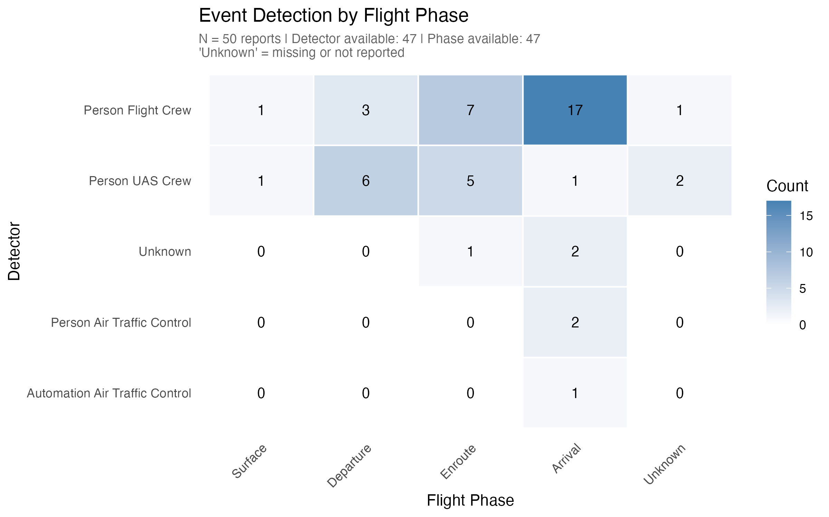
Figure 1. Event detection by flight phase
Figure 2. Severity marker prevalence with Wilson 95% intervals
Caption: How frequently do NMAC, evasive action, and ATC assistance markers appear in reports?
Denominator note: N = 50 reports. Wilson 95% confidence intervals shown.
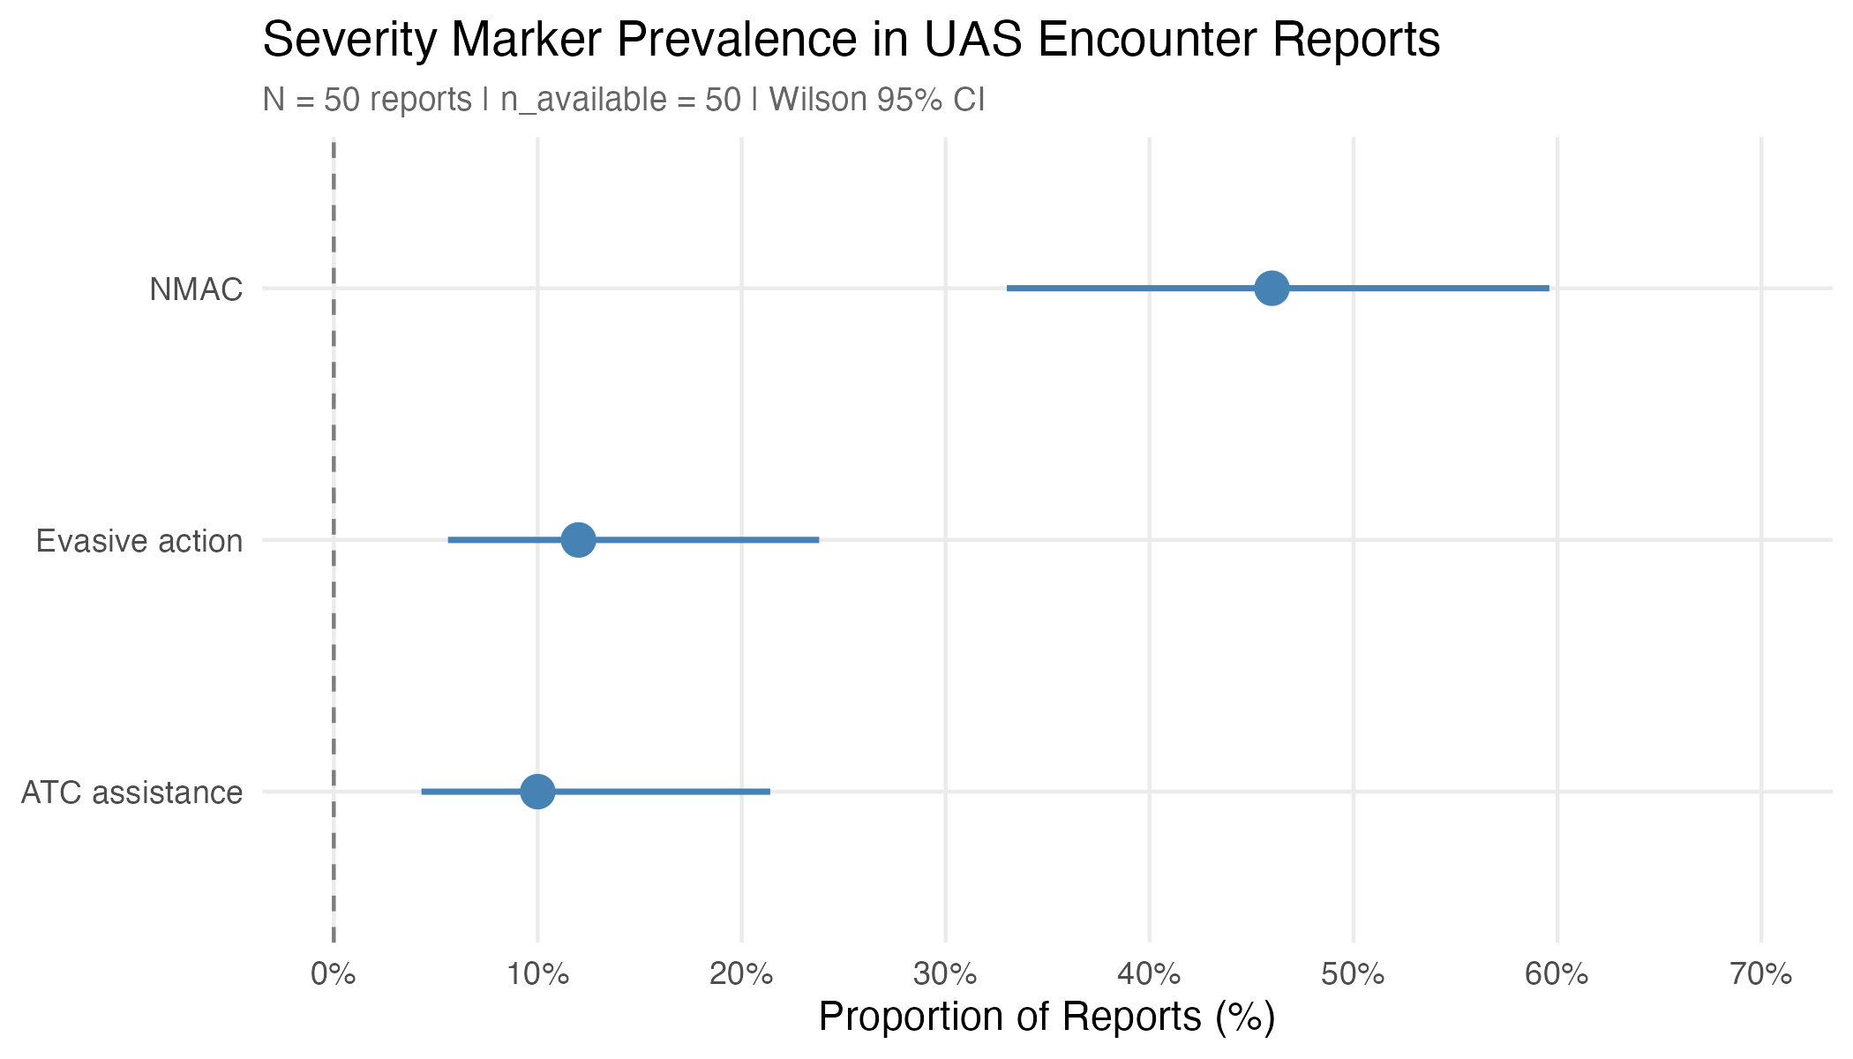
Figure 2. Severity marker prevalence with Wilson 95% intervals
Figure 3. Dominant tags in UAS encounter reports
Caption: What anomaly types and contributing factors are most frequently tagged?
Denominator note: N = 50 reports. Counts are report-level (each tag counted once per report regardless of repetition).
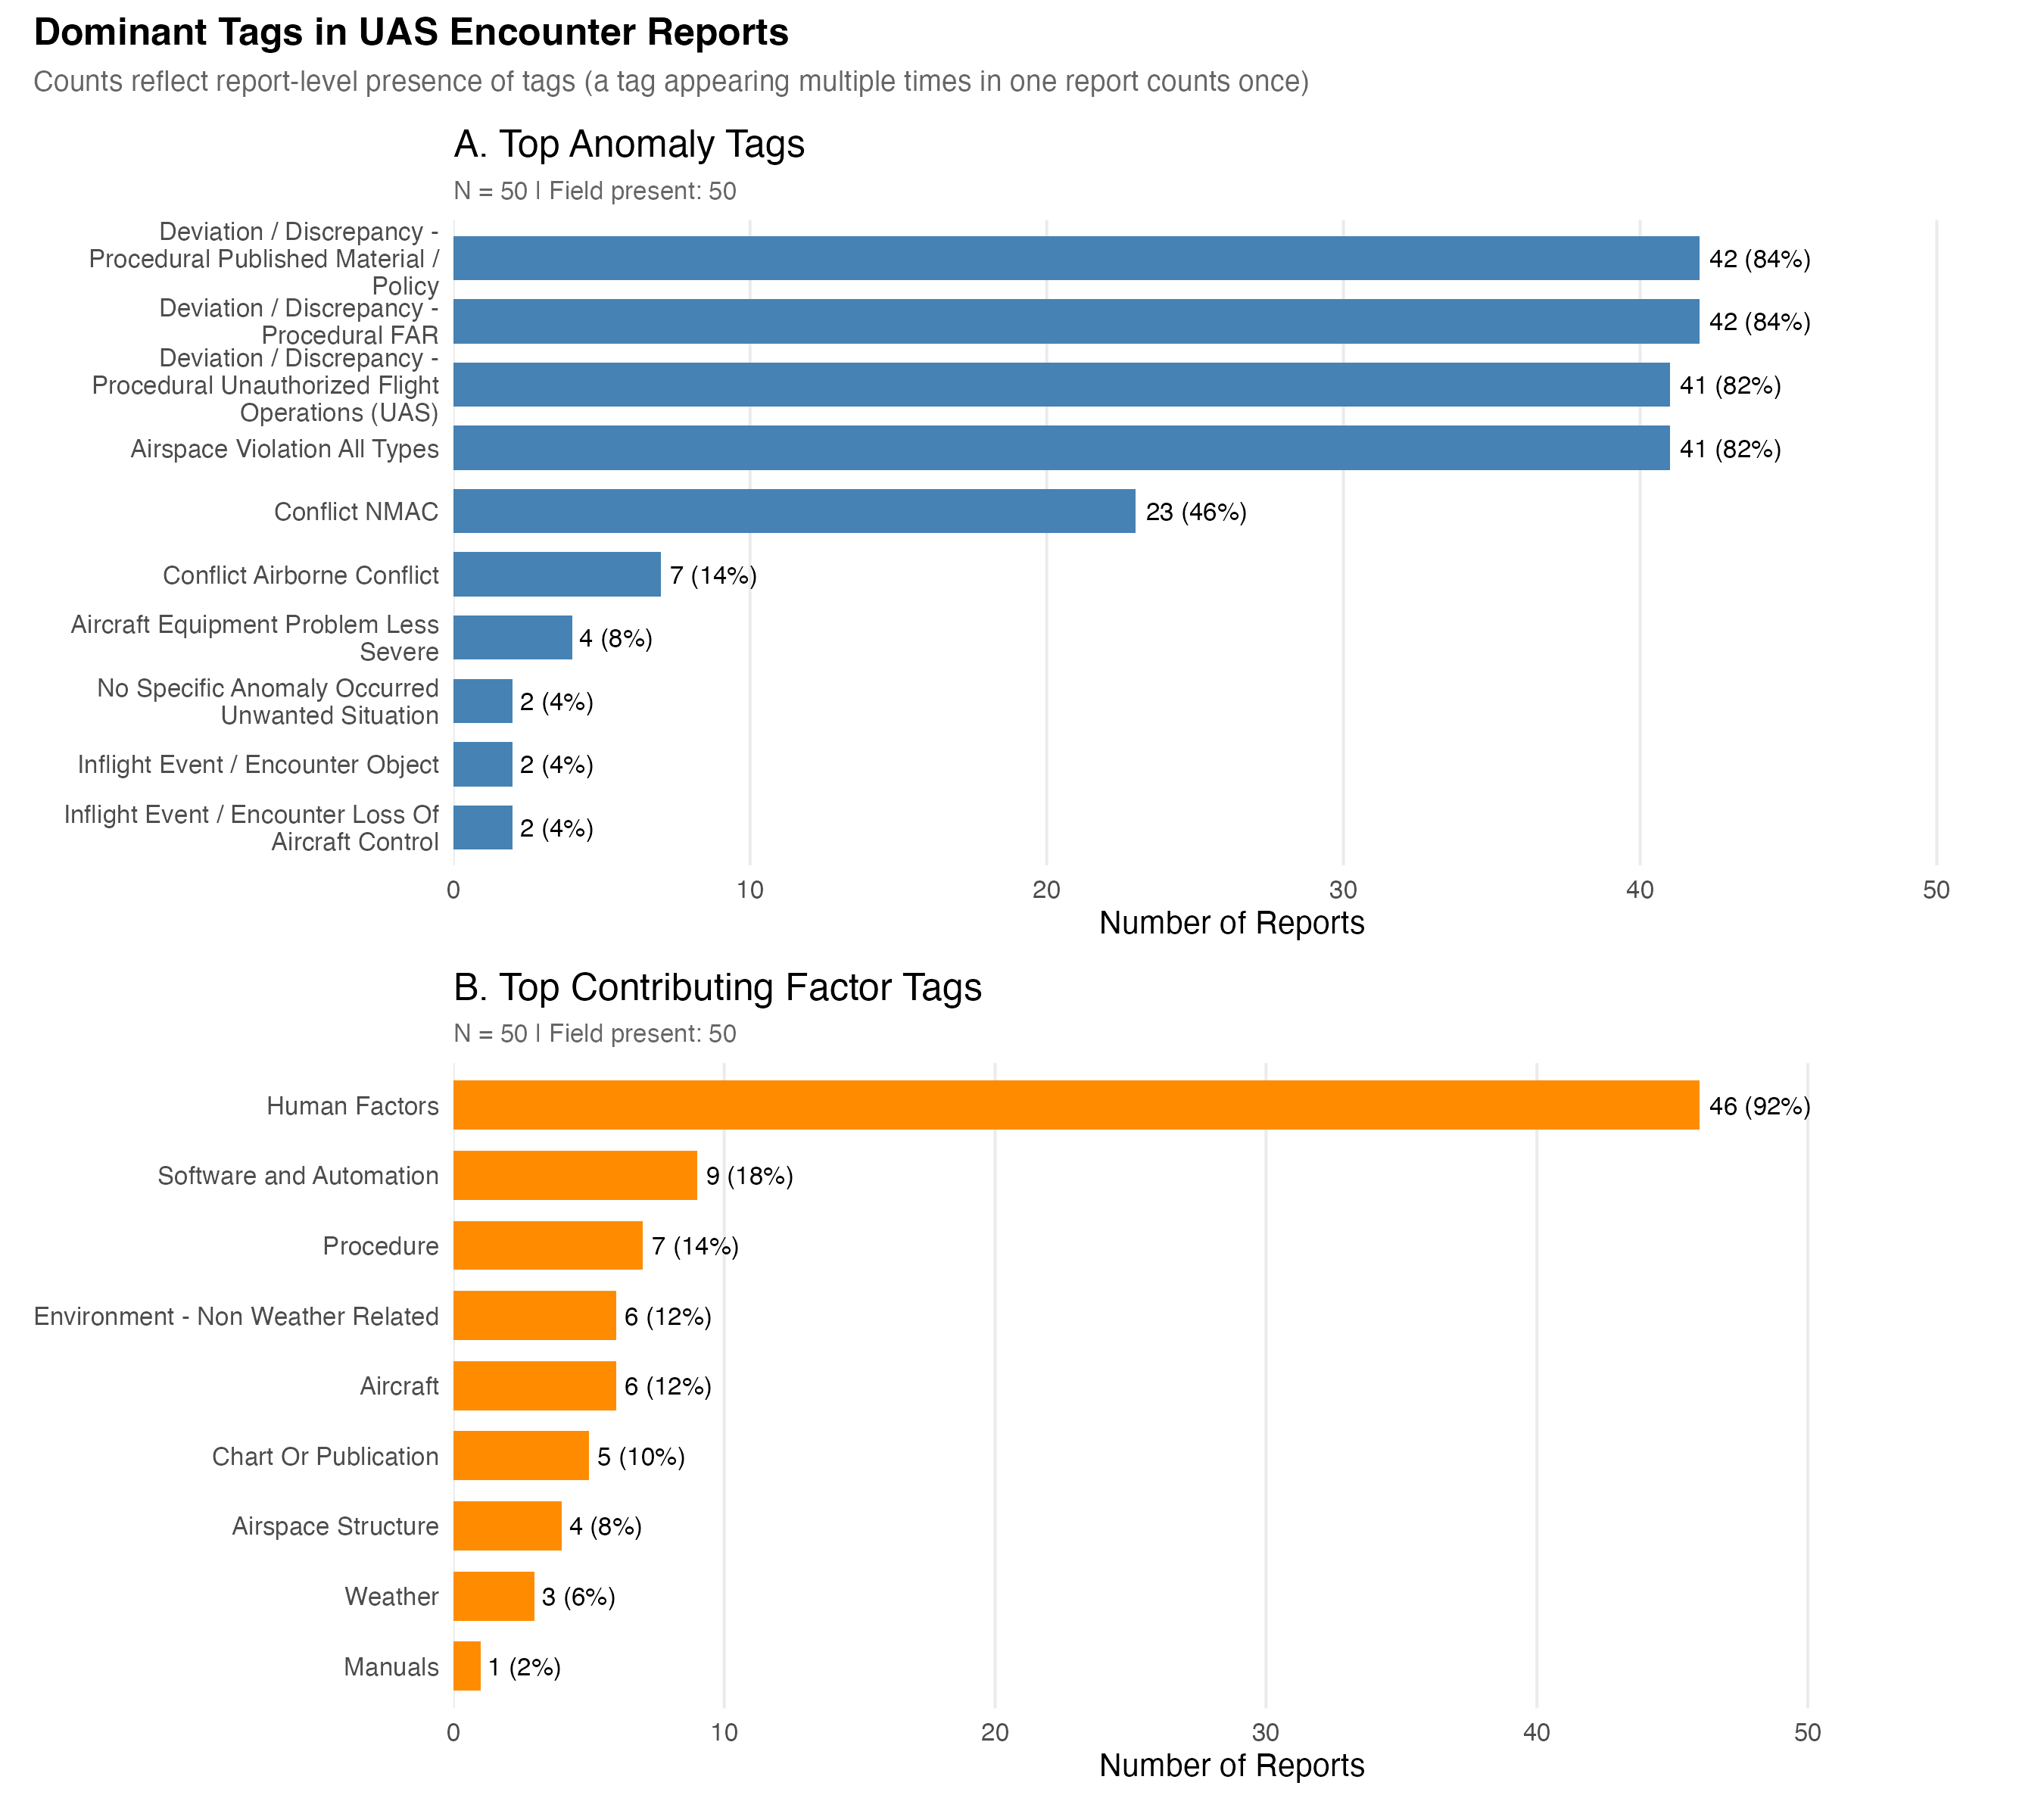
Figure 3. Dominant tags in UAS encounter reports
Figure 4. NMAC prevalence by flight phase with Wilson 95% intervals
Caption: How does NMAC prevalence vary by flight phase?
Denominator note: N = 50 reports. Groups with n >= 5 included in plot. Wilson 95% confidence intervals shown.
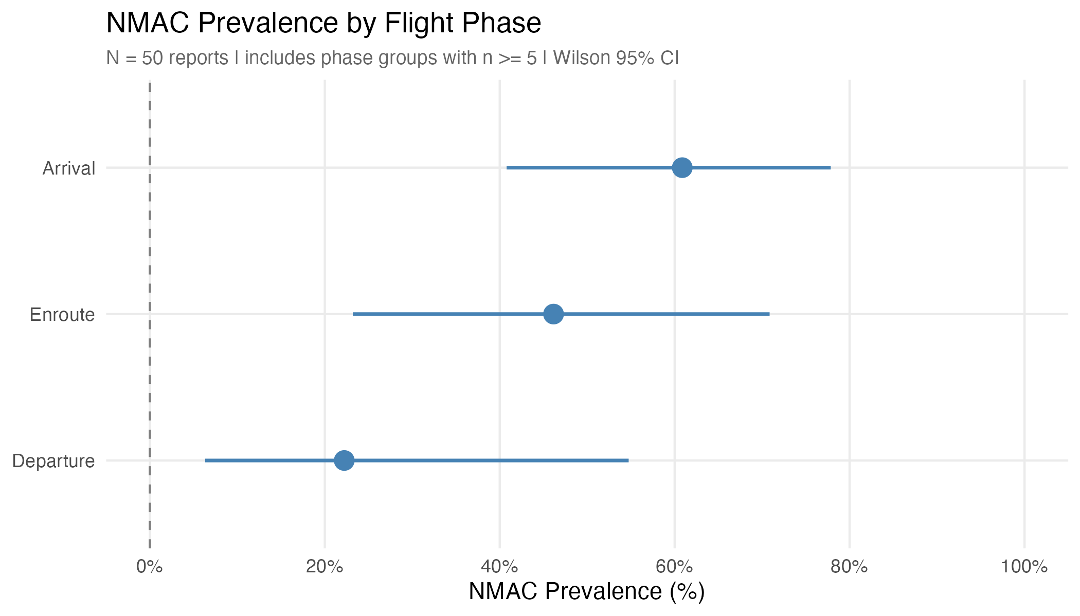
Figure 4. NMAC prevalence by flight phase with Wilson 95% intervals
Figure 5. NMAC prevalence by detector with Wilson 95% intervals
Caption: How does NMAC prevalence vary by detection source?
Denominator note: N = 50 reports. Groups with n >= 5 included in plot. Wilson 95% confidence intervals shown.
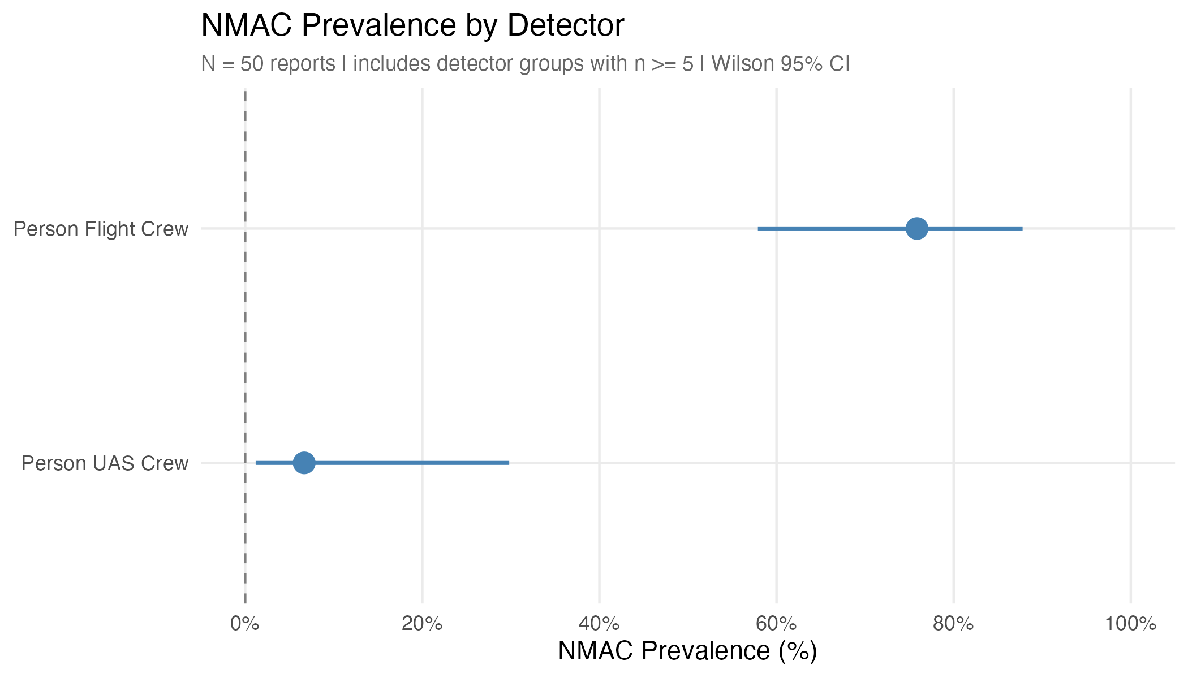
Figure 5. NMAC prevalence by detector with Wilson 95% intervals
Figure 6. NMAC prevalence by time of day with Wilson 95% intervals
Caption: How does NMAC prevalence vary by time of day?
Denominator note: N = 50 reports. Groups with n >= 5 included in plot. Wilson 95% confidence intervals shown.
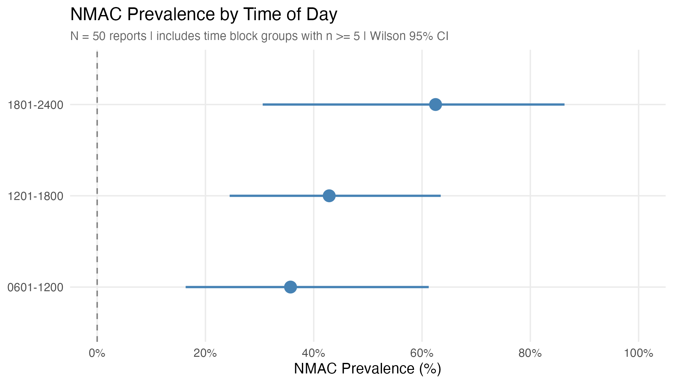
Figure 6. NMAC prevalence by time of day with Wilson 95% intervals

Reproducibility
This document was generated from CSV and PNG outputs in output/.
Assembly timestamp: 2025-12-27 01:45:36
Source scripts:
- scripts/eda/01_audit.R through 10_build_inventory_captions.R
- scripts/eda/11_assemble_descriptives_qmd.R
All numeric values in tables are programmatically generated from the underlying data to ensure consistency and prevent transcription errors.

