Name: Rodriguez, Michael SDEV300 Date: (11/21/2022)

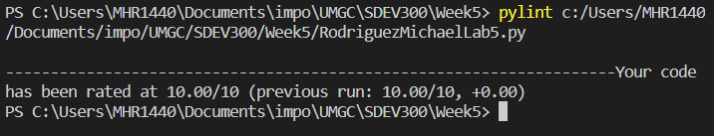

**Test Case: Pop Apr 1 Menu Analysis**

|  |  |  |  |
| --- | --- | --- | --- |
| Input | Expected Output | Actual Output | Pass? |
| Main Menu = 1  Sub Menu = 1 | Welcome to the Python Data Analysis App!!!  (1): Population Data  (2): Housing Data  (0): Exit Program  Choose a numbered option: 1  Select the data you want to analyze.  (1): Population April 1  (2): Population Jul 1  (3): Population Change  (0) Exit  Make a selection: 1  Total Values:557  Mean: 56557.31  Standard Deviation: 157985.10  Smallest Value: 13519  Biggest Value: 3726157 | Welcome to the Python Data Analysis App!!!  (1): Population Data  (2): Housing Data  (0): Exit Program  Choose a numbered option: 1  Select the data you want to analyze.  (1): Population April 1  (2): Population Jul 1  (3): Population Change  (0) Exit  Make a selection: 1  Total Values:557  Mean: 56557.31  Standard Deviation: 157985.10  Smallest Value: 13519  Biggest Value: 3726157 | Yes |

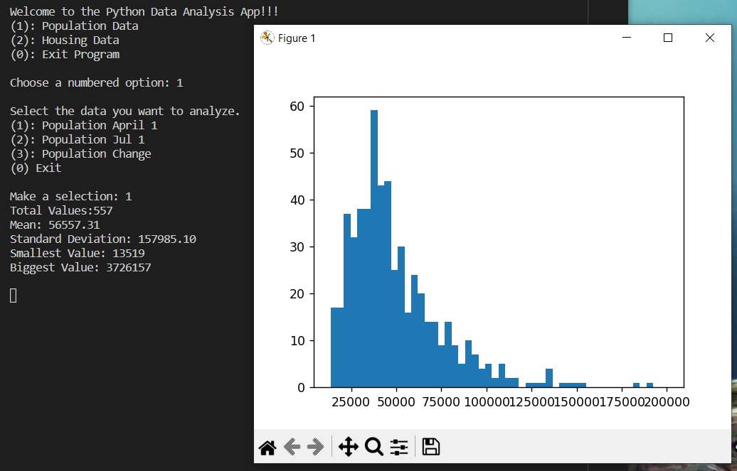

Notes: The Population csv had an extreme outlier that made it hard to graph properly. I eventually found the range key word to truncate the extreme value for the histogram. The extreme data is still kept for the final metrics of standard deviation and the biggest value. Menu and sub menu output will be omitted in future cases for brevity. The histogram uses fifty bars of data for accuracy in comparison to the 19 seen in the lab document.

**Test Case: Pop Jul 1 Menu Analysis**

|  |  |  |  |
| --- | --- | --- | --- |
| Input | Expected Output | Actual Output | Pass? |
| Main Menu = 1  Sub Menu = 2 | Make a selection: 2  Total Values:557  Mean: 55758.48  Standard Deviation: 135964.32  Smallest Value: 12619  Biggest Value: 3195153 | Make a selection: 2  Total Values:557  Mean: 55758.48  Standard Deviation: 135964.32  Smallest Value: 12619  Biggest Value: 3195153 | Yes |

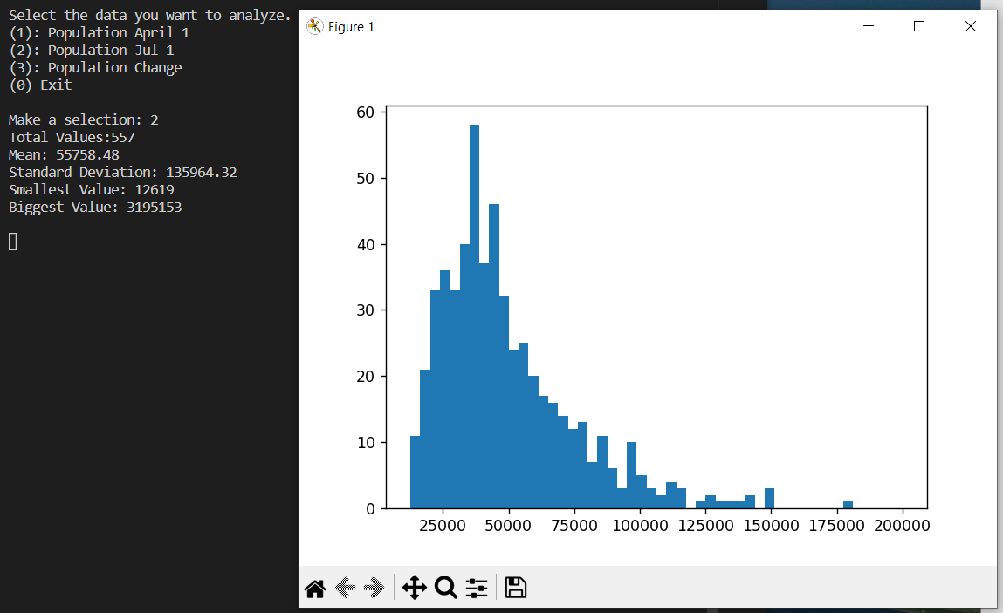

Notes: The Jul 1 data also has an extreme outlier that is truncated for the histogram only.

**Test Case: Population Change Menu Analysis**

|  |  |  |  |
| --- | --- | --- | --- |
| Input | Expected Output | Actual Output | Pass? |
| Main Menu = 1  Sub Menu = 3, 0 | Make a selection: 3  Total Values:557  Mean: -798.83  Standard Deviation: 22690.96  Smallest Value: -531004  Biggest Value: 22363 | Make a selection: 3  Total Values:557  Mean: -798.83  Standard Deviation: 22690.96  Smallest Value: -531004  Biggest Value: 22363 | Yes |

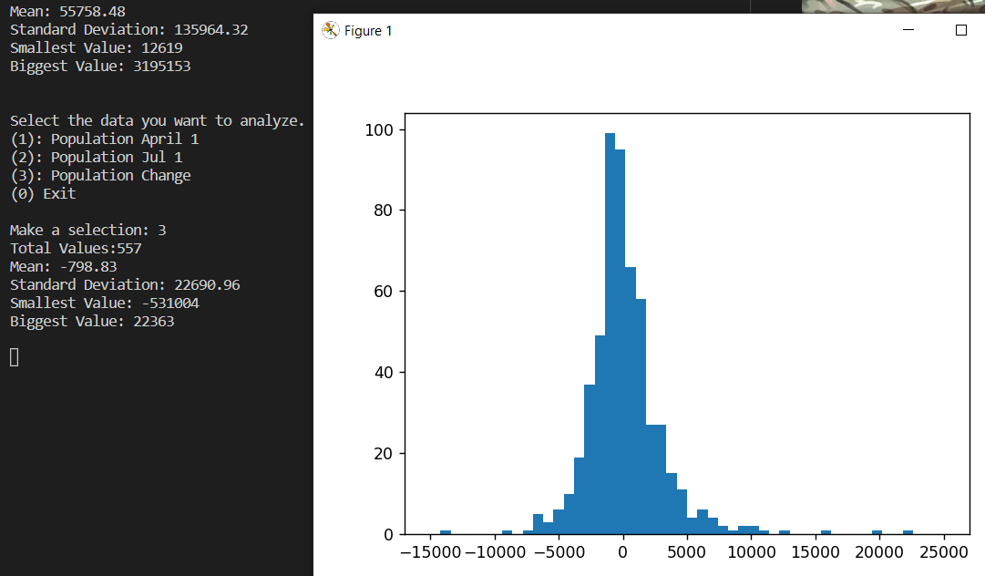

Notes: The data for this histogram had extreme ranges on both ends of the x-axis. This required a different range to show properly.

**Test Case: Age Menu Analysis**

|  |  |  |  |
| --- | --- | --- | --- |
| Input | Expected Output | Actual Output | Pass? |
| Main Menu = 2  Sub Menu = 1 | Make a selection: 1  Total Values:10042  Mean: 47.22  Standard Deviation: 23.15  Smallest Value: -9  Biggest Value: 93 | Make a selection: 1  Total Values:10042  Mean: 47.22  Standard Deviation: 23.15  Smallest Value: -9  Biggest Value: 93 | Yes |

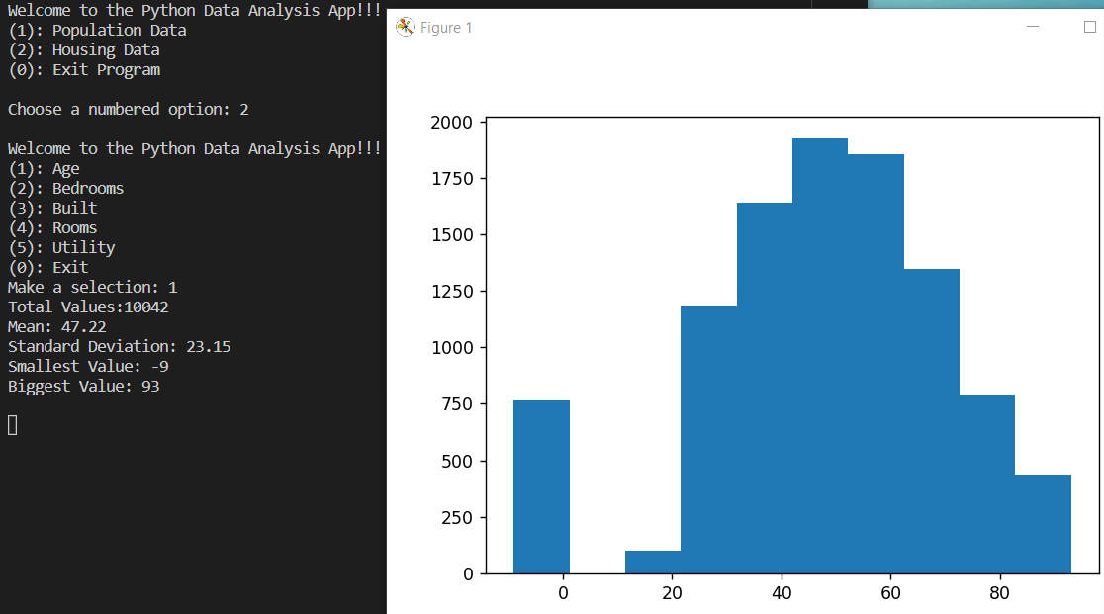

Notes: The housing data does not have any extreme outliers. The default histogram

**Test Case: Bedroom Amount Menu Analysis**

|  |  |  |  |
| --- | --- | --- | --- |
| Input | Expected Output | Actual Output | Pass? |
| Main Menu = 2  Sub Menu = 2 | Make a selection: 2  Total Values:10042  Mean: 2.71  Standard Deviation: 1.07  Smallest Value: 0  Biggest Value: 7 | Make a selection: 2  Total Values:10042  Mean: 2.71  Standard Deviation: 1.07  Smallest Value: 0  Biggest Value: 7 | Yes |

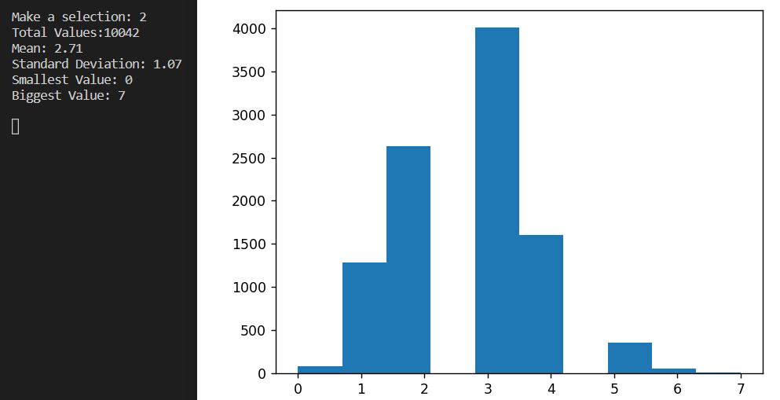

**Test Case: Build Year Menu Analysis**

|  |  |  |  |
| --- | --- | --- | --- |
| Input | Expected Output | Actual Output | Pass? |
| Main Menu = 2  Sub Menu = 3 | Make a selection: 3  Total Values:10042  Mean: 1966.95  Standard Deviation: 26.30  Smallest Value: 1919  Biggest Value: 2012 | Make a selection: 3  Total Values:10042  Mean: 1966.95  Standard Deviation: 26.30  Smallest Value: 1919  Biggest Value: 2012 | Yes |

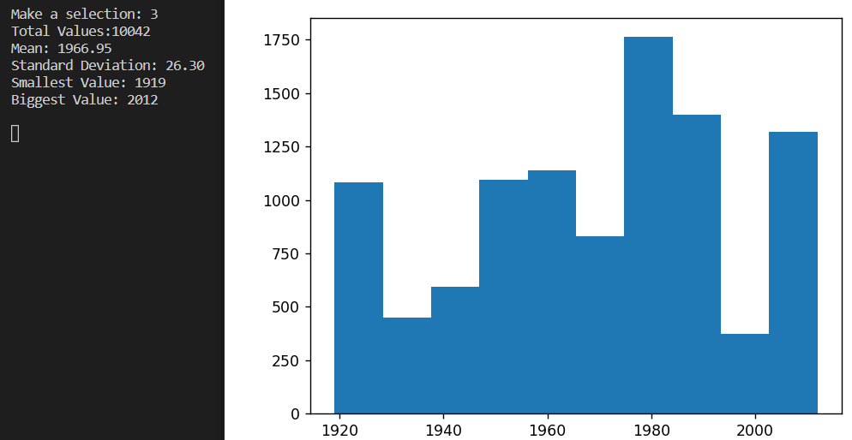

**Test Case: Room Amount Menu Analysis**

|  |  |  |  |
| --- | --- | --- | --- |
| Input | Expected Output | Actual Output | Pass? |
| Main Menu = 2  Sub Menu = 4 | Make a selection: 4  Total Values:10042  Mean: 5.72  Standard Deviation: 1.88  Smallest Value: 1  Biggest Value: 14 | Make a selection: 4  Total Values:10042  Mean: 5.72  Standard Deviation: 1.88  Smallest Value: 1  Biggest Value: 14 | Yes |

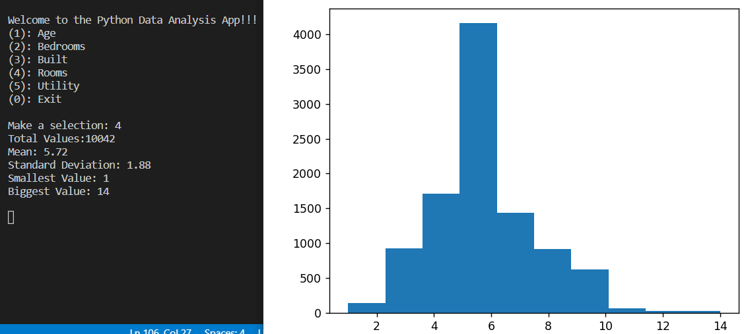

**Test Case: Utility Menu Analysis**

|  |  |  |  |
| --- | --- | --- | --- |
| Input | Expected Output | Actual Output | Pass? |
| Main Menu = 2  Sub Menu = 5, a, 0, 0 | Make a selection: 5  Total Values:10042  Mean: 189.59  Standard Deviation: 128.92  Smallest Value: 0.0  Biggest Value: 1107.583333  Welcome to the Python Data Analysis App!!!  (1): Age  (2): Bedrooms  (3): Built  (4): Rooms  (5): Utility  (0): Exit  Make a selection: a  Invalid input. Please try again.  Welcome to the Python Data Analysis App!!!  (1): Age  (2): Bedrooms  (3): Built  (4): Rooms  (5): Utility  (0): Exit  Make a selection: 0  Exiting population analysis...  Welcome to the Python Data Analysis App!!!  (1): Population Data  (2): Housing Data  (0): Exit Program  Choose a numbered option: 0  Thanks for using the data analysis app! | Make a selection: 5  Total Values:10042  Mean: 189.59  Standard Deviation: 128.92  Smallest Value: 0.0  Biggest Value: 1107.583333  Welcome to the Python Data Analysis App!!!  (1): Age  (2): Bedrooms  (3): Built  (4): Rooms  (5): Utility  (0): Exit  Make a selection: a  Invalid input. Please try again.  Welcome to the Python Data Analysis App!!!  (1): Age  (2): Bedrooms  (3): Built  (4): Rooms  (5): Utility  (0): Exit  Make a selection: 0  Exiting population analysis...  Welcome to the Python Data Analysis App!!!  (1): Population Data  (2): Housing Data  (0): Exit Program  Choose a numbered option: 0  Thanks for using the data analysis app! | Yes |

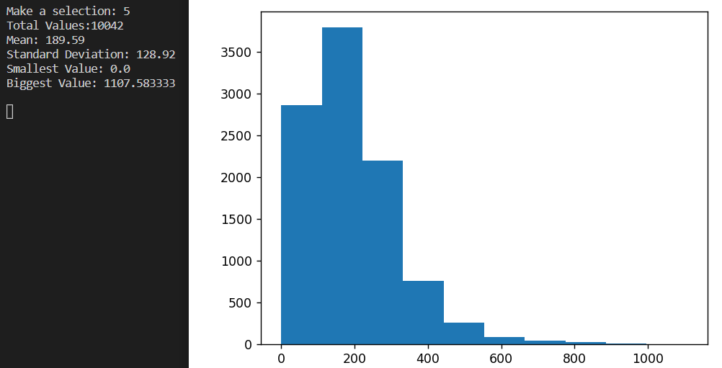

Notes: An a was inputted to verify error checking. The application requires specific input and treats every other input as an error.