2014_04_01

> Redefine the spot positions for ‘flat'

Type zc for Zero Centroids.

> - Measure and calculate a reconstructor

Measure: type measure when looking at the beacon, in open loop but with the centroids near-ish to the centers of the boxes.

Compute: type recon but I’m not entirely sure this works and I have to test it. Better, you can:

saveint to save the interaction matrix, then

compute_reconstructor INFILE OUTFILE

(compute_reconstructor us a python script installed in /usr/local/bin )

> - find the 'default' positions for a good wavefront.
> - Close the loop

Type close, then setflat. To save this to file, type savedef.

-----
Dr Michael IRELAND

2014_07_21
----------

Using PICO 1 and DICH-S2 step size of about 40 seems goog.

UP increases X
DOWN decreases X
LEFT increases Y
RIGHT decreases Y

0.01 seems a goo maximum offset.

2014_09_17
---------------

Using old method full range of tiptilt signal is when all spots are on edge of
box XTilt = -1.29 to 1.19 Ytilt = 1.40 to -1.53

We will now center the beam using Autoalign. A1 = 0.00 A2 = 0.01 Focus = -0.06

Switching to new code:

Now Tiptilt = -0.01 0.01 Focus = -0.21 A1 = -0.01 A2 - 0.02

Tiptilt Range X = -0.85 0.82 Y 0.69 0.78

Doing autoalign as a test, but the numbers will need to change. Will need
three decimal places for one.

Does this make sense?

For tiptilt:

Old way: divided by Nap / ARCSEC_PER_PIX = Nap/0.3
New way: divided by Nap * Centrois_width/2.0 = Nap * 5.5

Now 1/0.3 is 3.333 and so we expect our tiptilt numebrs to be 0.61 * old ones

Now 1.3 * 0.6 = 0.80 So this is OK.

As for fous etc:

Old way is the same. New way is just Nap so we expect these numbers to be
3.333 times larger.

Now 0.06 * 3.333 = 0.20 which makes perfect sense.

So, we should add a decimal place to the outputs, and change 0.01 to 0.005

Checked rail alignment and it is fine. We shold nw define this as a new
reference so the focus goes to zero.... which works. Save this as default.

Try the new code now.

Get lower numbers than before but of course larger numbers than old code. Try
zeroing here.... So things are making some sort of sense.

We now add a retro mirror and try and repeat all of this.

Right on TEST1 moves UP UP moves left

We get Focus = -0.03 A1 = -0.03 A2 = 0.03 TT = 0.02/-0.03 Hard to do better
and some images look pretty crappy! Taking screen shot:

2014_09_17_Retro_old_Code.png

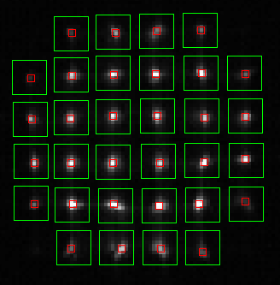

If we close the loop..... it doesn't seem to do much better.

We should by pass the OPLE and see how this looks.

I suspect this means we are not properly centered on the DM.

OK, let's not change the default mirror shape. We can now try adjusting focus
and so on.

Five cliks on FOC++ Focus = -0.46 10 on FOC-- Focus = 0.42. THis makes sense.
Both closing the loop and using defaults got things back.

Now setting Zerns to try astig:

Adjusted Z! until Focus said it was OK. Z1 = 0.689
Now incriment Z5/6 to see what happens.
Start F = -0.002 A1 = -0.19 A2 = 0.054

Z5 +0.1 F = -0.07 A1 = -0.19 A2 = -0.343
Z5 -0.1 F = -0.03 A1 = -0.180 S2 = 0.389

So Z5 is affecting mostly only A1.

Z6 +0.1 F = -0.005 A1 = 0.239 A2 = 0.051
Z6 -0.1 F = -0.113 A1 = -0.576 A2 = 0.055

So Z6 is affecting mostly only A2

Can we get something that looks close to zero on these?

Found Z1 = 0.689 Z5 = 0.01 Z6 = 0.05 Not very different to DEFAULT.

Now lunch...... and then we test the new code. THEN we need to realign this
sucker.

He's back.....

These same Zernike modes seem to look OK, so we will start from there.

Start F = -0.05 A1 = 0.064 A2 = 0.021

Five clicks on FOC++ F -1.58 A1 = 0.10 A2 = 0.02
Five on FOC-- F = 1.290 A1 = 0.05 A1 = -0.05

Z5 +0.1 F -0.212 A1=0.03 A2 = -1.28
Z5 -0.1 F -0.06 A1=0.16 A2 = 1.21
Z6 +0.1 F -0.09 A1=1.46 A2 = -0.05
Z6 -0.1 F -0.268 A1 = -1.20 A1 = -0.001

So this seems again to look right.

We also seem to have changed the scale in the follow ways:

Focus Old (0.46+0.42)/2 = 0.44
New (1.28+1.21)/2 = 1.24
Ratio 2.81 and we naively expect 3.333 - although there are some other
bugs in the old colde concerning max_offset.

Z5 Old (0.343+0.389)/2 = 0.366
New (1.21+1.28)/2 = 1.24
Ratio 3.3

Z6 Old (0.239+0.576)/2 = 0.408
New (1.46+1.20)/2 = 1.33
Ratio = 3.3

So this is exactly what we expect. So things look good. Now, let's check all
six beams for now using the new code.

Checked all six beams on north end target.

Set to Beam 1. Do autoalign take image - put in corner cube - Take image
Repeat.
Tx Ty Px Py F A1 A2
Beam 1 RF 0.008 -0.006 3.47 2.17 0.020 -0.017 -0.002
Beam 1 CC 0.044 0.014 2.28 2.20 0.190 -0.123 0.076
Beam 2 RF -0.006 0.002 3.43 2.17 0.027 -0.024 -0.005
Beam 2 CC 0.059 0.012 3.30 2.19 0.202 -0.096 0.065
Beam 3 RF -0.007 0.008 3.42 2.16 0.000 -0.041 0.020
Beam 3 CC 0.053 0.008 2.32 2.20 0.164 -0.127 0.078
Beam 4 RF -0.006 0.003 3.49 2.13 0.161 -0.022 0.011
Veam 4 CC 0.073 0.006 3.27 2.22 0.388 -0.091 0.058
Beam 5 RF 0.002 0.008 3.46 2.17 0.173 -0.010 0.010
Beam 5 CC 0.061 0.008 3.29 2.20 0.356 -0.090 0.073
Beam 6 RF 0.004 0.000 3.47 2.15 0.148 -0.028 0.013
Beam 6 CC 0.056 0.008 3.28 2.21 0.325 -0.102 0.057
Beam 1 RF 0.005 0.001 3.47 2.17 0.034 -0.015 -0.002

It seems B123 are different to B456.

The PAVO dichroics are in Beams 1 2 and 3!!!!

We need to

_ Redo "FLAT" withour pavo dichroics and LDCs
_ Test position
_ Realign WFS.

Here are the images LEFT: RF Right CC

BEAM 1

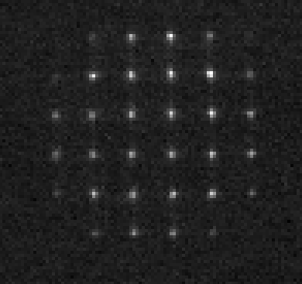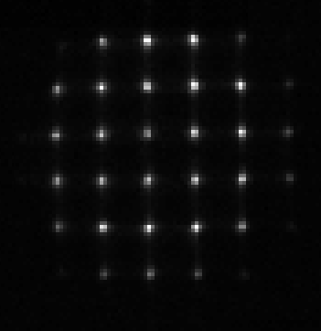

BEAM 2 Corner cube only:

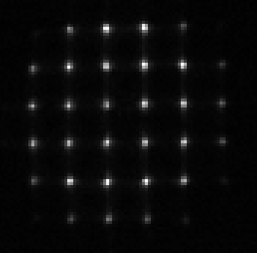
BEAM 3
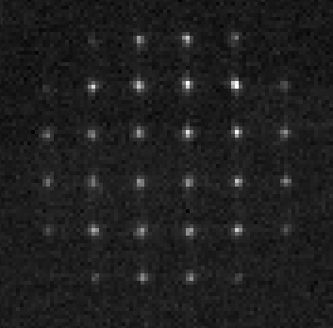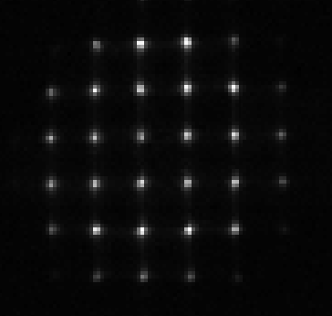
BEAM 4

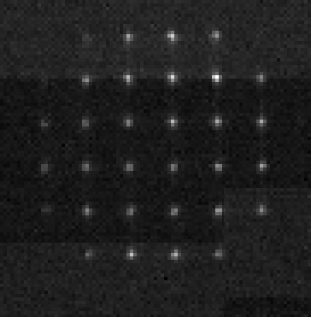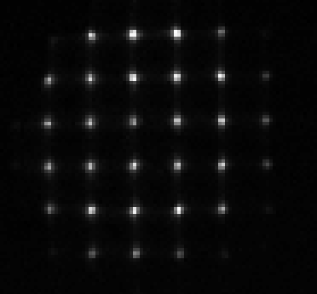

BEAM 5

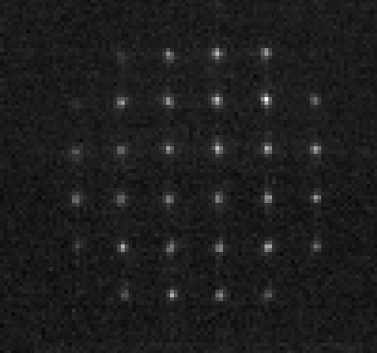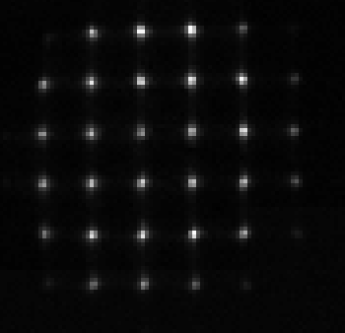

BEAM 6
