NVRAM

NVRAM is an acronym for non-volatile random access memory. Non-volatile means that it keeps its data even when power is removed from the system. It does this with a battery. It is used for storing basic setup information.
Contents:
Troubleshooting NVRAM
Replacing NVRAM chip on AXI
Replacing NVRAM battery on Sun Blade
Reprogramming NVRAM

Troubleshooting NVRAM
When NVRAM is failing, the computer is not retaining the necessary settings that it needs. Though the default BIOS settings remain, the computer will not function correctly since the BIOS relies on the settings stored in NVRAM in order to handle the particular hardware and environment.
Check for missing data:
Boot system
At white screen press Stop-A
At ok prompt type banner
If the information stored in NVRAM is gone, the Ethernet MAC address will be ff:ff:ff:ff:ff:ff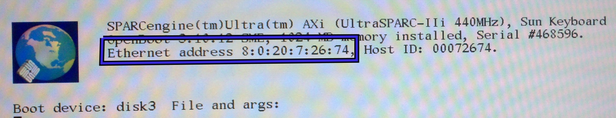
Another symptom of a bad NVRAM battery is a system clock that will not keep time when the system is powered down. If you see these indicators, it is likely that you should replace the NVRAM chip (AXI) or the NVRAM battery (Sun Blade).

Replacing a NVRAM chip on an AXI motherboard
Turn system off.
Remove old NVRAM chip.
Insert new NVRAM chip.
Program new NVRAM.

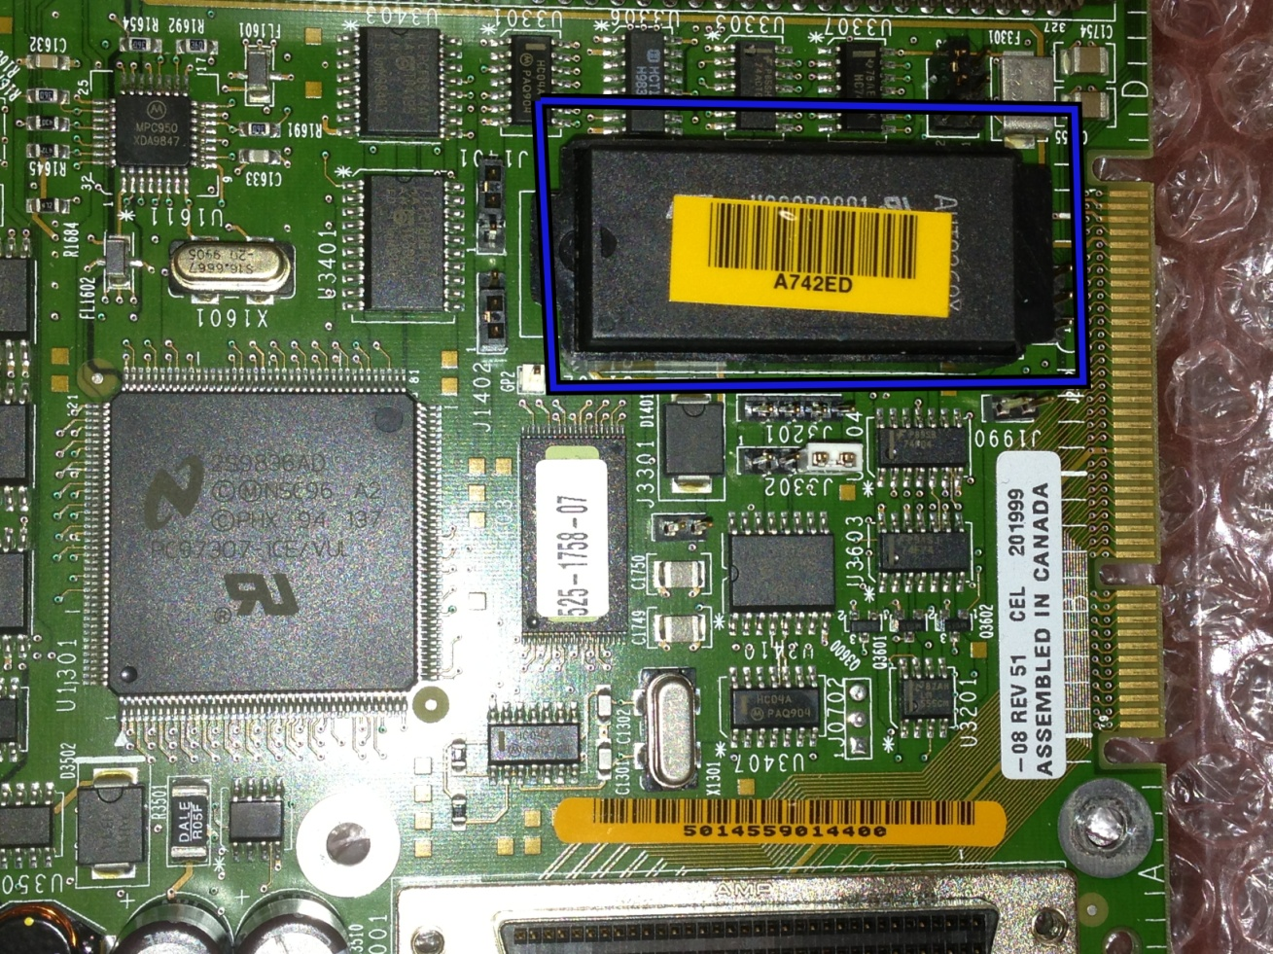
This is the NVRAM chip on the AXI mother board. This chip can be replaced.

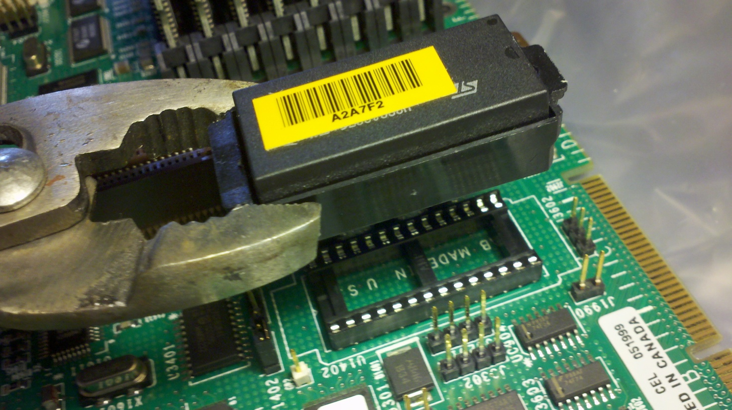
NVRAM chip in its caddy removed from the motherboard and the tool used to remove it.

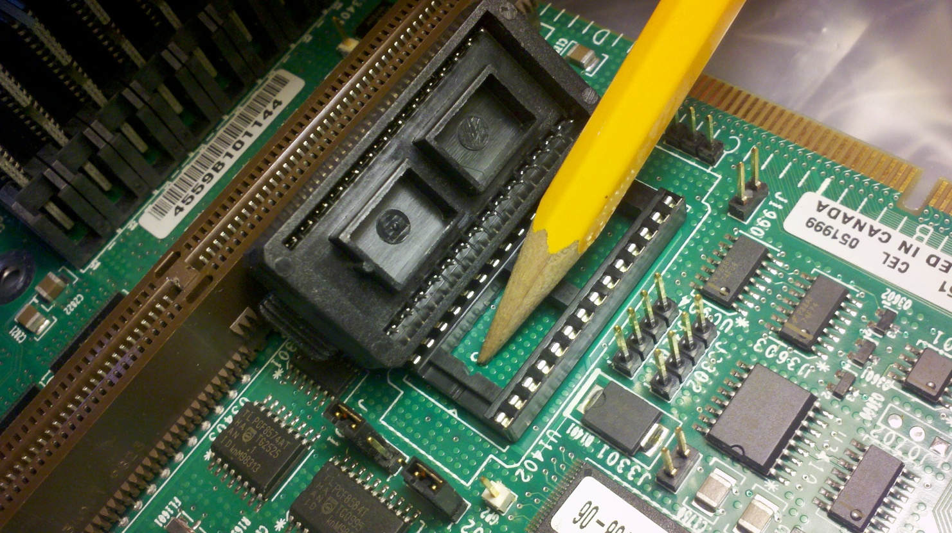
The underside of the NVRAM caddy beside the socket on the motherboard. Note the registration key and groove.

Replacing NVRAM battery on Sun Blade
Turn system off.
Replace the battery.
Reprogram the NVRAM.
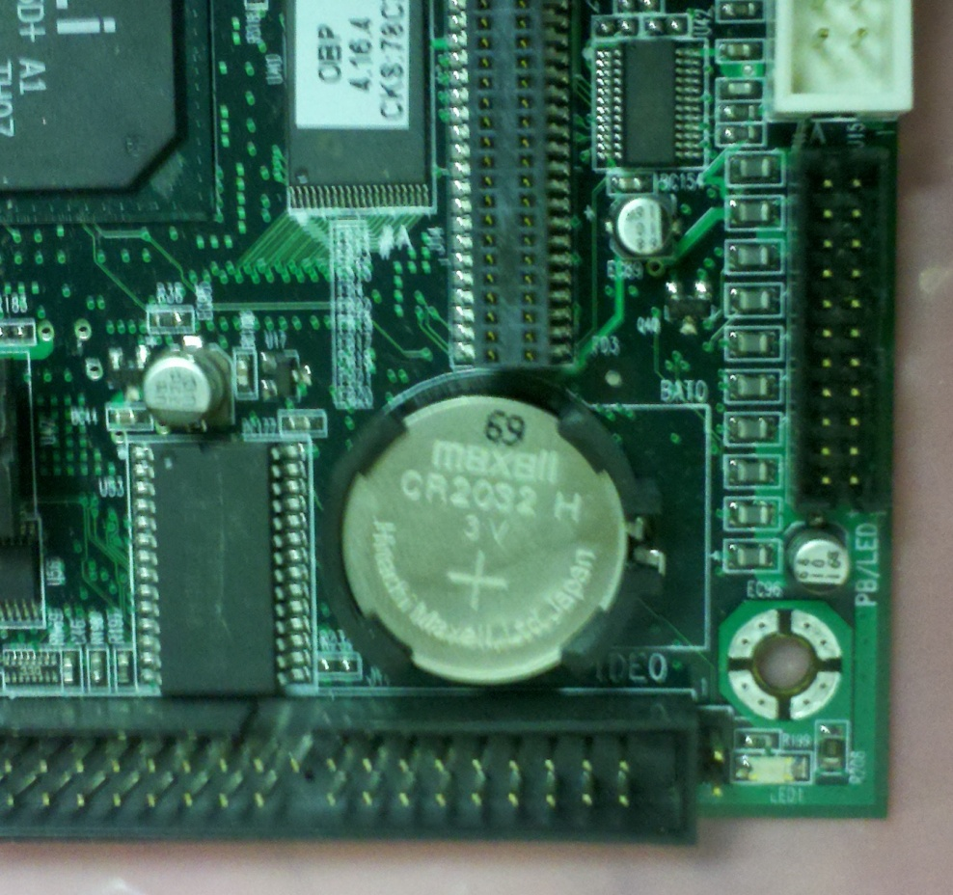
Sun Blade NVRAM battery in its holder.

The Sun Blade motherboard has a coin size battery. This is what is used to keep the power on the NVRAM. It is a CR2032. Purchase at any store on planet earth. Stick the new one in the mother board. Don’t break the flimsy battery holder on the motherboard. Reprogram NVRAM.

Reprogramming NVRAM
Boot system.
At white Screen type: Stop –A
At OK prompt type:
set-defaults
setenv output-device screen:r1280x1024x67
setenv boot-device disk3
setenv diag-switch? false
setenv setenv use-nvramrc? True
setenv nvramrc devalias disk1 /pci@1f,0/pci@1/scsi@1,1/disk@1,0
To see and check your work type: printenv

