R project #1

X=c(1,3,7,11,67)  
new=X\*3  
plot(new)

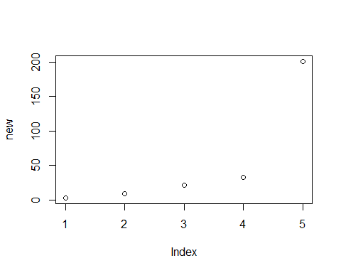

I created a vector and multiplied it by 3. I then created a scatterplot of the values of the vector for each index 1 to 5.