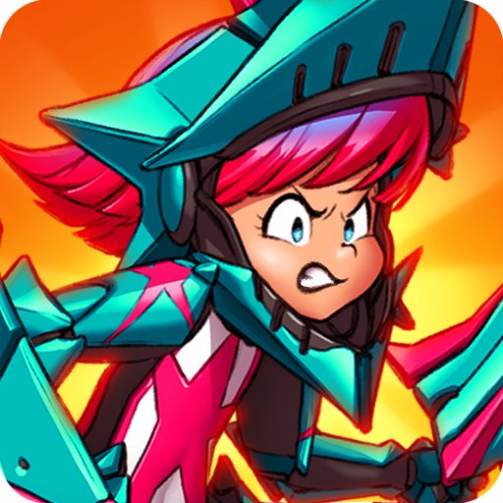
Mike Kasprzak  Video game systems, Toolchain, and Web programmer; Event organizer; Community manager; (Former) Small business owner; Influencer; Author | 801-500 Proudfoot Lane  London, ON  N6H 5G7  Canada 🍁  (519) 615-9860  mikekasprzak@gmail.com  @mikekasprzak
EXPERIENCE  Tiny Titan Studios, London ON — Programmer  Game Development Studio (under 20 people)  APRIL 2018 – DECEMBER 2019  Reworked an online multiplayer mobile game to scale. I lead the effort to re-engineer the game to run entirely server side on low cost VPS Linux servers. The game server was rewritten in C++, and it streamed updates over UDP to hundreds of game clients. I also deployed and managing the 40+ servers around the world that supported the game.  In addition, I helped develop and deploy the backend API servers. These supported the game by storing all persistent player information, purchases, matchmaking, and providing us with realtime game metrics and sales data. Written in PHP 7, and deployed to a cluster of redundant frontend (PHP+NGINX), database (MariaDB), and datastore (Redis) servers. Arena Stars launched on Android, iOS, and Steam in April 2019, but sadly shutdown in October 2019.  I lead the effort to implement rollback multiplayer netcode in a game coming to PC and consoles. I leave with this code running on PC and consoles, and my best efforts to prepare QA for submission to Sony, Nintendo, and Microsoft.  Ludum Dare, Online — Co-Founder, Developer, Caretaker  Event Hub for more than 65,000 game creators (over 200k including spambots)  APRIL 2002 - PRESENT  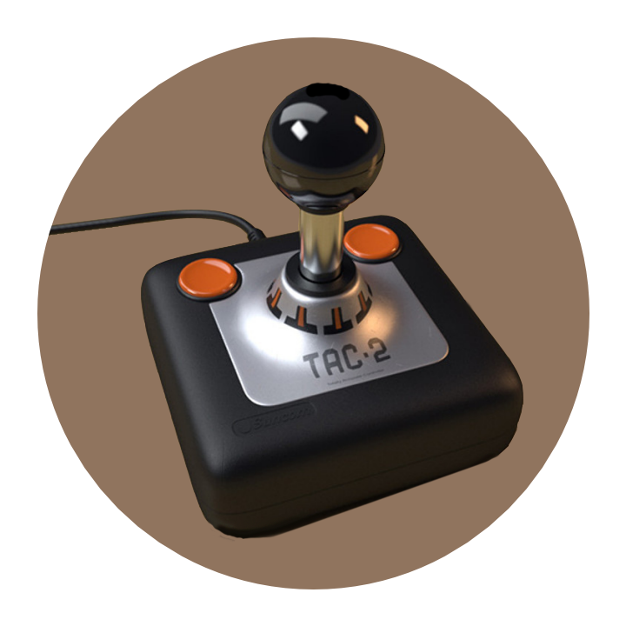  Founded in April of 2002, Ludum Dare is the largest online game jam event in the world. The event attracts many thousands of developers and challenges them to make a game from scratch in a weekend. Find us at https://ldjam.com  I’m part of the team that founded the event. Originally a hobby project we ran together, today I am the sole person responsible for the event. I handle scheduling, running the event, managing the servers, custom software development, and promotion of it and its social media accounts.  SUMMER 2015 - PRESENT  After growing far beyond expectation, and with our 15th anniversary on the horizon, I put my my small business on hold to focus on building a brand new event website for Ludum Dare. The new website is capable of scaling to support thousands of concurrent users, and runs on low cost VPS servers.  Buzzwords: Developed a custom multi-user social network entirely from scratch with a PHP 7 and a MariaDB backend, transpiled ES6 JavaScript code for the frontend (using Preact), a sophisticated compiler toolchain stapled together with GNU Make, and a local virtual machine testing environment powered by Vagrant and Virtualbox. Open Source.  Sykhronics Entertainment, London ON — Owner  My Independent Game Development Studio (usually 1 person, but up to 3)  2006 – 2015, CLOSED IN 2017  My small award winning independent game studio. I often worked alone and with contractors, though for over a year it had 1 other employee. Sykhronics’ (sigh-cron-icks) goal was to create original games for a variety of platforms, but I occasionally did contract work for other companies. Sykhronics was put on hiatus in 2015, but was eventually closed in 2017. I continue to sell software under my own name.  Sykhronics Entertainment was a licensed Sony PSP, Nintendo 3DS, Nintendo Wii U, Steam, Apple, and Android developer. Sykhronics also developed and published software for Amazon Kindle, Symbian, Nokia Maemo, Palm webOS, Intel AppUp, Intel MeeGo/Moblin, GameTree.TV, Microsoft Windows Mobile, Microsoft Windows Phone, Blackberry, Tizen, Samsung Bada, Linux, and Microsoft Windows.    Notable Released Projects:  Smiles HD (or sometimes “Smiles”) - smileshd.com  Released for multiple platforms, most of which don’t exist anymore (see list above). Winner of multiple awards. Finalist in the Independent Games Festival Mobile in 2009.  Big Blue Bubble, London ON — Technical Director  Game Development Studio (under 50 people)  2004 - 2005  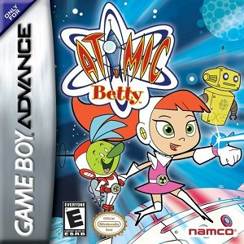  I was Technical Director, advising and assisting the project leads, interviewing candidates, among other things. I also personally lead and developed several projects at the studio.  Notable roles on released projects:  Atomic Betty (Game Boy Advance) - Lead, Engine Programmer  Dragon Tower (J2ME Mobile) - Lead Programmer  Mage Knight (Nintendo DS) - (Prototype) AI Programmer  Connect 4 (Mophun) - Complete rewrite port (J2ME to C)  Barry Bonds Home Run History (Mophun) - Complete rewrite port (J2ME to C)  Digital Illusions Canada, London ON — Senior Programmer  Game Development Studio (under 100 people)  2001 - 2004  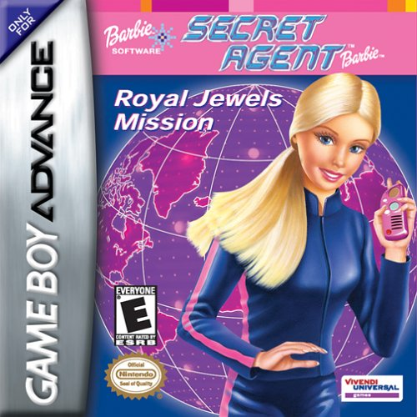  Formed after Sandbox Studios was purchased by Digital Illusions. I lead one of teams at the studio doing Handheld games. As the resident expert in our handheld division, I supported all our Handheld teams with technical knowledge of the platforms, and established our shared workflow.  Notable roles on released projects:  Barbie Gotta Have Games (PlayStation) - Tech Lead, Programmer  Polly Pocket (Game Boy Advance) - Tech Lead, Programmer  Secret Agent Barbie (Game Boy Advance) - Lead, Engine Programmer  Diva Starz: Mall Madness (Game Boy Color) - Tech Lead, Programmer  Jump Start: Dino Adventure (Game Boy Color) - Lead Programmer  Sandbox Studios, London ON — Senior Programmer  Game Development Studio (under 50 people)    1999 - 2001  At 19 I was hired as a “Game Boy Programmer”, but I was quickly promoted to a Senior Programmer thanks to my homebrew Game Boy development experience. I established our Handheld division, including the shared workflow and toolchains used by our teams for our projects.  Notable roles on released projects:  The Emperor’s New Groove (Game Boy Color) – Engine Programmer  Hoyle Card Games (Game Boy Color) - Lead Programmer  Other — Computer Technician, Manager's Assistant  1997 - 1998  A variety of roles at computer retailer Computers Canada (not to be confused with Canada Computers) and Microcad Computer Corporation in London ON. Roles included some Visual Basic and database programming, some sales, and A LOT of computer building. | CONTRACT WORK  2016    Digistump LLC, Portland OR - Added initial support for the Oak development board/IOT Module (ESP 8266) to the Arduino IDE.  2013    Shaw Cable, Calgary AB – 4 months on site in Alberta working with a team in India. Developed an Android and iOS TV guide to the spec of the client using proprietary HTML5 stack. Contract work done on behalf of Itaas Inc.  Itaas Inc, Deluth GA - Provided HTML5 Training a the London ON office, to prepare them for work with next generation TV set-top boxes.  2011    Hemisphere Games, Montreal QC - Ported Osmos game to Intel’s AppUp platform.  2010    Big Blue Bubble, London ON – Ported Thumpies game to Samsung’s Bada platform.  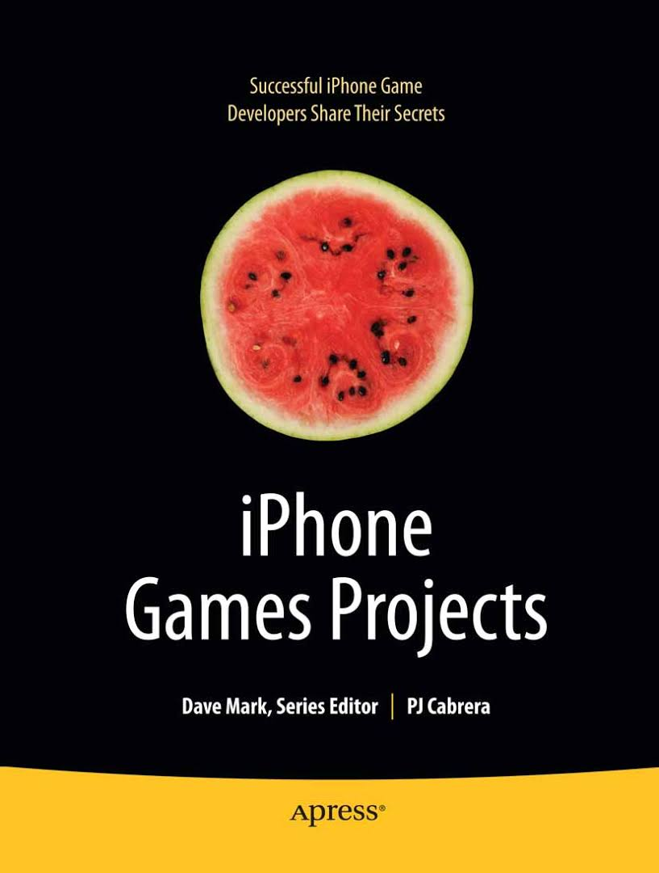  2009  Apress, Berkley CA - Wrote a chapter for the book “iPhone Games Projects”.  AWARDS    GameTree.TV’s Developer Competition (2011)  Winner: Developer Choice Award for Smiles HD    Intel’s Atom Developer Challenge (2010)  Winner: Most Elegant Design Award for Smiles HD    Bung’s 3rd Game Coding Competition (2000)  Neo Geo Pocket 3rd Place for SykoWar  Bung’s 2nd Game Coding Competition (1999)  Game Boy Runner Up for Poke Da Mon and Combat Soccer  NOMINATIONS    Independent Games Festival Mobile (2009)  Finalist: Best Mobile Game for Smiles    Slamdance Guerilla Gamemaker Competition (2006)  Finalist: Casual Game for PuffBOMB

EXPERIENCE EXPLAINED

I’ve spent over 20 years doing jobs that required an intimate understanding of computers, but mainly making video games. Even as a teenager I was making video games. I have many fond memories of making them for my Commodore 64 and Game Boy. I have a history with game making contests; Entering them, winning them, and even running them. That said I do a lot more than just making games.
HIGHLIGHTS I like Makefiles. I haven’t run in to many programmers that actually like working on build scrips, but I do. It’s something I started doing out of necessity, but I grew to like it. I’ve also shipped several commercial games written entirely in Assembly (see the Game Boy games). I’ve shipped games on hardware that lacked floating point numbers and fundamental math operations like multiplication and division. Devices that measured memory in kilobytes, and CPU clock rates at megahertz you could count on one hand. In general I’m very knowledgeable of writing code that runs on very low spec hardware. I’ve done the high end too. I’ve written lots of shader code, and many game/physics engines over the years.
Rather than cover every language and tool I’ve used, I’m going to list what I like, what I use regularly, and what I’m exploring.
PREFERRED DEVELOPMENT PLATFORM Ubuntu Linux; Microsoft Windows (running Ubuntu on WSL)
PREFERRED PROGRAMMING LANGUAGES C; C++; Assembly; GLSL; JavaScript; PHP; Squirrel
TECHNOLOGIES I REALLY LIKE GNU Make; GCC; Clang; OpenGL ES; SDL; Wayland; Ardiuno; HTML5; CSS; SVG
TECHNOLOGIES I USE MariaDB; Galera; Gluster; NginX; Apache; Litespeed Web Server; Redis; Preact (like React); Bublé (like Babel) APCu; Direct3D; HLSL; MinGW; Msys; Bash; VirtualBox; Vagrant; LXD; GIT; Mercurial; NodeJS; OpenVPN
TECHNOLOGIES I’M EXPLORING Vulkan; WebGL
SOFTWARE I USE UltraEdit; Krita; Inkscape; Blender; Davinci Resolve; Font Forge; Visual Studio Code; Chrome; OBS
SOFTWARE I’M EXPLORING Houdini; Capture One; Bitwig Studio; Unreal Engine
QUIRKS DVORAK keyboard layout; Audiophile; Retro game/computer nerd; Dislike of C#, Java, and Python
OTHER I love cooking. I maybe take it too far. I’ve been teaching myself photography and video production (on a budget). I’m working on getting better in front of a camera, but I’m still terrified speaking in front of a large crowd. ;)

