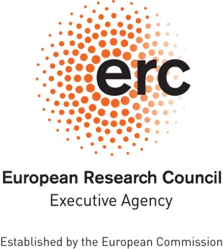

**ERC Data Management Plan**

**Template**

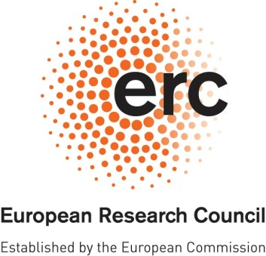**ERC OPEN RESEARCH DATA MANAGEMENT PLAN (DMP)**

# 

|  |  |
| --- | --- |
| **Project Acronym** | **Project Number** |
|  |  |

***Template for the ERC Open Research Data Management Plan (DMP)[1]. The following sections should describe how you plan to make the project data Findable, Accessible, Interoperable and Reusable (FAIR).***

***Each of the following five issues should be addressed with a level of detail appropriate to the project.***

|  |
| --- |
| **SUMMARY** *(dataset[2] reference and name; origin and expected size of the data generated/collected; data types and formats)* |
|  |

|  |
| --- |
| **1. MAKING DATA FINDABLE** *(dataset description: metadata, persistent and unique identifiers e.g., DOI)* |
|  |

|  |
| --- |
| **2. MAKING DATA OPENLY ACCESSIBLE** *(which data will be made openly available and if some datasets remain closed, the reasons for not giving access; where the data and associated metadata, documentation and code are deposited (repository?); how the data can be accessed (are relevant software tools/methods provided?)* |
|  |

|  |
| --- |
| **3. MAKING DATA INTEROPERABLE** *(which standard or field-specific data and metadata vocabularies and methods will be used)* |
|  |

|  |
| --- |
| **4. INCREASE DATA RE-USE** *(what data will remain re-usable and for how long, is embargo foreseen; how the data is licensed; data quality assurance procedures)* |
|  |

|  |
| --- |
| **5. ALLOCATION OF RESOURCES and DATA SECURITY** *(estimated costs for making the project data open access and potential value of long-term data preservation; procedures for data backup and recovery; transfer of sensitive data and secure storage in repositories for long term preservation and curation)* |
|  |

**DISCLAIMER. Please note that the ERC Data Management Plan is not a part of the Ethics Review. It is the responsibility of the Principal Investigator to inform the ERCEA Ethics Team of any ethics issues/concerns regarding the collection, processing, sharing and storage of data in relation to the project. The Principal investigator can also be asked to submit an Ethics Data Management Plan (Ethics DMP).**

1. *Based on* [*'Guidelines on FAIR Data Management in H2020'*](http://ec.europa.eu/research/participants/data/ref/h2020/grants_manual/hi/oa_pilot/h2020-hi-oa-data-mgt_en.pdf)*, version 3.0. 26.07.2016, Annex1*
2. *Several datasets may be included into a single DMP.*