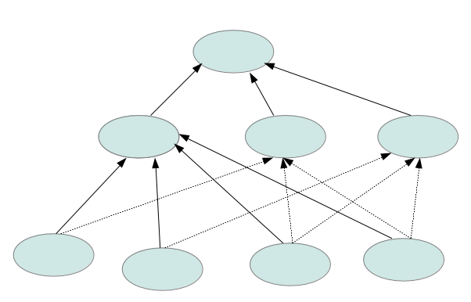
OWL ASSIGNMENT

Please send your answers (Ontologies in OWL and answers to questions as text) and questions to mikel.egana.aranguren@gmail.com.

In questions 1 and 2 you have to create an OWL ontology. In questions 3 and 4, you just have to think a bit and answer; you won't be marked on the correcteness of the answers, so don't be afraid to be wrong in the case of 3 and 4. The aim of questions 3 and 4 is to make you think about OWL semantics.

1.- Create an OWL ontology using Protégé 4 that represents the following knowledge domain:

- All the Audi cars, Skoda cars and Volkswagen cars are cars.
- Audi cars are not Skoda cars nor Volkswagen cars.
- Audi, Skoda and Volkswagen are car manufacturers.
- If we find a car made by Audi, it is an Audi car.
- Mikel's car is made by Audi; the reasoner should infer that it is an Audi car.
- All the Audi cars have an engine that has exactly 4 cylinders and such engine is made by at least an engine manufacturer.
- All the Audi cars have components made only by Audi, Skoda or Volkswagen, and all the Audi cars have at least one such component.

2.- In the following ontology, the circles represent classes and the arrows represent subClassOf axioms: there is a root class with three subclasses, and each of those subclasses has more subclasses. The continous lines represent asserted subClassOf axioms, whereas the dotted lines represent inferred subClassOf axioms. Thus, you have to create an OWL ontology holding the structure of continous lines, and add axioms to classes in order to obtain the remaining subclass axioms structure if reasoning is performed (ie, more subclassof axioms cannot be asserted). You can give the classes any name you like and create any properties needed. Hint: you can use OWLviz to view the hierarchy.

3.- Given the following OWL ontology in Manchester OWL Syntax:

Object Property: part_of
Domain: Component
Range: Car
Class: Wheel
subClassOf Component
subClassOf part_of some Car
Class: Engine
subClassOf Device
subClassOf part_of some Car
Class: Car
Class: Component
Class: Device

3.1- Considering the domain and range of part_of, would you say this ontology is consistent or inconsistent if reasoning is performed? Why? Write down your answer.

3.2.- After you have written down your answer, you can create the ontology in Protégé and perform reasoning. Do you obtain the result you expected? Why? If not, how would you change the ontology to obtain it?

4.- Given the following ontology Manchester OWL Syntax:

Object Property: p

Class: A
disjointWith B

Class: B
Class: C
equivalentTo p only (A and B)

4.1.- Considering that A and B are disjoint, would you say this ontology is consistent or inconsistent if reasoning is performed? Why? Write down your answer.

4.2.- After you have written down your answer, you can create the ontology in Protégé and perform reasoning. Do you obtain the result you expected? Why? If not, how would you change the ontology to obtain it?

