Less is More? Testing the Impact of Environmental Variable Refinement on Palaeolithic Site Location Models
Mikel Díaz-Rodríguez

Supplementary Material

Table S1. Synthesis of R packages used, authors and application details.
Package | Author/s | Application Details
sf | Pebesma and Bivand (2023) | Simple Features for R. Provides classes and methods for handling vector spatial data.
sp | Pebesma and Bivand (2005) | Package for spatial data.
raster | Hijmans (2023) | Used in the refinement phase for reading, stacking (stack), and resampling (resample) raster variables.
terra | Hijmans et al. (2025) | Main package for handling raster data.
spatstat | Baddeley et al. (2020) | Main package for spatial point process models.
spatstat.geom | Baddeley et al. (2025) | Provides the fundamental geometric structures for point pattern analysis.
spatstat.convert | Baddeley et al. (2025) | Facilitates conversion between sf/terra objects and native spatstat structures.
GGally | Schloerke et al. (2025) | Used to generate correlation matrices and pairwise plots for exploratory variable analysis.
writexl | Ooms and Denney (2025) | Allows exporting model results to Excel files.
dplyr | Wickham et al. (2023) | Provides an intuitive grammar of verbs for fast, efficient data manipulation.
broom | Robinson et al. (2023) | Converts messy statistical model outputs into clean, tidy data frames for easy analysis and visualisation.
tidyterra | Hernangómez (2023) | Integrates tidyverse workflows with terra spatial objects, providing familiar dplyr and tidyr methods alongside specialized ggplot2 geoms and scales for raster and vector data.
ggplot2 | Wickham et al. (2020) | Package designed to create highly customizable, multilayered plots based on the Grammar of Graphics.
foreach | Daniel et al. (2022) | Provides a flexible looping construct designed to execute expressions repeatedly.
tibble | Müller and Wickham (2023) | Gives a modern version of data frames.
magrittr | Bache and Wickham (2022) | Provides the %>% operator for chaining data manipulation operations.
brglm2 | Kosmidis (2026) | Implements Firth's bias-reduced logistic regression.
pROC | Robin et al. (2011) | Used to calculate AUC and ROC curves.
patchwork | Pedersen (2022) | Allows combining multiple ggplot2 plots into a single figure easily and intuitively.
cowplot | Wilke (2024) | ggplot2 extension in R designed to easily combine and annotate multiple plots.
ggspatial | Dunnington (2023) | Simplifies geospatial data visualisation.
virtualspecies | Leroy et al. (2016) | R package to generate virtual species distributions.
onpoint | Hesselbarth (2025) | Provides auxiliary functions for point pattern analysis.

Table S2. Pearson’s correlation coefficient results in Monforte de Lemos basin.
 | ALTA | WET | CPFPCG | GEOLC | HYDROC | LCPC | GEOLE | HYDROE | DIFINS | DIRINS | TOTINS | ASP | SLO | VISPR | TPI100 | TPI500 | TPI1000 | WIND
ALTA | 1 | 0,35667635 | -0,0835717 | -0,2833937 | 0,54714328 | -0,1592597 | -0,2651869 | 0,61769529 | 0,86176382 | -0,0011825 | 0,03768574 | 0,27253891 | -0,0054187 | -0,10299 | 0,06026189 | 0,13027888 | 0,15469177 | 0,67464251
WET | 0,35667635 | 1 | -0,1648189 | 0,02943039 | 0,10461158 | 0,11178294 | 0,03151997 | 0,0975001 | 0,29435648 | 0,20318306 | 0,21265617 | 0,17073204 | 0,26452627 | 0,45706674 | 0,43508317 | 0,52366338 | 0,5322878 | 0,1894196
CPFPCG | -0,0835717 | -0,1648189 | 1 | 0,20694941 | -0,2602858 | 0,31158221 | 0,19941915 | -0,1700096 | -0,0791709 | -0,1664644 | -0,1652326 | -0,1757421 | -0,1271031 | 0,18183008 | 0,11544349 | 0,07807601 | 0,05719123 | 0,29408736
GEOLC | -0,2833937 | 0,02943039 | 0,20694941 | 1 | -0,1994787 | 0,16664158 | 0,99385695 | -0,1925984 | -0,2504467 | 0,0874813 | 0,07491593 | -0,1890641 | -0,0305361 | 0,31091594 | 0,23797655 | 0,33944224 | 0,26712282 | -0,0792828
HYDROC | 0,54714328 | 0,10461158 | -0,2602858 | -0,1994787 | 1 | -0,2740253 | -0,2007674 | 0,96186192 | 0,45396958 | 0,1258638 | 0,14865235 | 0,14140918 | -0,0722259 | -0,0527679 | -0,1797557 | -0,0323634 | 0,10944885 | 0,20639941
LCPC | -0,1592597 | 0,11178294 | 0,31158221 | 0,16664158 | -0,2740253 | 1 | 0,16706366 | -0,3057448 | -0,2492251 | -0,0619717 | -0,0687489 | -0,0257109 | 0,19078521 | 0,34181459 | 0,34227219 | 0,24325614 | 0,14483218 | 0,10541525
GEOLE | -0,2651869 | 0,03151997 | 0,19941915 | 0,99385695 | -0,2007674 | 0,16706366 | 1 | -0,1893439 | -0,2458691 | 0,07189207 | 0,05999455 | -0,1969766 | -0,0177686 | 0,30502394 | 0,24584415 | 0,33744628 | 0,26040509 | -0,0534651
HYDROE | 0,61769529 | 0,0975001 | -0,1700096 | -0,1925984 | 0,96186192 | -0,3057448 | -0,1893439 | 1 | 0,49252864 | 0,08319093 | 0,10759489 | 0,14829719 | -0,0410161 | -0,076986 | -0,2058323 | -0,0398912 | 0,09212769 | 0,30995669
DIFINS | 0,86176382 | 0,29435648 | -0,0791709 | -0,2504467 | 0,45396958 | -0,2492251 | -0,2458691 | 0,49252864 | 1 | -0,0635427 | -0,0252187 | 0,2926964 | -0,4129374 | -0,1171219 | 0,08898387 | 0,10846128 | 0,10982423 | 0,68629862
DIRINS | -0,0011825 | 0,20318306 | -0,1664644 | 0,0874813 | 0,1258638 | -0,0619717 | 0,07189207 | 0,08319093 | -0,0635427 | 1 | 0,99895788 | 0,17676705 | 0,13616422 | 0,1481734 | -0,1315461 | 0,12375451 | 0,18661709 | -0,2652436
TOTINS | 0,03768574 | 0,21265617 | -0,1652326 | 0,07491593 | 0,14865235 | -0,0687489 | 0,05999455 | 0,10759489 | -0,0252187 | 0,99895788 | 1 | 0,18935697 | 0,12352073 | 0,14420152 | -0,1259876 | 0,12842216 | 0,1902228 | -0,2360727
ASP | 0,27253891 | 0,17073204 | -0,1757421 | -0,1890641 | 0,14140918 | -0,0257109 | -0,1969766 | 0,14829719 | 0,2926964 | 0,17676705 | 0,18935697 | 1 | -0,0407913 | -0,0142175 | 0,08720127 | 0,02989018 | -0,0188098 | 0,23118242
SLO | -0,0054187 | 0,26452627 | -0,1271031 | -0,0305361 | -0,0722259 | 0,19078521 | -0,0177686 | -0,0410161 | -0,4129374 | 0,13616422 | 0,12352073 | -0,0407913 | 1 | 0,10481389 | 0,00346309 | 0,00806037 | 0,01750512 | -0,2254083
VISPR | -0,10299 | 0,45706674 | 0,18183008 | 0,31091594 | -0,0527679 | 0,34181459 | 0,30502394 | -0,076986 | -0,1171219 | 0,1481734 | 0,14420152 | -0,0142175 | 0,10481389 | 1 | 0,65689845 | 0,7800659 | 0,76426279 | 0,03326149
TPI100 | 0,06026189 | 0,43508317 | 0,11544349 | 0,23797655 | -0,1797557 | 0,34227219 | 0,24584415 | -0,2058323 | 0,08898387 | -0,1315461 | -0,1259876 | 0,08720127 | 0,00346309 | 0,65689845 | 1 | 0,77561699 | 0,60635886 | 0,20381251
TPI500 | 0,13027888 | 0,52366338 | 0,07807601 | 0,33944224 | -0,0323634 | 0,24325614 | 0,33744628 | -0,0398912 | 0,10846128 | 0,12375451 | 0,12842216 | 0,02989018 | 0,00806037 | 0,7800659 | 0,77561699 | 1 | 0,89795242 | 0,18468664
TPI1000 | 0,15469177 | 0,5322878 | 0,05719123 | 0,26712282 | 0,10944885 | 0,14483218 | 0,26040509 | 0,09212769 | 0,10982423 | 0,18661709 | 0,1902228 | -0,0188098 | 0,01750512 | 0,76426279 | 0,60635886 | 0,89795242 | 1 | 0,13039354
WIND | 0,67464251 | 0,1894196 | 0,29408736 | -0,0792828 | 0,20639941 | 0,10541525 | -0,0534651 | 0,30995669 | 0,68629862 | -0,2652436 | -0,2360727 | 0,23118242 | -0,2254083 | 0,03326149 | 0,20381251 | 0,18468664 | 0,13039354 | 1

Table S3. Pearson’s correlation coefficient results in Northern Mountain ranges.
 | ALTA | WET | CPFPCG | GEOLC | HYDROC | LCPC | GEOLE | HYDROE | DIFINS | DIRINS | TOTINS | ASP | SLO | VISPR | TPI100 | TPI500 | TPI1000 | WIND
ALTA | 1 | 0, 33889875 | 0,094490098 | 0,06523226 | 0,452304535 | -0,41532048 | 0,05593978 | 0,417241137 | 0,73533471 | -0,25051725 | -0,21911518 | 0,33414153 | -0,02206166 | -0,25777325 | -0,242424962 | -0,19370621 | -0,187156097 | 0,25642064
WET | 0,33889875 | 1 | 0,241843406 | 0,55464163 | 0,029780171 | 0,09089408 | 0,54755769 | -0,013675044 | 0,10198870 | 0,08402084 | 0,08965918 | -0,04701028 | 0,18643962 | -0,04335985 | 0,079587139 | 0,10443461 | 0,273516307 | 0,01711672
CPFPCG | 0,09449010 | 0,24184341 | 1 | 0,55258697 | 0,198857591 | -0,27894097 | 0,55891778 | 0,156468872 | 0,01210837 | -0,14793280 | -0,14893197 | -0,05883196 | 0,03377703 | -0,31720596 | -0,119586148 | -0,12094024 | -0,009330111 | -0,05099712
GEOLC | 0,06523226 | 0,55464163 | 0,552586968 | 1 | 0,115344582 | 0,10811406 | 0,99823093 | 0,072459603 | -0,34428152 | 0,11463122 | 0,09992080 | 0,03912378 | 0,53869792 | -0,25630111 | 0,292823980 | 0,16150837 | 0,381872509 | 0,17756099
HYDROC | 0,45230454 | 0,02978017 | 0,198857591 | 0,11534458 | 1 | -0,39345654 | 0,12982061 | 0,994666060 | 0,37481597 | -0,05135212 | -0,03453721 | 0,24582534 | -0,06727607 | 0,06724350 | 0,005933684 | 0,07687153 | 0,121558163 | 0,32942299
LCPC | -0,41532048 | 0,09089408 | -0,278940967 | 0,10811406 | -0,393456543 | 1 | 0,09148620 | -0,381568967 | -0,62532189 | 0,47407389 | 0,45016457 | -0,16600445 | 0,48668310 | 0,06791321 | 0,284551025 | 0,24376308 | 0,193825192 | -0,05625445
GEOLE | 0,05593978 | 0,54755769 | 0,558917784 | 0,99823093 | 0,129820613 | 0,09148620 | 1 | 0,087475874 | -0,34376288 | 0,10732150 | 0,09255761 | 0,04532777 | 0,53089241 | -0,25507117 | 0,301249723 | 0,16370689 | 0,392234949 | 0,18927536
HYDROE | 0,41724114 | -0,01367504 | 0,156468872 | 0,07245960 | 0,994666060 | -0,38156897 | 0,08747587 | 1 | 0,36571854 | -0,03214748 | -0,01555284 | 0,24817241 | -0,08129538 | 0,05196503 | -0,008527173 | 0,05690385 | 0,096740393 | 0,27858369
DIFINS | 0,73533471 | 0,10198870 | 0,012108371 | -0,34428152 | 0,374815967 | -0,62532189 | -0,34376288 | 0,365718540 | 1 | -0,25215395 | -0,20852425 | 0,26813267 | -0,66621846 | -0,11814152 | -0,498556348 | -0,43448250 | -0,438435240 | 0,02543305
DIRINS | -0,25051725 | 0,08402084 | -0,147932802 | 0,11463122 | -0,051352117 | 0,47407389 | 0,10732150 | -0,032147480 | -0,25215395 | 1 | 0,99899487 | -0,31922114 | 0,17016910 | 0,17157751 | 0,423117422 | 0,29416996 | 0,407238532 | -0,02391553
TOTINS | -0,21911518 | 0,08965918 | -0,148931974 | 0,09992080 | -0,034537213 | 0,45016457 | 0,09255761 | -0,015552840 | -0,20852425 | 0,99899487 | 1 | 0,31022045 | 0,14114303 | 0,16794433 | 0,404551220 | 0,27719901 | 0,391291534 | -0,02296708
ASP | 0,33414153 | -0,04701028 | -0,058831961 | 0,03912378 | 0,245825340 | -0,16600445 | 0,04532777 | 0,248172406 | 0,26813267 | -0,31922114 | -0,31022045 | 1 | -0,01529822 | -0,10809192 | 0,052831344 | 0,01193246 | -0,026565799 | 0,32043428
SLO | -0,02206166 | 0,18643962 | 0,033777032 | 0,53869792 | -0,067276066 | 0,48668310 | 0,53089241 | -0,081295378 | -0,66621846 | 0,17016910 | 0,14114303 | -0,01529822 | 1 | -0,08977910 | 0,502461528 | 0,43525519 | 0,452383309 | 0,23321122
VISPR | -0,25777325 | -0,04335985 | -0,317205961 | -0,25630111 | 0,067243499 | 0,06791321 | -0,25507117 | 0,051965033 | -0,11814152 | 0,17157751 | 0,16794433 | -0,10809192 | -0,08977910 | 1 | 0,445784893 | 0,49953220 | 0,447354113 | 0,50820755
TPI100 | -0,24242496 | 0,07958714 | -0,119586148 | 0,29282398 | 0,005933684 | 0,28455103 | 0,30124972 | -0,008527173 | -0,49855635 | 0,42311742 | 0,40455122 | 0,05283134 | 0,50246153 | 0,44578489 | 1 | 0,91633750 | 0,921353714 | 0,42182470
TPI500 | -0,19370621 | 0,10443461 | -0,120940235 | 0,16150837 | 0,076871534 | 0,24376308 | 0,16370689 | 0,056903853 | -0,43448250 | 0,29416996 | 0,27719901 | 0,01193246 | 0,43525519 | 0,49953220 | 0,916337501 | 1 | 0,914792255 | 0,33945666
TPI1000 | -0,18715610 | 0,27351631 | -0,009330111 | 0,26712282 | 0,121558163 | 0,19382519 | 0,39223495 | 0,096740393 | -0,43843524 | 0,40723853 | 0,39129153 | -0,02656580 | 0,45238331 | 0,44735411 | 0,921353714 | 0,91479226 | 1 | 0,40435591
WIND | 0,25642064 | 0,01711672 | -0,050997125 | -0,0792828 | 0,329422987 | -0,05625445 | 0,18927536 | 0,278583692 | 0,02543305 | 0,02391553 | -0,02296708 | 0,32043428 | 0,23321122 | 0,50820755 | 0,421824696 | 0,33945666 | 0,404355905 | 1

Table S4. Pearson’s correlation coefficient results in Central Mountain ranges.
 | ALTA | WET | CPFPCG | GEOLC | HYDROC | LCPC | GEOLE | HYDROE | DIFINS | DIRINS | TOTINS | ASP | SLO | VISPR | TPI100 | TPI500 | TPI1000 | WIND
ALTA | 1 | 0,25062240 | 0,301859329 | 0,7639864 | 0,463544643 | -0,22878627 | 0,71390660 | 0,43108974 | 0,937202994 | -0,128412612 | -0,102804626 | 0,018008381 | 0,1554974654 | -0,14281908 | 0,2561461889 | 0,26752697 | 0,26986810 | 0,7799100
WET | 0,25062240 | 1 | 0,118272452 | 0,1844494 | 0,338466037 | 0,06337780 | 0,13916330 | 0,20213235 | 0,207153506 | -0,085007734 | -0,079525717 | 0,268902878 | 0,1489156539 | 0,41318337 | 0,1548095862 | 0,16590364 | 0,16332439 | 0,3778731
CPFPCG | 0,30185933 | 0,11827245 | 1 | 0,1244690 | 0,264802963 | -0,05002421 | 0,09943713 | 0,23018343 | 0,272954361 | 0,208289273 | 0,216460225 | -0,008842439 | 0,0587793937 | 0,02276501 | -0,2190399311 | -0,21933287 | -0,21273593 | 0,2432923
GEOLC | 0,76398637 | 0,18444940 | 0,124468960 | 1 | 0,177504818 | -0,26354595 | 0,99421825 | 0,14336075 | 0,761005849 | -0,131255254 | -0,110537208 | 0,143411251 | 0,0261980031 | -0,17534269 | 0,2087889390 | 0,20415999 | 0,20375654 | 0,5874801
HYDROC | 0,46354464 | 0,33846604 | 0,264802963 | 0,1775048 | 1 | -0,32751819 | 0,12102027 | 0,97367213 | 0,421403591 | -0,005914584 | 0,005745663 | 0,044397413 | 0,1094387465 | 0,15201726 | 0,2295086774 | 0,24250937 | 0,24446697 | 0,4878802
LCPC | -0,22878627 | 0,06337780 | -0,050024215 | -0,2635460 | -0,327518192 | 1 | -0,25426545 | -0,39678493 | -0,183007494 | -0,096557582 | -0,101921219 | 0,081952784 | -0,1763349901 | 0,26227445 | 0,1215805283 | 0,12643663 | 0,12527782 | 0,1381639
GEOLE | 0,71390660 | 0,13916330 | 0,099437125 | 0,9942183 | 0,121020268 | -0,25426545 | 1 | 0,09090872 | 0,715202334 | -0,126220971 | -0,106757837 | 0,141139967 | 0,0110416736 | -0,19837506 | 0,2002600807 | 0,19354882 | 0,19238725 | 0,5377881
HYDROE | 0,43108974 | 0,20213235 | 0,230183429 | 0,1433608 | 0,973672129 | -0,39678493 | 0,09090872 | 1 | 0,395148779 | 0,011121548 | 0,022101946 | 0,017547906 | 0,0985148088 | 0,02844762 | 0,1894278714 | 0,19457801 | 0,19758446 | 0,4319218
DIFINS | 0,93720299 | 0,20715351 | 0,272954361 | 0,7610058 | 0,421403591 | -0,18300749 | 0,71520233 | 0,39514878 | 1 | -0,122164531 | -0,094800959 | 0,007076314 | -0,1810146093 | -0,13456632 | 0,2688369127 | 0,26616898 | 0,26994673 | 0,7310310
DIRINS | -0,12841261 | -0,08500773 | 0,208289273 | -0,1312553 | -0,005914584 | -0,09655758 | -0,12622097 | 0,01112155 | -0,122164531 | 1 | 0,999621146 | -0,247501584 | -0,0513711975 | -0,14376101 | -0,5921411808 | -0,50755205 | -0,50357866 | -0,4087172
TOTINS | -0,10280463 | -0,07952572 | 0,216460225 | -0,1105372 | 0,005745663 | -0,10192122 | -0,10675784 | 0,02210195 | -0,094800959 | 0,999621146 | 1 | -0,248056798 | -0,0565297579 | -0,14791593 | -0,5864760053 | -0,50170442 | -0,49761424 | -0,3896850
ASP | 0,01800838 | 0,26890288 | -0,008842439 | 0,1434113 | 0,044397413 | 0,08195278 | 0,14113997 | 0,01754791 | 0,007076314 | -0,247501584 | -0,248056798 | 1 | 0,1130322913 | 0,28569967 | 0,3811137318 | 0,31932280 | 0,31663727 | 0,3257488
SLO | 0,15549747 | 0,14891565 | 0,058779394 | 0,0261980 | 0,109438747 | -0,17633499 | 0,01104167 | 0,09851481 | -0,181014609 | -0,051371198 | -0,056529758 | 0,113032291 | 1 | 0,03947497 | -0,0005357583 | 0,04027069 | 0,03538874 | 0,1251470
VISPR | -0,14281908 | 0,41318337 | 0,022765006 | -0,1753427 | 0,152017264 | 0,26227445 | -0,19837506 | 0,02844762 | -0,134566321 | -0,143761005 | -0,147915931 | 0,285699671 | 0,0394749744 | 1 | 0,3057288413 | 0,32025388 | 0,31781128 | 0,1563806
TPI100 | 0,25614619 | 0,15480959 | -0,219039931 | 0,2087889 | 0,229508677 | 0,12158053 | 0,20026008 | 0,18942787 | 0,268836913 | -0,592141181 | -0,586476005 | 0,381113732 | -0,0005357583 | 0,30572884 | 1 | 0,98584349 | 0,98580411 | 0,6010035
TPI500 | 0,26752697 | 0,16590364 | -0,219332866 | 0,2041600 | 0,242509371 | 0,12643663 | 0,19354882 | 0,19457801 | 0,266168980 | -0,507552047 | -0,501704421 | 0,319322801 | 0,0402706856 | 0,32025388 | 0,9858434867 | 1 | 0,99912931 | 0,5654236
TPI1000 | 0,26986810 | 0,16332439 | -0,212735933 | 0,2037565 | 0,244466968 | 0,12527782 | 0,19238725 | 0,19758446 | 0,269946726 | -0,503578660 | -0,497614238 | 0,316637272 | 0,0353887422 | 0,31781128 | 0,9858041109 | 0,99912931 | 1 | 0,5667778
WIND | 0,77990998 | 0,37787311 | 0,243292300 | 0,5874801 | 0,487880164 | -0,13816395 | 0,53778806 | 0,43192177 | 0,731031029 | -0,408717212 | -0,389684998 | 0,325748810 | 0,1251470417 | 0,15638056 | 0,6010035353 | 0,56542359 | 0,56677778 | 1

Table S5. Mann–Whitney U test results for the comparison between archaeological sites and randomly resampled background points in Northern area.
Variable | Statistic | Lower CI | Median | Upper CI
ALTA | U statistic | 715.925 | 846 | 954.6
ALTA | p-value | 0 | 0.0005 | 0.0459
TPI100 | U statistic | 592.925 | 695 | 786.55
TPI100 | p-value | 0.0054 | 0.0765 | 0.4298
TPI500 | U statistic | 516 | 635 | 750.1
TPI500 | p-value | 0.0177 | 0.2442 | 0.7783
TPI1000 | U statistic | 464.9 | 579 | 692.05
TPI1000 | p-value | 0.0818 | 0.4976 | 0.9182
SLO | U statistic | 489.4 | 600.5 | 709.5
SLO | p-value | 0.054 | 0.3936 | 0.8628
ASP | U statistic | 580.5 | 714 | 843.5
ASP | p-value | 0.0006 | 0.0482 | 0.4902
HYDROE | U statistic | 481.475 | 598 | 700.025
HYDROE | p-value | 0.068 | 0.4055 | 0.883
HYDROC | U statistic | 459 | 575 | 690.1
HYDROC | p-value | 0.0855 | 0.5171 | 0.9286
WET | U statistic | 345 | 464 | 590.1
WET | p-value | 0.4434 | 0.9199 | 0.9979
GEOLE | U statistic | 291.475 | 391 | 517.025
GEOLE | p-value | 0.7756 | 0.9895 | 0.9998
GEOLC | U statistic | 281.95 | 389 | 507.15
GEOLC | p-value | 0.8103 | 0.9902 | 0.9999
VISPR | U statistic | 408.4 | 514 | 615.525
VISPR | p-value | 0.3248 | 0.7857 | 0.9816
LCPC | U statistic | 442.925 | 563.5 | 673.05
LCPC | p-value | 0.123 | 0.573 | 0.9518
TOTINS | U statistic | 560.975 | 685 | 794.05
TOTINS | p-value | 0.0041 | 0.0957 | 0.5851
DIRINS | U statistic | 555.9 | 676.5 | 794.2
DIRINS | p-value | 0.0041 | 0.1147 | 0.6092
DIFINS | U statistic | 676.95 | 777 | 859.5
DIFINS | p-value | 0.0003 | 0.0074 | 0.1136
WIND | U statistic | 483.95 | 610 | 736
WIND | p-value | 0.0267 | 0.3496 | 0.8769
CPFPCGc | U statistic | 379 | 514 | 652.05
CPFPCGc | p-value | 0.1835 | 0.7856 | 0.9928
CPFPCDc | U statistic | 544 | 578 | 578
CPFPCDc | p-value | 0.8484 | 1 | 1

Table S6. Mann–Whitney U test results for the comparison between archaeological sites and randomly resampled background points in Central area.
Variable | Statistic | Lower CI | Median | Upper CI
ALTA | U statistic | 3309.925 | 3461.5 | 3566.525
ALTA | p-value | 0 | 0 | 0
TPI100 | U statistic | 1467.475 | 1725.5 | 1979.125
TPI100 | p-value | 0.2726 | 0.7561 | 0.9781
TPI500 | U statistic | 1769.7 | 2042 | 2325.2
TPI500 | p-value | 0.0087 | 0.177 | 0.6799
TPI1000 | U statistic | 2027.95 | 2315 | 2574.25
TPI1000 | p-value | 0.0001 | 0.01 | 0.1963
SLO | U statistic | 1511.95 | 1800.5 | 2098.1
SLO | p-value | 0.1123 | 0.6217 | 0.9631
ASP | U statistic | 1484.95 | 1772 | 2025.525
ASP | p-value | 0.1998 | 0.6757 | 0.9729
HYDROE | U statistic | 2705.5 | 2978.5 | 3205.225
HYDROE | p-value | 0 | 0 | 0
HYDROC | U statistic | 2686.95 | 2974 | 3207.25
HYDROC | p-value | 0 | 0 | 0
WET | U statistic | 1329.875 | 1600 | 1890.1
WET | p-value | 0.4408 | 0.9093 | 0.9967
GEOLE | U statistic | 2292.75 | 2681 | 3064.35
GEOLE | p-value | 0 | 0 | 0.0135
GEOLC | U statistic | 2301.75 | 2692 | 3071.1
GEOLC | p-value | 0 | 0 | 0.012
VISPR | U statistic | 847.975 | 1071 | 1317.05
VISPR | p-value | 0.9974 | 1 | 1
LCPC | U statistic | 1573.425 | 1856.5 | 2145
LCPC | p-value | 0.0728 | 0.5092 | 0.9296
TOTINS | U statistic | 1915.85 | 2186 | 2465.3
TOTINS | p-value | 0.001 | 0.048 | 0.3894
DIRINS | U statistic | 1802.85 | 2099 | 2355.15
DIRINS | p-value | 0.0057 | 0.1115 | 0.6171
DIFINS | U statistic | 3329.8 | 3470.5 | 3566.575
DIFINS | p-value | 0 | 0 | 0
WIND | U statistic | 2370.725 | 2640.5 | 2908.05
WIND | p-value | 0 | 0 | 0.0045
CPFPCGc | U statistic | 957.8 | 1354 | 1743.4
CPFPCGc | p-value | 0.7265 | 0.9953 | 1
CPFPCDc | U statistic | 1830 | 1860.5 | 1860.5
CPFPCDc | p-value | 0.8453 | 1 | 1

Table S7. Mann–Whitney U test results for the comparison between archaeological sites and randomly resampled background points in Monforte area.
Variable | Statistic | Lower CI | Median | Upper CI
ALTA | U statistic | 438.475 | 761.5 | 1130.675
ALTA | p-value | 1 | 1 | 1
TPI100 | U statistic | 2323.8 | 2793.5 | 3266.125
TPI100 | p-value | 0.082 | 0.6369 | 0.9813
TPI500 | U statistic | 2624.45 | 3083 | 3565.15
TPI500 | p-value | 0.0063 | 0.2368 | 0.8347
TPI1000 | U statistic | 2510.95 | 2974 | 3471.35
TPI1000 | p-value | 0.0159 | 0.3764 | 0.9179
SLO | U statistic | 751.35 | 1046 | 1412.275
SLO | p-value | 1 | 1 | 1
ASP | U statistic | 2198.475 | 2560.5 | 2909.05
ASP | p-value | 0.4698 | 0.8866 | 0.9945
HYDROE | U statistic | 2086.325 | 2545.5 | 2970.4
HYDROE | p-value | 0.3814 | 0.8969 | 0.9984
HYDROC | U statistic | 1921.4 | 2321 | 2739.2
HYDROC | p-value | 0.7089 | 0.9817 | 0.9998
WET | U statistic | 866 | 1168.5 | 1540.725
WET | p-value | 1 | 1 | 1
GEOLE | U statistic | 2240.825 | 2720 | 3142.625
GEOLE | p-value | 0.1707 | 0.735 | 0.9919
GEOLC | U statistic | 2258.9 | 2700 | 3127.5
GEOLC | p-value | 0.185 | 0.7587 | 0.9901
VISPR | U statistic | 4182.725 | 4499 | 4777
VISPR | p-value | 0 | 0 | 0
LCPC | U statistic | 2554.875 | 2918 | 3253.25
LCPC | p-value | 0.0894 | 0.4567 | 0.8905
TOTINS | U statistic | 2294.6 | 2844 | 3370.375
TOTINS | p-value | 0.0379 | 0.5651 | 0.9857
DIRINS | U statistic | 2362 | 2911 | 3393.25
DIRINS | p-value | 0.0314 | 0.467 | 0.9738
DIFINS | U statistic | 1124.825 | 1577.5 | 2062.825
DIFINS | p-value | 0.9988 | 1 | 1
WIND | U statistic | 1582.9 | 2039 | 2491.1
WIND | p-value | 0.9285 | 0.9991 | 1
CPFPCGc | U statistic | 3686 | 4111 | 4491.1
CPFPCGc | p-value | 0 | 0 | 0.0016
CPFPCDc | U statistic | 2546 | 2698 | 2850
CPFPCDc | p-value | 0.8445 | 0.9885 | 0.9994

Table S8. Results for the statistical tests applied in all study areas.
 | Shapiro-Wilk Test (sites) |  | Shapiro-Wilk Test (random sites) |  | K-S Test (sites vs random sites)
Region | W | p-value | W | p-value | D | p-value
Monforte de Lemos basin | 0.88135 | 3.557^{e-06} | 0.95329 | 0.007074 | 0.36807 | 5.46^{e-05}
Northern Mountain ranges | 0.63203 | 5.181^{e-08} | 0.96294 | 0.2957 | 0.58824 | 8.662^{e-06}
Central Mountain ranges | 0.95885 | 0.03876 | 0.96351 | 0.06598 | 0.42623 | 2.364^{e-05}

Table S9. Covariates used in the GLM analysis for the Monforte area.
Area | Covariate | Used in GLM
 | ALTA | YES
 | TPI100 | YES
 | TPI500 | NO
 | TPI1000 | NO
 | SLO | YES
 | ASP | YES
 | HYDROC | YES
 | HYDROE | NO
 | WET | YES
Monforte de Lemos basin | GEOLC | YES
 | GEOLE | NO
 | CPFPCG | YES
 | CPFPCD | NO
 | VISPR | YES
 | LCPC | YES
 | DIRINS | NO
 | DIFINS | NO
 | TOTINS | YES
 | WIND | YES

Table S10. Covariates used in the GLM analysis for the Northern Mountain ranges area.
Area | Covariate | Used in GLM
 | ALTA | YES
 | TPI100 | NO
 | TPI500 | NO
 | TPI1000 | NO
 | SLO | YES
 | ASP | YES
 | HYDROC | YES
 | HYDROE | NO
 | WET | YES
Northern Mountain ranges | GEOLC | YES
 | GEOLE | NO
 | CPFPCG | NO
 | CPFPCD | NO
 | VISPR | YES
 | LCPC | NO
 | DIRINS | NO
 | DIFINS | NO
 | TOTINS | YES
 | WIND | YES

Table S11. Covariates used in the GLM analysis for the Central Mountain ranges area.
Area | Covariate | Used in GLM
 | ALTA | YES
 | TPI100 | YES
 | TPI500 | NO
 | TPI1000 | NO
 | SLO | YES
 | ASP | YES
 | HYDROC | YES
 | HYDROE | NO
 | WET | YES
Central Mountain ranges | GEOLC | YES
 | GEOLE | NO
 | CPFPCG | NO
 | CPFPCD | NO
 | VISPR | YES
 | LCPC | YES
 | DIRINS | NO
 | DIFINS | NO
 | TOTINS | YES
 | WIND | NO

Table S12. Coefficients of the Firth-penalized logistic regression models predicting Palaeolithic site presence in the Monforte de Lemos basin, Central Mountain ranges and Northern Mountain ranges. Significance codes: *** p < 0.001; ** p < 0.01; * p < 0.05; . p < 0.10.
Zone | Covariate | Estimate | Std.error | Statistic | P.value | Signif. codes
Monforte | (Intercept) | 5.8589 | 2.166 | 2.705 | 0.0068 | **
Monforte | ALTA | -0.013 | 0.006 | -2.1721 | 0.0298 | *
Monforte | SLO | -0.2803 | 0.1061 | -2.6412 | 0.0083 | **
Monforte | VISPR | 0.0368 | 0.0175 | 2.0986 | 0.0359 | *
Monforte | WET | -0.0015 | 0.001 | -1.4861 | 0.1373
Monforte | HYDROC | 0.0006 | 0.0003 | 1.687 | 0.0916 | .
Northern | (Intercept) | -10.8659 | 3.6696 | -2.961 | 0.0031 | **
Northern | ALTA | 0.0192 | 0.0064 | 3.0232 | 0.0025 | **
Northern | SLO | 0.1916 | 0.0802 | 2.3906 | 0.0168 | *
Northern | VISPR | 0.0562 | 0.0341 | 1.648 | 0.0993 | .
Northern | WET | -0.1635 | 0.0776 | -2.1078 | 0.035 | *
Northern | HYDROC | -0.0285 | 0.0182 | -1.5679 | 0.1169
Central | (Intercept) | -11.6675 | 2.9184 | -3.9979 | 0.0001 | ***
Central | ALTA | 0.0189 | 0.0044 | 4.3446 | 0 | ***
Central | VISPR | -0.0747 | 0.0403 | -1.8548 | 0.0636 | .
Central | LCPC | 0.5839 | 0.3386 | 1.7246 | 0.0846 | .

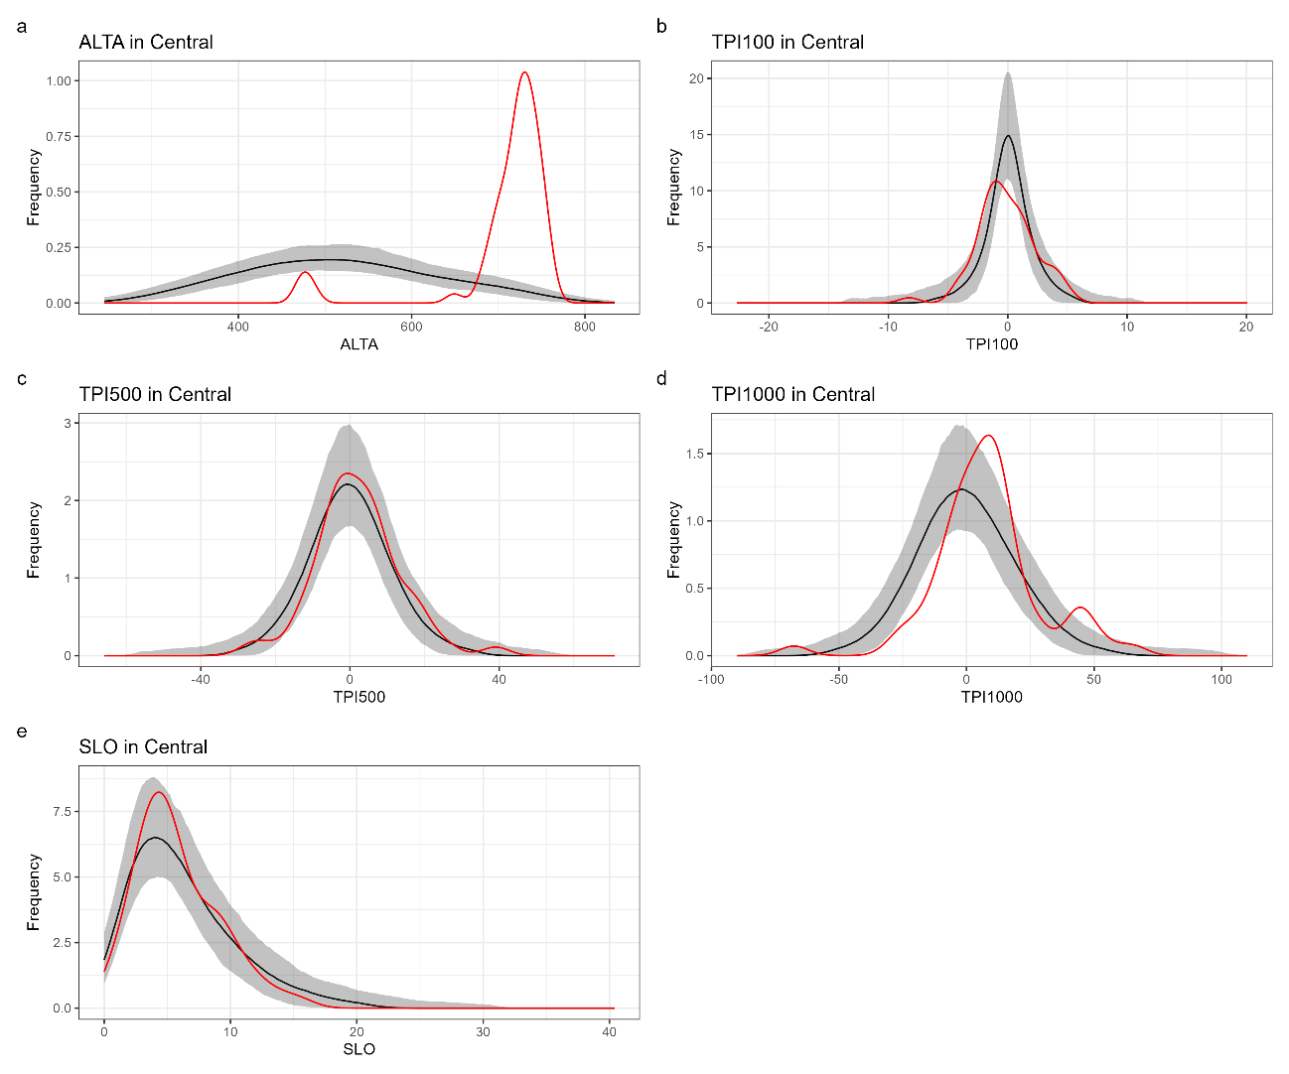
Fig. S1. Kernel density plots comparing the empirical distribution of archaeological sites (red line) and the expected distribution of randomly resampled background points (black line) for elevation (a: ALTA), Topographic Position Index (b: TPI100; c: TPI500; d: TPI1000), and slope (e: SLO) in the Central Mountain ranges. The grey shaded area denotes the 95% confidence envelope generated from 999 Monte Carlo simulations. Deviations of the observed curve (red) outside this simulated envelope (grey) indicate statistically significant differences between site locations and the available landscape background.
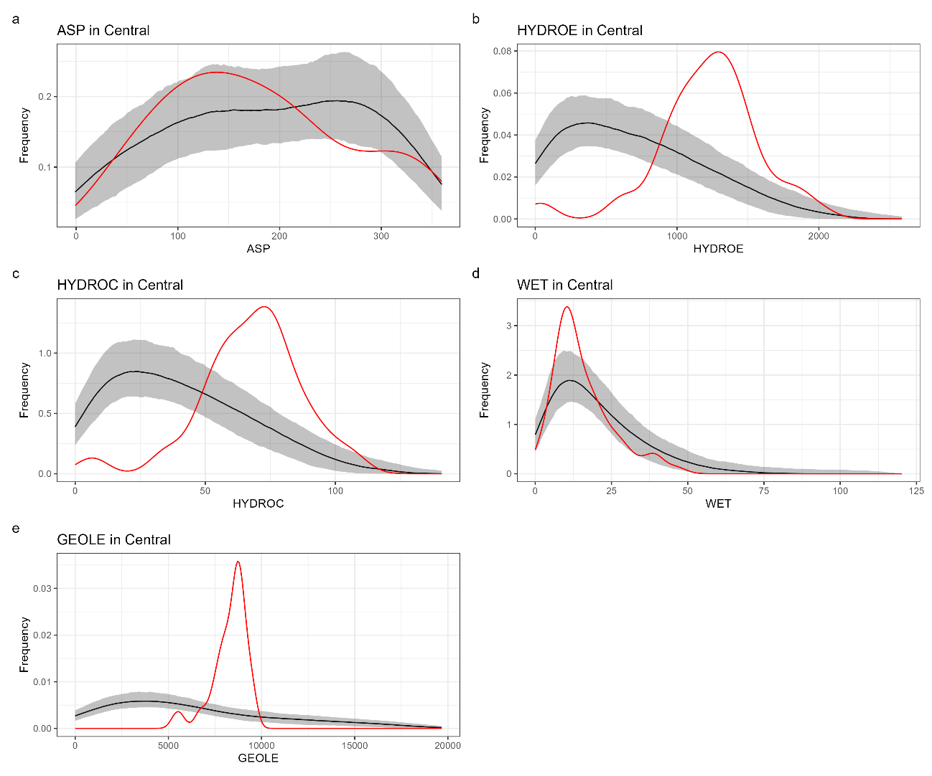
Fig. S2. Kernel density plots comparing the empirical distribution of archaeological sites (red line) and the expected distribution of randomly resampled background points (black line) for aspect (a: ASP), Euclidean distance to hydrology (b: HYDROE), cost distance to hydrology (c: HYDROC), wetland cost (d: WET), and Euclidean distance to geology (e: GEOLE) in the Central Mountain ranges. The grey shaded area denotes the 95% confidence envelope generated from 999 Monte Carlo simulations. Deviations of the observed curve (red) outside this simulated envelope (grey) indicate statistically significant differences between site locations and the available landscape background.
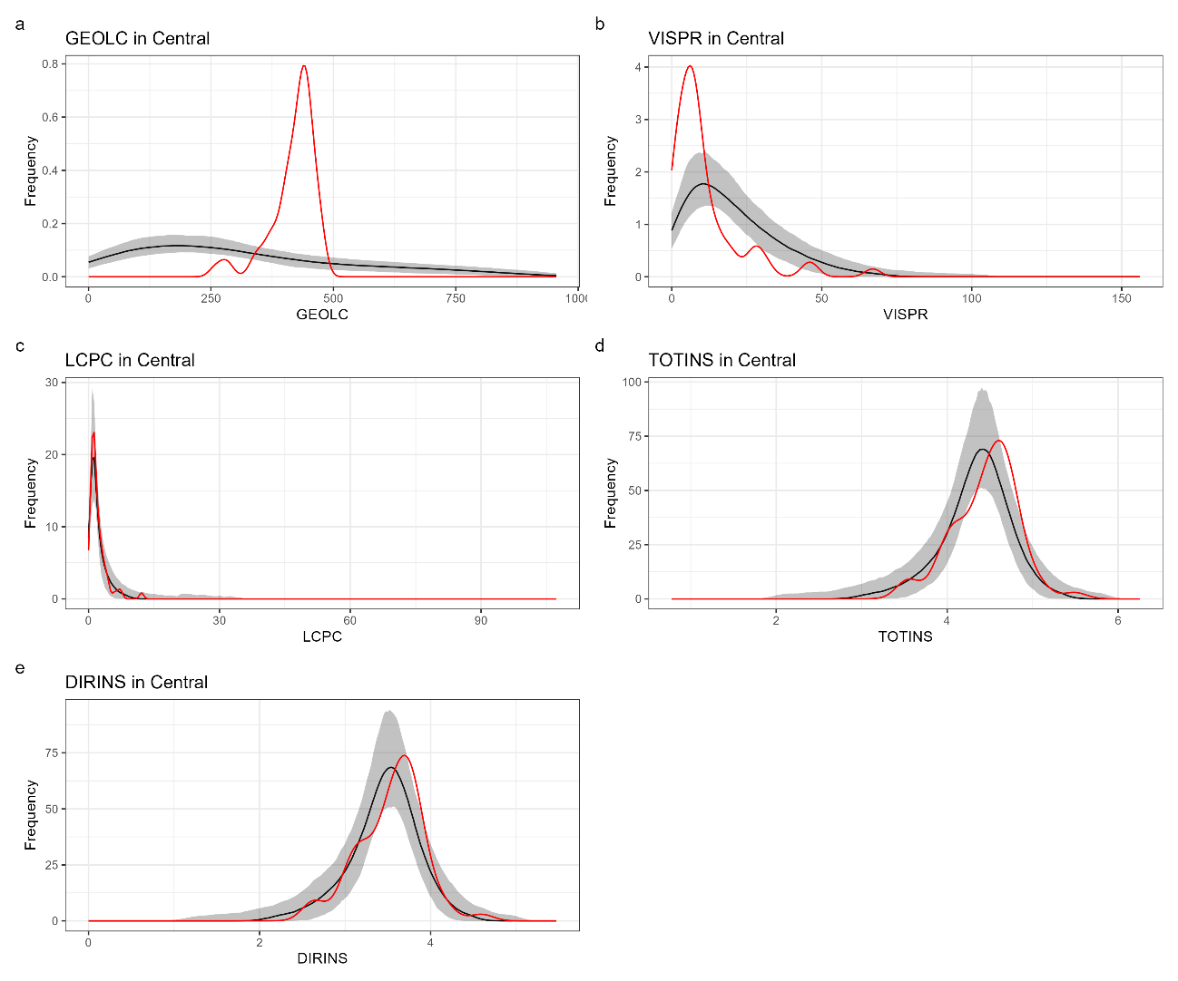
Fig. S3. Kernel density plots comparing the empirical distribution of archaeological sites (red line) and the expected distribution of randomly resampled background points (black line) for cost distance to geology (a: GEOLC), visual prominence (b: VISPR), cost to routes (c: LCPC), total insolation (d: TOTINS), and direct insolation (e: DIRINS) in the Central Mountain ranges. The grey shaded area denotes the 95% confidence envelope generated from 999 Monte Carlo simulations. Deviations of the observed curve (red) outside this simulated envelope (grey) indicate statistically significant differences between site locations and the available landscape background.
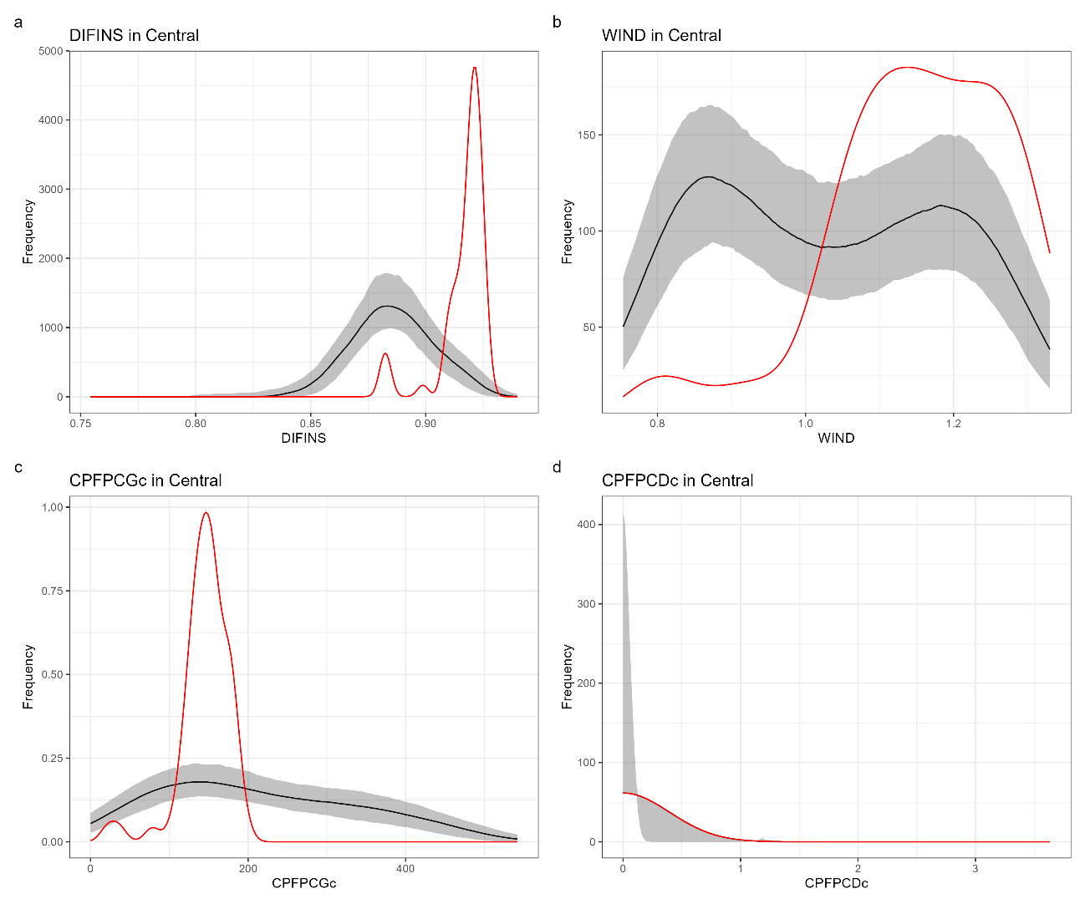
Fig. S4. Kernel density plots comparing the empirical distribution of archaeological sites (red line) and the expected distribution of randomly resampled background points (black line) for diffuse insolation (a: DIFINS), wind exposure (b: WIND), cost potential for goats (c: CPFPCGc), and cost potential for deer (d: CPFPCDc) in the Central Mountain ranges. The grey shaded area denotes the 95% confidence envelope generated from 999 Monte Carlo simulations. Deviations of the observed curve (red) outside this simulated envelope (grey) indicate statistically significant differences between site locations and the available landscape background.
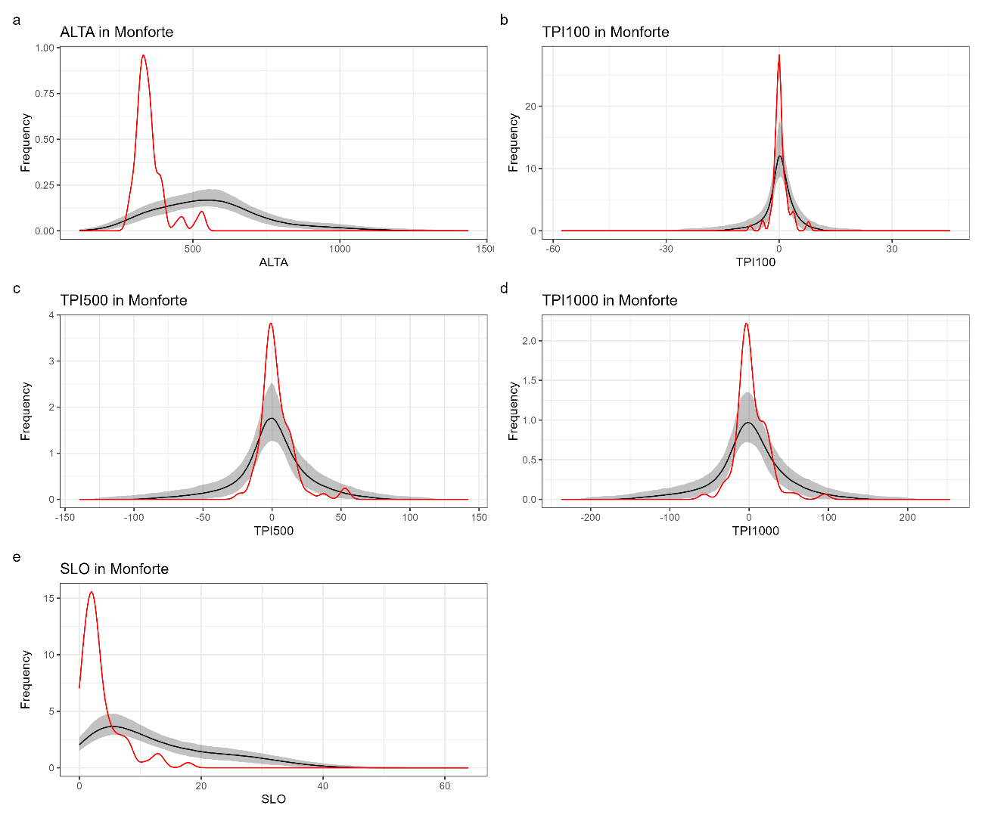
Fig. S5. Kernel density plots comparing the empirical distribution of archaeological sites (red line) and the expected distribution of randomly resampled background points (black line) for elevation (a: ALTA), Topographic Position Index (b: TPI100; c: TPI500; d: TPI1000), and slope (e: SLO) in the Monforte de Lemos basin. The grey shaded area denotes the 95% confidence envelope generated from 999 Monte Carlo simulations. Deviations of the observed curve (red) outside this simulated envelope (grey) indicate statistically significant differences between site locations and the available landscape background.
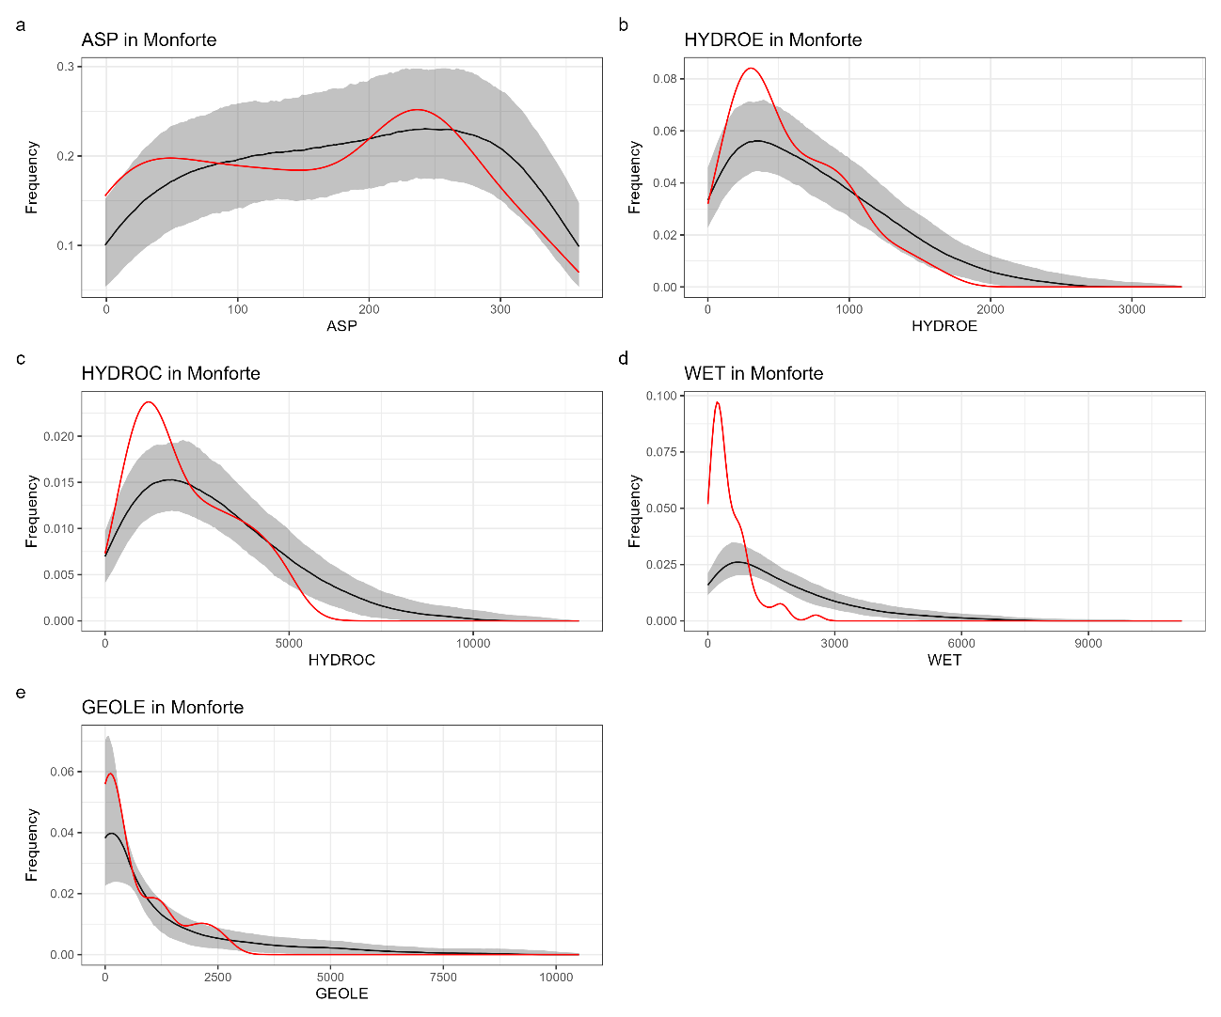
Fig. S6. Kernel density plots comparing the empirical distribution of archaeological sites (red line) and the expected distribution of randomly resampled background points (black line) for aspect (a: ASP), Euclidean distance to hydrology (b: HYDROE), cost distance to hydrology (c: HYDROC), wetland cost (d: WET), and Euclidean distance to geology (e: GEOLE) in the Monforte de Lemos basin. The grey shaded area denotes the 95% confidence envelope generated from 999 Monte Carlo simulations. Deviations of the observed curve (red) outside this simulated envelope (grey) indicate statistically significant differences between site locations and the available landscape background.
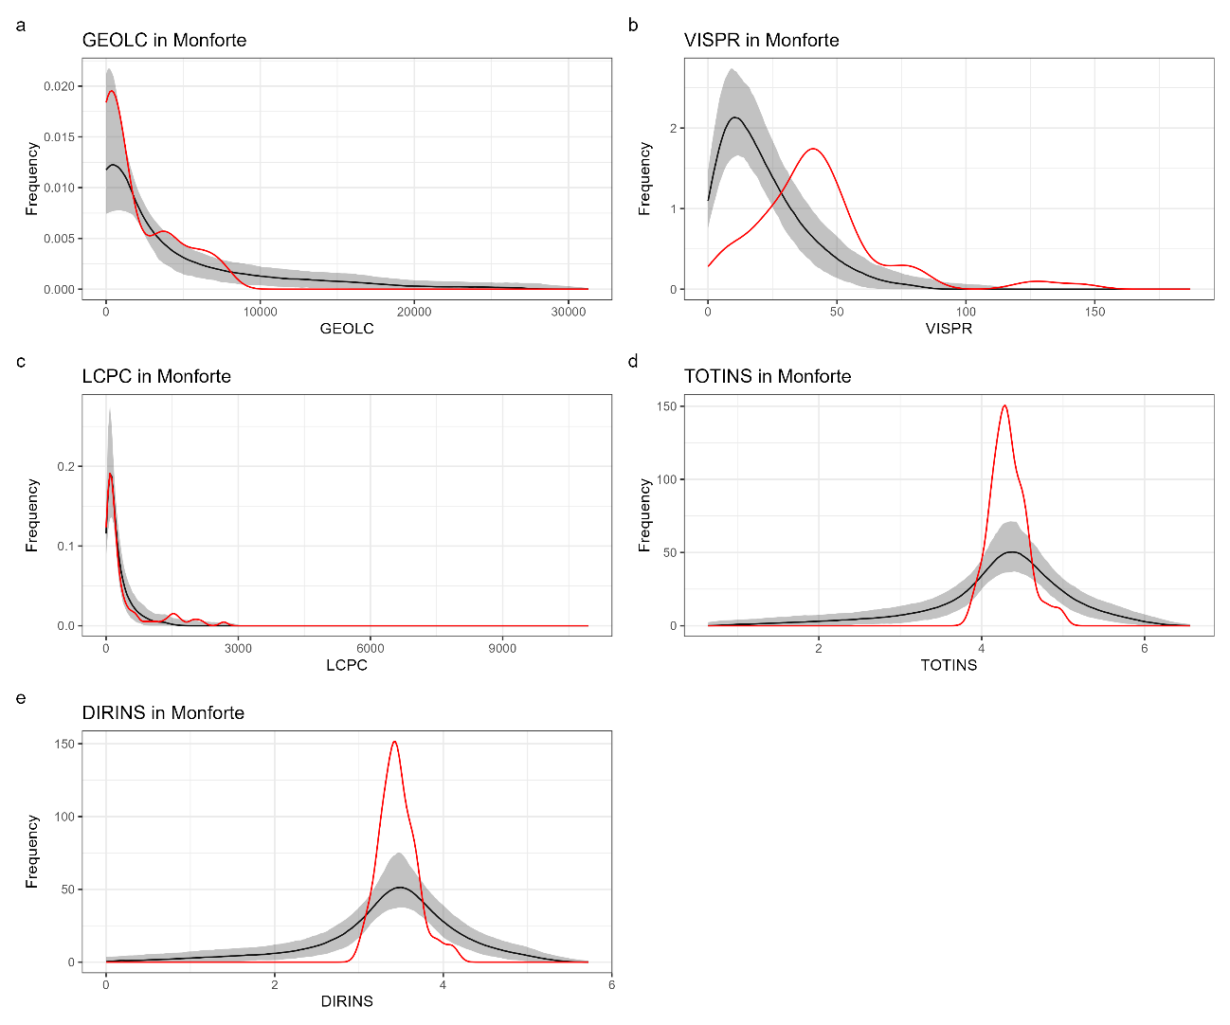
Fig. S7. Kernel density plots comparing the empirical distribution of archaeological sites (red line) and the expected distribution of randomly resampled background points (black line) for cost distance to geology (a: GEOLC), visual prominence (b: VISPR), cost to routes (c: LCPC), total insolation (d: TOTINS), and direct insolation (e: DIRINS) in the Monforte de Lemos basin. The grey shaded area denotes the 95% confidence envelope generated from 999 Monte Carlo simulations. Deviations of the observed curve (red) outside this simulated envelope (grey) indicate statistically significant differences between site locations and the available landscape background.
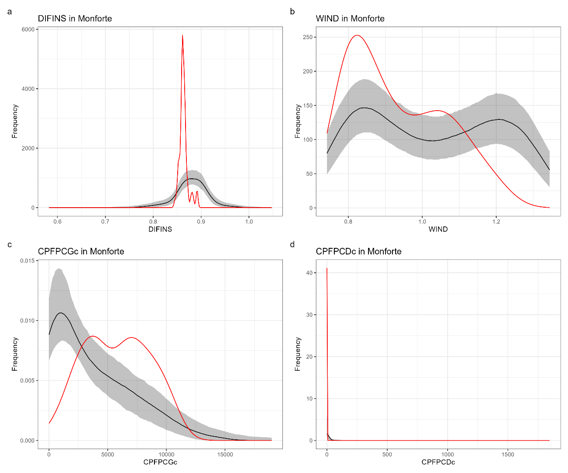
Fig. S8. Kernel density plots comparing the empirical distribution of archaeological sites (red line) and the expected distribution of randomly resampled background points (black line) for diffuse insolation (a: DIFINS), wind exposure (b: WIND), cost potential for goats (c: CPFPCGc), and cost potential for deer (d: CPFPCDc) in the Monforte de Lemos basin. The grey shaded area denotes the 95% confidence envelope generated from 999 Monte Carlo simulations. Deviations of the observed curve (red) outside this simulated envelope (grey) indicate statistically significant differences between site locations and the available landscape background.
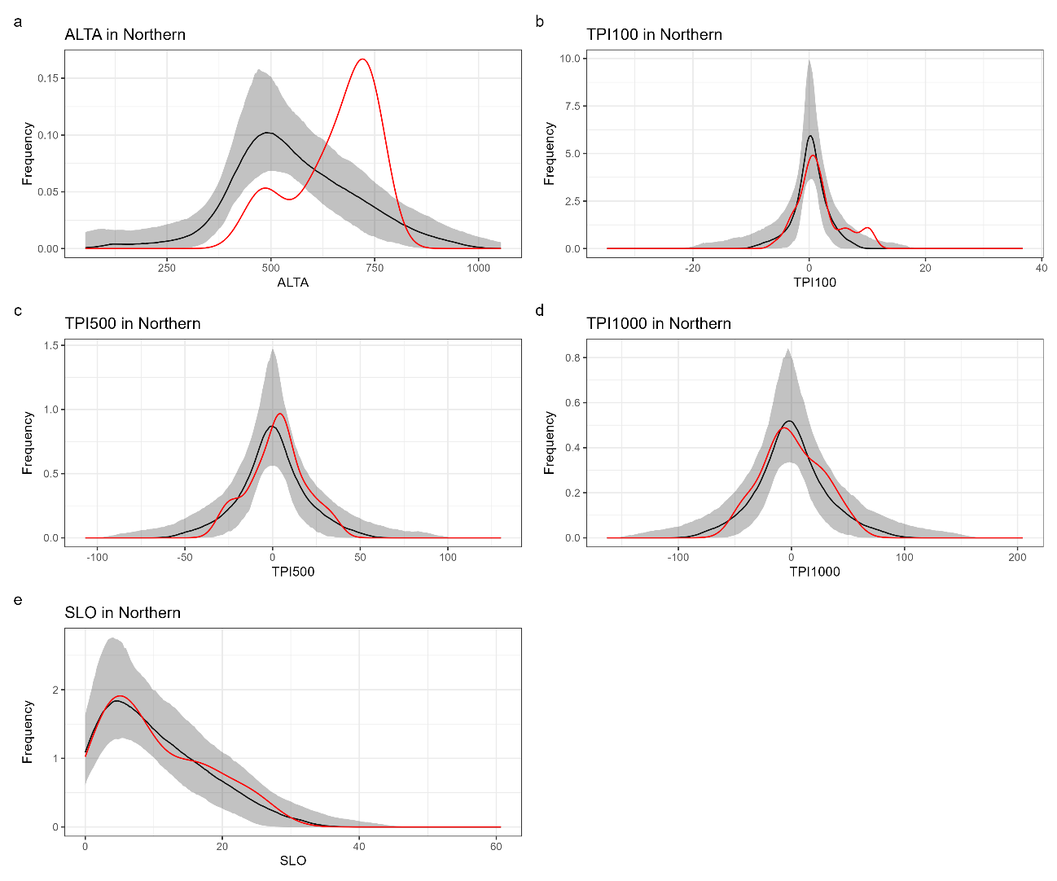
Fig. S9. Kernel density plots comparing the empirical distribution of archaeological sites (red line) and the expected distribution of randomly resampled background points (black line) for elevation (a: ALTA), Topographic Position Index (b: TPI100; c: TPI500; d: TPI1000), and slope (e: SLO) in the Northern Mountain ranges. The grey shaded area denotes the 95% confidence envelope generated from 999 Monte Carlo simulations. Deviations of the observed curve (red) outside this simulated envelope (grey) indicate statistically significant differences between site locations and the available landscape background.
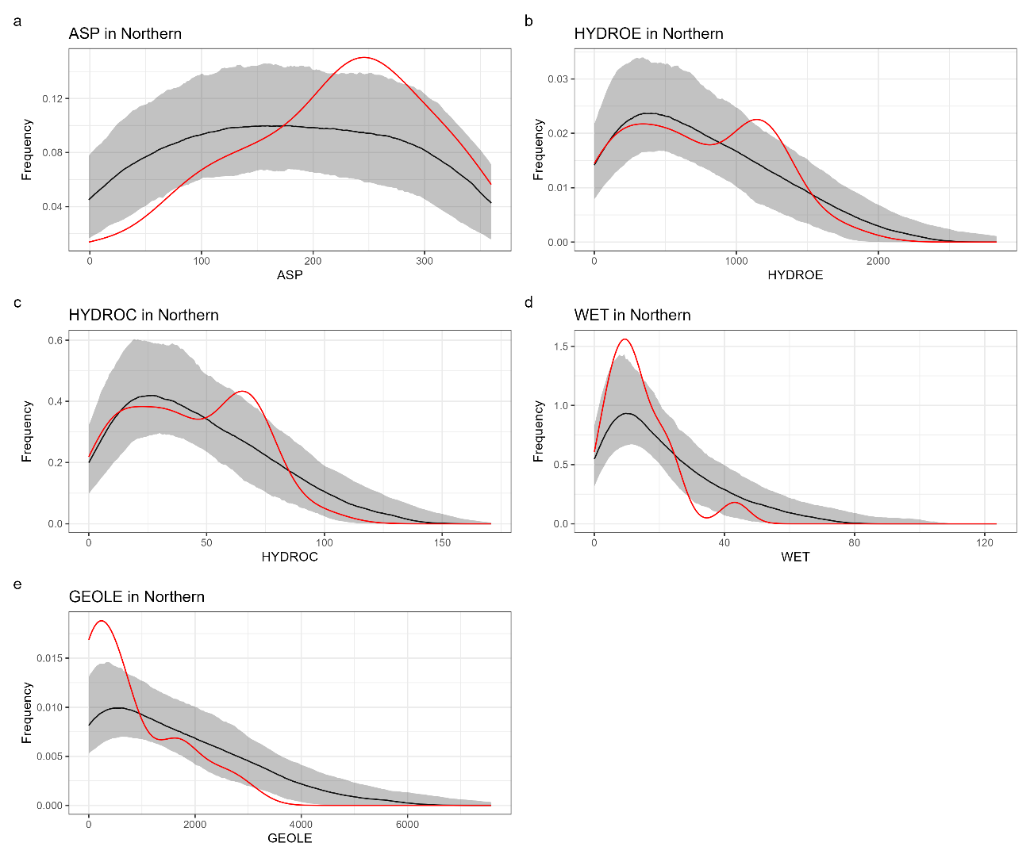
Fig. S10. Kernel density plots comparing the empirical distribution of archaeological sites (red line) and the expected distribution of randomly resampled background points (black line) for aspect (a: ASP), Euclidean distance to hydrology (b: HYDROE), cost distance to hydrology (c: HYDROC), wetland cost (d: WET), and Euclidean distance to geology (e: GEOLE) in the Northern Mountain ranges. The grey shaded area denotes the 95% confidence envelope generated from 999 Monte Carlo simulations. Deviations of the observed curve (red) outside this simulated envelope (grey) indicate statistically significant differences between site locations and the available landscape background.
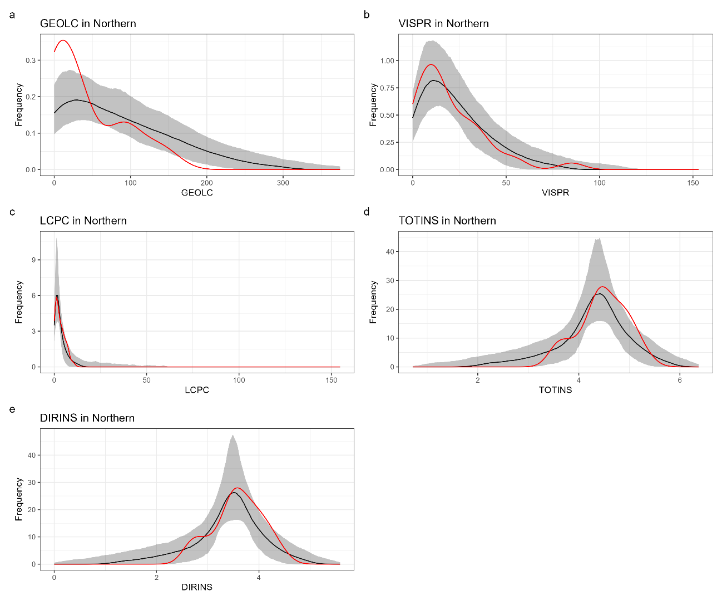
Fig. S11. Kernel density plots comparing the empirical distribution of archaeological sites (red line) and the expected distribution of randomly resampled background points (black line) for cost distance to geology (a: GEOLC), visual prominence (b: VISPR), cost to routes (c: LCPC), total insolation (d: TOTINS), and direct insolation (e: DIRINS) in the Northern Mountain ranges. The grey shaded area denotes the 95% confidence envelope generated from 999 Monte Carlo simulations. Deviations of the observed curve (red) outside this simulated envelope (grey) indicate statistically significant differences between site locations and the available landscape background.
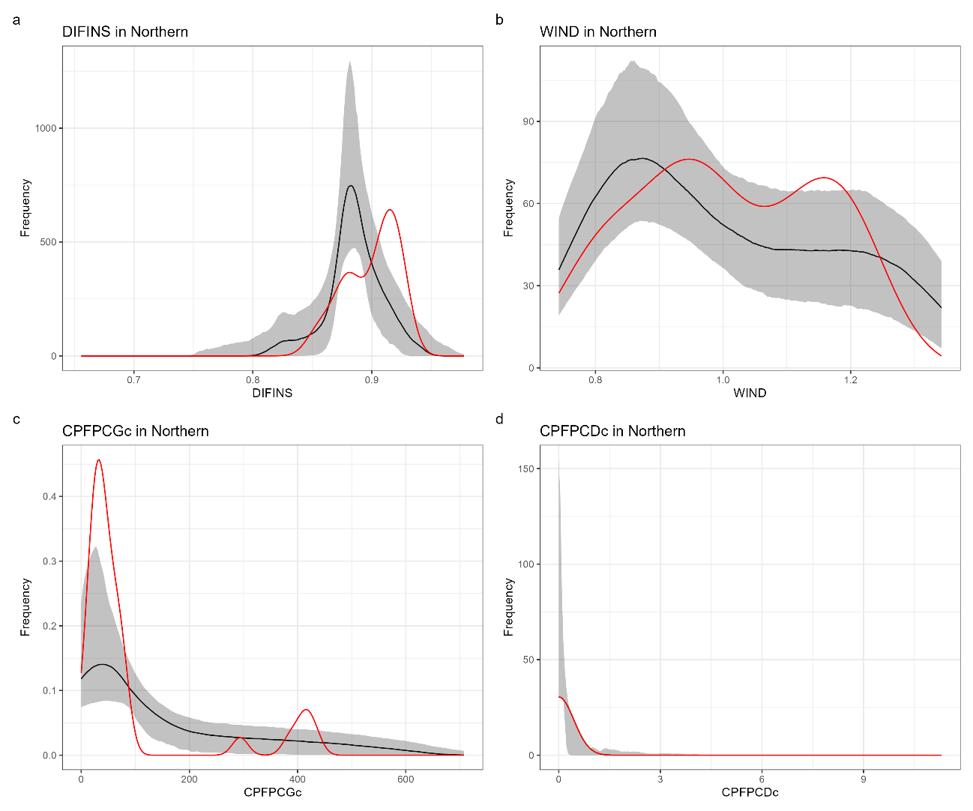
Fig. S12. Kernel density plots comparing the empirical distribution of archaeological sites (red line) and the expected distribution of randomly resampled background points (black line) for diffuse insolation (a: DIFINS), wind exposure (b: WIND), cost potential for goats (c: CPFPCGc), and cost potential for deer (d: CPFPCDc) in the Northern Mountain ranges. The grey shaded area denotes the 95% confidence envelope generated from 999 Monte Carlo simulations. Deviations of the observed curve (red) outside this simulated envelope (grey) indicate statistically significant differences between site locations and the available landscape background.

References
Bache, S. M., & Wickham, H. (2022). magrittr: A Forward-Pipe Operator for R.
Baddeley, A. J., Turner, R., & Rubak, E. (2025). spatstat.convert: Extension to ‘spatstat’ for Converting Data Formats.
Baddeley, A., Turner, R., & Rubak, E. (2025). spatstat.geom: Geometrical Functionality of the ‘spatstat’ Family.
Baddeley, Adrian, Turner, R., & Rubak, E. (2020). spatstat: Spatial Point Pattern Analysis, Model-Fitting, Simulation, Tests.
Daniel, F., Ooi, H., Calaway, R., Microsoft, & Weston, S. (2022). foreach: Provides Foreach Looping Construct.
Dunnington, D. (2023). ggspatial: Spatial Data Framework for ggplot2.
Hernangómez, D. (2023). Using the tidyverse with terra objects: the tidyterra package. Journal of Open Source Software, 8(91), 5751. https://doi.org/10.21105/joss.05751
Hesselbarth, M. H. K. (2025). onpoint: Helper Functions for Point Pattern Analysis. https://doi.org/10.32614/CRAN.package.onpoint
Hijmans, R. J., Barbosa, M., Bivand, R., Brown, A., Chirico, M., Cordano, E., et al. (2025). terra: Spatial Data Analysis.
Hijmans, Robert J. (2023). raster: Geographic Data Analysis and Modeling.
Kosmidis, I. (2026). brglm2: Bias Reduction in Generalized Linear Models.
Leroy, B., Meynard, C. N., Bellard, C., & Courchamp, F. (2016). virtualspecies, an R package to generate virtual species distributions. Ecography, 39(6), 599–607. https://doi.org/10.1111/ecog.01388
Müller, K., & Wickham, H. (2023). tibble: Simple Data Frames.
Ooms, J., & Denney, B. (2025). writexl: Export Data Frames to Excel ‘xlsx’ Format.
Pebesma, E., & Bivand, R. (2023). Spatial Data Science: With applications in R. Chapman and Hall/CRC. https://doi.org/10.1201/9780429459016
Pebesma, Edzer, & Bivand, R. (2005). Classes and methods for spatial data in R. R News, 5(2), 9–13.
Pedersen, T. L. (2022). patchwork: The Composer of Plots.
Robin, X., Turck, N., Hainard, A., Tiberti, N., Lisacek, F., Sanchez, J.-C., & Müller, M. (2011). pROC: an open-source package for R and S+ to analyze and compare ROC curves. BMC Bioinformatics, 12, 77.
Robinson, D., Hayes, A., & Couch, S. (2023). broom: Convert Statistical Objects into Tidy Tibbles.
Schloerke, B., Cook, D., Larmarange, J., Briatte, F., Marbach, M., Thoen, E., et al. (2025). GGally: Extension to ‘ggplot2’. https://doi.org/https://ggobi.github.io/ggally/
Wickham, H., François, R., Henry, L., Müller, K., & Vaughan, D. (2023). dplyr: A Grammar of Data Manipulation. https://doi.org/10.32614/CRAN.package.dplyr
Wickham, Hadley, Chang, W., Henry, L., Pedersen, T. L., Takahashi, K., Wilke, C., et al. (2020). ggplot2: Create Elegant Data Visualisations Using the Grammar of Graphics.
Wilke, C. O. (2024). cowplot: Streamlined Plot Theme and Plot Annotations for ‘ggplot2’.

