# Webhook Recipe Example via Microsoft Azure App Service

The DocuSign Webhook recipe shows developers how to receive updates from DocuSign via a webhook. With a webhook, an application is called by the DocuSign platform when a status change occurs.

This memo shows how the Webhook Recipe’s php example may be run on the Microsoft Azure App Service using their free “Try App Service” system. For this trial, Azure does not request a credit card or even registration.

## Getting ready

You need an email and password for a DocuSign Developer Sandbox account. These are free via the [Developer registration page](https://secure.docusign.com/signup/developer).

You’ll also need an Integration Key for your Sandbox Account. The integration key is also free. [See this page for instructions on how to obtain an integration key.](https://www.docusign.com/developer-center/quick-start/overview)

## How to do it

**Step 1.**

Create your free site via the Microsoft Azure Web App Service.

Start: goto <https://tryappservice.azure.com/en-us>

Select app type: "Web App"

Click: Next

Select a template

Change Language: PHP

Choose PHP Empty Site

Click: Create

You will get a popup to sign in. You can use an Google account if you wish.

No credit card is needed.

You see the next web page with the message "Your web app has been created!"

Click the left most icon to ‘“Edit with Visual Studio Online "Monaco"’

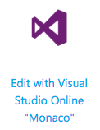

**Step 2.**

Now that your free Azure App Service is running, delete the existing files, import the example from GitHub, configure and run it.

**The Azure App Service Online editor**

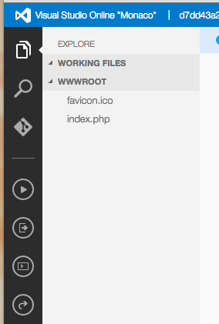

**Files explorer**

**Github controls**

**Show website**

In the Online Editor,

Click Files Explorer icon

Delete the two existing files (favicon.ico and index.php) by using the right mouse button

Next, clone the existing Git repo that holds the example:

Click Github controls icon. Enter

<https://github.com/LarryKlugerDS/azure-webhook> as the Repository URL

Click “Clone from a git URL”

Add your DocuSign credentials:

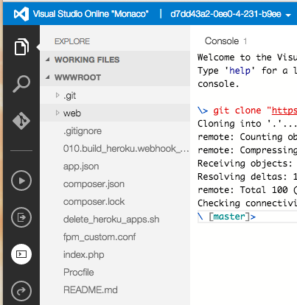

The editor should be in “EXPLORE” mode, so you can see your project’s files. If not, click the file explorer icon.

Click on the “web” folder name to open it.

Click on the file 010.webhook_lib.php

The file will appear in the main window of the editor:

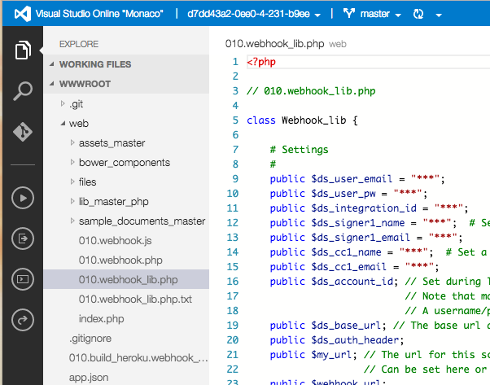

Update ONLY lines 9, 10, and 11 with your DocuSIgn Developer credentials instead of the asterisks.

The file is automatically saved

****Try out the example!

Go to the website by using the "Show website" icon on the left –

A new tab is opened in your browser. You should see the welcome screen for the recipe example.