Homework #6: ECL

Note on drawing from PSPICE: if a node is not indicated, the lines do not touch.

Question #1: FAN OUT for an ECL Inverter: β_{F} = 20
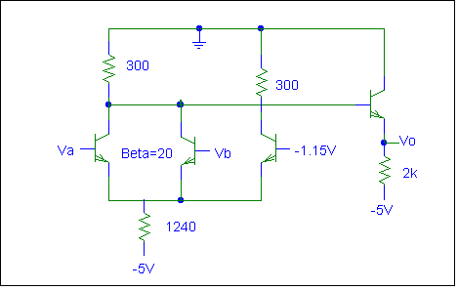

- Fan Out N for V_{A} = "1", V_{B} = "0", V_{OH} = -0.9V
- Fan Out N for V_{A} = "1", V_{B} = "1", V_{OH} = -0.9V
- Fan Out N for V_{A} = "1", V_{B} = "0", V_{OH} = -0.8V
- Fan Out N for V_{A} = "1", V_{B} = "0", V_{OH} = -1.0V

Question #2: ECL Inverter
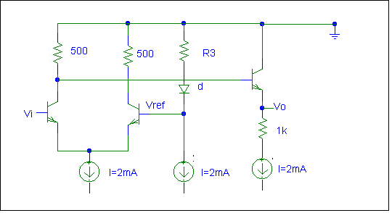
β_{F} = 10, V_{BE(on)} = 0.8V, V_{D(on)} = 0.8V, V_{REF} = -1.12V, I = 2mA

Questions on Next page:
- Find V_{oL} if V_{i} = -0.8V. Do not neglect I_{B3}
- Find V_{oH} if V_{i} = -1.6V. Do not neglect I_{B3}
- Find a new V_{REF} that would be symmetrical with V_{oL} and V_{oH} and find a a value for R₃ to generate this new V_{REF}. Neglect I_{B2.}
- Find the power in the circuit. Neglect base currents and assume V_{REF} = -1.2V and V_{i}= -0.8V.

Question #3: ECL Gate
V_{BE(on)} = 0.8V
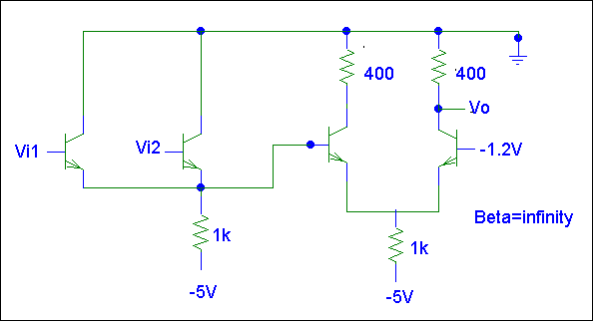

- Find V_{oH}
- Find V_{oL}
- Find V_{o} when V_{i1} = V_{oL} and V_{i2} = V_{oH}
- Find V_{o} when V_{i1} = V_{i2} = V_{oH}
- Find V_{o} when V_{i1} = V_{i2} = V_{oL}

Question #4: ECL Gate
V_{BE(on)} = 0.8V, β = 10, I_{o} = 0.5mA, R_{E12} = 10kΩ, R_{E34} = 1kΩ

- Find V_{oH}
- Find V_{oL}
- Find V_{iL}
- Find I_{iH} for worst case input configuration with V_{i} = -0.1V

(Picture on the next page…)

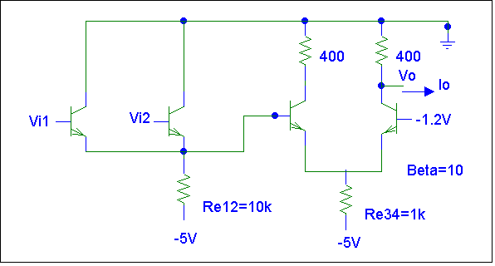
Drawing for Question #4.

Question #5:
V_{D(on)} = 0.2V, V_{BE(on)} = 0.8V, β = 10

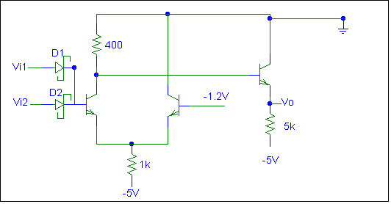
- Find the function of the gate.
- Find V_{iL}
- Find V_{iH}
- Find I_{IH} for worst case input conditions at V_{i} = V_{iH} of part C.
- Find the fan out for logic high when V_{o} = V_{iH} of part C.

You can also do questions 38, 43, 44 and 45 of Chapter 14 of Sedra & Smith.

