File: Installation_notes.pdf
Date: 2019/07/12

Here, we will describe some tips for the installation (Linux ubuntu 18.04). Our Flow Composed Implicit Runge-Method (FCIRK) implementation is developed in C-programming language and the integration method is interfaced via Jupyter/Julia powerful computational enviroment.

You can install FCIRK application and Julia packages by “installation_Notebook.ipyn” Jupyter notebook but previously, you must install some C special libraries, Julia programming language and Jupyter tool.

Language C

We use some special library that you must be installed:

(1) uuid-dev
install by synaptic tool

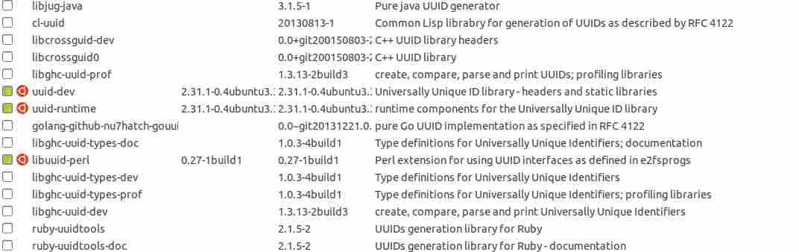
(2) quadmath library
Quad-Precision Math Library Application Programming Interface (API).
https://gcc.gnu.org/onlinedocs/libquadmath/#toc-Typedef-and-constants-1

(3) mpfr library
MPFR is a portable library written in C for arbitrary precision arithmetic on floating-point numbers.
The MPFR library is already installed on some GNU/Linux distributions and “How to Install” instructions, are explained in “GNU MPFR” manual.
(4) OpenMP Application Programming Interface
OpenMP API for parallelism in C, C++ and Fortran programs. Most of Compilers support Open API. http://www.openmp.org

Jupyter/Julia computational enviroment

(1) Julia.

We use Julia 1.1.0 version (http://julialang.org).

Additionally, these packages must be install:

Pkg.add("NBInclude")
Pkg.add("Plots")
Pkg.add("Dates")
Pkg.add("DelimitedFiles")
Pkg.add("LinearAlgebra")

(2) Jupyter.

We build our experiments on Jupyter notebooks (an open source tool for interative computing) using Julia programming language.

To install

$ julia
julia> ]
pkg> add IJulia
julia>using IJulia
julia>notebook()
julia>exit()

To execute:

$ jupyter notebook

