CSCI 580E/470 - Assignment 5 - Fall 2014
In this assignment you will write a timed self-practice quiz.
It will present a self-practice quiz by loading and displaying a set of questions within a pre-set time limit. The user provides an answer to each question and the program judges the answer by comparing the user's answer with the actual answer of the question. When the test is done, a total score is given out to the user. This assignment involves multiple concepts include polymorphism and multi-threading. You will need a proportionate amount of time for this assignment. Start early and do it incrementally.
For the ease of grading, the main class will be called QuizApp. Please zip up all the source files and supporting images for submission.
The questions can be either text or images (possibly with embedded text). The answers will be text. The user sets the total duration before clicking the Start button. The user cannot change the time limit during the test. So you should disable the Start button and the JTextField for the duration of the quiz once a quiz is started.
Two "Question Images" are shown below - you can use them in your project. Alternately, feel free to create your own if you like. (The source of the second question image is http://en.wikipedia.org/wiki/Ada_lovelace)
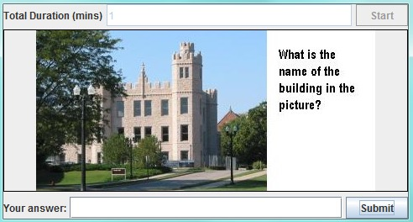
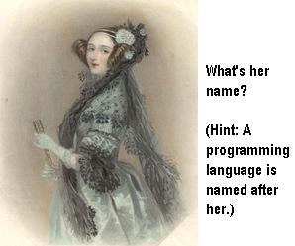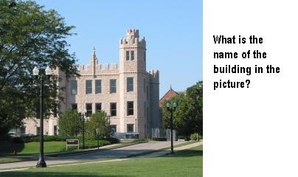
Quiz is started when the start Button is clicked. The program keeps track of the remaining time.
When the user clicks the Submit Button, the next question should be displayed. The quiz will stop either when the time limit is up or all the questions are answered. It then displays a message on the canvas area:
"Quiz is finished. Your total score is 2." (This could be displayed on 2 lines.)
At the end of one quiz, clear the student's answer line, disable the Submit Button, and enable the Start button and the JTextField for the duration. In general, the JButtons and JTextFields should be disabled/enabled whenever appropriate.
--------------------------- Important Classes
You will need to write a custom JPanel (subclass of JPanel): QuestionPanel that displays the questions. Then it will be placed on the QuizApp, which is a custom JFrame that groups everything together with reasonable layout, handles events for buttons.
For the purpose of layout, you may need some additional JPanel objects serving as an intermediate container that groups the components together.
QuestionPanel
QuestionPanel class extends JPanel. It is where the questions are painted and the time is checked. It contains the method:
public void paintComponent(Graphics g) that displays the questions.
Inside the paintComponent(..), it will call the corresponding method in the Question class hierarchy that does the actual drawing of the question (see Question class hierarchy below). The paintComponent(..) will also draw the message “Quiz is finished, your score is ..” when time is up or all questions are answered. Note that when the quiz is first displayed, it does not show any
question. The first question is shown once the Start button is clicked. So paintComponent(..) needs to have a logic to handle this (such as using a flag).
It also implements runnable, so that a separate thread is used for determining whether the time limit is up (or if all questions are done).
In the
public void run(),
the thread should sleep for a while before its next check for time, say 1 second. You can use System.currentTimeMillis() to get the current time. If time is up, it sets a boolean flag to true and then call repaint(). The flag is for paintComponent(..) to draw the summarizing messages when the test is done.
The class has an instance variable of Thread. It also contains two methods to start (or restart) and stop a thread.
To prepare for a quiz, the program reads the question file before it starts to draw the questions. These need to be done before a thread is started. Read the file using Scanner class. After a quiz is done, disable and enable the buttons as needed.
Question class hierarchy -- Question; TextQuestion; ImageQuestion
You should create and save a text file that contains the questions and answers. You could hardcode the file name as "quiz.txt". The file consists of pairs of lines, one line for the question and the other for the answer. If the question line ends with ".jpg" or ".gif" (you can add more meaningful extensions but these two are minimum), the program knows that it indicates an Image. The answer line is never an image. For example, you can have a file containing the following lines (without the dots):
• 1+1=? •2
• buildingquestion.jpg

• Altgeld
You will define a Question class. It is an abstract class that encapsulates information such as the question, the answer and the score. Important methods include:
1) Constructor: The constructor takes in two Strings for the question (or the image name of the question) and the answer.
2) draw(). This is an abstract method. It takes in arguments of Graphics and Dimension.

3) judgeAnswer(String). Clicking the Submit Button will call this method to judge the answer and store the score for that question. If right, the score for that question is 1, otherwise it is 0. Use equalsIgnoreCase() and trim() to (partly) avoid misjudging student answers.
To practice inheritance and polymorphism, you will define 2 more classes: TextQuestion and ImageQuestion, which are subclasses of Question and provide concrete implementations of draw() which will either draw a String (Use FontMetrics to do the cosmetics and positioning for Strings) or an Image centered on the QuestionPanel.
For ImageQuestion, its constructor loads the image into JVM (using Toolkit as explained in class). Its constructor requires one more parameter: an instance of current application (or the instance of QuestionPanel). This is used as the last parameter as the ImageObserver, for g.drawImage(...), which is called in draw().
You should construct TextQuestion or ImageQuestion instances while reading the file and store them into a java.util.ArrayList. Attributed to polymorphism, the program just needs one ArrayList for the type Question, which stores instances of either TextQuestion or ImageQuestion. The method paintComponent(Graphics) in QuestionPanel contains codes that call the draw(Graphics, Dimension) on the instance of current Question.
Other remarks:
1. As you see from the above explanation, thoughts need to be put to the design of a program with some degree of complexity. For example, which class is the best place to hold the implementation of certain method? --- A very general answer is to put it in the one that has the best knowledge on how to implement it. There are of course other considerations such as polymorphism. When needed, you also pass the objects of some classes to the constructors of other classes in order to link them together which is called “association” (e.g. pass the QuizApp object to the QuestionPanel's constructor so that the QuestionPanel’s code can access the components on QuizApp).

2. In this assignment, you are asked to use a thread to check if the time is up. It is for practicing multi-threaded programming. There exist alternatives in Java for checking if time is up (e.g. using a Timer).

--------------------------------
Bonus (5 points):
You can add the following for extra credit (you need to finish both items below in order to get the bonus points):
a. The total duration of a test should be between 1 minute and 20 minutes. If the entered number is not in the desired range, display a meaningful error message (in the JTextField or use a popup dialog). The test should not be started. Submitting an empty answer String will result in an error message: "Submission not successful. Please provide an
answer.". The program should also display an error message if it encounters problems in
reading the q/a file.
b. Show the answers of each question in addition to scores, at the end of the quiz.
Submission:
You should zip up all the source files (and supporting images or other text files) for submission.
If bonus items are implemented, you must explicitly state in Blackboard Comment Box AS WELL AS in your source code comment block of the main class.

