CSCI 470/680E - Assignment 3 100pts
Rewrite your first java file in Assignment 2 to be a GUI SWING program interface. Create a new solution with three .java files. Name your solution RPSGApp.
Make your GUI professional in appearance, with you choosing colors If you want to add a “STOP” button for 10 points extra credit, that is ok. In this GUI version of the game, there are no fixed number of rounds, the game will end when they hit START NEW GAME or hit the STOP button. Make text fonts large so they are readable.
SAMPLE RPS SCREEN SHOT
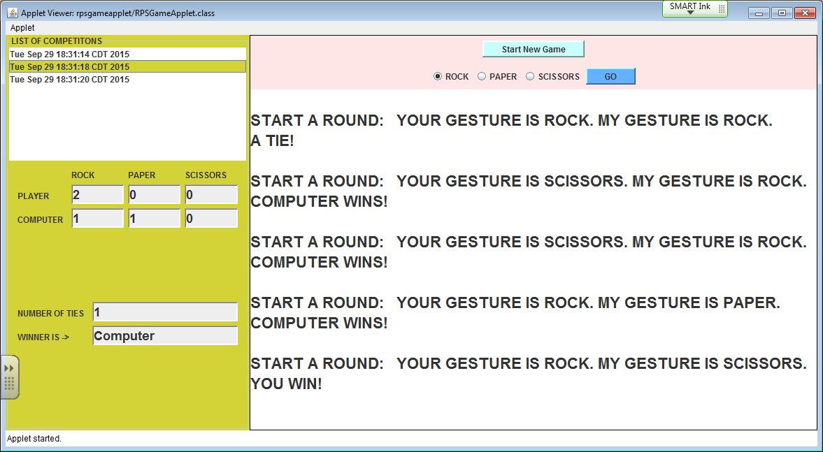

EAST PANEL WEST PANEL
Jlist with a jscroll pane –(north) one panel ((north),2x1 grid) with 2 subpanels panel with two sub panels(south) subpanel1 has start btn, other subpanel2 has 3 radio btns+go btn
Subpanel 1 (north) is 3x4 grid layout south area is outputtext panel
Subpanel 2 (south) is 2x2 grid
Creating custom colors-
Color c1 = new Color(211, 211, 55); //higher numbers means lighter colors
myPanel.setBackground(c1) //sets the color

