Initial screen:
Game Play Screenshots
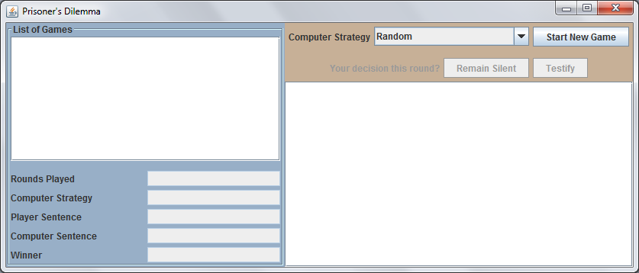
After choosing a strategy for the computer and starting a new game:
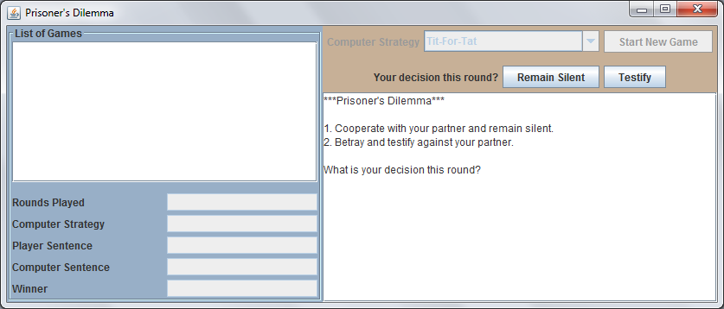
Player decides to remain silent for the first round:
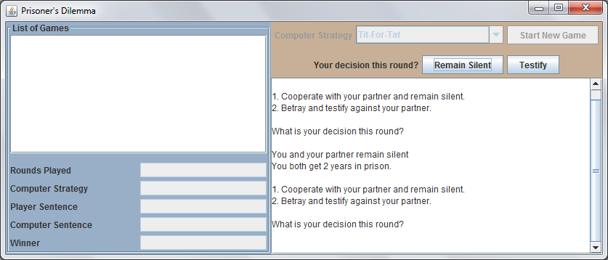
After a random number of rounds of play, the game ends:
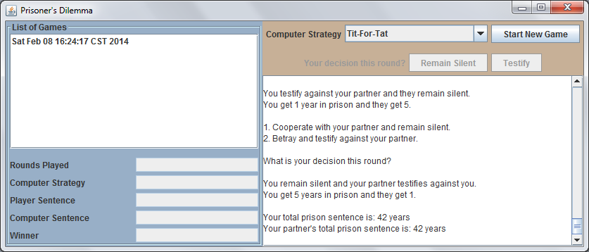
The player may now view the statistics for completed games:
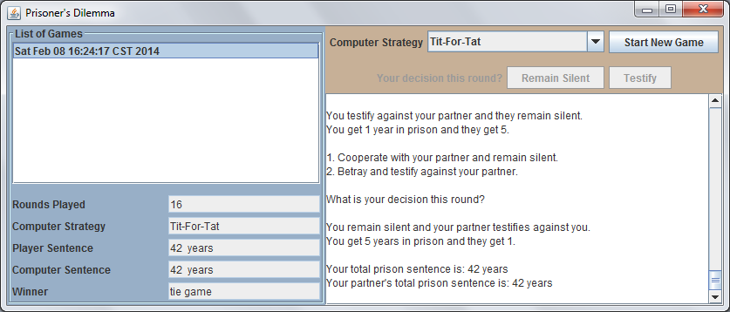
After three games have been completed:
