JAVA GARBAGE COLLECTING

Objects are created on the heap with pointers to them from the call stack.

As one creates objects, what happens to the available memory allocated for the Heap?

How is the heap managed? Answer: Garbage Collector program of JVM (GC)

→ Garbage collection relieves the Java programmer from memory management.

Garbage collection is a program/mechanism provided by Java Virtual Machine to reclaim heap space from objects which are “eligible” for Garbage collection.

When is an object elgible for collection?

1) All references to that object explicitly set to null e.g. object = null
2) The object is created inside a block and reference goes out scope once control exit that block.

HEAP MEMORY

STACK MEMORY

ST

ss

s
s
sj st1
STUDENT:
BETTY
CSCI
22

nnnnnnnnn
STUDENT:
BOB
MATH
20
Let us run a test of objects taking up heap memory with this code

public class LeakTest {

public static void main(String[] args) {
while(true)
{

int[] intArrayPtr = new int[100000000];

//8 zeros is ok, 9 zeros is too big an array
//analyze the storage used in task manager (cont,alt, delete)
System.out.println("running program-allocating int arrays/objects on heap");

}
}
}

To perform a leak test, do the following (click profile, leak test , and run)
Below is after clicking live results on the left. GC percentage is at far bottom on left
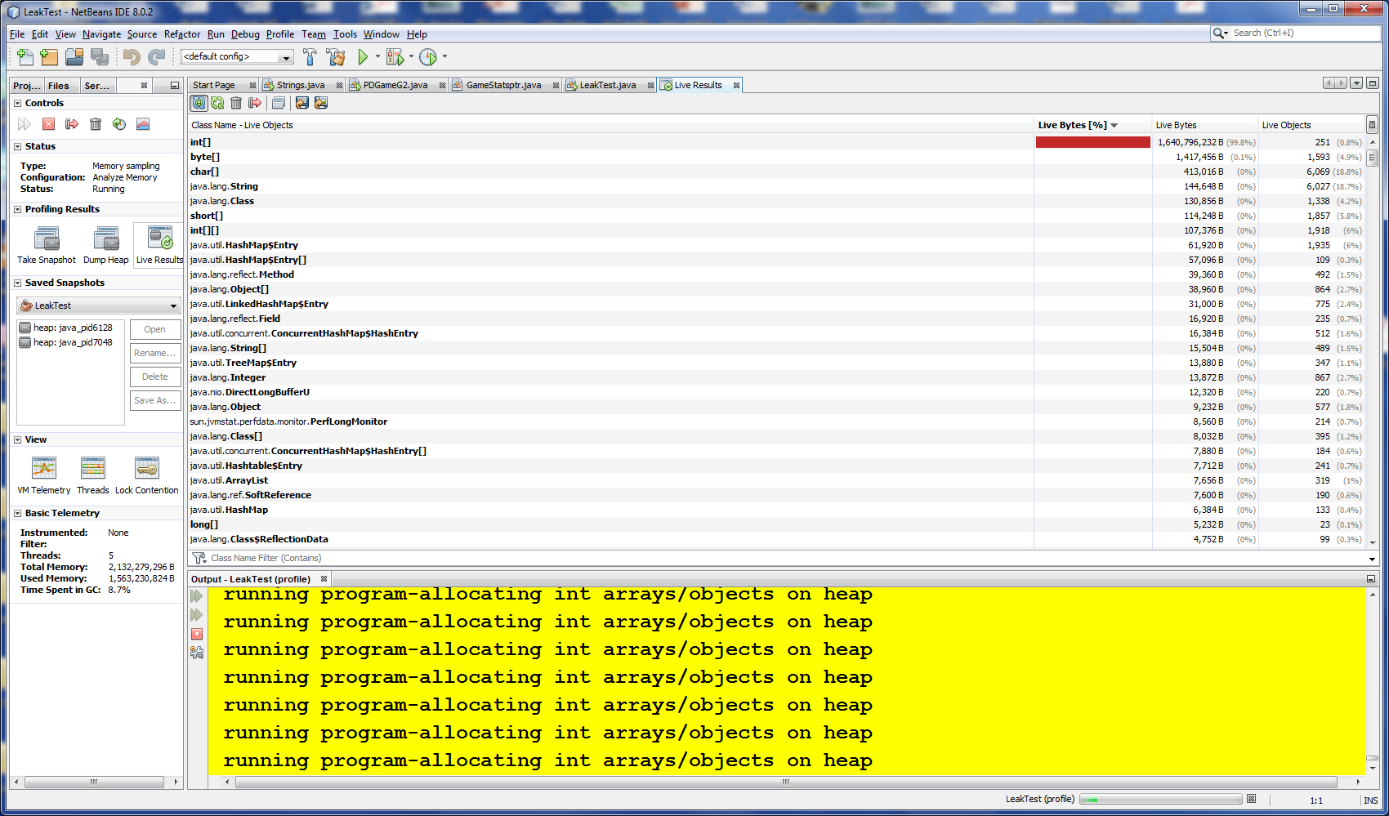

Can also do windows task manager by hitting control, alt ,delete
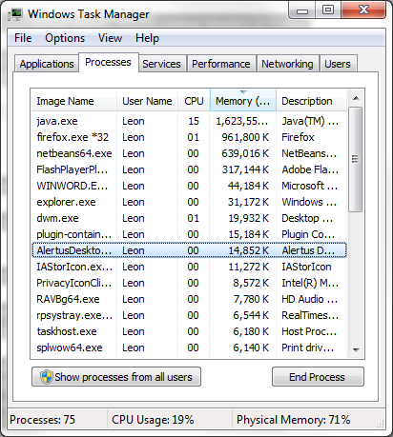
Java will monitor heap usage and trigger the garbage collector code if JVM thinks it needs a garbage collection based on Java heap size.

PERMANENT AREA
1.7 or less versions

OLD GENERATION
“MAJOR/FULL GC”

YOUNG GENERATION
“”MINOR GC”

Survivor 1

Survivor 2

Eden

JVM parameters in Java
On the basis of how we specify JVM option it can be divided into two parts, JVM Options which starts with –X and those which starts with -XX:
1) JVM Options that begin with -X are non-standard (thy are not guaranteed to be supported on all JVM implementations), and are subject to change without notice in subsequent releases of the JDK.
2) JVM Options or parameters which are specified with -XX are not stable and are not recommended for casual use. These options are subject to change without notice also.

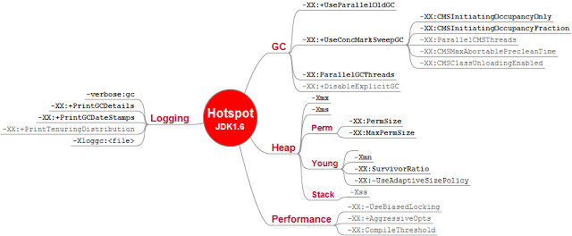

JVM SWITCHES IN NET BEANS

https://performance.netbeans.org/howto/jvmswitches/

For example, to set the -Xmx (maximum heap size) for the JVM NetBeans will run in, edit the file called netbeans.conf in the $NB_HOME/etc directory, and include the option -J-Xmx256m or launch the ide by typing
./netbeans -J-Xmx256m
or, on Windows systems
netbeans.exe -J-Xmx256m
The netbeans.conf file can have the various JVM switches included in the text string assigned to netbeans_default_options variable. Note that the Sun JVM does not start when passed line switches it doesn't understand, but it will return a message pointing out what the problem was, for example:

1) JVM memory options related to java heap size
Following three JVM options are used to specify initial and max heap size and thread stack size while running Java programs.

-Xms set initial Java heap size
-Xmx set maximum Java heap size
-Xss> set java thread stack size

