jar cf path\\\*.class

c means create new jar file
f means the jar file is specifuied

t - list contents of jar file
veriy jar tf path/// x.jar
run it
java –jar x.jar

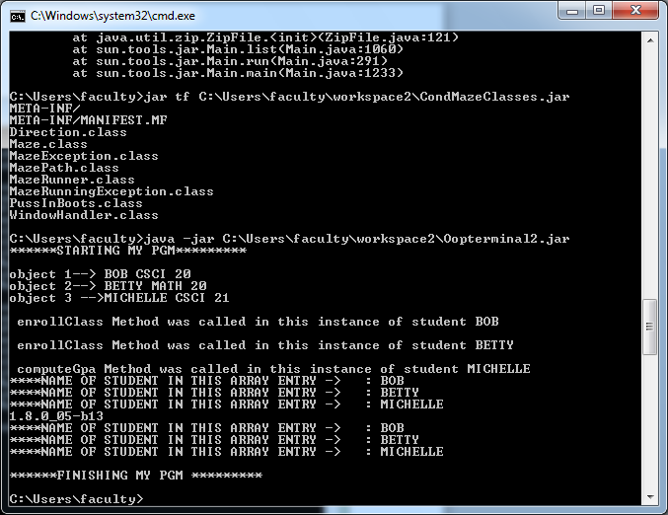

-j

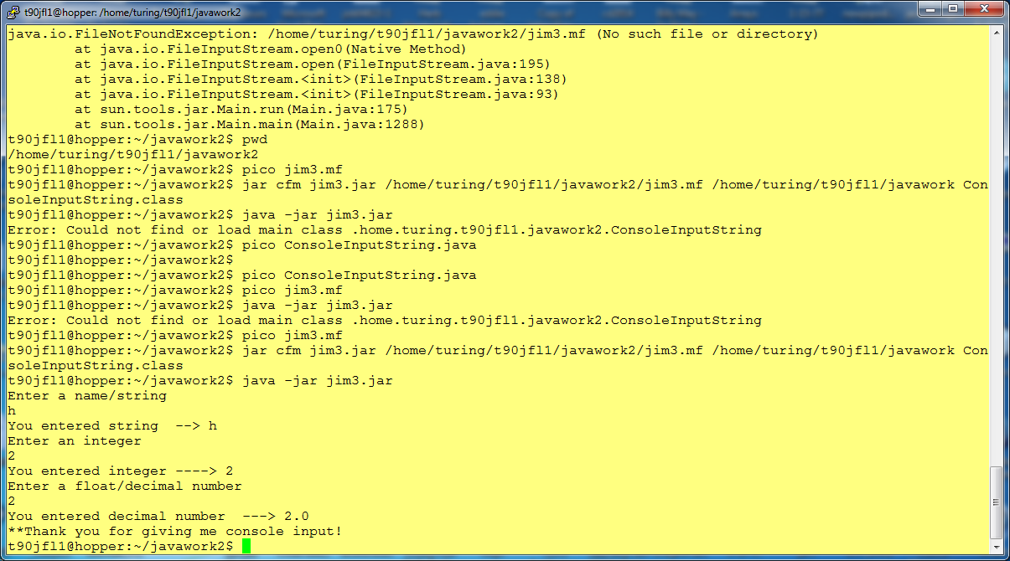

Need to make a jim3.mf file before you do the jar cfm xxx
Jim3.mf has

Main-Class: ConsoleInputstring

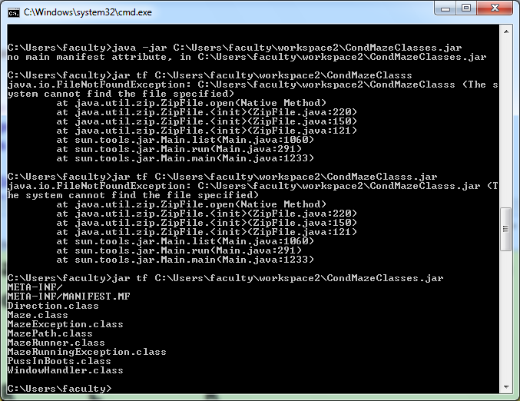

This below made jar file out of helloworld
First need to pico helloworld.mf
Main-Class: helloworld

t90jfl1@hopper:~/javawork2$ jar cfm hw.jar /home/turing/t90jfl1/javawork2/helloworld.mf /home/turing/t90jfl1/javawork2 helloworld.class

then to run it

java -jar hw.jar

IN ECLIPSE

//Create a Java archive (.jar) file using NetBeans as follows:

// Right-click on the Project name
// Select Properties
// Click Packaging
// Check Build JAR after Compiling
// Check Compress JAR File
// Click OK to accept changes
// Right-click on a Project name
// Select Build or Clean and Build - you will see messages that it is built and where it is located

(The jar is put in the /dist file of the directory, use explorer to find it)

Message given:
//To run this application from the command line without Ant, try:
//java -jar "G:\ajava\IntroOOPprograms\EqualPgm\dist\EqualPgm.jar"
// java -jar C:\Users\Leon\Desktop\PDGameApp2.jar if on desktop in office

