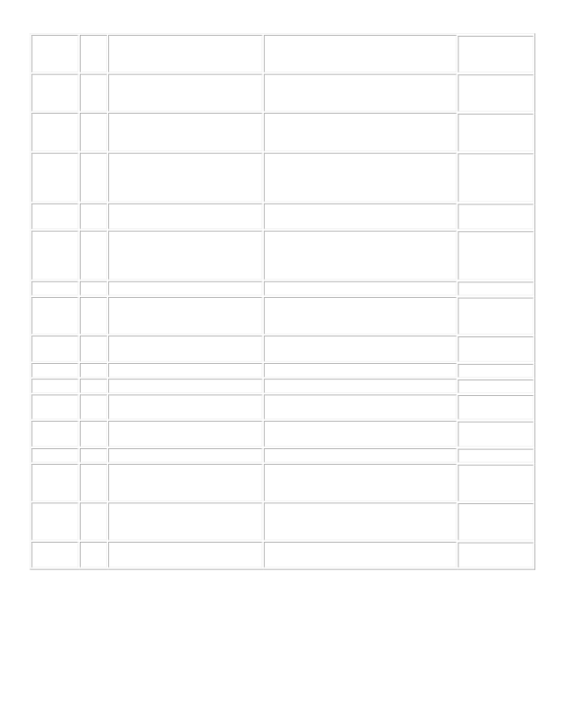
Date of
1st Week Topics Meeting
Chapter (for Notes Reference
Only)
2
09/01: Labor day 3 Program 0 (Preparation. no submission
needed).
08/25 1
Java language
introduction. Development cycle. Simple I/O.
09/01 (09/03)
Object-oriented programming in 2 Java: Abstraction. Program
examples.
Java language features: keywords, data types, exception handling, memory management, argument passing etc.
Java language features cont. Java Strings.
Java applet in Swing. Layout managers.
Swing components. Event handling.
Object-oriented programming in Java Part 2: Inheritance, Polymorphism, Interface
Test 1.
Start on painting
Painting in Swing; start on Threads. Threads
Networking
T est 2 etc.
JDBC, Object Serialization
Collection framework
GraduateStudentPresentations;Test 3 review
09/08 3
09/15 4
09/22 5
09/29 6 10/06 7
10/13 8
10/20 9 10/27 10
11/03 11
11/10 12 11/17 13
11/24 14
12/01 15
Program 1 due.
6, 7, 8, 11
11, 16
12/08 (12/10)
16 Test 3.
Thanksgiving break. Enjoy food ...
Program7due(withDatabase!)
No late submission is allowed for the last assignment.
Test 3 on Wednesday 12/10, 10am
Program 2 due. (A Console-based Java 23 Program)
14
9, 10 Program 3 due. (A Java app with Swing GUI)
Test 1 on Monday
Program 4 due (Painting etc.) 15
26 Program 5 due. (Now with threads! Yeah!) 27
Test 2 on Monday.
Program 6 due. (on Networking) 28
Note: This is a tentative schedule for CSCI 470/580 Fall 2014 Section 1.
• Assignments are due at the end of the day (11:59pm) of the due dates. The due dates will be shown in Blackboard e-
submission system, which will be considered as the official due dates for grading.

• Dates for the first two tests may be adjusted. The actual test dates will be notified in class at least one week in
advance.

• Chapters for the Deitel&Deitel book are for reference only. Lectures may cover different contents at different depth
and width in different order.

20

