SWING PGM WITH SCROLL PANES

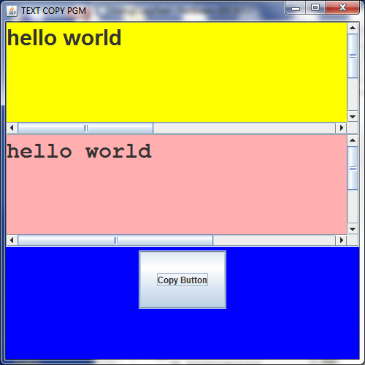

//program has a frame, and we add 2 scrollpanes with textareas to it to
//copy text and a red panel at bottom with a button

package swingcopytext;
import java.awt.*;
import java.awt.event.*;
import javax.swing.*;

public class SwingCopyText
{ public static void main(String[] args)
{
TextFrameApp frame = new TextFrameApp(500, 500); //width,height
frame.setTitle("TEXT COPY PGM");
frame.setVisible(true);
}
} //end swing copy text
//******************************************************
class TextFrameApp extends JFrame //textframeapp is a "frame", dont need to new up
//a frame explicitly
{
//these instance variables are defined outside main
//so all methods can access..they get filled in the constructor
private JTextArea inputAreaTA,outputAreaTA; // null pointers
private JButton copyBtn1; // null pointer
private JLbuttonListener jL1; //null pointer
//constructor
public TextFrameApp(int width, int height)
{
setSize(width, height); // width and height are passed in

// prepare text area for user input area for typing in text
// text area will hold 6 lines deep, 42 characters per line
// =====================================================
this.inputAreaTA = new JTextArea(6, 42); // Default is editable...

// pick font for the text the user enters
inputAreaTA.setFont( new Font("SansSerif", Font.BOLD, 30) );
inputAreaTA.setBackground(Color.yellow);

//add the input JTextArea to a scroll bar/pane object
JScrollPane inputScrollArea =
new JScrollPane(inputAreaTA, JScrollPane.VERTICAL_SCROLLBAR_ALWAYS,
JScrollPane.HORIZONTAL_SCROLLBAR_ALWAYS);

// prepare text area for output text area
outputAreaTA = new JTextArea(6, 42);
outputAreaTA.setEditable(false); // No editing in output area....

outputAreaTA.setFont( new Font("Monospaced", Font.BOLD, 30) );
outputAreaTA.setBackground(Color.PINK);

// Add JTextArea output area to another scroll bar/pane
JScrollPane outputScrollArea =
new JScrollPane(outputAreaTA, JScrollPane.VERTICAL_SCROLLBAR_ALWAYS,
JScrollPane.HORIZONTAL_SCROLLBAR_ALWAYS);

// set gridlayout for frame to be 3 rows, 1 column
setLayout(new GridLayout(3, 1));
// ======================================================
// Place the 3 components in grid -2 scroll areas and 1 panel
// ======================================================
this.add(inputScrollArea); //grid 1 element-scroll
this.add(outputScrollArea); //grid 2 element-scroll

// add a panel with button for grid 3 element
JPanel Panel1 = new JPanel(); // button
Panel1.setBackground(Color.blue); //make panel blue

copyBtn1 = new JButton("Copy Button"); //create a copy button
copyBtn1.setPreferredSize(new Dimension(120, 80)); //width, height of button
Panel1.add(copyBtn1); // add copy button to panel..
this.add(Panel1); // add blue panel to frame
jL1 = new JLbuttonListener(); //fill in pointer above
copyBtn1.addActionListener(jL1);//add listener class
}

// nested non-static inner "class" for the Copy button
private class JLbuttonListener implements ActionListener
{ //here the "implement" is on a different class and this class
//has total access to above class since it is an inner class

public void actionPerformed(ActionEvent event)
{
String inputtext;

// user has clicked copy button .get user input from text area
inputtext = inputAreaTA.getText();

//write it to output area
outputAreaTA.append(inputtext);

} //end action performed method
} //end class button listener
}//end class textframe app

SWING PROGRAM THAT COMPUTES AVERAGE

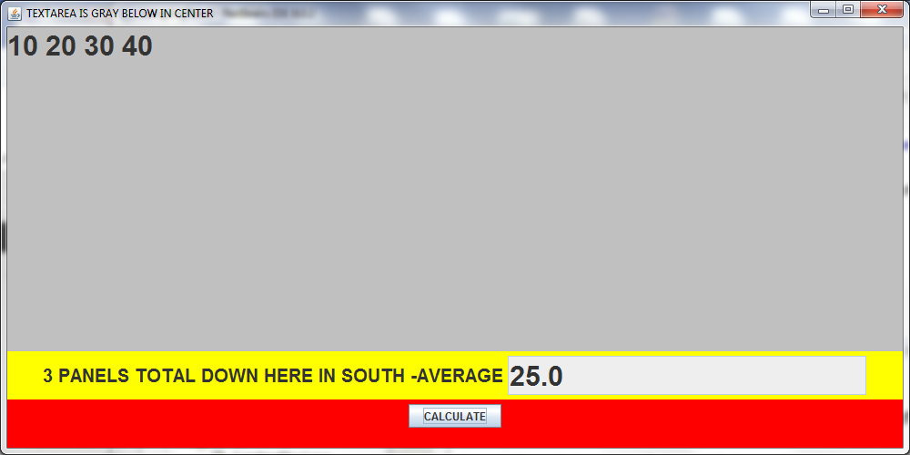

public class SwingAvgPanel extends JFrame {

private JTextArea inputTA; // pointer set to null
private JTextField answerTF; // pointer set to null
private JButton calcB; // pointer set to null

public static void main(String[] args)
{
SwingAvgPanel frame1 = new SwingAvgPanel();
frame1.setSize(1000, 500); // Set frame size
frame1.setVisible(true);

}
//constructor
public SwingAvgPanel(){
inputTA = new JTextArea(); //fills pointer above...
inputTA.setFont( new Font("SansSerif", Font.BOLD, 30) );
inputTA.setBackground(Color.lightGray);
this.getContentPane().add(inputTA, "Center");
//text field for output answer that is computed

answerTF = new JTextField(15); //fills pointer above
answerTF.setFont( new Font("SansSerif", Font.BOLD, 30) );
answerTF.setEditable(false); // No editing allowed here....

// ======================================================
// ResultPanel1 will be yellow
// +----------+-------------------------+
// | Average: | (output text field) |
// +----------+-------------------------+
// ======================================================
JPanel resultPanel1 = new JPanel(); // result panel to show answer
resultPanel1.setBackground(Color.yellow); // make it yellow
JLabel label1 = new JLabel("3 PANELS TOTAL DOWN HERE IN SOUTH -AVERAGE");
label1.setFont(new Font("SansSerif", Font.BOLD, 20));//LABEL FONT
resultPanel1.add(label1); // Add label first

resultPanel1.add(answerTF); // add output text area to yellow panel
//default is flow for this panel
// ======================================================
// Panel2 will be red and have calculate button
// +-----------------+
// | Calculate |
// +-----------------+
// ======================================================

JPanel buttonPanel2 = new JPanel(); //panel to show calc button
buttonPanel2.setBackground(Color.red);
// calculate button;
calcB = new JButton("CALCULATE");
buttonPanel2.add(calcB); // Add Calculate button

// ======================================================
// southPanel3...stack other two panels on top 2x1 in gridlayout format
//
//
// +--------------------------------------+
// |+----------+-------------------------+|
// || Average: | .....(output text area) ||
// |+----------+-------------------------+|
// | +-----------------+ |
// | | Calculate | |
// | +-----------------+ |
// +--------------------------------------+
// ======================================================

JPanel southPanel3 = new JPanel(); // Make a panel
southPanel3.setBackground(Color.red);
southPanel3.setLayout(new GridLayout(2, 1)); // 2 rows 1 column.
//order below is important,
southPanel3.add(resultPanel1); // Add first yellow panel
southPanel3.add(buttonPanel2); // Add red panel

// ========================================================
// Finally, put the stacked panels at "South" of JFrame
// ========================================================

this.add(southPanel3, "South");
calcB.addActionListener(new ButtonListener()); // register listener

}

/* =============================================================
Inner Listener class example for the Calculate button
This inner non-static class can access ANYTHING from above class
============================================================= */
class ButtonListener implements ActionListener {

public void actionPerformed(ActionEvent event)
{
String input;
double sum;
int i, N;

// get user input from text area
input = inputTA.getText(); // numbers are typed in here

// Tokenize the string
StringTokenizer tokenizer1 = new StringTokenizer(input);

N = tokenizer1.countTokens(); //see how many numbers are typed
sum = 0;
for ( i = 0; i < N; i++ ) //loop through the input numbers summing
sum += Double.parseDouble(tokenizer1.nextToken());

// display the average of numbers
answerTF.setText("" + sum/N);
} //end action performed method
} //end class Button Listener
} //end class swingavgpanel

