NST10 Final Exam Review Guide

Note: This review guide outlines major topics covered in lectures, discussion, and the required reading. It is meant to help you organize course material and study efficiently, and is therefore in no way exhaustive. Please remember all topics addressed in required course material are eligible for the exam.

Nutrition terms.

Essential nutrients- nutrients that must be provided in the diet because the body either cannot make them or cannot make them in sufficient quantities to satisfy its needs

Fortified foods- have nutrients added (usually nutrients that are deficient in our diets)

* milk with added Vitamin A and grains with added Vitamin B
* amounts and types of nutrients added to these foods specified by government mandated fortification programs; added to some foods to meet consumer demand for nutrients

enriched foods- adding vitamins that were taken out back into foods (vs. fortified which is adding vitamins that were never there)

refined foods- may lose some of the vitamins that they have

Macronutrients (protein, lipids, carbohydrate)- energy yielding nutrients that are needed in the body in large amounts each day

* remember 4-9-4 rule for carbs, lipids and proteins
* carbs include sugars and starches and provide a readily available source of energy (fiber is a carb too but does not provide energy)
* lipids are called “fats” or “oils” and are a concentrated form of energy
  + triglyceride is a type of fat that is abundant in the body
  + foods high in saturated fats may promote certain diseases; foods high in unsaturated fats may help to prevent certain diseases
* proteins are made of different amino acids and are required for growth and maintenance of the body (also provide energy)

Micronutrients (water, vitamins, iron etc.)- provide no energy for the body but are essential for the body to function (vitamins and minerals)

* Note: his lecture says that water is a macronutrient as it is needed in large amounts, the book says it is not part of either category (water does not provide kcals)
* only required in small amounts
* vitamins are organic molecules needed to regulate body processes
* minerals are inorganic molecules that either have regulatory roles or are important structurally

Nutrient density- measure of the nutrient a food provides compared to its energy content

Food pyramid and my plate

* food pyramid- set of dietary guidelines organized in a pyramid shape that was first shown in 1992; changed to more modern myPyramid in 2005
* my plate is the latest food guide and was introduced in 2011

Digestive system

Digestion- process of breaking foods into small enough components to be absorbed by the body

* Absorption- process of taking substances into the body

Gastrointestinal tract- hollow tube consisting of mouth, pharynx, esophagus, stomach, small intestine, large intestine and anus

* transit time- amount of time it takes food to pass through the GI tract
* wall of GI tract contains four layers of tissues
* digestion inside GI tract is aided by digestive secretions of mucus and enzymes
* mouth- entry point of food where food is broken down
* pharynx- food and liquid pass through here on the way to the stomach; shared with respiratory tract
* esophagus- tube that passes through the diaphragm to connect the pharynx and the stomach
* stomach- serves as a temporary storage space for food
* small intestine- narrow tube that is the main site of digestion of food and absorption of nutrients
  + villi- fingerlike projections on the small intestine that help maximize surface area
  + microvilli- very small projections on the villi that further increase surface area (often referred to as the brush border)
* large intestine- can absorb water and some vitamins and minerals
* GI tract protects the body from infection

Accessory organs of the digestive tract (saliva, pancreas, liver)

* pancreas secretes digestive enzymes and bicarbonate ions into the small intestine during digestion
* liver- produces bile
* saliva- watery fluid produced and secreted into the mouth that serves a variety of purposes

Villi- line the small intestine and are meant to increase the surface area

Microvilli- villi on top of villi that are meant to further increase surface area of small intestine

Gastric pits- tiny openings on the surface of the stomach mucosa which lead to gastric glands that secrete substances into stomach

Digestive enzymes

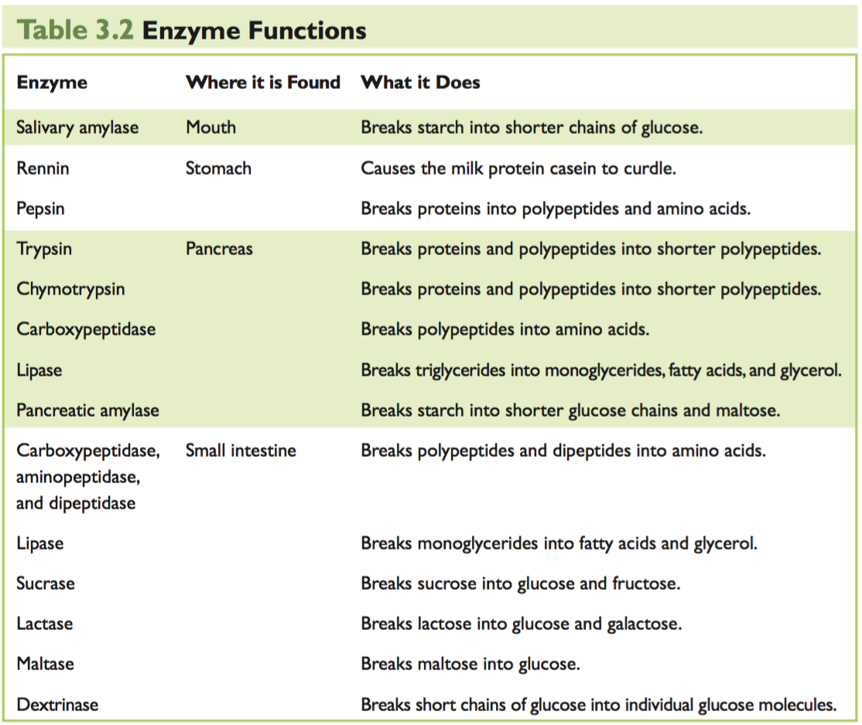

Digestive hormones (gastrin, somatostatin, secretin, CCK, gastric inhibitory peptide)

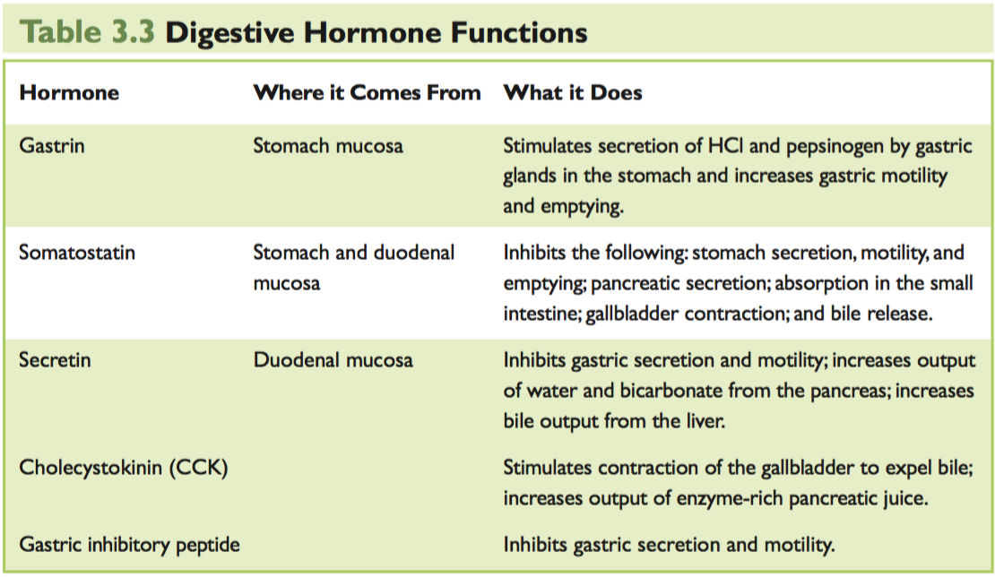

Bile acids- substance produced in the liver and stored in the gallbladder necessary for fat digestion and absorption

Bicarbonate ions

Nutrient absorption

Microflora- bacteria in the small intestine that aid with digestion

Probiotics

* live microorganism that when ingested in adequate amounts confers health benefits on the host

prebiotics

* substance that stimulates bacterial growth in the small intestine

Digestive problems (ulcers, heartburn, gallstones, etc.)

Gluten intolerance

Metabolism of Nutrients

Catabolic reaction

Enzymatic reactions

ATP

* chemical that supplies energy for many cellular processes and reactions

Oxidative metabolism

Carbohydrate

Monosaccharides (glucose, fructose, galactose)- single sugar molecule that is the basis of a carbohydrate

* glucose is the primary form of carb used to provide energy in the body (called blood sugar)
* galactose combines with glucose to form lactose or milk sugar (Both glucose & galactose are rarely present as a monosaccharide in food)
* fructose is the primary form of carb found in fruit (most of the fructose in our diet comes from high-fructose corn syrup)

Disaccharides (maltose, sucrose, lactose) - simple carbs made of two monosaccharides linked together

* sucrose (common white table sugar) is formed by linking glucose to fructose (only sweetener that can be labeled as sugar in the US)
* lactose is combo of glucose and galactose and is the only sugar found naturally in animal foods
* maltose consists of two molecules of glucose

Condensation and hydrolysis reactions

* condensation reaction- chemical reaction that links two sugar molecules together
* hydrolysis reaction- chemical reaction that breaks sugar molecules apart

Complex Carbohydrates (oligosaccharide, polysaccharide)- made up of many monosaccharides linked together

* oligosaccharides- short chains of less than ten monosaccharides
* polysaccharide- long chains of monosaccharides that include glycogen, starch and fiber

Dietary fiber (soluble fiber, insoluble fiber)- includes certain complex carbs that cannot be digested by human enzymes

* soluble fiber dissolves in water, insoluble fibers do not

Lactose intolerance- enzyme lactase is needed to digest lactose, milk sugar. If lactose is not digested in small intestine, it passes into the large intestine and can cause cramping, diarrhea, etc.

Insulin- hormone made in the pancreas that allows the uptake and storage of glucose by body cells and has other effects (reduces blood glucose levels)

Glucagon- hormone made in pancreas that stimulates the breakdown of liver glycogen and the synthesis of glucose (increases blood glucose levels)

Gluconeogenesis - synthesis of glucose from simple noncarbohydrate molecules; essential for meeting the body’s immediate need for glucose

Ketogenesis- breakdown of fatty acids into ketones, which can be used as energy

Diabetes (T1DM, T2DM)- leading cause of blindness and leads to kidney failure

* type 1: insulin is no longer made in the body
* type 2: insulin is present, but the cells do not respond

Diabetes complications

* immediate symptoms: excessive thirst, frequent urination, blurred vision and weight loss
* long term complications: damage to the heart, blood vessels, kidneys, eyes and nervous system; greater chance of infection

Lipids

Triglycerides- consist of three fatty acids attached to a glycerol molecule and is the major form of lipid in food and the body

Fatty acids (short-chain, medium- chain or long-chain fatty acids, saturated or unsaturated

fatty acids, cis- or trans-fatty acids)

* short chain fatty acids range from 4-7 carbons and are liquid at colder temperatures
* medium chain fatty acids are 8-12 carbons and solidify when chilled (still liquid at room temp)
* long chain fatty acids, greater than 12 carbons, are solid at room temperature
* saturated fatty acids contain carbons in a change bound by two hydrogens (found in most animal fats and tropical oils)
* unsaturated fatty acids contain some carbons that are not saturated with hydrogen (include the essential fatty acids, Omega 3 and Omega 6, monounsaturated fatty acids, and polyunsaturated fatty acids)
* trans fatty acids can be created by hydrogenation; raise blood cholesterol levels and increases risk of heart attack

Omega-3 fatty acids (linolenic acid, EPA, DHA)or omega-6 fatty acids (linoleic acid,

arachidonic acid)

* omega-3 fatty acids contain a carbon-carbon double bond between the third and fourth carbons from the omega end
* omega-6 acids contain a carbon-carbon double bound between the sixth and seventh carbons from the omega end
* essential fatty acids

Phospholipids- lipids attached to a phosphate group

* phosphoglycerides are the major class of phospholipids
* form a lipid bilayer in cell walls, regulating what goes in and out

Cholesterol- type of sterol found only in animals that can increase the risk of heart disease

Lipoproteins (VLDL, IDL, LDL, HDL)- transport particles for water insoluble lipids; help transport triglycerides, cholesterol, and fat-soluble vitamins from ghe small intestine and stored lipids from the liver.

* Very low density lipoproteins (VLDLs)- lipoproteins assembled by the liver that carry lipids from the liver and deliver triglycerides to the cells
* IDL- denser, smaller lipoprotein once triglycerides are removed from VLDLs
* Low density lipoproteins (LDLs)- lipoproteins that transport cholesterol to the cells; increases chances of heart disease
* High density lipoproteins (HDLs)- lipoproteins that pick up cholesterol from cells and transports them to the liver so that it can be eliminated from the body; decreases chances of heart disease

Chylomicrons- combination of diet-derived triglycerides, cholesterol, phospholipids, and a small amount of protein; delivers triglycerides to the body’s cells

Essential fatty acids (linolenic acid, linoleic acid)- fatty acids that must be consumed

Eicosanoids- regulatory compounds that can be synthesized from omega-3 and omega-6 fatty acids

Beta-oxidation- first step in metabolic pathway to produce ATP

Cardiovascular disease (atherosclerosis)

* Atherosclerosis is a disease in which lipids and fibrous materials are deposited in artery walls
* nutrition plays an important role in the risk of development of cardiovascular disease

Protein:

Essential- amino acids that cannot be synthesized by body in sufficient amounts and thus must be included in the diet

Four types of amino acids: Glucogenic, ketogenic, nonessential, and limiting amino acids

* glucogenic amino acids can be converted to glucose if necessary
* ketogenic amino acids are converted to ketone bodies
* nonessential amino acid can be made in the body
* limiting amino acids must be obtained to finish protein

Deamination

* production of ammonia and keto acid
* Given a source of ammonia (NH3), the body can make nonessential amino acids from keto acids

Transamination- process by which nonessential amino acids are made by the body

Denaturation

* Breaking down of proteins

Central dogma (transcription and translation, in ribosome)

* DNA -> RNA -> making protein
* Information is encoded in DNA
* DNA copied to messenger RNA (transcription)
* From the info in RNA, protein is made

Protein Functions

* enzymes speed up metabolic reactions
* transporter proteins move substances in and out of cells
* antibodies help the immune system in fighting of foreign bodies
* contractile proteins help muscles to move
* hormones are chemical messengers such as glucagon and insulin

Protein-energy malnutrition (PEM): kwashiorkor, marasmus

* Protein-energy malnutrition (PEM) is a term that covers a range of protein deficiency conditions that may include only protein deficiency or protein deficiency plus energy deficiency
* Kwashiorkor is pure protein deficiency (swollen belly)
* Marasmus is energy and protein deficiency (thin kid)

Protein excess- elevated amounts of protein over a long period of time can result in hydration and kidney function issues, bone health issues, kidney stones, increased risk of heart disease and cancer

Protein Requirements: 0.8g/kg, Acceptable Macronutrient Distribution Range (AMDR): 10–35% of energy for adults

Vitamins

Fat-soluble vitamins (nonpolar molecules and need fat to be absorbed)

Vitamin A: pre-formed = retinoids (in animal products and supplements), precursor = carotenoids (from plant foods in diet)

* Hypercarotenemia- excess intake of Vitamin A
* Role: night vision, cell differentiation and growth regulation

Vitamin D: for calcium absorption

* Osteomalacia- dietary calcium cannot be absorbed efficiently and there can be improper bone mineralization and abnormalities in bone structure

Vitamin E: deficiency is hemolytic anemia, functions as an anti-oxidant

Vitamin K (phylloquinone, menaquinone): for blood coagulation

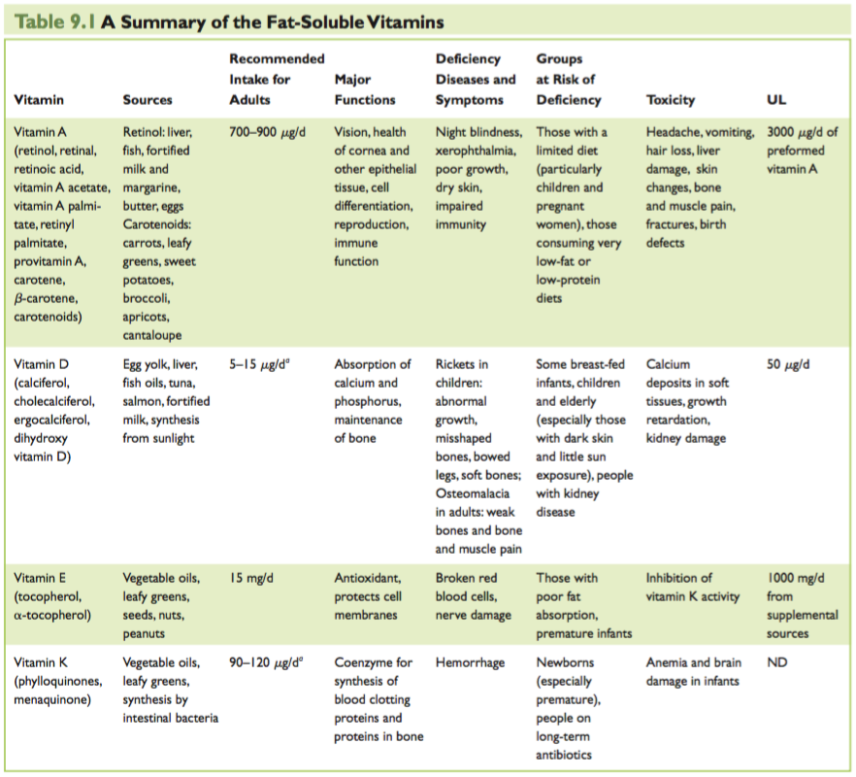

Water-soluble vitamins (polar molecules)

Thiamin (B1): beri beri

Riboflavin (B2): FAD, FMN, ariboflavinosis

Niacin (B3): NAD, NADP, pellagra, can be synthesized from tryptophan

Biotin (B7)

Pantothenic acid

Pyridoxine (B6)

Vitamin C (ascorbic acid): scurvy, antioxidant

Folate: DNA synthesis, neural tube defects, CVD

Vitamin B12: CVD

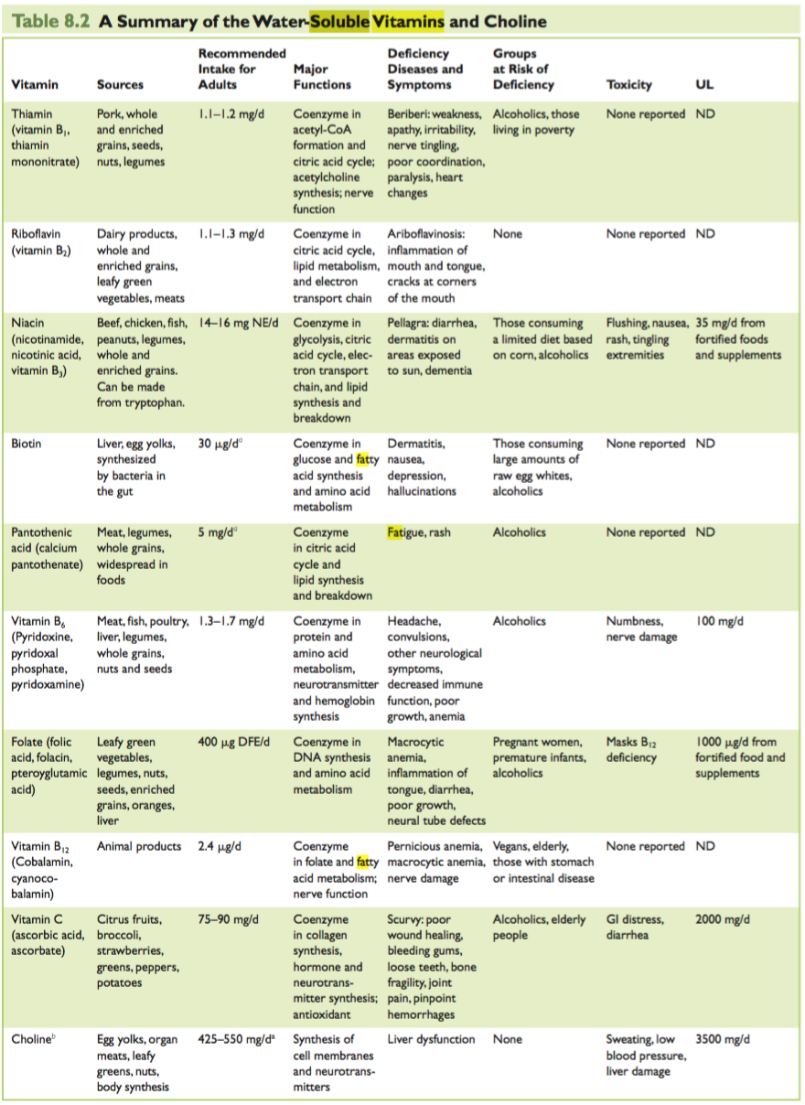**B vitamins are important for energy metabolism.**

Obesity

Current characteristics of US obesity epidemic

* Disorder of body fat (BMI > 30)
* Prevalence is increasing in US and the world
* Becoming disease of youth
* Highly related to CVD and diabetes

Body Mass Index- one way to check if you are obese, but not always accurate because people with high muscle mass can still be obese

Diseases associated with overweight/ obesity- CVD, cancer, diabetes, dyslipidemia, NAFLd, etc.

Metabolic syndrome- three of the following: high fasting glucose, large waist circumference, high serum triglycerides, high HDL cholesterol, high blood pressure)

Central vs gluteo-femoral adipose, Subcutaneous vs internal adipose

* Apple vs. pear body shape
* Central obesity/internal fat is associated with much worse health outcomes

Intervention to change EE- thyroid hormone replacement, beta-3 agonist, epinephrine, leptin, fidgeting, exercise

Possible effects of exercise- changes in EE, body composition and food intake pattern

Caloric restriction- reducing caloric intake without malnutrition

Beneficial effects

* Increase life span
* Decreased age-related diseases

Starvation

* Phase 1: Glycogen depletion, nitrogen losses
* Phase 2: Fatty acid oxidation; ketosis; reduced nitrogen losses
* Phase 3: Brain keto-adaptation; greatly reduced nitrogen losses; further adaptatons

Eating Disorders

Anorexia nervosa (as a primary psychiatric disorder)

* <85% of ideal body weight
* Distorted body image
* Denial of importance of low body weight
* Loss of menstrual period
* Fear of gaining weight
* Begins shortly after menstruation
* Likely to be diagnosed in college years or early 20s

Major symptoms and prevalence of anorexia nervosa

* Affects 0.3-3% of women
* Only 50% of women fully recover

Medical complications of anorexia nervosa

* Osteoporosis
* Depression
* Reproductive dysfunction
* Death

Treatments for anorexia nervosa- prevention, hospitalization, counseling, behavioral therapy and outpatient programs, etc.

Cancer

Pro-carcinogens- substance that promotes carcinogenesis

Anti-carcinogens- substance that prevents/slows carcinogenesis

Mutagenesis- gene mutations (initiation)

Mitogenesis- cell division (promotion)

Dietary chemoprevention- preventing cancer through the diet; modifying the diet intake so cells divide slower

Dietary Carcinogens (Mutagens)

* Heterocyclic amines- formed by cooking meat, poultry, and fish
* Nitrosamines- in cured meats
* Aflatoxin- produced by aspergillus flavus and aspergillus parasiticus

Dietary Chemopreventives

* Indoles- cruciferous vegetables
* Isoflavones- soy products, flax seed, red clover, etc.
* Polyphenols- green and black tea

Caloric restriction

* Has anti-carcinogenic effects
* Decreased promotion due to caloric restriction

Tumeric

Bone, Calcium, Fluids, and Flectrolytes

Water: most abundant molecule in the body (about 2/3 of body water is intracellular and 1/3 is extracellular)

Calcium

* Ca balances in the body can influence bone mass and strength and the risk of fractures
* Calcium also plays a roll in nerve conduction, intracellular signaling, muscle contraction, etc

Phosphate

* Along with calcium, phosphate forms calcified bone around the primary structural protein, collagen

Vitamin D

* Deficiency can lead to rickets or soft bone due to inadequate calcification of bone collagen
* Active Vitamin D stimulates calcium and phosphate absorption by the intestine
* Can be obtained from diet or synthesized by skin

Rickets

Soft bone (osteomalacia)

Osteoporosis

* Most prevalent modern disease of bone and reflects reduction in bone mass
* Increases in prevalence with age and is much more common in women
* Increased risk for bone fractures

Parathyroid hormone (PTH)

* Stimulated by body when blood calcium levels are low
* Stimulates calcium release from bone, retention of calcium by kidney, and absorption of calcium and phosphate by intestine

Calcitonin

* Has opposite effects of PTH

Non-dietary factors influencing bone mass (sex steroid hormone, weight bearing, etc)

* Sex steroid hormones have profound effects on bone mass
* Weight bearing stimulates bone deposition of bone- heavier people tend to have greater bone mass

Major ions inside of cells: potassium (K) and chloride (Cl)

Major ions outside of cells; sodium (Na) and chloride (Cl)

Antidiuretic hormone (ADH)

* When the blood becomes too CONCENTRATED, ADH is secreted and free water is retained by the kidney- so the blood becomes more DILUTE
* When the blood becomes too DILUTE, ADH secretion is suppressed, so free water is lost from the kidney- and the blood becomes more CONCENTRATED

Aldosterone

Nutrition in Pregnancy

Which hormone increases during pregnancy and why?

Placenta

Pregnancy complications (fetal alcohol syndrome and diabetes, etc.)

**The following nutrient needs increase during pregnancy:**

Protein

Folate: neural tube defects, macrocytic anemia

Vitamin B12: converts inactive to active folate

Vitamin C: helps generate connective tissues

Vitamin B6

Iron; synthesis of hemoglobin

Zinc: works as a cofactor, involved in DNA and RNA synthesis

Thiamin, niacin and riboflavin: support maternal and fetal tissue growth and increasing energy use

Iodine: synthesis of thyroid hormone, goiter

Sport Nutrition Endocrinology

Glycogen

* Muscle carbohydrate stores provide energy for contractions

Aerobic/endurance activities examples and benefits: reduced cardiovascular disease, reduced diabetes, reduced at each BMI level, reduced cancers (colon, prostate, breast), improved mood and cognitive function, increased bone mass and less osteoporosis

Strength/ resistance activities

* Ie. Football, baseball, golf
* Duration is seconds= bursts
* Involves increase in muscle mass, increase in neuromeuscular function

Muscle anabolism and catabolism

Medical applications of exercise (diabetes, cancer, HIV, etc.)

Androgens/ anabolic steroids

* Increase muscle mass

Blood doping/erythropoietin

* Increases oxygen carrying capacity of blood
* EPO stimulates production of red blood cells

Fitness vs. Fatness and Visceral vs. Subcutaneous Fat as Health Risks

Fitness (capacity to do aerobic work)

* Greater capacity to deliver oxygen to tissues
* Greater capacity of tissues to consume oxygen

What is the secondary effect of fitness?

* Fitness may alter risk factors for disease

Visceral fat vs. Subcutaneous

* Visceral fat is greater risk factor than subcutaneous fat for metabolic and cardiovascular disease

Aging and Frailty

Sarcopenia

* Sarcopenia is the age-related loss of muscle mass and function that leads to disability

Cachexia

* Cachexia is a complex metabolic syndrome associated with underlying illness and characterized by loss of muscle with or without loss of fat

Factors leading to muscle loss

* loss of activity, bed rest, inadequate dietary protein and illnesses, etc.

Diseases associated with sarcopenia or cachexia (e.g., hip fracture, COPD (chronic obstructive pulmonary disease))

* many hip fracture patients ill not recover their pre-fracture functioning even after successful repair of the fracture and therapy

Growth and Nutrition

Breast feeding

* strongly indicated for infants because it contains many nutrients

What breast milk includes? (Lactose, vitamins, alphalactalbumin, minerals, etc.)

* lactose, essential fatty acids, proteins, vitamins (except D), monerals, etc.

Growth hormone

* stimulates IGF-1 synthesis by tissues
* secreted by pituitary gland and increases dramatically during puberty

IGF-1

* production controlled by nutrient intake
* active hormone

Sex steroids

* Sex steroids increase growth rate but lead to closure of bone epiphyseal growth plates = end of bone length and body height gain

Discussion Section

Dietary Reference Intakes (DRI’s: EAR, RDA, AI, UL, EER, AMDR)

Dietary Guidelines for Americans

My plate

the Harvard Healthy Eating Plate (HHEP)

Food labels and food claims

How is a new label different from a current label?

Calculation of energy and nutrient intake (4-9-4 rule)

Saturated fats and unsaturated fats (poly- or mono-saturated fats, omega 3, 6 or 9 fatty acid, cis or trans fatty acids)

Dietary ingredient

Supplement labeling

Supplement label requirements

cGMP

USP

Components of a good experiment

Human (observational (cross-sectional or longitudinal) or experimental studies)

Animal experiments

Methods of assessing dietary intake (self-report, observed/controlled eating environments, biomarkers, anthropometry)

Research paper components (abstract, introduction, material and methods, results, discussion, references/ acknowledgment)

Protein functions (structure, enzyme, transporters, etc.)

Vegetarianism (benefits and risks)

What factors influence food security?

Four main components of food security: availability, access, utilization and stability

Supplemental Nutrition Assistance Program (SNAP)

Special Supplemental Nutrition Program for Women, Infants and Children (WIC)

The National School Lunch Program (NSLP)

Fad diet examples and characteristics

Problems associated with fad diets and why they may not work

Healthy diets (e.g. Mediterranean diet)

What is a “healthy” diet?

Practice questions

1.Refined grains are ______ with B vitamins and iron and ______ with folic acid.

a. Fortified; enriched

b. Fortified; fortified

c. Enriched; fortified

d. Fortified, fueled

e. Fueled; rehydrated

2. Which of the following responses might the body exhibit with the acute phase response due to infection along with starvation?

a. Reduced metabolism

b. Reduced blood lipids

c. Increased loss of nitrogen

d. Strengthened immune response

e. Strengthened response to supplemented nutrition

3. All of the following characteristics of body fat should be minimized except:

a. Number of large fat cells

b. Proportion of centralized fat

c. Proportion of gluteo-femoral fat

d. Proportion of subcutaneous fat

e. Presence of fat in non-adipose tissue

4. How is fitness defined?

a. Capacity to do aerobic work

b. Being lean

c. Having little body fat

d. Capacity for completing strength/power exercises

e. All of the above

5. A 20 year old female consumed 50 grams of protein in a day and consumed a total of 2000 calories. What percentage of her calories came from protein?

a. 7%

b. 10%

c. 15%

d. 20%

e. 35%

6. Which of the following dietary patterns has been shown most consistently in clinical trials to reduce risk of heart disease and stroke?

a. Mediterranean diet

b. Paleo diet

c. Juice cleanse

d. Adherence to USDA MyPlate

e. Intermittent fasting

7. What is the role of creatine in sustaining energy during physical activity?

a. Creatine can burned directly for energy

b. Creatine is used to generate glucose for energy

c. Creatine is used for energy in aerobic exercise, while ATP is used in anaerobic exercise

d. Creatine is used to replace ATP in anaerobic exercise

e. Creatine is not involved in respiration

8. Digestion is a(n) ______ process because it involves a series of mechanical processes and enzymatic reactions that break foods into smaller components.

a. Anabolic

b. Catabolic

c. Agonistic

d. Neutropenic

e. Scientific

9. At which age can we predict the size a child will be once an adult?

New-born

a. 5-8 months

b. 8-12 months

c. Toddler

d. Impossible; it is never possible to predict adult size