Assembler

It Gives You Wings Ltd.

Programmer’s Guide

Programmer’s Guide 46
Introduction 49
Data Structure Descriptions 50
Input File Storage 50
Literals 50
Symbols 50
Instruction enumeration 50
Main data structure 50
Ops Map 50
Design Conventions 51
Input Files 51
Context Free Grammar for Input Files 51
Global Variables 52
Local Variables 52
Parameter Passing 52
Directory Structure 52
Main Component Overviews 55
Component Interaction 55
Parser 55
Overview 55
Specifications 55
Implementation 56
Encoder 58
Overview 58
Specifications 58
Implementation 58
Writer 60
Overview 60
Specifications 60
Implementation 60
Assembler 62
Overview 62
Specifications 62
Implementation 62
Function Descriptions 64
Text_To_Int 64
Convert_Symbol 65
Convert_Literal 66
Convert_Hex 67
Convert_Decimal 68
Convert_Register 69
Remove 70
Print_Bin 71
Find 72
Find 73
Insert 74
Insert 75
Initialize 76
Update_Literal_Table 77
Output_Literal_Table 78
Print_Op_Code 79
Get_Next_Token 80
Get_Next_Non_Whitespace_Token 81
Insert 82
Dispense 83
Flush_A_Token 84
Is_Ready_To_Dispense 85
Size 86
Is_Whitespace_Char 87
Is_Digit_Char 88
Is_Hex_Digit_Char 89
Is_Alphabetic_Char 90
Is_Symbol_Char 91
Can_Start_Token 92
Is_Branch_Op 93
Op_Or_Symbol_Or_Register 94
Buffer_Type 95
Token_Kind 96
Initialize 97
Data Element Dictionary 98
Error-Catching and Error-Message Generation 106

Introduction

The Programmer’s Guide details the process of implementing the Assembler. Its goal is to assist in the maintenance and modification of the Assembler. It is imperative that maintainers follow the major design conventions, input conventions, and module interaction conventions that are laid out in this section. Strict adherence to these conventions will ensure that maintenance work will operate properly.

What you will find in the Programmer’s Guide:

- Data Structure Descriptions

This section will describe the major shared data structures, including the role each structure plays in execution, as well as its implementation.

- Design Conventions

This section will outline a strict set of conventions that have been laid out to make coding and design similarly structured.

- Overview of System and Data Flow

This section will give a high-level analysis of system design and functionality. It will outline directory structure for easier file accessibility, as well as the contents of the directories.

- Main Component Overviews

This section will show what the function of each component is, as well as how it works, and
which other components it uses.

- Function Descriptions

This section gives the module descriptions and algorithms for each function.

- Data Element Dictionary

This section will describe each shared variable used in the Assembler.

Data Structure Descriptions

Input File Storage

Each line of the input file is placed in a struct called ‘Source’. It contains seven fields. The ‘addr’ field is the address of that line. The ‘label’ field contains the label used for that line, if there is one. If there is no label, the field is just left as the initial value. The ‘opcode’ field contains the instruction. ‘op1’, ‘op2’, ‘op3’ all contain the operands for the instruction. If there is no operand, then the field is just left as the initial value. The ‘rel’ field is used to indication whether the address of a relocatable program is relative or absolute.

Literals

Each literal is stored in a struct called ‘Literal’. This struct contains three fields. The ‘value’ field is the value of the original literal converted to an unsigned short. The ‘address’ field contains the address for the literal. The ‘rel’ field is used to indication whether the address of a relocatable program is relative or absolute.

Symbols

Each symbol is stored in a struct called ‘Symbol’. This struct contains three fields. The ‘name’ field is the actual string that was used in the input file. The ‘value’ field is the value for the ‘name’ field. The ‘rel’ field is used to indication whether the address of a relocatable program is relative or absolute.

Instruction enumeration

The instructions are enumerated and called ‘Operations’.

Main data structure

The main data structure, called ‘Tables’, contains eleven fields. It contains a ‘src_arr[]’ field, which is an array of ‘Source’ structs. The number of input lines is stored in the src_len field. The ‘sym_arr []’ field is an array of ‘Symbol’ structs. The ‘sym_len’ field contains the number of symbols. The ‘lit_arr[]’ field is an array of ‘Literal’ structs. The ‘lit_len’ field is the number of Literals. The ‘op’ field contains the enumerated operations. The ‘start’ field contains the footprint start address. The ‘end’ field contains the footprint end address. The ‘exec’ field contains the address at which execution is to begin.

Ops Map

The ops_map is a mapping from text to enumerated integers. It is used to do case/select statements on a string.

Design Conventions

Input Files

Input files must be ASCII formatted in DOS, MAC, or UNIX.

Context Free Grammar for Input Files:

Context-Free Grammar for Assembly Language File

<file> -> {<line>}

<line> -> \n | <comment>\n | <WS><Inst>\n | <WS><Inst><WS>\n |
<WS><Inst><WS><comment>\n | <Symbol><WS><Inst>\n |
<Symbol><WS><Inst><WS>\n |
<Symbol><WS><Inst><WS><comment>\n

<Comment> -> ;{all ascii characters (except newline)}

<Symbol> -> <Lbl Start> | <Lbl Start><Lbl Char> |
<Lbl Start><Lbl Char><Lbl Char> |
<Lbl Start><Lbl Char><Lbl Char><Lbl Char> |
<Lbl Start><Lbl Char><Lbl Char><Lbl Char><Lbl Char> |
<Lbl Start><Lbl Char><Lbl Char><Lbl Char><Lbl Char><Lbl Char>

<WS> -> <WS Char>{<WS Char>}

<WS Char> -> ' ' | '\t'

<Inst> -> <ADD> | <AND> | <BR> | <DBUG> | <JSR> | <JMP> | <JSRR> | <JMPR> | <LD> | <LDI> |
<LDR> | <LEA> | <NOT> | <RET> | <ST> | <STI> | <STR> | <TRAP>

<ADD> -> ADD<WS><Reg>,<Reg>,<Reg> | ADD<WS><Reg>,<Reg>,<Imm>

<AND> -> AND<WS><Reg>,<Reg>,<Reg> | AND<WS><Reg>,<Reg>,<Imm>

<BR> -> BR<BRcond><WS><Addr>

<BRcond> -> | N | Z | P | NZ | ZP | NP | NZP

<DBUG> -> DBUG

<JSR> -> JSR<WS><Addr>

<JMP> -> JMP<WS><Addr>

<JSRR> -> JSRR<WS><Reg>,<Index>

<JMPR> -> JMPR<WS><Reg>,<Index>

<LD> -> LD<WS><Reg>,<Addr>

<LDI> -> LDI<WS><Reg>,<Addr>

<LDR> -> LDR<WS><Reg>,<Reg>,<Index>

<LEA> -> LEA<WS><Reg>,<Addr>

<NOT> -> NOT<WS><Reg>,<Reg>

<RET> -> RET

<ST> -> ST<WS><Reg>,<Addr>

<STI> -> STI<WS><Reg>,<Addr>

<STR> -> STR<WS><Reg>,<Reg>,<Index>

<TRAP> -> TRAP<WS><Trapvect>

<Lbl Start> -> a - w | y - z | A - Q | S - Z | 0 - 9

<Lbl Char> -> a - Z | 0 - 9

<Reg> -> R(0-7) | <Symbol>

<Imm> -> #(-16 - 15) | x(0 - 1F) | <Symbol>

<Addr> -> #(0 - 65535) | x(0 - FFFF) | <Symbol>

<Index> -> #(0 - 63) | x(0 - 3F) | <Symbol>

<Trapvect> -> #(0 - 255) | x(0 - FF) | <Symbol>

Global Variables

There are no global variables.

Local Variables

Local variables will be named in all lower case letters. Spaces will be distinguished with the first letter of additional words being capitalized.

Parameter Passing

There are no global variables. Therefore, all large variables are passed by reference.

Directory Structure

This structure is formed initially by the makefile that creates the directory structure and fills it with the source, object and executable files. An input directory is created for the user to have a place to store input programs. The directory structure is located in Table P1. The dependency forest for the makefile is shown in Figure P1.

Table P1: Directory Breakdown Structure.

Directory | Folders | File Name | Contents
igyw |  | build | csh shell script
igyw |  | asm | executable
igyw |  | readme.txt | installation instructions
igyw | install | Tokenizer.cpp | Insert(), Dispense(), Flush_A_Token(), Is_Ready_To_Dispense(), Size(), Is_Whitespace_Char(), Is_Digit_Char(), Is_Hex_Digit_Char(), Is_Alphabetic_Char(), Is_Branch_Op(), Op_Or_Symbol_Or_Register(), Buffer_Type(), Token_Kind, Initialize_Machine()
igyw | install | Tokenizer.h | TokenKind, BufferState, Tokenizing_Machine, prototypes
igyw | install | Tokenizer.o
igyw | install | Get.cpp | Get_Next_Token(), Get_Next_Non_Whitespace_Token(), Display_Token_Kind(), Display_Buffer_State()
igyw | install | Get.h | prototypes
igyw | install | Get.o
igyw | install | Parser.cpp | Parser(), Update_Literal_Table(), Output_Literal_Table(), Print_Opcode()
igyw | install | Parser.h | prototypes
igyw | install | Parser.o
igyw | install | Utility.cpp | Remove(), Print_Bin(), Text_To_Int(), Convert_Literal(), Convert_Symbol(), Convert_Hex(), Convert_Decimal(), Convert_Register(), Find(), Find(), Insert(), Insert(), Initialize()
igyw | install | Utility.h | prototypes
igyw | install | Utility.o
igyw | install | defs.h | Source, Symbol, Literal, Operations, Tables
igyw | install | Assembler.cpp | main()
igyw | install | Assembler.h
igyw | install | Assembler.o
igyw | install | Encoder.cpp | Encoder()
igyw | install | Encoder.h | prototypes
igyw | install | Encoder.o
igyw | install | Writer.cpp | Writer()
igyw | install | Writer.h | prototypes
igyw | install | Writer.o
igyw | install | makefile

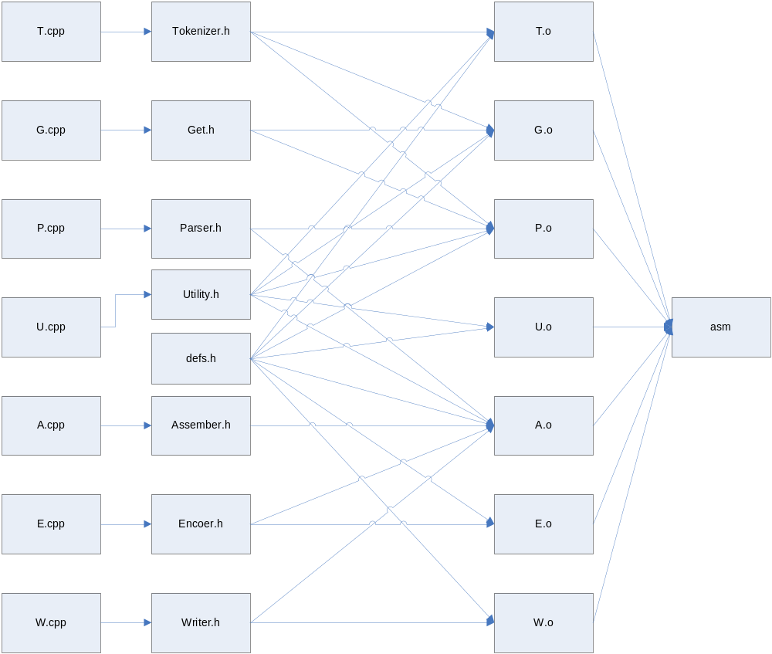
Figure P1: Dependency Forest Diagram.

Main Component Overviews

Component Interaction

The system is comprised of three main parts. These parts include the Parser, the Encoder, and the Writer. Each component is called by the Assembler. The Parser reads in the input file, checks for structure and grammar errors, creates the literals table, and creates the symbols table. The Encoder converts each line into a corresponding hex value. The Writer creates the object file and the list file.

Parser

Overview

The parser implements the first pass of the two pass assembly process. Its main function is to parse input from a file into a “useable” form. It also must create the literals table and symbols table. The parser checks for syntax errors in the input file, reporting as many errors as possibly until the end of the file or .END is encountered. If errors are found the Parser returns false, otherwise, it returns true.

Specifications

Requires:
input_file.is_open() = true
Ensures:
input_file.contents = #input_file.contents
input_file.is_open() = true
the parsed tokens of line, n, will be stored in table.src_arr[n]
if(.ORIG op is found) then
program_name = label on that line
if(line n has an operand in the valid range)
table.start = operand
relocate = false
else
table.start = 0
relocate = true
endif
endif
if(.END op is found) then
table.src_len = line number, n, where .END is found
if(line n has an operand in the valid range)
table.exec = operand
else
table.exec = table.start
endif
endif
tables.sym_len = number of symbols in the program
tables.lit_len = number of literals in the program

Implementation

The implementation of the Parser starts with a Tokenizer. A Tokenizing Machine is a struct with 3 fields: string buffer, integer buffer_state, boolean token_ready. The buffer holds the text characters of the given token, until the token is either dispensed or flushed. The buffer_state holds an integer of enumerated type, which designates what kind of token is being formed in the buffer. And the token_ready boolean tells whether a token is ready to be dispensed or not.

The Parser uses the Tokenizer via the Get functions: Get_Next_Token and Get_Next_Non_Whitespace_Token. The Get_Next_Token function works by getting characters from the input file and inserting them into the Tokenizing Machine until a token is ready or the end of the file is reached. At this point it will either use the Tokenizing functions Dispense to get a token if one is ready, or Flush_A_Token the end of the file is reached. The Get_Next_Non_Whitespace_Token function uses Get_Next_Token until the token_kind is not whitespace. Both functions pass back an integer, token_kind, and string, token_text, as parameters. Token_kind is the enumerated token_kind, this can be used to tell between the different types of tokens. Token_text is the string of characters that created the token.

Using tokens from the Tokenizer the parser can then check for syntax errors using the token_kind and token_text, against what it expected to get for the given line. Pseudocode for the Parser can be found in Figure P2.

Look at first non-comment line:
Check for label
Check for .ORIG statement
If there is an operand
Check it’s value between 0000 and FFFF
Set LC=value
Program not relocatable
Else
Set LC=0
Program relocatable
End if

Increment line counter

While(true)
If(comment)
Get token
Else if(op or label)
If (label)
Store name
Set value to LC
Get token
If(not op)
Error
End if
If(op==ADD, AND, LDR, STR)
Store LC
Get 3operands
LC ++
Else if(op==NOT, LDI, LEA, ST, STI, JSRR, JMPR)
Store LC
Get 2 operands
LC + +
Else if(op==JSR, JMP, TRAP, BRx)
Store LC
Get 1 operand
LC ++
Else if(op==RET, DBUG)
Store LC
LC++
Else if(op==LD)
Store LC
Get 2 operands
If(op2 is a literal)
Store in literal table
Else if(op==.ORIG)

Else if(op==.ORIG)
Error
Else if(op==END)
If it has an operand
Check if it is valid
Set exec start address
Else no operand
Set exe start address
to operand of .ORIG
End if
Update literal table
Store end address
If any errors return false
Else return true
End if
Else if(op==.EQU)
Get operand
Change symbol value
Set rel if operand
is a rel symbol
Else if(op==FILL)
Store LC
LC++
Get 1 operand
Else if(op==string)
Store LC
Get string
LC=LC+length of string
Else if(op==BLKW)
Store LC
Get 1 operand
LC=LC+operand.value
End if

Get token
If token is comment
Get token
End if
If token not a newline
Error
Endif
End if

Else if(token not newline)
Error
Check range errors
If there was an error
Print message
If error was fatal
Return false
End if
End if
End if
Linenum++
End while

Figure P2: Parser Pseudocode.

Encoder

Overview

The assembler passes the Tables struct and line number to the encoder to encode the instruction that will be written to the object files. The encoder is inside of a loop along with the writer thus the encoder only acts upon one source record (one line of source code) at a time. The encoder passes the encoded instruction back to the assembler, which then passes it to the writer for file writing.

Specifications
Requires:
Tables table be filled and complete:
- Symbols table must be complete with all symbols and their values.
- Literals table must be complete with all literals and their addresses.
- Source table must be complete with all source code records stored per specification. (including program load address/relative index and program footprint length)
- Line number be a valid source code line (within Tables table bounds)
Ensures:
Instruction is equal to binary representation of source code line (specified by variable line) stored as an unsigned short (sixteen bits)

Implementation
A basic switch case based on the operation (ADD, AND, etc) is used to create the encoded instruction. All instructions are sixteen bit integer values, thus encoded instructions are stored as unsigned shorts (sixteen bit integers). The first piece of information added to the instruction is the operation code from the source record. For the basic operations, the operation code is a 4-bit integer. JMP and JMPR operations have an operation code equivalent to JSR and JSRR, respectively, with an additional 5th (high end) 1-bit. Thus, when the operation code is shift to the first 4 bits of the instruction, the fifth bit is pushed off and the remaining value is identical to JSR or JSRR, respectively. For the .FILL pseudo-ops, the instruction value is set to zero. For all other pseudo-ops, the instruction value is not used by the writer and is therefore irrelevant. The case select then converts each operation's three operands from string representations into their integer (unsigned short) values by calling Text_To_Int. Thus all symbols, registers, immediates (hex and decimal), and literals are converted to the value they represent. Empty strings (null or
extra operands) are set to zero. The case select then does appropriate range checking on all operands (including trap vector validity) and bit-shifts them into the bit locations they shall hold in the final encoded instruction. Flag bits are bitwise OR'ed into the operands and the final instruction is encoded by bitwse OR'ing the opcode with all three operands. Because of this OR'ing, it is essential to set all null operands to zero, and shift all operands to their proper bit location. So-called “don’t-care bits” are implicity set to zero through the OR’ing however, It Gives You Wings, Ltd. reserves the right to change this behavior at any time. Any and all errors encountered while encoding the instruction are caught and messages are displayed. The encoder then returns a false to the assembler if an error has ben encountered, and true otherwise. The basic encoder logic is shown in Figure P3.

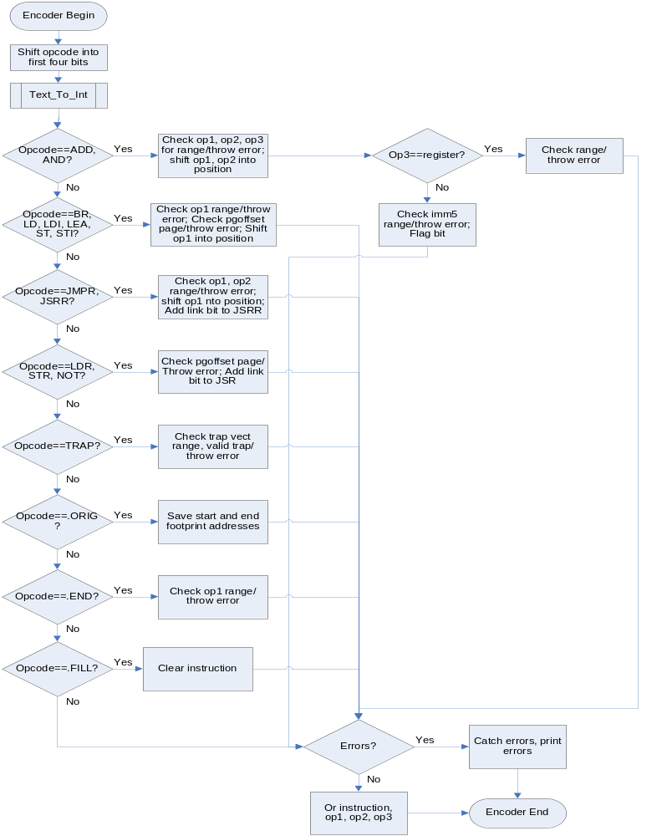
Figure P3: Encoder Flowchart.

Writer

Overview

The writer takes the source records from the assembler and outputs them to the object (.o) and listing (.lst) files. The writer is inside of a loop along with the encoder thus the writer only acts upon one source record (one line of source code) at a time.

Specifications

Requires:
Tables table be filled and complete:
- No errors
- Source table must be complete with all source code records stored per specification. (including program load address/relative index and program footprint length)
- Line number be a valid source code line (within Tables table bounds)
Instruction is equal to binary representation of source code line stored as an unsigned short (sixteen bits)
Current source code line is not a comment

Ensures:
Line of source code is correctly output to the listing and/or object files

Implementation

A basic switch case is used to decide how and where to print out each line from the source code. All of the instructions are output to both the .o and .lst files. Some of the pseudo ops have their own special cases (ORIG, END, EQU, STRZ, FILL). The END case does not print anything to the .o file because the literal table has to be printed before the end record. BLKW instructions are handled with the instructions except nothing is output to the .o file. The logic of the writer is shown in Figure P4.

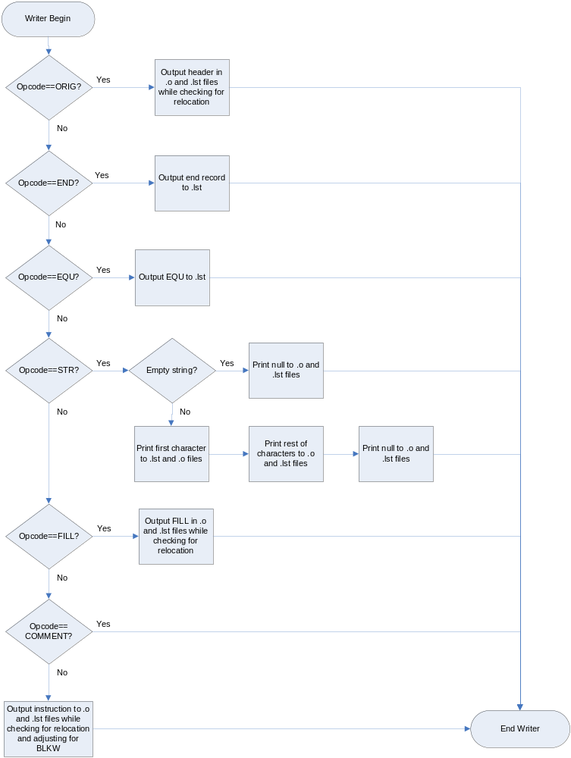Figure P4: Flowchart for Writer.

Assembler

Overview

The assembler calls the parser, encoder, and writer. It initializes the input and output streams. If there are errors in the parser, it does not call the encoder and writer. If there are no errors, it calls the encoder and the writer to encode and output the lines to the object and list files. If there were errors in the encoder, it then deletes the object file.

Specifications

Requires:
Tables table be filled and complete:
- The Source array contains the entire file.
- The opcode is valid.
Ensures:
The files created are correct if there were no errors while encoding. The files are deleted if there were errors in encoding.

Implementation

The assembler first processes all command line arguments to determine the object files to be created (either an object file, list file, neither or both) and their filenames. The helper function initialize is called to correctly create the table struct and ops_map. If a valid source code file is given, the parser is called to read in the source and fill the tables. If parsing completes without errors, control is passed to the encoder and writer, otherwise the assembler exits with error messages. The encoder and writer are called inside of a loop to process each source code record at a time, creating the object file and listing file. Error messages are printed as encountered. Control is then returned to the assembler once all source records have been encoded and processed. The assembler then displays the final assembly status and removes the object file if complete assembly has failed (errors encountered). A flowchart showing the logic of the assembler can be found in Figure P5.
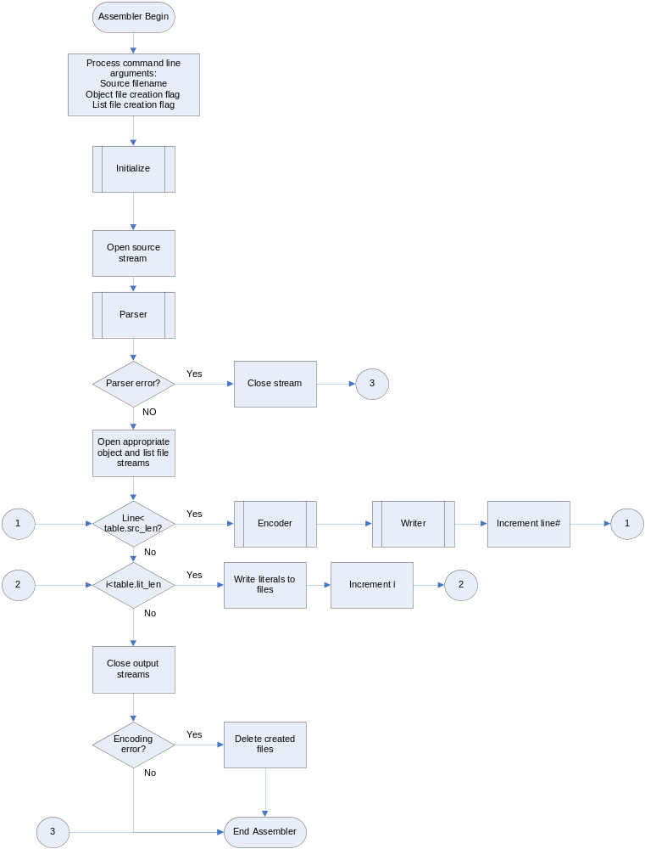
Figure P5: Assembler Flowchart.

Function Descriptions

Procedure Name:
Text_To_Int
Description: Calls the appropriate function to convert a character string to an unsigned short.
Prototype Statement: bool Text_To_Int(unsigned short &ret, string op, Tables& tab, int line)
Input Parameters:
Output Parameters:
Requires: string is one of following:
register
- string begins with capital ‘
- remaining characters are valid decimal digits
hex value
- string begins with lowercase ‘x’
- remaining characters are valid hex digits
decimal value
- string begins with ‘#’
- the next character is either plus ‘+’, minus ‘-‘, or valid decimal digit
- all remaining characters are all valid decimal digits
literal
- string begins with ‘=’
- all remaining characters form either valid decimal string or valid hex string (see Convert_Decimal and Conver_Hex requirements)
symbol
text string in quotes
Modifies: ret
Ensures: the function corresponding to the string format is called
Error Conditions Tested: none
Error Messages Generated: none
Procedure Creation Date: 01/31/05
Modification Log:
Who Date Why
JN 02/04/05 input/output format change
JN 02/15/05 added comments
JK 02/17/05 changed error generation to try/catch

Algorithm:
- begin
- check to make sure that there are characters in op
- remove first character
- use switch/case to determine what kind of string it is
- call appropriate function and return error state
- end

Procedure Name:
Convert_Symbol
Description: Converts a character string symbol to an unsigned short.
Prototype Statement: bool Convert_Symbol(unsigned short &ret, string op, Tables& tab, int line)
Requires: the string length is greater than zero
Modifies: ret
Ensures: the correct value of the symbol is put in ret or an error message is asserted
Error Conditions Tested:
-the symbol name is not the same as the program name
-the symbol is not defined in the program
Error Messages Generated:
- cout<<"symbol '"<<ar<<"' is the same as the program name"<<endl;
- cout<<"symbol '"<<ar<<"' is not defined"<<endl;
Procedure Creation Date: 02/04/05
Modification Log:
Who Date Why
JN 02/15/05 added comments
JK 02/17/05 changed error generation to try/catch

Algorithm:
- begin
- determine program name
- if symbol is the same as the program name print out appropriate error; got to 5
- linearly search the entire symbol table until the symbol is found; if it is found set ret to the address; else print out appropriate error message
- end

Procedure Name:
Convert_Literal
Description: Converts a character string literal to an unsigned short.
Prototype Statement: bool Convert_Literal(unsigned short &ret, string op, Tables& tab, int line)
Requires: string must form either valid decimal string or valid hex string (see Convert_Decimal and Conver_Hex requirements)
Modifies: ret
Ensures: the correct value of the literal is put in ret or an error message is asserted
Error Conditions Tested:
-the literal is not defined in the program
Error Messages Generated:
-cout<<"literal '"<<ar<<"' does not have an address"<<endl;
Procedure Creation Date: 02/04/05
Modification Log:
Who Date Why
JN 02/15/05 added comments
JK 02/17/05 changed error generation to try/catch

Algorithm:
- begin
- convert the literal string to an unsigned short
- linearly search the entire literal table until the value is found; if it is found set ret to the address; else print out appropriate error message
- end

Procedure Name:
Convert_Hex
Description: Converts a hex character string to an unsigned short.
Prototype Statement: bool Convert_Hex(unsigned short &ret, string op, int line)
Requires: all characters are valid hex digits
Modifies: ret
Ensures: the correct value of hex string is put in ret or an error message is asserted
Error Conditions Tested:
- Hex value falls within valid hex range (0x0000-0xFFFF)
Error Messages Generated:
- Invalid Hex String: '[operand]' Out of Range: [0x0000 : 0xFFFF]
Procedure Creation Date: 02/04/05
Modification Log:
Who Date Why
JN 02/15/05 added comments
JK 02/17/05 changed error generation to try/catch
JK 02/21/05 requires changed due to parser/tokenizer
formating is no longer checked, only range
temporary long integers are used to check range

Algorithm:
- begin
- enter loop for each character of string
- convert character
- shift sum one hex digit (multiply by 16), add last character to sum
- if there are more characters to be converted go to 3, else go to 6
- if value lies within valid hex range go to 8, else go to 7
- throw/catch error, print error message, go to 9
- convert to unsigned short
- end

Procedure Name:
Convert_Decimal
Description: Converts a decimal character string to an unsigned short.
Prototype Statement: bool Convert_Decimal(unsigned short &ret, string op, int line)
Requires: first character is either plus ‘+’, minus ‘-‘, or valid decimal digit and all remaining characters are all valid decimal digits
Modifies: ret
Ensures: the correct value of decimal string is put in ret or an error message is asserted
Error Conditions Tested:
- the decimal is not within valid decimal range (-32768 to 32767)
Error Messages Generated:
- Invalid Decimal String: '[operand]' Out of Range: [-32,768 : 32,767]
Procedure Creation Date: 02/04/05
Modification Log:
Who Date Why
JN 02/15/05 added comments
JK 02/17/05 changed error generation to try/catch
JK 02/21/05 requires changed due to parser/tokenizer
formating is no longer checked, only range
temporary long integers are used to check range
JK 02/22/05 added ability to check different ranges of values for different instructions

Algorithm:
- begin
- if first character is not ‘-‘, go to 5
- remove first character
- set negation variable to -1, go to 7
- if first character is not ‘+’, go to 7
- remove first character
- enter loop for each character of the string
- convert character
- shift sum one digit left (multiply by 10)
- add last character to sum
- if there are more characters to be converted go to 7, else go to 12
- if operand is for ‘addr’ field go to 13, for .EQU instruction to to 14, for all others go to 15.
- if the sum is greater than 65535 or less than 0 throw error, else go to 17
- if the sum is greater than 65535 or less than -32768 throw error, else go to 17
- if the sum is greater than 32767 or less than -32768 throw error, else go to 17
- catch errors, print messages, return
- convert sum to unsigned short and return
- end

Procedure Name:
Convert_Register
Description: Converts a register string to an unsigned short.register value
Prototype Statement: bool Convert_Register(unsigned short &ret, string op, int line)
Requires: all characters are valid decimal digits
Modifies: ret
Ensures: the correct register value is put in ret or an error is returned
Error Conditions Tested:
- the register index is not 0-7
Error Messages Generated:
- Invalid Operand: Register Index '[operand]' is not 0-7
Procedure Creation Date: 02/04/05
Modification Log:
Who Date Why
JN 02/15/05 added comments
JK 02/17/05 changed error generation to try/catch
JK 02/21/05 requires changed due to parser/tokenizer
formating is no longer checked, only range
temporary long integers are used to check range

Algorithm:
- begin
- enter loop for each character of the string
- convert character
- shift sum one digit left (multiply by 10)
- add last character to sum
- if there are more characters to be converted go to 3, else go to 7
- if the sum is greater than 7 print out error
- end

Procedure Name:
Remove
Description: removes a character from a string
Prototype Statement: bool Remove(string& str, char& ch, int pos)
Requires: integer pos must be a valid position in the string (pos < str.length)
Modifies: str, ch
Ensures: ch contains the character in position pos of str if pos is within the string
Error Conditions Tested:
none
Error Messages Generated:
none
Procedure Creation Date: 02/04/05
Modification Log:
Who Date Why
JK 02/12/05 added “position” integer to specifiy which character to remove rather than always removing the first one

Algorithm:
- begin
- if pos is not within string return false go to 6
- set ch=str[pos]
- erase the character at position pos
- return true
- end

Procedure Name:
Print_Bin
Description: prints an unsigned short as binary
Prototype Statement: void Print_Bin(unsigned short x, ofstream& file)
Requires: none
Modifies: file
Ensures: the unsigned short is printed in binary
Error Conditions Tested:
none
Error Messages Generated:
none
Procedure Creation Date: 02/04/05
Modification Log:
Who Date Why
JK 02/12/05 instead of passing back binary string, pass in file stream and output binary string directly inside function

Algorithm:
- begin
- convert x to binary
- print to file
- end
Procedure Name:
Find
Description: finds a literal in a table
Prototype Statement: bool Find(Tables& table, unsigned short value, unsigned short& address, bool& rel)
Requires:
Modifies: value, rel
Ensures: if the literal is found address contains the address of the literal, rel contains the relativity of the literal and Find returns true, else Find returns false
Error Conditions Tested:
none
Error Messages Generated:
none
Procedure Creation Date: 02/06/05
Modification Log:
Who Date Why
JK 02/15/05 pass back relativity of literal in addition to address of literal

Algorithm:
- begin
- look for literal in table
- if found, pass back the address, return true, else return false
- end

Procedure Name:
Find
Description: finds a symbol in a table
Prototype Statement: bool Find(Tables& table, string sym, unsigned short& value, bool& rel)
Requires: none
Modifies: value, rel
Ensures: if the symbol is found value contains the value of the symbol, rel contains the relativity and returns true, else returns false
Error Conditions Tested:
none
Error Messages Generated:
none
Procedure Creation Date: 02/06/05
Modification Log:
Who Date Why
JK 02/15/05 pass back relativity of symbol in addition to value

Algorithm:
- begin
- look for symbol in table
- if found, pass back the value and relativity, return true, else return false
- end

Procedure Name:
Insert
Description: inserts a literal in a table
Prototype Statement: void Insert(Tables& table, unsigned short value, bool rel)
Requires: the literal is not already in the table
Modifies: table
Ensures: the value is placed into the literal table
Error Conditions Tested:
none
Error Messages Generated:
none
Procedure Creation Date: 02/06/05
Modification Log:
Who Date Why
JK 02/15/05 no longer return a value (function now void)

Algorithm:
- begin
- put literal in table
- increment table length
- end

Procedure Name:
Insert
Description: inserts a symbol in a table
Prototype Statement: void Insert(Tables& table, string, str, unsigned short value, bool rel)
Requires: the symbol is not already in the table
Modifies: table
Ensures: the string, value, and relativity are inserted in the table
Error Conditions Tested:
none
Error Messages Generated:
none
Procedure Creation Date: 02/06/15
Modification Log:
Who Date Why
JK 02/15/05 no longer return a value (function now void)

Algorithm:
- begin
- put string in table
- put value in table
- put relativity in table
- increment table length
- end

Procedure Name:
Initialize
Description: initializes the system
Prototype Statement: void Initialize(Tables& table)
Requires:
Modifies: table
Ensures: the opcodes array, operations map, and source table opcode value are initialized properly
Error Conditions Tested:
none
Error Messages Generated:
none
Procedure Creation Date:
Modification Log:
no modifications

Algorithm:
- begin
- initialize operations map
- initialize source table opcode value to comment value
- end

Procedure Name:
Update_Literal_Table
Description: Updates the Literal Table using LC and rel
Prototype Statement:
void Update_Literal_Table(
Tables& tables,
int& LC,
bool rel
)
Requires: none
Modifies: tables struct, int LC
Ensures: for each literal stored in table.lit_arr the LC is stored and incremented, and rel is stored.
Error Conditions Tested: none
Error Messages Generated: none
Procedure Creation Date: 2/14/05
Modification Log:
Who Date Why
MB 2/20/05 Add bool rel to parameters and code

Algorithm:
- Begin
- Iterate through lit_arr lit_len times
- Store LC in address
- Increment LC after each store
- Store rel
- End
Procedure Name:
Output_Literal_Table
Description: Outputs the contents of the literals table to cout. Used for debugging.
Prototype Statement:
void Output_Literal_Table(
Tables& tables
)
Requires: none
Modifies: none
Ensures: cout has contents of tables.lit_arr
Error Conditions Tested: none
Error Messages Generated: none
Procedure Creation Date: 2/14/05
Modification Log:
no modifications

Algorithm:
- Begin
- Iterate through lit_arr lit_len times
- Output literal value, address, rel
- End
Procedure Name:
Print_Op_Code
Description: outputs the text representation of the enumerated opcodes. Used for debugging.
Prototype Statement:
void Update_Literal_Table(
int op
)
Requires: none
Modifies: cout
Ensures: cout has the text representation of the given op.
Error Conditions Tested: none
Error Messages Generated: none
Procedure Creation Date: 2/16/05
Modification Log:
no modifications

Algorithm:
- Begin
- Output text string corresponding to int op
- End
Procedure Name:
Get_Next_Token
Description: gets the next token from the file stream using tokenizer functions
Prototype Statement:
void Get_Next_Token(
Tokenizing_Machine& m,
fstream& file,
string& token_text,
int& token_kind
)
Requires: fstream.is_open()
Modifies: m, token_text, token_kind
Ensures: m.token_ready = false
#m.buffer = token_text + m.buffer
token_kind = Token_Kind(m.bs, token_text)
m.bs = Buffer_Type(#m.buffer – token_text)
Error Conditions Tested: none
Error Messages Generated: none
Procedure Creation Date: 2/14/05
Modification Log:
Who Date Why
MB 2/21/05 fix end of file token_kind

Algorithm:
- Begin
- Insert from fstream until token ready or end of file
- Dispense or Flush_A_Token
- End
Procedure Name:
Get_Next_Non_Whitespace_Token
Description: gets the next non whitespace token from the fstream
Prototype Statement:
void Get_Next_Token(
Tokenizing_Machine& m,
fstream& file,
string& token_text,
int& token_kind
)
Requires: fstream.is_open()
Modifies: m, token_text, token_kind
Ensures: m.token_ready = false
#m.buffer = token_text + m.buffer
token_kind = Token_Kind(m.bs, token_text) and token_kind != WHITE_SPACE
m.bs = Buffer_Type(#m.buffer – token_text)
Error Conditions Tested: none
Error Messages Generated: none
Procedure Creation Date: 2/14/05
Modification Log:
Who Date Why
MB 2/21/05 fix end of file token_kind

Algorithm:
- Begin
- Use Get_Next_Token until token_kind != WHITE_SPACE
- End

Procedure Name:
Insert
Description: Inserts a character into the Tokenizing_Machine buffer. Changes token_ready to true if the character will start the next token.
Prototype Statement:
void Insert(
Tokenizing_Machine& m,
char& ch
)
Requires: nothing
Modifies: m
Ensures:
if(#m.buffer is a valid token and #m.buffer + ch is not a valid token)
token_ready = true
else
token_ready = false
endif
m.buffer = #m.buffer + ch
Error Conditions Tested: none
Error Messages Generated: none
Procedure Creation Date: 2/13/05
Modification Log:
Who Date Why
MB 2/15/05 Add more ends to Insert

Algorithm:
- Begin
- Check whether ch begins the next token
- Add ch to m.buffer
- End
Procedure Name:
Dispense
Description: Dispenses a token for buffer. Changes bs appropriately. Changes token_ready to false.
Prototype Statement:
void Dispense(
Tokenizing_Machine& m,
string& token_text,
int& token_kind
)
Requires: m.token_ready = true
Modifies: m, token_text, token_kind
Ensures:
#m.buffer = token_text + ch
token_kind = Token_Kind(m.bs, token_text)
m.bs = Buffer_Type(ch)
m.buffer = ch
m.token_ready = false
Error Conditions Tested: none
Error Messages Generated: none
Procedure Creation Date: 2/13/05
Modification Log:
no modifications

Algorithm:
- Begin
- Remove the last character from m.buffer into ch
- Set token_text = m.buffer
- Set token_kind using m.bs and token_text
- Set m.bs using ch
- Set m.buffer = ch
- Set m.token_ready = false
- End
Procedure Name:
Flush_A_Token
Description: Dispenses a token for buffer. Initializes m
Prototype Statement:
void Flush_A_Token(
Tokenizing_Machine& m,
string& token_text,
int& token_kind
)
Requires: m.token_ready = false
Modifies: m, token_text, token_kind
Ensures:
if(token_text length > 0)
#m.buffer = token_text + ch
else
#m.buffer = token_text
endif
Is_Initialize(m)
Error Conditions Tested: none
Error Messages Generated: none
Procedure Creation Date: 2/13/05
Modification Log:
Who Date Why
MB 2/22/05 Fix duplicate character on token_text length > 0

Algorithm:
- Begin
- If necessary remove the last character from m.buffer into ch
- Set token_text = m.buffer
- Set token_kind using m.bs and token_text
- Initialize(m)
- End
Procedure Name:
Is_Ready_To_Dispense
Description: returns if a token is ready
Prototype Statement:
bool Is_Ready_To_Dispense(
Tokenizing_Machine& m
)
Requires: nothing
Modifies: nothing
Ensures:
return m.token_ready
Error Conditions Tested: none
Error Messages Generated: none
Procedure Creation Date: 2/13/05
Modification Log:
no modifications

Algorithm:
- Begin
- return m.token_ready
- End
Procedure Name:
Size
Description: returns length of buffer
Prototype Statement:
int Size(
Tokenizing_Machine& m
)
Requires: nothing
Modifies: nothing
Ensures:
return m.token_ready
Error Conditions Tested: none
Error Messages Generated: none
Procedure Creation Date: 2/13/05
Modification Log:
no modifications

Algorithm:
- Begin
- return m.buffer.length()
- End
Procedure Name:
Is_Whitespace_Char
Description: returns if ch is a space or tab
Prototype Statement:
bool Is_Whitespace_Char(
char ch
)
Requires: nothing
Modifies: nothing
Ensures:
return ch = ‘ ‘ or ch = ‘\t’
Error Conditions Tested: none
Error Messages Generated: none
Procedure Creation Date: 2/13/05
Modification Log:
no modifications

Algorithm:
- Begin
- return ch = ‘ ‘ or ch = ‘\t’
- End
Procedure Name:
Is_Digit_Char
Description: returns if ch is a digit character
Prototype Statement:
bool Is_Digit_Char(
char ch
)
Requires: nothing
Modifies: nothing
Ensures:
return ‘0’ <= ch <= ‘9’
Error Conditions Tested: none
Error Messages Generated: none
Procedure Creation Date: 2/13/05
Modification Log:
no modifications

Algorithm:
- Begin
- return ‘0’ <= ch <= ‘9’
- End
Procedure Name:
Is_Hex_Digit_Char
Description: returns if ch is a hex character
Prototype Statement:
bool Is_Hex_Digit_Char(
char ch
)
Requires: nothing
Modifies: nothing
Ensures:
return ‘0’ <= ch <= ‘9’ or ‘a’ <= ch <= ‘f’ or ‘A’ <= ch <= ‘F’
Error Conditions Tested: none
Error Messages Generated: none
Procedure Creation Date: 2/13/05
Modification Log:
no modifications

Algorithm:
- Begin
- return ‘0’ <= ch <= ‘9’ or ‘a’ <= ch <= ‘f’ or ‘A’ <= ch <= ‘F’
- End
Procedure Name:
Is_Alphabetic_Char
Description: returns if char is a-Z
Prototype Statement:
bool Is_Alphabetic_Char(
char ch
)
Requires: nothing
Modifies: nothing
Ensures:
return ‘a’ <= ch <= ‘z’ or ‘A’ <= ch <= ‘Z’
Error Conditions Tested: none
Error Messages Generated: none
Procedure Creation Date: 2/13/05
Modification Log:
no modifications

Algorithm:
- Begin
- return ‘a’ <= ch <= ‘z’ or ‘A’ <= ch <= ‘Z’
- End
Procedure Name:
Is_Symbol_Char
Description: returns if char is a-Z or 0-9
Prototype Statement:
bool Is_Symbol_Char(
char ch
)
Requires: nothing
Modifies: nothing
Ensures:
return ‘a’ <= ch <= ‘z’ or ‘A’ <= ch <= ‘Z’ or ‘0’ <= ch <= ‘9’
Error Conditions Tested: none
Error Messages Generated: none
Procedure Creation Date: 2/13/05
Modification Log:
no modifications

Algorithm:
- Begin
- return ‘a’ <= ch <= ‘z’ or ‘A’ <= ch <= ‘Z’ or ‘0’ <= ch <= ‘9’
- End
Procedure Name:
Can_Start_Token
Description: returns if ch can start a legal token
Prototype Statement:
bool Can_Start_Token(
char ch
)
Requires: nothing
Modifies: nothing
Ensures:
return ch can start a legal token
Error Conditions Tested: none
Error Messages Generated: none
Procedure Creation Date: 2/13/05
Modification Log:
Who Date Why
MB 2/16/05 add ‘.’ ‘”’ ‘;’

Algorithm:
- Begin
- return Is_Alphabetic_Char(ch) or Is_Whitespace_Char(ch) or ch == '#' or
ch == ',' or ch == '=' or ch == '.' or ch == ';' or ch == '\"'
- End
Procedure Name:
Is_Branch_Op
Description: returns if ch can start a legal token
Prototype Statement:
bool Is_Branch_Op(
string& t
)
Requires: nothing
Modifies: nothing
Ensures:
return token_kind based on bs and str
Error Conditions Tested: none
Error Messages Generated: none
Procedure Creation Date: 2/13/05
Modification Log:
no modifications

Algorithm:
- Begin
- return token_kind based on bs and str
- End

Procedure Name:
Op_Or_Symbol_Or_Register
Description: returns token_kind of the string t
Prototype Statement:
int Op_Or_Symbol_Or_Register(
string& t
)
Requires: nothing
Modifies: nothing
Ensures:
return if t is OP, SYMBOL, REGISTER, or ERROR
Error Conditions Tested: none
Error Messages Generated: none
Procedure Creation Date: 2/13/05
Modification Log:
no modifications

Algorithm:
- Begin
- Look at t determing token_kind
- return token_kind
- End

Procedure Name:
Buffer_Type
Description: returns integer buffer_state ch is starting
Prototype Statement:
int Buffer_Type(
char ch
)
Requires: nothing
Modifies: nothing
Ensures:
return the buffer_state ch is starting
Error Conditions Tested: none
Error Messages Generated: none
Procedure Creation Date: 2/13/05
Modification Log:
Who Date Why
MB 2/20/05 Add Literal String

Algorithm:
- Begin
- Look at ch determine new bs
- return bs
- End

Procedure Name:
Token_Kind
Description: returns integer token_kind based on buffer_state and string
Prototype Statement:
int Token_Kind(
int bs,
string& str
)
Requires: nothing
Modifies: nothing
Ensures:
return the buffer_state ch is starting
Error Conditions Tested: none
Error Messages Generated: none
Procedure Creation Date: 2/13/05
Modification Log:
Who Date Why
MB 2/20/05 Add Literal String

Algorithm:
- Begin
- Look at ch determine new bs
- return bs
- End

Procedure Name:
Initialize
Description: intitializes Tokenizing_Machine
Prototype Statement:
void Initialize(
Tokenizing_Machine& m
)
Requires: nothing
Modifies: nothing
Ensures:
m.buffer = “”
m.bs = EMPTY_BS
m.token_ready = false
Error Conditions Tested: none
Error Messages Generated: none
Procedure Creation Date: 2/13/05
Modification Log:
no modifications

Algorithm:
- Begin
- m.buffer = “”
- m.bs = EMPTY_BS
- m.token_ready = false
- End

Data Element Dictionary

Variable Name | Type | Declared In | Used By | Purpose
i | int | Convert_Symbol | Convert_Symbol | loop counter
i | int | Convert_Literal | Convert_Literal | array index
i | int | Convert_Hex | Convert_Hex | power index
integer | long int | Convert_Hex | Convert_Hex | value of last converted character
sum | long int | Convert_Hex | Convert_Hex | running total value
k | int | Convert_Hex | Convert_Hex | loop counter
integer | long int | Convert_Decimal | Convert_Decimal | hex value of converted character
sum | long int | Convert_Decimal | Convert_Decimal | running total value
k | int | Convert_Decimal | Convert_Decimal | loop counter
neg | int | Convert_Decimal | Convert_Decimal | used to make the sum a negative number
num | string | Print_Bin | Print_Bin | converted value in binary
k | int | Print_Bin | Print_Bin | loop counter
ch | char | Text_To_Int | Text_To_Int | ch is 1st character removed from op
k | int | Find | Find | loop counter
k | int | Initialize | Initialize | loop counter
argc | int | Assembler | Assembler | number of arguments from command line call of asm used by command line processor (inside assembler)
argv | char * array | Assembler | Assembler | array of command line arguments used by command line processor (inside assembler)
table | Tables | Assembler | Initialize | passed to Initialize to initialize member variables’ values; passed to parser to store tables, their lengths, Operations enumeration and operations map
object | ofstream | Assember | Writer | output stream to object file. Created by assembler, attached to object file specified by user from command line, passed to Writer for creating object file.
list | ofstream | Assembler | Writer | output stream to listing file. Created by assembler, attached to listing file specified by user from command line, passed to Writer for creating listing file.
source | ifstream | Assembler | Parser | input stream from source file. Created by assembler, attached to source code file specified by user from command line, passed to Parser for parsing.
src_filename | string | command line | Assembler | name for source code file passed from command line by user
obj_filename | string | command line | Assembler | name for object file to be created, passed from command line by user
lst_filename | string | command line | Assember | name for listing file to be created, passed from command line by user
instruction | unsigned short | Assembler | Encoder | encoded instruction from source code. created by assembler, passed to encoder for assignment, passed to writer for writing
error | bool | Assember | Assember | stores state of errors encountered by encoder, if encoder ever returns false, an error has been encountered and del_files is set to true. if del_files is true at the end of assembling, the object file and listing file are deleted
bas_filename | string | Assember | Assember | stores the source code file name minus extension, is used by assembler during command line processing to implicitly created the default object and list files (bas_filename + .ext)
cmd | string | Assember | Assember | stores the Usage Error message for command line processing, is printed if asm is not called with proper arguments
k | int | Assember | Assember | loop counter for converting command line arguments from character arrays to strings
str | array of strings | Assember | Assember | stores command line arguments as strings instead of character arrays
k | int | Assember | Assember | position of last period ‘.’ in src_filename, used to remove filename extension and create bas_filename
k | int | Assember | Assember | loop counter for processing command line arguments one at a time
k | int | Assember | Assember | loop counter for encoding and then writing each source record stored in Source table inside Tables table
k | int | Assember | Assember | loop counter for appending literals table to end of object and list files
rm_file | string | Assember | Assember | system command for removing object file stored as string and converted to c-style string for system() call
table | Tables | Assember | Encoder | created by assembler and used by Encoder to get Source record opcode; operands 1, 2, and 3; and Operations enumeration (for case select)
line | int | Assember | Encoder | created by assembler used to index the Source table array for the proper source code line
op1 | unsigned short | Encoder | Encoder | stores operand 1 after converted from string to int by Text_To_Int
op2 | unsigned short | Encoder | Encoder | stores operand 2 after converted from string to int by Text_To_Int
op3 | unsigned short | Encoder | Encoder | stores operand 3 after converted from string to int by Text_To_Int
tab | Tables | Writer | Writer | access elements of the source code
index | int | Writer | Writer | line number
object | ofstream | Writer | Writer | write to object file
list | ofstream | Writer | Writer | write to listing file
instruction | unsigned short | Writer | Writer | instruction code
opcodes[29] | string | Writer | Writer | array of op code strings for outputting
object_open | bool | Writer | Writer | ofstream, object open?
list_open | bool | Writer | Writer | ofstream, list open?
opcode | int | Writer | Writer | stores opcode
length | int | Writer | Writer | length of STRZ operand
startAddr | unsigned short | Writer | Writer | beginning of a string
i | int | Writer | Writer | loop counter
ch | char | Writer | Writer | store single characters in memory
LC | int | Parser | Parser | maintain location of next available memory slot
m | Tokenizing_Machine | Parser | Parser, Get, Tokenizer | a struct of 3 fields: buffer (string), bs (int), token_ready (bool)
BufferState | enum | Tokenizer.h | Tokenizer | on integer enumeration of the buffer states for tokenizing machine
TokenKind | enum | Tokenizer.h | Parser, Get, Tokenizer | an integer enumeration of the token kinds
token_kind | int | Parser | Parser, Get, Tokenizer | used to tell the kind of token that is being parsed from the input file, uses an enumeration
foundError | bool | Parser | Parser | tells whether and error has been encountered. Parser returns not foundError
relocate | bool | Parser | Parser | tells whether the program is relocatable, used to tell if symbols or literals are relocatable.
token_text | string | Parser | Parser, Get, Tokenizer | holds the text from that file that created the token
symbol_found | bool | Parser | Parser | tells whether a line has a label
symbol_rel | bool | Parser | Parser | tells whether the symbol is relocatable
symbol_name | string | Parser | Parser | holds the label text
symbol_value | unsigned short | Parser | Parser | holds the value of the symbol
dummy | unsigned short | Parser | Parser | holds an unsigned short that we don't care about
dummy | bool | Parser | Parser | holds a boolean that we don't care about
literalValue | unsigned short | Parser | Parser | holds the integer value of the literal text
tempValue | unsigned short | Parser | Parser | holds the integer value of the operand of .BLKW
tempRel | bool | Parser | Parser | tells whether a symbol is relative for .BLKW operand
n | int | Update_Literal_Table | same | counter for loop
ch | ch | Dispense(), Flush_A_Token, Get_Next_Token | all Tokenizer functions | holds a character, either taken from a string and to be added to a string
result | int | Op_Or_Symbol_Or_Register, Buffer_Type(), Token_Kind | same | holds the enumerated token_kind or buffer_state

Error-Catching and Error-Message Generation

A complete listing of errors can be found in the error section of the User’s Guide.

