Linker

It Gives You Wings Ltd.

Programmer’s Guide

Table of Contents
Programmer’s Guide 1
Table of Contents 2
Table of Figures 2
Introduction 3
Introduction 3
Data Structures Description 4
Design Conventions 5
Context Free Grammar for Input Files 5
Parameter Passing 6
Error-Catching and Error-Message Generation 6
Linker 8
Overview 8
Specifications 8
Implementation 9
Function and Procedure Descriptions 10
Get 10
Convert_Hex 11
Defined 12
Data Element Dictionary 13
Data Element Dictionary 13
Troubleshooting/Errata 15
Error Messages 15
Errata 15

Table of Figures
Programmer’s Guide 1
Figure 1: Flowchart for the Linker 7

Introduction

The Programmer’s Guide details the process of implementing the Linker. Its goal is to assist in the maintenance and modification of the Linker Machine. It is imperative that maintainers follow the major design, input, and module-interaction conventions that are laid out in this section. Strict adherence to these conventions will ensure that maintenance work will operate properly.

What you will find in the Programmer’s Guide:

- Data Structure Descriptions

This section will describe the major shared data structures, including the role each structure plays in execution, as well as its implementation.

- Design Conventions

This section will outline a strict set of conventions that have been laid out to make coding and design similarly structured.

- Notable Design Details

This section will cover important design details that a maintainer will need to know.

- Overview of System and Data Flow

This section will give a high-level analysis of system design and functionality. It will outline directory structure for easier file accessibility, as well as the contents of the directories.

- Component Descriptions

This section will show what the function of each component is, as well as how it works, and which other components it uses.

- Data Element Dictionary

This section will describe each shared variable used in the Linker.

- Linker Code

This will contain the original source file for the Linker.

Data Structures Description

Each input object file to be linked is read in and stored in a file record structure (File_rec). This structure has as members an array of line record structures (Line_rec), an unsigned short segment length (seg_len), and an unsigned short program load address (PLA). All pertinent information read from the object file is stored in this structure. Each line is stored in the line record structure that has as members, line record type as a chararcter, unsigned short address, unsigned short value, and symbol string if applicable. The type each line can assume is one of relative header record (denoted by R), 9-bit external reference record, (X), 16-bit external reference record (Y), 9-bit internal reference record (S), 16-bit internal reference record (L), general text record (T) and an end record (E). Entry point records and comments are not stored in the line record structure, however, the array index is incremented for these lines so as to accurately reference subsequent lines. Finally there is an all-encompassing container structure (Total) that stores the array of File_rec structures (and transitively, the Line_rec structure). This container also stores as an integer the total number of input object files, the numerical index of the main object file, an array of external symbol tables (store symbol name and its value), the total program length, the program load address (from user), and the program start of execution address.

Design Conventions

Context Free Grammar for Input Files:

<file> ->
<headIdentifier><programName><hexInteger><hexInteger>{<comments>}<newline>
<text><comments><newline>{ <text><comments><newline> }

<endIdentifier><hexInteger><comments><newline>

<entryPoint> ->

{ <entryIdentifier><symbol>=<hexInteger><comments><newline> } (up to 4)

<text> -> <textIdentifier><hexInteger><hexInteger> |

<shortRelIdentifier><hexInteger><hexInteger> |

<longRelIdentifier><hexInteger><hexInteger> |

<shortsymbolRelIdentifier><hexInteger><hexInteger><symbol> |

<longsymbolRelIdentifier><hexInteger><hexInteger><symbol>

<programName> -> <pchar><pchar><pchar><pchar><pchar><pchar>

<hexInteger> -> <hexChar><hexChar><hexChar><hexChar>

<symbol> -> <char> | <char><char> | <char><char><char> |

<char><char><char><char> | <char><char><char><char><char> |

<char><char><char><char><char><char>

<headIdentifier> -> R

<entryIdentifier> -> N

<textIdentifier> -> T

<shortRelIdentifier> -> S

<longRelIdentifier> -> L

<shortsymbolRelIdentifier> -> X

<longsymbolRelIdentifier> -> Y

<endIdentifier> -> E

<pchar> -> ASCII characters 32 – 127

<char> -> ASCII characters 33-127

<hexChar> -> 0 - 9 | a – f | A - F

<comments> -> € | ASCII characters 32 - 127

<newline> -> ASCII (10)

Parameter Passing

The main container structure is, for the most part, the only variable that needs passed to all functions and procedures. Using this container structure, any function can have complete access to all of the data structure members by simply passing one variable (the container structure) by reference.

Error-Catching and Error-Message Generation

- Error messages are generate using the try/catch method.
- There is a maximum error counter for pass one and pass two of 20 errors such that once this maximum is reached, the linker terminates (other errors may be caught in between passes).
- If there are errors in pass one, pass two is not attempted.
- Once an error has been encountered on a line, the linker proceeds to the next line.
- The following errors are fatal:
- #5, 12, 24, 25
- Line numbers are printed (where applicable) with the associated error (counting comment lines, and non-object record generating lines)
- See the Error Description Appendix for more details

Figure 1: Flowchart for the Linker 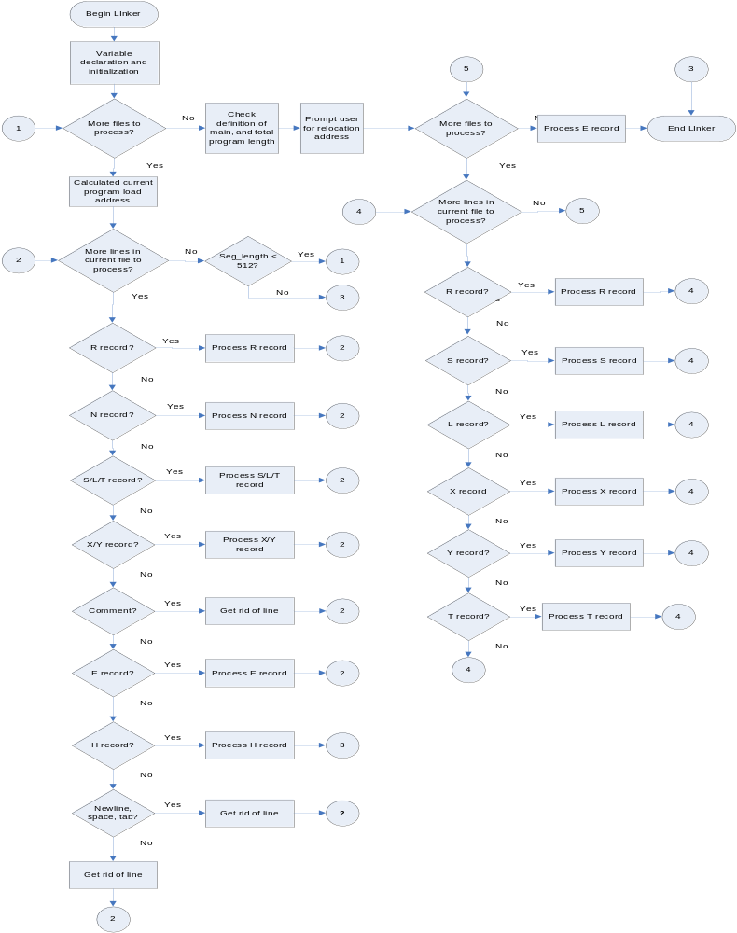
Component Overviews

Linker

Overview

The linker is called by the IGYW main. It gets passed an array of input files to link and an output file to write to. It creates one absolute output file from one or more relocatable files. The files are linked together in the order they are found in the ifstream array, starting at index zero. The start address of the linked files is the start address of file which has the segment name ‘MAIN ’ (not case sensitive). If there is an error in the input files, the output file is not generated. It returns true if there are no errors and false if there are errors generated.

Specifications

Requires:
- 0 <#ifstreams <=512
- the input and output file streams are open
- length = #ifstreams

Ensures:
#errors=0 , #warnings>0 -> output file will be written to but could be incorrect
will return true;
#errors=0 , #warnings=0 -> output file will be written to and will be correct
will return true;

#errors>0 -> output file will not be written to
will return fales;

Implementation

The files are linked and relocated in two passes. A flowchart which shows the logic of the Linker can be found in Figure 1. In the first pass, all of the files are read in and stored in the File_rec struct array using a switch case based on the type of record. The switch case is nested inside two while loops. The entry points are stored in the xsymbol struct array. If entry points are declared multiple times, an error message is asserted. The maximum number entry points is four plus the segment name. The segment name is stored in both the File_rec struct array and the xsymbol struct array. The segment name is given a value of zero when it is added to the xsymbol struct array. The program load address of each file is calculated by assuming the initial program load address is zero. The input files are linked together in the same order as the ifstream array. Each input file is checked against the input file specifications, which are defined earlier in this document and error messages are asserted if the input file does not meet the specifications. The external symbols are not checked to see if they are defined after pass one. Absolute programs and programs that do not fit on one page are fatal errors during pass one.

If there are any errors after the first pass, the output file is not written to and the linker returns false. If there are no errors in pass one, possible program load addresses are calculated and a prompt is give to the user. It is also at this point that the definition of a main file is checked.

In pass two, a switch case based on the type of record nested inside two while loops is used to relocate each record. The output file is created. The external symbols are checked for definition during pass two. There are no fatal errors. The start of execution address is the start of execution address for the file specified as main.

The linker returns true if there were no errors and false if there were errors. The maximum number of errors and warnings generated before halting is twenty.
Function and Procedure Descriptions

Get
Description: Gets a specified number of characters from the ifstream.
Prototype Statement: bool Get(char arr[], int num, ifstream &input, int line, char file[])
Requires: The ifstream is open.
Modifies: arr
Ensures:
- if there are #num characters before the newline-> arr contains those characters; returns true
- if there are less than #num characters before the newline -> arr contains those characters; an error message is asserted; returns false
- if there are zero characters before the newline -> arr is empty; an error message is asserted; returns false
Error Conditions Tested:
- less than #num characters before the newline
Error Messages Generated:
- link ERROR: #1
Character expected, newline received.
Procedure Creation Date: 02/20/05
Modification Log:
no modifications
Algorithm:
- begin
- get character from ifstream
- if character=’\n’ go to 5
- if more characters go to 2; else go to 6
- throw error, return false
- return true
- end

Convert_Hex
Description: Converts a string of characters into a hex unsigned short number.
Prototype Statement: bool Convert_Hex(unsigned short& ret, char op[], int line, char file[])
Requires: 1<=length(file)<=4
Modifies: ret
Ensures:
- if file contains only hex characters -> ret will have the correct hex value; returns true
- if file contains non hex characters -> ret will be zero; returns false

Error Conditions Tested:
- string contains non-hex characters
Error Messages Generated:
- link ERROR: #2
String contains non-hex characters.
Procedure Creation Date: 02/20/05
Modification Log:
no modifications
Algorithm:
- begin
- if character is a hex character, convert to hex; else go to 5
- multiply by 16 and add to sum
- if there are more characters to be converted go to 2; else go to 6
- throw error, return false
- return true
- end

Defined
Description: Determines if an external symbol/ entry point has been previously defined.
Prototype Statement: bool Defined(Total& table, char value[], int counter)
Requires: nothing
Modifies: counter
Ensures:
- if value is defined in the external table -> counter will contain the index of value in the external table; returns true
- if value is not defined in the external table-> counter will not be modified; returns false
- if length(external table) = zero -> counter will not be modified; returns false
Error Conditions Tested:
- none
Error Messages Generated:
- none
Procedure Creation Date: 02/20/05
Modification Log:
Who Date Why
JN 2/23/05 counter was added to return the index of value if it is found
Algorithm:
- begin
- if value match external symbol set counter = index, return true, go to 5; else go to 3
- if there are more symbols to search through go to 2; else go to 4
- return false
- end

Data Element Dictionary

Data Element Dictionary

Variable Name | Type | Declared In | Used By | Purpose
k | int | Defined | Defined | loop counter
sum | long | Convert_Hex | Convert_Hex | used in the conversion of characters to an unsigned short
integer | long | Convert_Hex | Convert_Hex | used in the conversion of characters to an unsigned short
err | string | Convert_Hex | Convert_Hex | used to throw an error message
k | int | Convert_Hex | Convert_Hex | loop counter
err | string | Get | Get | used to throw an error message
counter | int | Get | Get | loop counter
ch | char | Get | Get | used to get a character from ifstream
err | string | Linker | Linker | used to throw an error message
tot | Total | Linker | Linker | used to store the input files and external symbols table
i | int | Linker | Linker | keeps track of current number of records that go into each input file
count | int | Linker | Linker | keeps track of the current number of input files
chars | int | Linker | Linker | index for getting the entry point symbol name; index for getting the external symbol name
Nnum | int | Linker | Linker | keeps track of number of entry points per file
j | int | Linker | Linker | keeps track of the actual number of lines in each input file
errors | int | Linker | Linker | keeps track of the number of errors; reset between passes
warnings | int | Linker | Linker | keeps track of the number of warnings
k | int | Linker | Linker | used to find the index where an external symbol or entry point is defined (passed to Defined)
n | int | Linker | Linker | used as an index to convert the segment name to uppercase, to check if duplicate mains are defined
address | long | Linker | Linker | stores the value the user entered for the relocation address
seg_len | unsigned short | Linker | Linker | keeps track of the actual number of text records in a segment
ch | char | Linker | Linker | used to get the entry point symbol name and the external symbol name
arr[5] | char | Linker | Linker | used to get 4 characters from the ifstream
st | string | Linker | Linker | used to throw away the rest of a line
Ninsert | bool | Linker | Linker | keeps track of whether entry points are being declared at the beginning of the segment, Linker before the text records (true if entry points can be delared)
go | bool | Linker | Linker | keeps track of fatal errors(true if no errors)
Rinsert | bool | Linker | Linker | keeps track of whether a header record has already been found (true if not found)
Einsert | bool | Linker | Linker | keeps track of whether an end record has already been found (true if not found)
sym_arr[7] | char | Linker | Linker | used to temporarily store an entry point name
upper_arr[7] | char | Linker | Linker | used to temporarily store the segment name in uppercase

Troubleshooting/Errata

Error Messages

Please refer to the Error Message Appendix.

Errata

Once the program has finished execution, either through completion of execution or through an error, the restricted command prompt no longer displays the run modes (quiet, trace, step, stepx) as valid selections. Selecting one of these modes results in identical behavior as selecting quit. However, the expected behavior would be to consider the input invalid and request the user again for a valid selection.

If the loader encounters an error while loading an input file and exits abnormally, a partially loaded program may be stored in memory. This is actually intentional, such that the user may view the state of the machine after loading to determine the extent of progress, trace the error, etc. This can only be remedied by loading another input file.

