Linker

Overview

The linker is called by the IGYW main. It gets passed an array of input files to link and an output file to write to. It creates one absolute output file from one or more relocatable files. The files are linked together in the order they are found in the ifstream array, starting at index zero. The start address of the linked files is the start address of file which has the segment name ‘MAIN ’ (not case sensitive). If there is an error in the input files, the output file is not generated. It returns true if there are no errors and false if there are errors generated.

Specifications

Requires:
- 0 <#ifstreams <=512
- the input and output file streams are open
- length = #ifstreams

Ensures:
- #errors=0 , #warnings>0 -> output file will be written to but could be incorrect will
return true;
- #errors=0 , #warnings=0 -> output file will be written to and will be correct
will return true;
- #errors>0 -> output file will not be written to
will return fales;

Implementation

The files are linked and relocated in two passes. A flowchart which shows the logic of the Linker can be found in Figure 1. In the first pass, all of the files are read in and stored in the File_rec struct array using a switch case based on the type of record. The switch case is nested inside two while loops. The entry points are stored in the xsymbol struct array. If entry points are declared multiple times, an error message is asserted. The maximum number entry points is four plus the segment name. The segment name is stored in both the File_rec struct array and the xsymbol struct array. The segment name is given a value of zero when it is added to the xsymbol struct array. The program load address of each file is calculated by assuming the initial program load address is zero. The input files are linked together in the same order as the ifstream array. Each input file is checked against the input file specifications, which are defined earlier in this document and error messages are asserted if the input file does not meet the specifications. The external symbols are not checked to see if they are defined after pass one. Absolute programs and programs that do not fit on one page are fatal errors during pass one.

If there are any errors after the first pass, the output file is not written to and the linker returns false. If there are no errors in pass one, possible program load addresses are calculated and a prompt is give to the user. It is also at this point that the definition of a main file is checked.

In pass two, a switch case based on the type of record nested inside two while loops is used to relocate each record. The output file is created. The external symbols are checked for definition during pass two. There are no fatal errors. The start of execution address is the start of execution address for the file specified as main.

The linker returns true if there were no errors and false if there were errors. The maximum number of errors and warnings generated before halting is twenty.

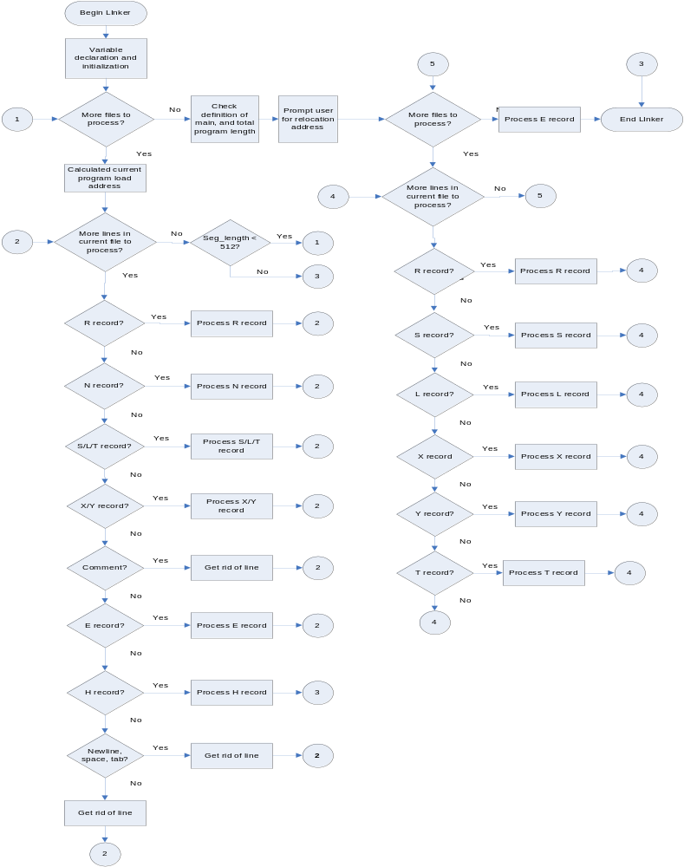
Figure 1: Flowchart for the Linker.

Errata
- If an external symbol is undefined, an output file is still created by using zero for the symbol value.
- If the bits to be relocated of an ‘X’ or ‘Y’ are not set to zero, an output file is still created by setting those bits to zero before relocation.
- When extreme values are entered for the program load address, the program goes into an infinite loop.

Function Descriptions

Procedure Name:

Get
Description: Gets a specified number of characters from the ifstream.
Prototype Statement: bool Get(char arr[], int num, ifstream &input, int line, char file[])
Requires: The ifstream is open.
Modifies: arr
Ensures:
- if there are #num characters before the newline-> arr contains those characters; returns true
- if there are less than #num characters before the newline -> arr contains those characters; an error message is asserted; returns false
- if there are zero characters before the newline -> arr is empty; an error message is asserted; returns false
Error Conditions Tested:
- less than #num characters before the newline
Error Messages Generated:
- link ERROR: #1
Character expected, newline received.
Procedure Creation Date: 02/20/05
Modification Log:
no modifications
Algorithm:
- begin
- get character from ifstream
- if character=’\n’ go to 5
- if more characters go to 2; else go to 6
- throw error, return false
- return true
- end

Procedure Name:

Convert_Hex
Description: Converts a string of characters into a hex unsigned short number.
Prototype Statement: bool Convert_Hex(unsigned short& ret, char op[], int line, char file[])
Requires: 1<=length(file)<=4
Modifies: ret
Ensures:
- if file contains only hex characters -> ret will have the correct hex value; returns true
- if file contains non hex characters -> ret will be zero; returns false

Error Conditions Tested:
- string contains non-hex characters
Error Messages Generated:
- link ERROR: #2
String contains non-hex characters.
Procedure Creation Date: 02/20/05
Modification Log:
no modifications
Algorithm:
- begin
- if character is a hex character, convert to hex; else go to 5
- multiply by 16 and add to sum
- if there are more characters to be converted go to 2; else go to 6
- throw error, return false
- return true
- end

Procedure Name:

Defined
Description: Determines if an external symbol/ entry point has been previously defined.
Prototype Statement: bool Defined(Total& table, char value[], int counter)
Requires: nothing
Modifies: counter
Ensures:
- if value is defined in the external table -> counter will contain the index of value in the external table; returns true
- if value is not defined in the external table-> counter will not be modified; returns false
- if length(external table) = zero -> counter will not be modified; returns false
Error Conditions Tested:
- none
Error Messages Generated:
- none
Procedure Creation Date: 02/20/05
Modification Log:
Who Date Why
JN 2/23/05 counter was added to return the index of value if it is found
Algorithm:
- begin
- if value match external symbol set counter = index, return true, go to 5; else go to 3
- if there are more symbols to search through go to 2; else go to 4
- return false
- end

Data Element Dictionary

Variable Name | Type | Declared In | Used By | Purpose
k | int | Defined | Defined | loop counter
sum | long | Convert_Hex | Convert_Hex | used in the conversion of characters to an unsigned short
integer | long | Convert_Hex | Convert_Hex | used in the conversion of characters to an unsigned short
err | string | Convert_Hex | Convert_Hex | used to throw an error message
k | int | Convert_Hex | Convert_Hex | loop counter
err | string | Get | Get | used to throw an error message
counter | int | Get | Get | loop counter
ch | char | Get | Get | used to get a character from ifstream
err | string | Linker | Linker | used to throw an error message
tot | Total | Linker | Linker | used to store the input files and external symbols table
i | int | Linker | Linker | keeps track of current number of records that go into each input file
count | int | Linker | Linker | keeps track of the current number of input files
chars | int | Linker | Linker | index for getting the entry point symbol name; index for getting the external symbol name
Nnum | int | Linker | Linker | keeps track of number of entry points per file
j | int | Linker | Linker | keeps track of the actual number of lines in each input file
errors | int | Linker | Linker | keeps track of the number of errors; reset between passes
warnings | int | Linker | Linker | keeps track of the number of warnings
k | int | Linker | Linker | used to find the index where an external symbol or entry point is defined (passed to Defined)
n | int | Linker | Linker | used as an index to convert the segment name to uppercase, to check if duplicate mains are defined
address | long | Linker | Linker | stores the value the user entered for the relocation address
seg_len | unsigned short | Linker | Linker | keeps track of the actual number of text records in a segment
ch | char | Linker | Linker | used to get the entry point symbol name and the external symbol name
arr[5] | char | Linker | Linker | used to get 4 characters from the ifstream
st | string | Linker | Linker | used to throw away the rest of a line
Ninsert | bool | Linker | Linker | keeps track of whether entry points are being declared at the beginning of the segment, Linker before the text records (true if entry points can be delared)
go | bool | Linker | Linker | keeps track of fatal errors(true if no errors)
Rinsert | bool | Linker | Linker | keeps track of whether a header record has already been found (true if not found)
Einsert | bool | Linker | Linker | keeps track of whether an end record has already been found (true if not found)
sym_arr[7] | char | Linker | Linker | used to temporarily store an entry point name
upper_arr[7] | char | Linker | Linker | used to temporarily store the segment name in uppercase

Warnings

link WARNING: #1
Bits 0-8 of ‘X’ record not zero. They will be set to zero before relocation.
- The bits which depend on the relocation address are not zero.

link WARNING: #2
Bits 0-15 of ‘Y`’ record not zero. They will be set to zero before relocation.
- The bits which depend on the relocation address are not zero.

Errors
link ERROR: #1
Character expected, newline received.
Possible causes:
- text(T, S, L) record is not nine characters long.
- text(X, Y) record less than fifteen characters long.
- end record is not five characters long.
- header record is not fifteen characters long.

link ERROR: #2
String contains non-hex characters.
Possible causes:
- in a place where there should be an address or an instruction value, there are non-hex characters.

link ERROR:#3
Second segment name declaration. This segment will not be used as an entry point.
Possible causes:
- two or more files contain the same segment name.

link ERROR: #4
Relocatable program load address must be zero.
Possible causes:
- the load address of a relocatable program is not zero.

link ERROR: #5
Program length greater than one page.
Possible causes:
- The length of a relocatable program, as defined in the header record, is greater than 512.
- This error is fatal.

link ERROR: #6
Multiple header records. This line will be skipped.
Possible causes:
- A file contains more than one relocatable header record.

link ERROR: #7
Duplicate entry points defined. Value of first entry point taken.
Possible causes:
- Entry points are redefined in the same file.
- Different files have define the same entry point.

link ERROR: #8
Greater than 4 entry points. Entry point will not used.
Possible causes:
- There are more than four entry points defined in one file.

link ERROR: #9
Entry points must be declared prior to all text records.
Possible causes:
- An entry point is declared after the first text record.

link ERROR: #10
External symbol ‘<symbol>’ greater than 6 characters long.
Possible causes:
- An external symbol is more than six characters.

link ERROR: #11
END record already declared.
Possible causes:
- There are two or more end records declared in the same file.

link ERROR: #12
Program is not relocatable.
Possible causes:
- The header record begins with ‘H’.
- This error is fatal.

link ERROR: #13
Invalid character at line start.
Possible causes:
- A line does not begin with a space, tab, newline, or valid record character.

link ERROR: #14
Text records do not fit in the footprint.
Possible causes:
- The actual number of text records is greater than the value defined in the header to be the footprint length.
- This is a fatal error.

link ERROR: #15
External symbol ‘<symbol>’ undefined.
Possible causes:
- An external symbol is used but never defined as an entry point.

link ERROR: #16
Linked programs do not fit on one page.
Possible causes:
- The sum of the lengths of each program is greater than 512.

link ERROR: #17
MAIN undefined.
Possible causes:
- The programs to be linked do not contain a main. Main is necessary so that the start of execution address can be determined.

link ERROR: #18
Entry point value not between [segment load address] and [segment load address + segment length].
Possible causes:
- The value of an entry point must be within the footprint of the program.

link ERROR: #19
Address not between [segment load address] and [segment load address + segment length].
Possible causes:
- The address of an instruction must be within the footprint of the program.

link ERROR: #20
Start address not between [segment load address] and [segment load address + segment length].
Possible causes:
- The start address of the program must be within the footprint.

link ERROR:#21
Second declaration of main. It will not be used as an entry point.
Possible causes:
- Two files have “main ”(not case sensitive) as their program name.

link ERROR: #22
Relocatable record with symbol missing a symbol.
Possible causes:
- An ‘X’ record does not have a symbol.
- A ‘Y’ record does not have a symbol.

link ERROR: #23
No end record.
Possible causes:
- A file does not contain and end record.

link ERROR: #24
Header record undefined.
Possible causes:
- An (N, T, S, L, X, Y, or E) record has been declared before the header
- This error is fatal.

link ERROR: #25
Text records after end record.
Possible causes:
- An end record is not the last record in the file.
- This error is fatal.

link ERROR: #26
Entry point symbol length greater than 6.
Possible causes:
- An entry point symbol is more than 6 character.
link ERROR: #27
One relocatable program with no text records cannot be relocated.
Possible causes:
- There are no text (T, S, L, X, Y) records in the relocatable program.

link ERROR: #28
Bits 0-8 of ‘S’ record are not within the footprint.
Possible causes:
- An ‘S’ record pgoffset is an address that is not in the footprint.

link ERROR: #29
Bits 0-15 of ‘L’ record are not within the footprint.
- An ‘L’ record value is not in the footprint.

