**MISKOM 02 – MATERIAL LIST R01**

**============================================================**

# TRANSMISORES DE PRESION

|  |  |  |
| --- | --- | --- |
| MARCA | Modelo | CANTIDAD |
| WIKA | 0-16bar: 4-20mA | 5 |

# MANOMETROS

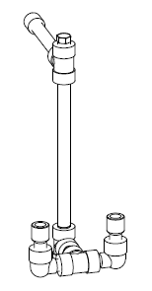

|  |  |  |
| --- | --- | --- |
| MARCA | Modelo | CANTIDAD |
| WIKA | 0-25 bar | 4 |

|  |  |
| --- | --- |
| Válvula manual negra pequeña | 8 |
| Junta cobre para manual negra pequeña | 16 |
| Conjunto para PT y manómetro | 4 |

# TRANSMISORES DE TEMPERATURA

|  |  |  |
| --- | --- | --- |
| MARCA | Modelo | CANTIDAD |
| WIKA | 1/4” | 24 |

|  |  |
| --- | --- |
| Junta de Cobre para Pt100 1/4” | 24 |

# BRIDAS

|  |  |  |
| --- | --- | --- |
| DN20 | DN25 | DN65 |
| 8 | 8 | 4 |

# CODOS BW

|  |  |  |  |  |
| --- | --- | --- | --- | --- |
| DN20 | DN25 | DN40 | DN50 | DN65 |
| 12 | 24 | 2 | 2 | 7 |

# CAPS BW

|  |  |
| --- | --- |
| DN25 | DN65 |
| 8 | 3 |

# TE BW

|  |
| --- |
| DN65 |
| 4 |

# REDUCCIONES

|  |  |
| --- | --- |
| DN: 20 x 25 | 10 |
| DN: 40 x 65 | 1 |
| DN: 50 x 65 | 1 |

# VALVULAS MANUALES BRIDAS

|  |  |
| --- | --- |
| 1 | Válvula ARI DN65 volante verde |
| 1 | Válvula ARI DN65 volante rojo |
| 4 | Válvula ALFA DN20 |

# VALVULAS ELECTRO-NEUMATICAS

|  |  |
| --- | --- |
| 4 | Válvula electroneumática ARI DN25 |

# VALVULAS NEUMATICAS

|  |  |
| --- | --- |
| 4 | Válvula ON-OFF S&S 7032 N.C. DN20 |
| 1 | Válvula ON-OFF S&S 7032 N.C. DN25 |

** PONER RACORES!

# FILTROS Y CON BRIDAS

|  |  |
| --- | --- |
| 4 | Filtro DN20 |
| 4 | Filtro DN25 |

# FILTROS Y ROSCADOS

|  |  |
| --- | --- |
| 4 | Filtro roscado DN15 |

# PURGADORES

|  |  |
| --- | --- |
| 1 | ARI CONA DN15 – roscado |

# JUNTAS

|  |  |  |  |
| --- | --- | --- | --- |
| DN20 | DN25 | DN40 | DN65 |
| 30 | 90 | 20 | 6 |

# TORNILLERIA

|  |  |
| --- | --- |
|  |  |
| M12x35 | 40 |
| M12x50 | 50 |
| M12x55 | 110 |
| M16x65 | 40 |
|  |  |
| M12 | 150 |
| M16 | 40 |

# ANCLAJES

|  |  |
| --- | --- |
|  |  |
| M12 x 70 mm | 20 |

# ABRAZADERA

|  |
| --- |
| DN65 |
| 5 |

# OTROS

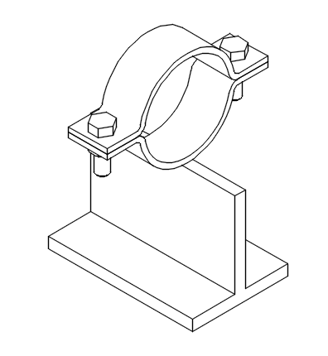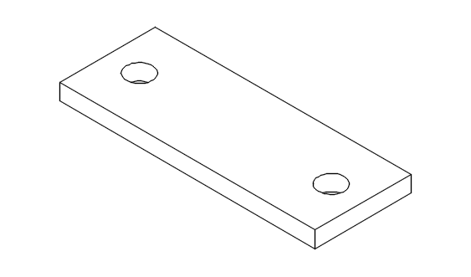

|  |  |
| --- | --- |
| CANTIDAD | Descripción |
| 1 | Paquetes de rollos de Teflón |
| 8 | Aforos DN25 – 5mm |
| 4 | Pletinas medianas con dos agujeros |
| 6 | T100 con una abrazadera DN65 |
| 1m | Tubo sch40 DN40 |
| 1m | Tubo sch40 DN50 |
| 1m | Viga cuadrada 30 |

# MATERIAL ELECTRICO

|  |  |
| --- | --- |
| CANTIDAD | Descripción |
| 1 | Rollo de tubo plástico DN10 |
| 10 | Racores DN10 : PG9 – para trans. de presión |
| 4 | Racores DN10 : M20x1,5 – para Pt100 |
| 4 | Racores DN10 : M20x1,5 – para electroneumática |