gstack Tutorial #5

Executive memo — gstack Tutorial #5
From YouTube analytics to a re-engineered Short: CSR-RAP × Claude Opus 5.5 × HyperFrames
Subject | How the AGI Race V2 was made, and what must happen next
Date | 29 September 2026
Companion files | TUTORIAL.md (full tutorial) · slide deck · starter/prompts

1. Bottom line
- The leverage was not a better prompt. It was splitting the work across three systems with different jobs: a CSR-RAP agent decides what to change, Claude Opus 5.5 in Claude Code (with gstack) writes the change, and HyperFrames renders it deterministically.
- V2 re-engineers the published AGI Race Short (58,736 views, 98 comments). It opens on the strongest punchline, completes the hook by 4.15 s, replaces name recognition with role tags, re-directs every shot for 9:16, and ends on a bridge to Episode 2. Master 56.34 s (−9.8 %); Short 46.54 s (−25.5 %).
- CSR-RAP rates V2's structural quality at B = 0.770 against V1's 0.602 (+27.9 %). That is a design score. Whether viewers behave better is an open A/B test to be settled with 72 hours of real analytics.

2. Scope
This memo covers V2 of the existing AGI Race Short only. Episode 2 (“OpenAI vs. Anthropic — Mission: Impossible Edition”) is still in production and appears only where its pilot taught something about the production system.

3. The system
Each layer has one job and one thing it must never do. The strategy layer must not invent platform data; the agent layer must not merely write prompts for another generator; the render layer must not be asked to invent photoreal humans. The rule that governs the split is the seek-safe test: if the renderer jumps straight to any time, is the frame still correct? Everything that must be exactly right (timing, text, role tags, 9:16 crops, freezes, end-cards, audio cues) goes in HyperFrames.
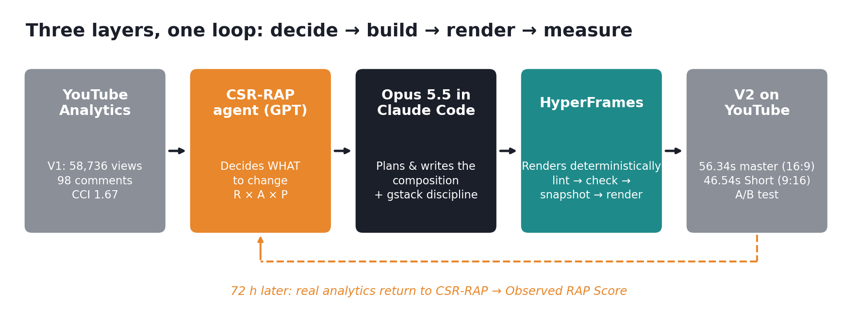
Figure 1 — Three layers, one loop

4. Setup on Windows 11 (about 10 minutes)
Step | Action
Prerequisites | winget install Git, Node.js (≥ 22), FFmpeg; install Bun (≥ 1.0) for gstack.
gstack (~1 minute) | In Claude Code: git clone --single-branch --depth 1 https://github.com/garrytan/gstack.git ~/.claude/skills/gstack && cd ~/.claude/skills/gstack && ./setup. Test with /office-hours.
HyperFrames | claude plugin marketplace add heygen-com/hyperframes; claude plugin install hyperframes@hyperframes; restart Claude Code.
Doctor first | npx hyperframes init agi-race-v2; npx hyperframes doctor. Pin the CLI version (the project used 0.8.79).
Windows pitfall encountered: “'claude' is not recognized”. Fix by adding %LOCALAPPDATA%\Microsoft\WinGet\Links to the user PATH and opening a new PowerShell.

5. What the V1 data said
V1 scored R 88 × A 90 × P 76, so B = 0.602. The views validated the topic (R × A resonance); 1.67 comments per 1,000 views showed conversion had not followed. A FFmpeg-measured Visual DNA then fixed what to keep and what to repair: 47 shots with a median of 1.08 s, the fastest cutting (0.95 s mean) just before the climax, a 1.5 s near-freeze followed by 0.84 s of black, and a 9:16 centre crop that loses the title, the wide ensemble, the final freeze and every subtitle.

6. The detour, and why it matters
The first sequel plan used Opus 5.5 to write prompts for a text-to-video model. On the home PC it stopped at its own entry gate, “FAIL”, because no reference images existed, and it refused to invent scores. After the pivot to HyperFrames, the C24 structure pilot proved the controlled layer (countdown correct at any seek time, black cut on frame 139, lint 0 errors, contrast 13/13) and also showed the limit: its R 0.82 and A 0.75 were held back by placeholder characters. V2 was the right next project because its pixels already existed.

7. What V2 changed
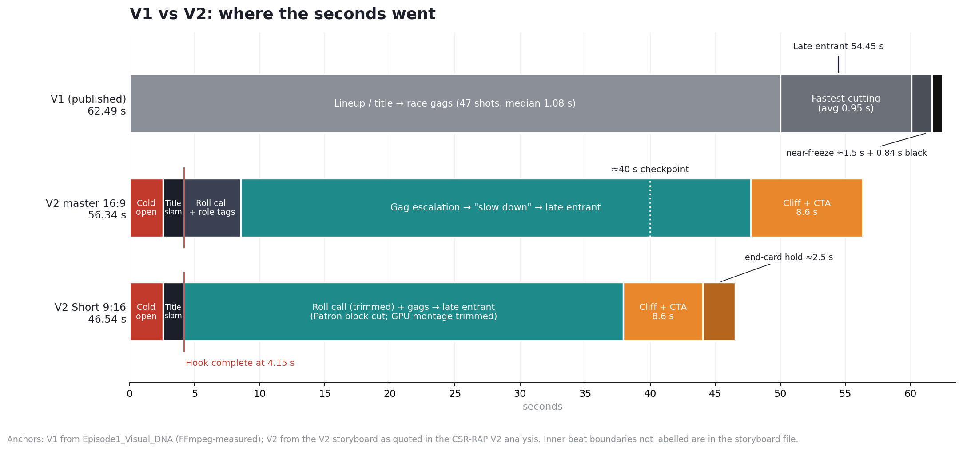
Figure 2 — V1 vs V2 timing
Metric | V1 | V2 | Assessment
Main runtime | 62.49 s | 56.34 s | −9.8 %
Short runtime | — | 46.54 s | −25.5 % vs V1
Opening | Lineup / title | Strongest gag first | Clear upgrade
Hook complete | Slower | 4.15 s | Stronger
Role comprehension | Relies on recognition | Explicit role tags | Major upgrade
9:16 | Fails in several places | Shot-by-shot reframing | Major upgrade
Ending | Unresolved jump | Jump + Episode 2 bridge | Commercial upgrade
CTA system | Weak / generic | TO BE CONTINUED → EP 2 → SUBSCRIBE | Clear upgrade
Production | Video generation | Programmable HyperFrames re-edit | P upgrade

8. The re-score, read honestly
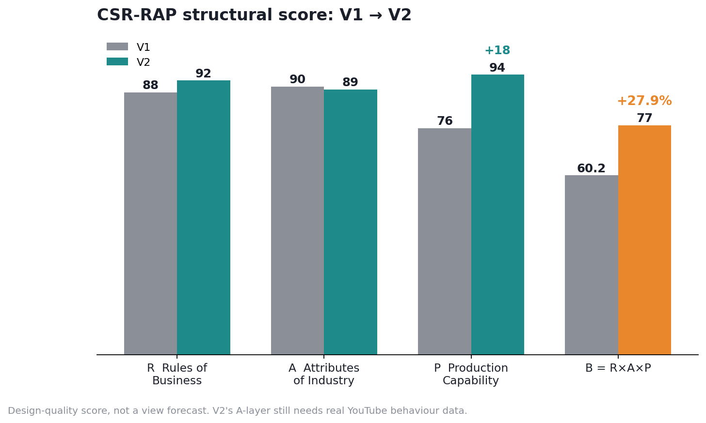
Figure 3 — CSR-RAP structural score, V1 vs V2
R rose from 88 to 92 (joke-first order, role tags, dead lines removed). A moved from 90 to 89: the structure fits Shorts better, but CTA length is untested. P rose from 76 to 94 (analyse → extract DNA → redesign → render). The strongest coupling is now R × P = 0.865, a production advantage that compounds across episodes. A +27.9 % structural gain is not a forecast of +27.9 % views.

9. What must happen next
- Freeze both uploads (youtube.com/shorts/mEztESwn7mI and youtu.be/6MnhRmSR_TA) for 24–72 hours.
- Pull Shorts metrics (views, shown in feed, stayed to watch, AVD, APV, likes, comments, shares, subscribers) and 16:9 metrics (impressions, CTR, AVD, retention, subscribers).
- Read three windows: 0–4.15 s (does the cold open stop the swipe?), ≈40 s (does “slow down → late entrant” lift attention?), last 8.6 s (does the end-card convert or cause exits?).
- If there is a retention cliff at the end-card and no subscriber lift, cut the hold from ≈2.5 s to ≈1–1.5 s in the next version.
- Compute an Observed RAP Score (proposed: stayed-to-watch %, APV, CCI with target > 2.5, subscribers per 1,000 views, Short APV ÷ master APV) and return it to the CSR-RAP agent before finalising the Episode 2 brief.

10. Limits and verification debt
Item | Note
No V2 analytics yet | All V2 claims are structural.
Scores are judgements | CSR-RAP rates design quality, not behaviour.
Mock screenshots | The annotated screenshots are illustrative; replace before publishing a fork.
Determinism | Renders are visually but not bit-for-bit identical (61/144 frames in C24).
Generative layer | Episode 2's faces, hands and keys remain untested.
Likeness | The videos satirise real public figures; role tags reduce but do not remove this. Review platform policy each release.

Appendix — annotated setup screenshots (illustrative mock-ups)
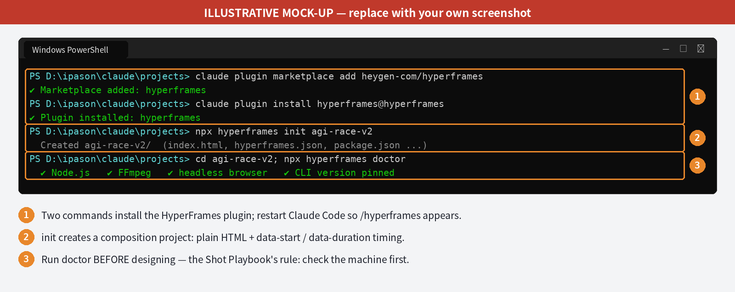
Figure 4 — HyperFrames install and doctor (mock-up)
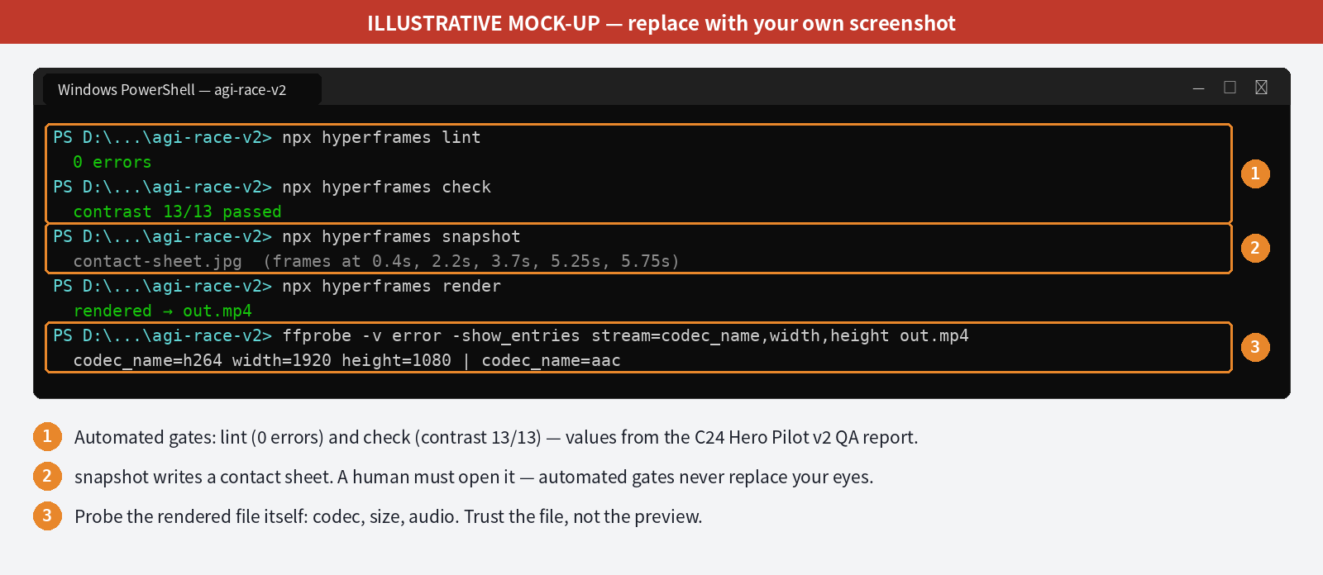
Figure 5 — Verification gates (mock-up; values from the C24 QA report)

