Michael Lygas

1) Main Observations:

* In category, we can verify that “theater” has the largest amount of contribution asks. We can also verify that “music” is the most successful (77%). And we note that 100% of “journalism” campaigns have been canceled.
* In sub-category, we can verify that “plays” has the largest amount of contribution asks. We can also verify that rock and classical music are 100% successful.
* By month, we can show that most campaigns were created in the months of May thru July. April and May were the most successful months when aggregating data over the past 9 years.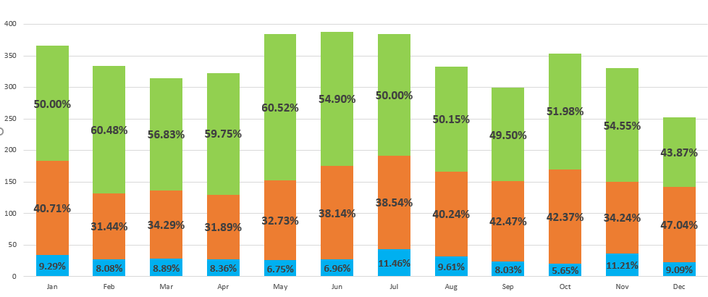
* The higher the $ goal, the greater likelihood the campaign is of failing.

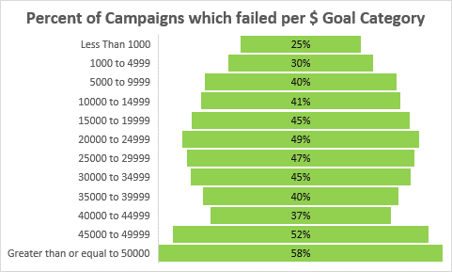

2) Some of the limitations of this dataset include:

* Not having full year data for 2009 or 2017. Related to that, it is important not to rely on just one year if doing predictive analysis as state or outcome of campaigns vary year over year.
* Not providing quantitative data such as survey results as to why a person would choose to donate or not to a campaign or why it would be cancelled.
* Relying only on one crowdfunding service

3) Other possible charts/ tables that can be created include:

* A map chart shows goal, pledged and average donation by country or by currency
* Correlations between pledged amount (dependent variable) and independent variables such as backers count, spotlight, staff picked or count of words in blurb.
* Time between “launched at” and “deadline” as a correlation factor to attainment or percent of goal funded.