# Heading

Content

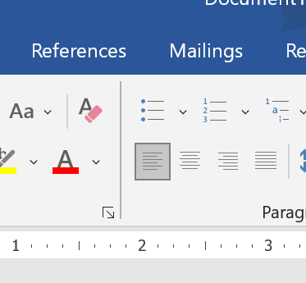

Figure - Thing