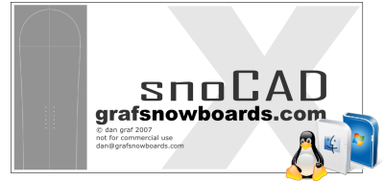
snoCAD-X
user guide

version 1.0.3.b

www.grafsnowboards.com

Introduction

snoCAD-X is an interactive application with which you can design all sorts of boardsports equipment. The main features are intended for snowboard and ski design, but you can also use it for skateboard decks, wakeboards, kiteboards, surfboards and ironing boards – if that’s what takes your fancy.

System Requirements

snoCAD-X is a Java application and as such will run on any platform. It has been successfully demonstrated on Windows XP, Linux and Apple Macintosh OS X.

The Windows XP and Linux versions require the Java JRE version 1.6 or above, and the Apple Macintosh version requires 1.5.

These will most likely be updated automatically for you when you download snoCAD-X.

Installation

Click on the correct link for your system type on the snoCAD-X download page. This will start the Sun Microsystems Java Web Start process, which will guide you through the installation.

License and Usage Policy

snoCAD-X is NOT Open Source software. Reverse Engineering and re-use of modules is not permitted.

snoCAD-X in the version available online is FREEWARE.

snoCAD-X is not intended for commercial use, but is aimed at hobby board builders and low volume custom board builders. Any commercial users should contact dan@grafsnowboards.com for agreement of a license fee.

The author of snoCAD-X takes no responsibility for programming inaccuracies which could lead to any mishap or damages whatsoever including loss of materials, damage to equipment, tools, personal injury etc.
Using snoCAD-X

The User Interface

snoCAD-X uses a standard Java GUI (Swing). The application allows multiple snowboards to be edited at once, each one having a separate window on the snoCAD-X desktop.
Editor Menu
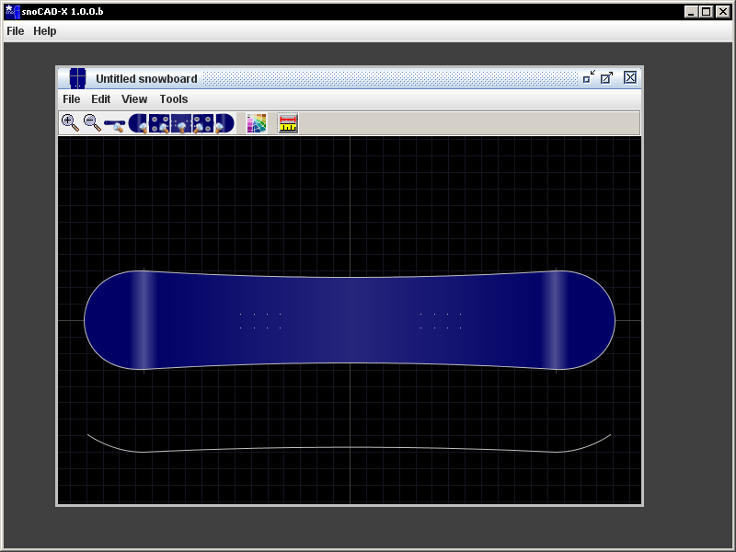
Board Editor
Desktop Area
Main Menu
Editor Toolbar
Board Display
Profile Display

Navigation
You can navigate around the Board Display by dragging the mouse over the display.

Zooming can be achieved either using the Magnifier buttons on the Editor Toolbar, or by rolling the mouse wheel in or out of the display.

Quick Navigation
You can easily and quickly move to key points on the board with the Quick Navigation buttons :

Tail

All
Nose
Front Pack
Centre
Rear Pack

Editing Modes

snoCAD-X has three modes of editing your board :

- Geometry Edit
- Core Edit
- Graphics Edit

The “Edit” Menu of the Board Editor lets you choose which one of the editing modes is active

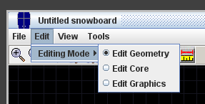

Geometry Edit Mode

This mode is your primary means of changing the major geometry of the board outline and profile.

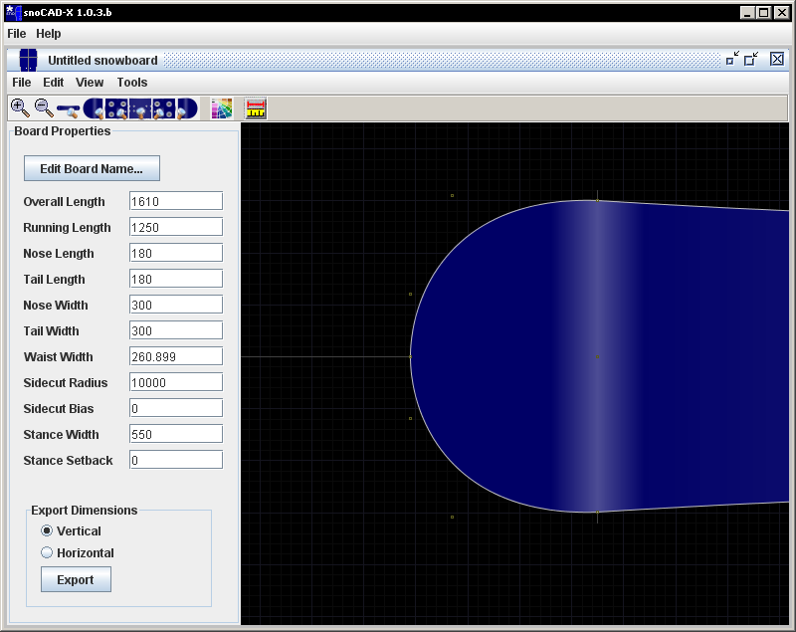

The Dimensions button on the Board Editor toolbar (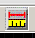) displays the dimensions of the major geometry of the board. Pressing the button again removes this screen.

To change the geometry, move your mouse pointer over the Board Display and notice how small square nodes appear at key places.

As your mouse moves closer to the nodes, they illuminate in yellow and display the current dimension associated with them.

Use your mouse to drag the node. This causes the board geometry to change and be instantly updated in the dimensions display.

You can use the Board Properties panel to edit any of the dimensions apart from Overall Length and Waist Width which are derived from the other measurements.
The Tipshaper is integrated in the Board Display. Only cubic bezier tip styles are available as they can simulate the old types of tip shape fine, and are the most intuitive and flexible.

By manipulating a Tip Curve node, the Smooth Aid line is automatically added to ease in matching curve tangents.

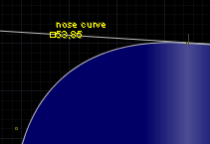

Rail Shaper
The Rail Shaper is available under the Tools menu when in Geometry Edit mode. It allows you to reverse the curvature of the rails to go convex, and to apply fixed numbers of serrations, and variable serration depth to the rails.
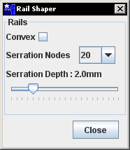

A Tape Measure function is available – hold down SHIFT and drag the mouse to measure parts of the board in millimetres.

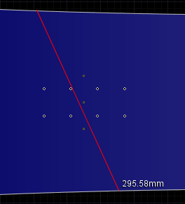

Core Editing Mode

The Core Editing mode disables most of the geometry manipulators (except for the Inserts) and makes use of the Core Shaper to derive the core geometry.

The Core Shaper is located under the Tools menu when in Core Editing mode.

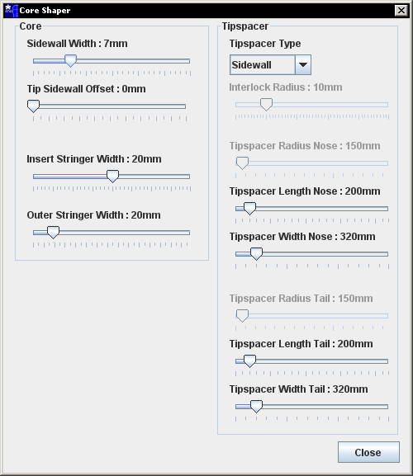

The parameters available are :

Sidewall Width – control the distance between the edge of the base and the edge of the core. Don’t forget to base this on your available sidewall material width, leaving room for the edge and a bit of overhang.

Tip Sidewall Offset – add an extra amount of distance between the edge of the core and the edge of the base around the tips :

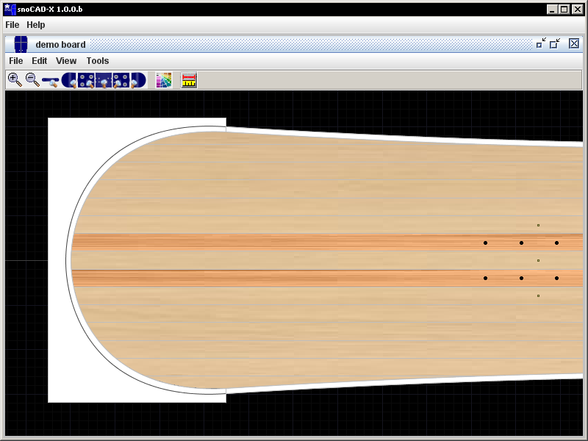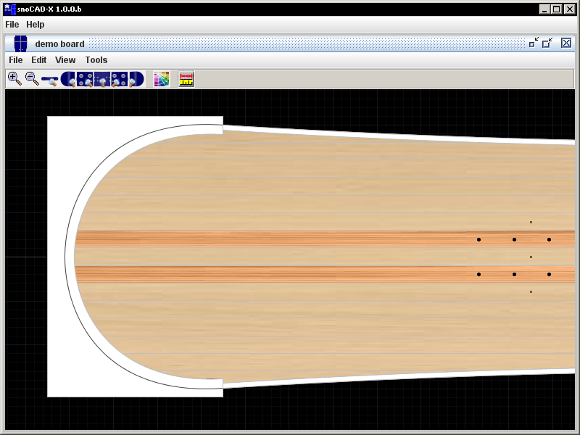
With no Tip Sidewall Offset Tip Sidewall Offset 5mm

Insert Stringer Width – Set the width of the (usually) hardwood stringers which bear the binding inserts.

Outer Stringer Width – Set the width of the outer core strips.

Tipspacer Type – choose which type of joint is used between core and tipspacer :

Sidewall : The tip has the same geometry as the base, but is
inset by the width of the sidewall plus offset

Radius : The tip uses a circular arc sector which is constrained
to pass through the widest points of the tip

Interlock : Like Sidewall, but with a quadrant shaped mechanical lock to hold the tipspacer in position.

Straight : The core ends in a straight cut-off at the widest point. This is intended for either no tipspacers, or full plastic tipspacers.

None : The tipspacer does not interfere with the core, and the tip extends fully to the edge of the base.

Tipspacer Length and Width – allows you to set the material size of the material rectangle used to form the tipspacer.

Tipspacer Radius – When using a Radius tipspacer type, this is used to set the radius available. The slider automatically sets the maximum and minimum values to plausible values. Anything higher or lower would either prevent the radius passing through the widest points, or would exceed the board tip length or width.

Interlock Radius – When using an Interlock tipspacer type, this is used to set the radius of the circular quadrant used in the interlock.

Graphics Editing Mode

In Graphics Editing mode, the Board Graphics bar appears on the right hand side of the Board Editor. The geometry manipulator handles are inactive.

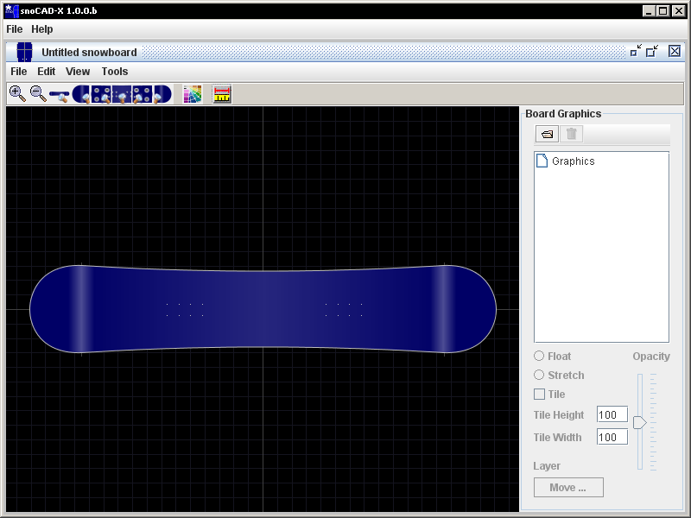

The “open folder” icon at the top left allows you to load graphic files (JPG, GIF, PNG). The graphic is automatically resized to become 300mm long, and is positioned just above the nose of the board.

The graphic is only actually rendered when it is visible on the topsheet. Outside the topsheet you only see a grey bounding box.

The graphic appears in a tree structure on the Board Graphics bar. It can be manipulated in the following ways :

Float Mode (default) – The image is free floating and can be resized and moved using the yellow handles either corner of the image bounding box.

Stretch Mode – The image is stretched automatically to the maximum bounding box which encloses the snowboard. It also adds 20mm perimeter outside the board to account for sublimation shrinkage and misalignment in layup.

Tile Mode – Can be applied to floating and stretched images, tile mode makes the image repeat over and over in tiles sized according to the Tile Height and Tile Width boxes (in mm).

Opacity – This control is only enabled if the graphic has an alpha channel (eg a PNG). This makes the graphic progressively more transparent and is useful for subtle layering of images.

Move Up Button – In multi-layered graphics, Move Up raises the level of the currently selected graphic and draws it in front of images lower down the tree.

Output Functions

snoCAD-X has a range of functions to output data. These are available from the File menu of the Board Editor :

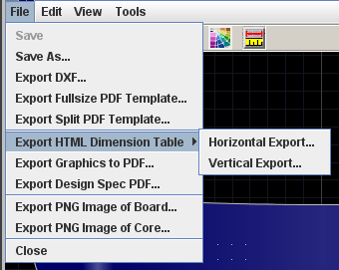

Save / Save As… - This saves the board in the new snoCAD-X “snx” file format. This file stores all geometry and settings as well as any graphics you have added. File size is therefore dependent on the images you have put into the graphics editor. This feature allows you to share decorated boards with other builders.

Export DXF – Exports all board geometry including tipspacers, profile and flex views to a Drawing eXchange Format file for further CAD processing. The individual entities have closed paths and are coloured for easy identification.

Export Fullsize PDF template – Produces a 100% sized PDF board template with a 20mm border. Plot this and use it to cut out a wooden template.

Export Split PDF template – Produces a PDF board template with the outline split across multiple small sheets. You can select your desired paper size, and the output features lateral and longitudinal alignment aids.

Export HTML Dimension Table – Exports a HTML format table either across or down the page with the major dimensions of the board. This can then be opened in Excel if you like to store records of your boards.

Export Graphics to PDF – This produces a 100% scale PDF of the graphic in rectangular format including 20mm printed borders. This is intended to be sent to a sublimation processing centre for printing on your topsheet.

Export Design Spec to PDF – This produces a 4 page document featuring a cover sheet, rendered board image, rendered core image and dimensions table.

Export PNG Image of Board / Core – Produces a high resolution PNG image of the board or core for use in your documentation.

End of Document

