OG Games Database User Manuel

**Intro**

This is the user manual for the database designed by Michael Martin and Frank Sanchez for the use of OG Games database administrators. The purpose of this manual is to provide support for using and navigating the OG Games database.

**Apendix**

Open up to the Homepage

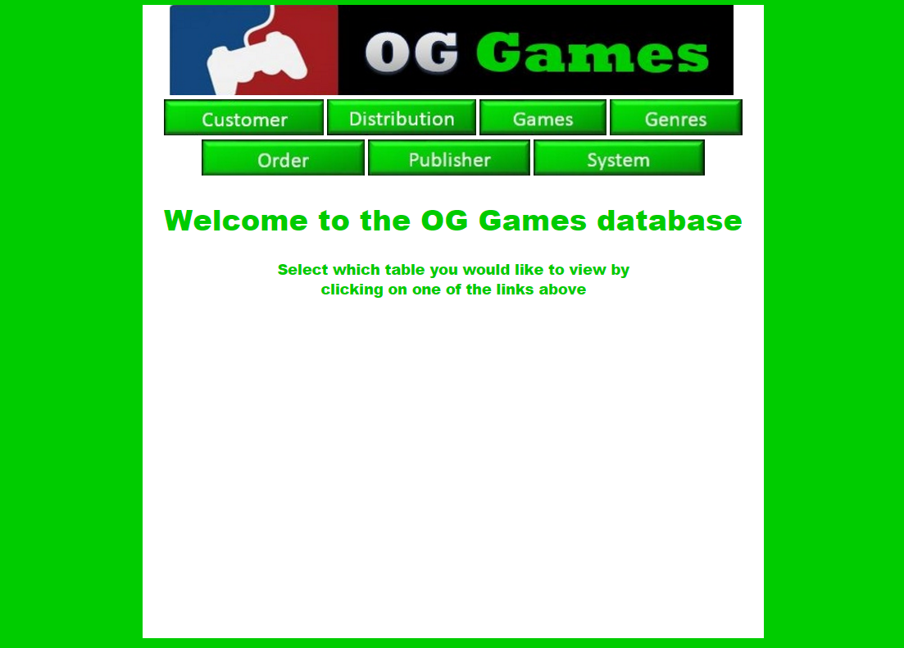

From the homepage, you can click on which table you would like to make changes to.

The user can navigate back to the homepage on any webpage within the website by clicking the OG Games banner (pictured below) at the top of the every page.

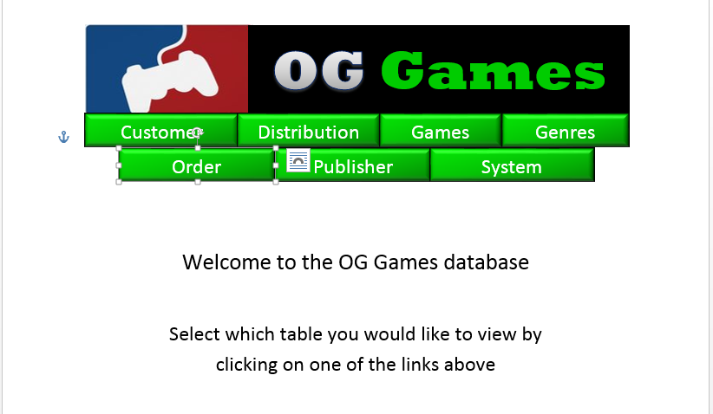

The process for making changes to a table is about the same for every table, so I will go over how to perform maintenance on the table that contains the data for all OG Games distribution centers.

To change/add/delete records in this table of the database, click on the distribution button in the top navigation.

From here you can update, insert, and delete information from the table. In addition, you may also search the data for specific records using queries we have developed. The page is divided into three sections. They are query data, inserting a new record, and displaying all the data in the table. When first navigating to the page, the insert tab will be displayed by default, but the query data and list all portions will be hidden. You may reveal these sections by clicking on the specific tab you would like to see. Also, you may collapse the tabs by clicking on the sections. Please note that only one tab may be expanded at a time.

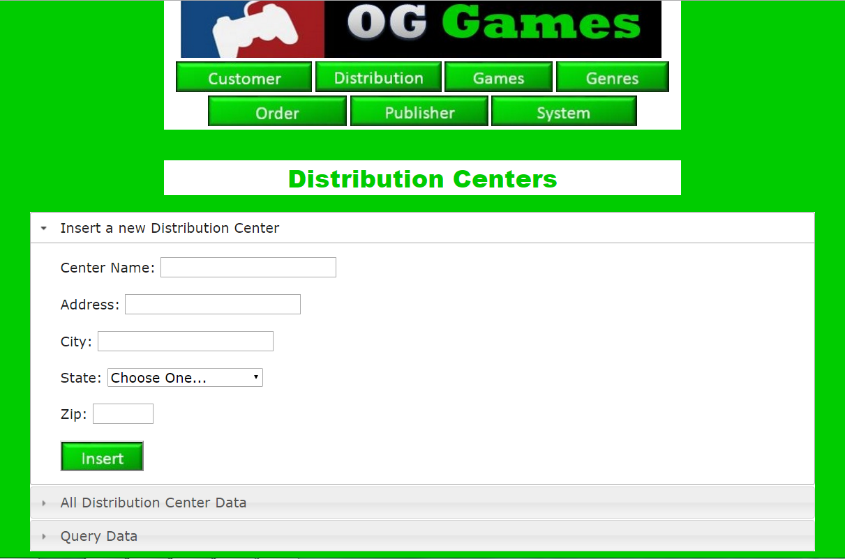

You can tell which tab is expanded and which ones are hidden by the right arrow or down arrow to the left of each tab. If the symbol is a right arrow, the tab is hidden. Otherwise, if the symbol is a down arrow; that indicates that the tab is expanded.

To query the data, simply click on the query data tab and enter in the data in which you would like to search for. In this case, you may search by Center ID or by State.

If you click on search next to a field but leave the field blank, a message will pop up stating that you need to fill in the field. Also, if you try to search using invalid information, a pop up will let you know that you have entered an invalid entry.

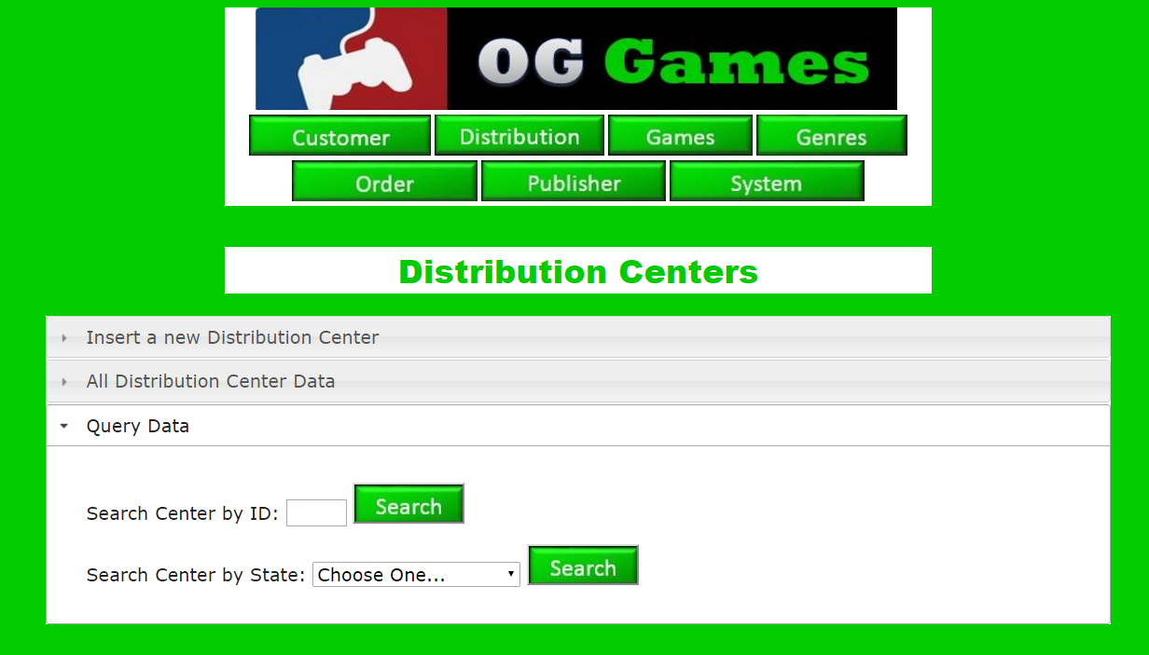

To insert a new record into this table, make sure that the insert a new Distribution Center tab is expanded.

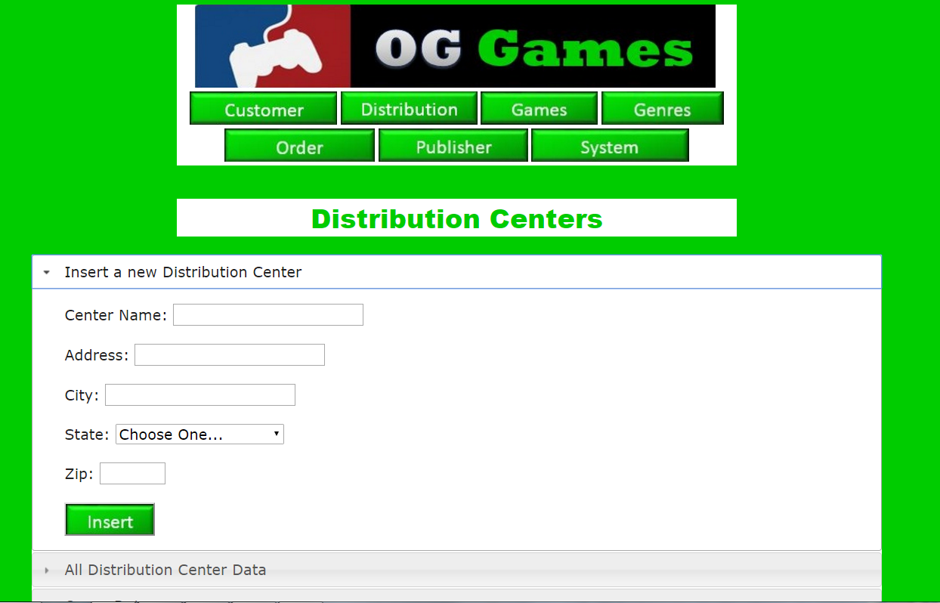

If any of the information entered into the fields when clicking insert is invalid, then a message will pop up stating that the information was invalid and that you need to correct the error before continuing. Likewise, if a field is left blank, a message will pop up stating that not all required information was entered. The blank field will need to be filled in before and further action is taken.

Once you enter valid information in every field, the new record will be inserted into the table and the page will refresh. The page will display that the insertion was successful and include the new record that was just added. The primary key will be assigned by adding 1 to the highest primary key at the time of insertion.

Viewing all data in the table is accomplished by making sure the ‘View all Distribution Center data’ tab is expanded. Once expanded, you can update any entry in the table by modifying any field in a specific record, then clicking update at the end of that record’s row. If a field is left blank or contains invalid information, a pop up message will let you know. Once valid information is entered, you will receive a pop up asking if you are sure you would like to update that record. If you click OK, the record will update and the page will be refreshed so that you can see your updated data.

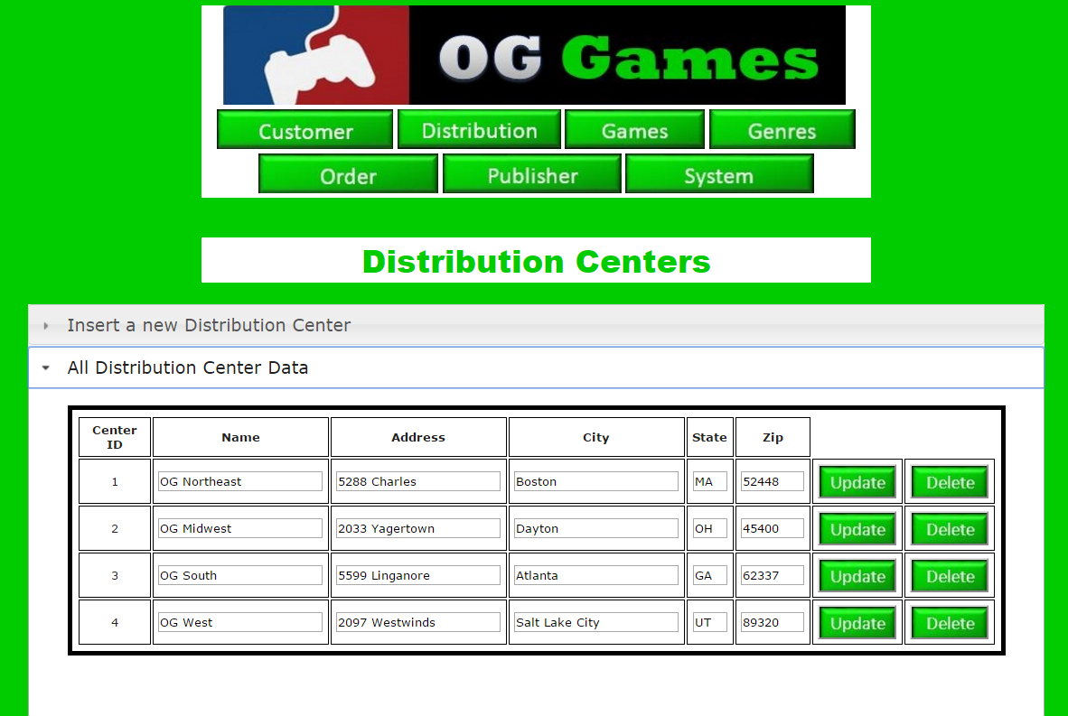

To delete a record, click the delete button at the end of the row in which you wish to delete. When you click delete, a pop up message will ask you if you are sure you would like to delete that record. Once OK is clicked, the page will be refreshed so that you can see all the data in the table.