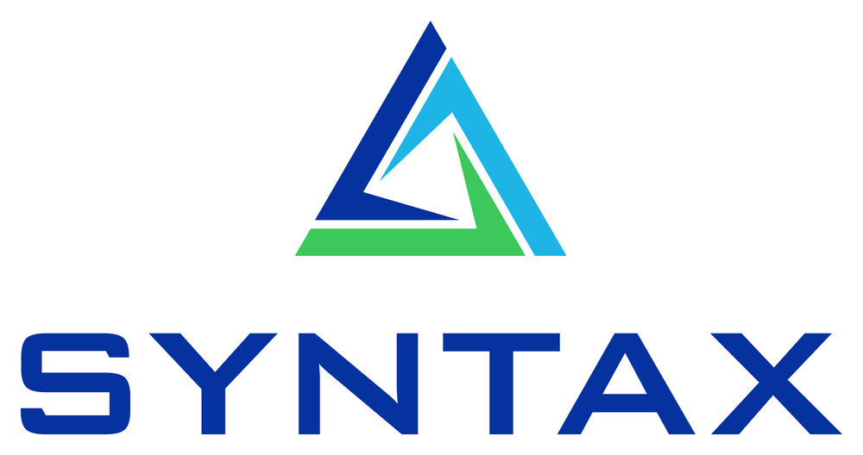

STATEMENT OF WORK
EBS Contract Renewal PAF
Implementation & managed services — signable SOW
Syntax Corporation · Build 1.0.0 · 2026-06-04

1. Scope
Syntax Corporation will deliver a production Private Agent Factory agent that automates Oracle EBS Blanket Purchase Agreement renewals end-to-end: quote extraction, governed EBS reads, deterministic renewal policy, a balanced PDOI batch for Import Price Catalogs, a QA gate, the XXPAF PL/SQL package, and managed-MCP integration. Read-only by default; the buyer approves each renewal in EBS.

2. Architecture
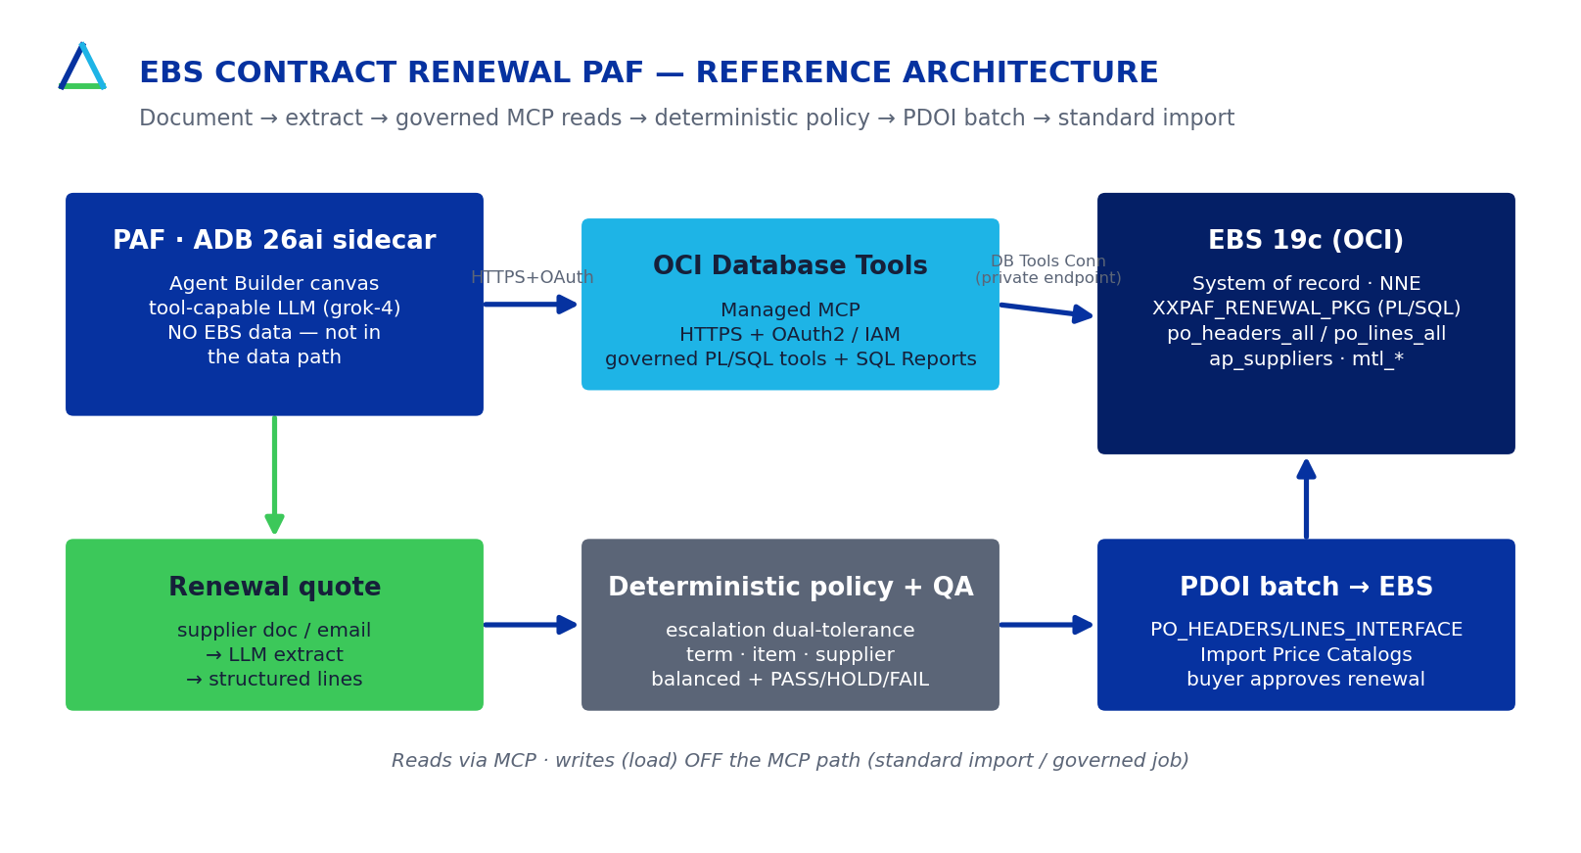

3. Deliverables
- The renewal agent (extractor, repository, policy engine, PDOI writer, QA gate, CLI).
- XXPAF_RENEWAL_PKG PL/SQL + parity harness; managed-MCP tool/SQL-Report definitions.
- Test suite (hermetic + live golden), QA report, and full documentation.
- PAF Agent Builder canvas recipe + published REST API hook.

4. Timeline
Phase | Weeks | Outcome
Discover & verify | 1–2 | Live SQL verification; golden record; spec sign-off
Build vertical slice | 3–5 | Agent + PL/SQL + tests against the customer instance
QA & UAT | 6–7 | Zero-bug convergence; balanced batch in UAT
Cutover & enablement | 8 | Managed-MCP wiring; runbook; go-live
Estimated effort: 640 hours at a $95/hr blended delivery rate (20/40/40 onshore/nearshore/offshore).

5. RACI
Activity | Syntax | Customer
EBS discovery & SQL verification | R/A | C (access)
Agent + PL/SQL build | R/A | C
Tolerance / policy sign-off | C | R/A
UAT & acceptance | C | R/A
Production approval of renewals | I | R/A
Managed services (run) | R/A | C

6. Commercials
Fixed-fee implementation (one-time): $60,800.
Managed services | 12-month | 24-month | 36-month
Per month | $7,350 | $6,615 | $5,880
Per year | $88,200 | $79,380 | $70,560
Term discount | 0% | 10% | 20%
Indicative value: $614,000 net annual savings, ~1.4-month payback, 466% 3-year ROI (validate in a read-only value assessment). OCI consumption billed separately per the OCI BOM.

7. Acceptance criteria
Green live golden-renewal test and a balanced PDOI batch staged and validated in the customer UAT environment.

8. Assumptions
- Customer provides timely EBS access (read-only service account) and a test instance.
- Managed-MCP availability for the target EBS edition/region is confirmed at install.
- Legal terms are governed by the parties' master agreement; this SOW is a generic shell.

9. Signatures
 | Syntax Corporation | Customer
Name
Title
Signature
Date

