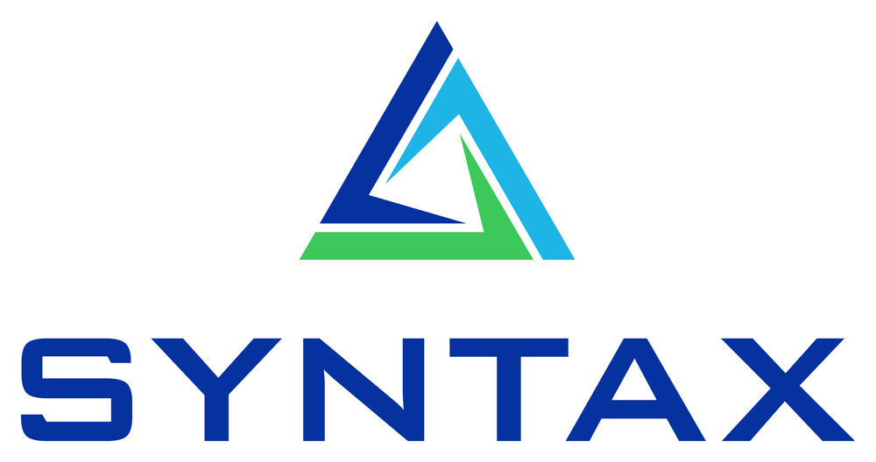

TECHNICAL DESIGN
EBS Contract Renewal PAF
Architecture, data contract & policy design
Syntax Corporation · Build 1.0.0 · 2026-06-04

1. Overview
A Private Agent Factory agent that renews EBS Blanket Purchase Agreements: it ingests a supplier renewal quote, pulls current prices from EBS via a governed MCP, applies a deterministic renewal-template policy, and stages a balanced Purchasing Documents Open Interface (PDOI) batch for the standard Import Price Catalogs program. Reproduces the Oracle blog 'Simplifying Contract Renewals: An AI Agent for EBS with Private Agent Factory'.

2. Reference architecture
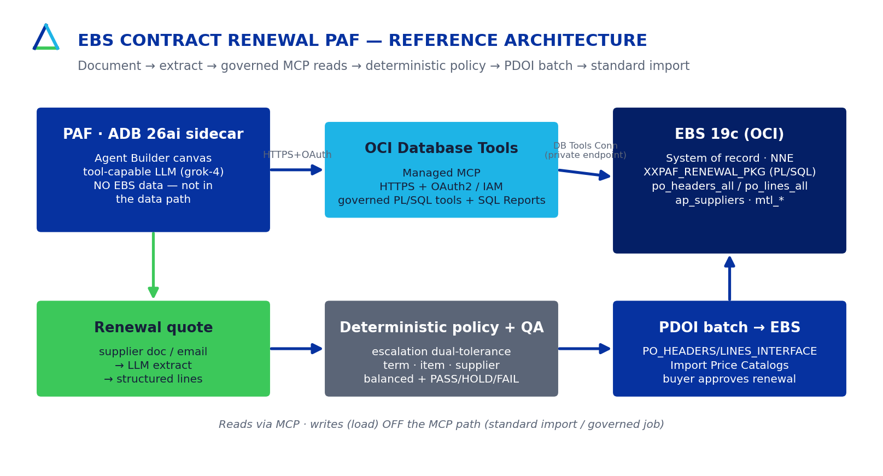
EBS 19c is the system of record (NNE; XXPAF PL/SQL). PAF runs on an ADB 26ai sidecar holding no EBS data and not in the data path. The OCI Database Tools Managed MCP (HTTPS + OAuth/IAM) reaches EBS via a Database Tools Connection. Writes (the load) stay off the MCP path.

3. Pipeline
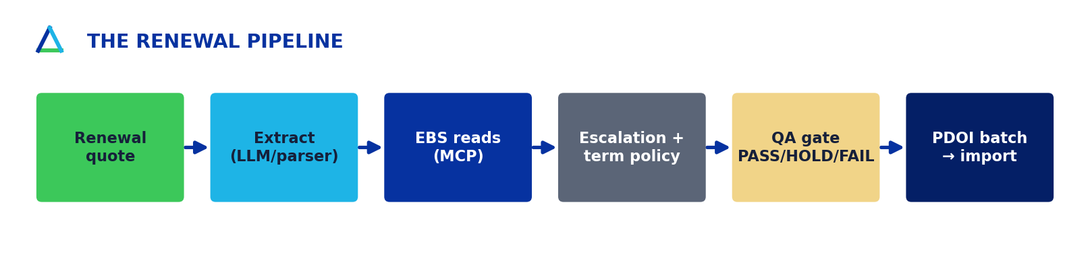

4. EBS interface contract (PDOI)
Target: PO_HEADERS_INTERFACE + PO_LINES_INTERFACE; program: Import Price Catalogs. Verified live against EBS_Vision_12214:
- ACTION='UPDATE' references the existing agreement by PO_HEADER_ID (DOCUMENT_NUM is an obsoleted stub).
- BATCH_ID is NUMBER; the agreement total is AMOUNT_AGREED (no BLANKET_TOTAL_AMOUNT on the interface).
- UOM_CODE for 'Each' is 'Ea'; PO_LINES_INTERFACE has no ATTRIBUTE columns.
- APPROVAL_STATUS='INCOMPLETE' — the buyer approves the renewal in EBS.

5. Renewal policy (deterministic)
Rule | Logic | Outcome
Price escalation | increase > 7% AND annual $ impact > $250 | HOLD (dual gate)
Term length | renewed term > 36 months | HOLD
Term contiguity | gap/overlap vs prior expiration | HOLD
Item validity | item inactive / non-purchasable | HOLD
Supplier site | site inactive / not a purchasing site | HOLD
Structural | non-positive price / no matching line | FAIL
Balance | AMOUNT_AGREED = Σ(price × qty) | FAIL if unbalanced

6. Quality & parity
- 43 hermetic + 8 live tests (golden record BPA 4467); read-only by default.
- Python reference engine is the test oracle; XXPAF_RENEWAL_PKG kept at parity (verified live).
- Deterministic policy outside the LLM → auditable, reproducible; full agent_trace.json.

