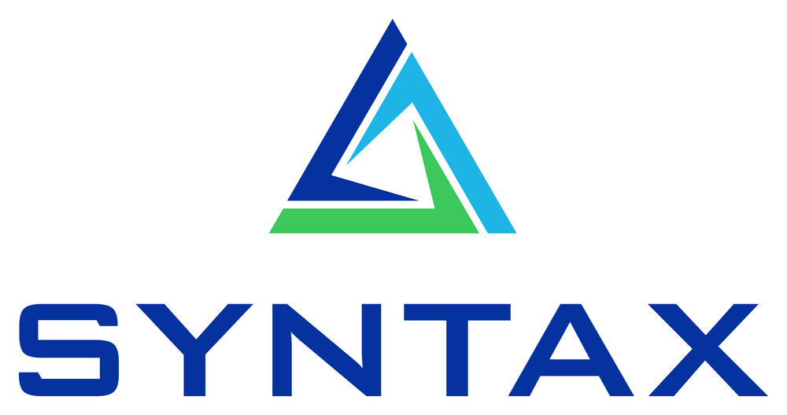
BLANKET PURCHASE AGREEMENT — RENEWAL
Agreement No. BPA-90001

This Renewal is entered into between Acme Facilities Supply, Inc. (“Supplier”) and the Buyer, renewing the above Blanket Purchase Agreement on the terms below.
1. Term
The renewed term is effective 2026-01-01 through 2028-12-31 (36 months), contiguous with the prior term ending 2025-12-31.
2. Revised pricing
The unit prices for the renewed term are set out below, reflecting current pricing retrieved from the system of record with the agreed adjustment applied:
Line | Item | Prior $ | New $ | Δ | Effective
1 | FILTER-A | 20.00 | 20.14 | 0.70% | 2026-01-01
2 | BELT-B | 50.00 | 58.30 | 16.60% | 2026-01-01
3 | PUMP-C | 500.00 | 530.00 | 6.00% | 2026-01-01
3. Warranty
Supplier warrants that all goods supplied under this Agreement will be free from defects in material and workmanship for a period of twelve (12) months from delivery and will conform to the agreed specifications and quantities.
4. Governing law
This Agreement shall be governed by and construed in accordance with the laws of the State of California, without regard to its conflict-of-laws principles.
5. Signatures
Name | Supplier | Buyer
Title
Signature
Date

