Statement of Work
EBS AP Invoice Automation Agent · Syntax Corporation
1. Overview & scope
Syntax will implement the EBS AP Invoice Automation Agent on Oracle Private Agent Factory, integrating to the customer's EBS 19c via the OCI Database Tools Managed MCP, with deterministic 3-way match, GL/tax coding, QA, and load through the standard Payables Open Interface Import.
2. Architecture
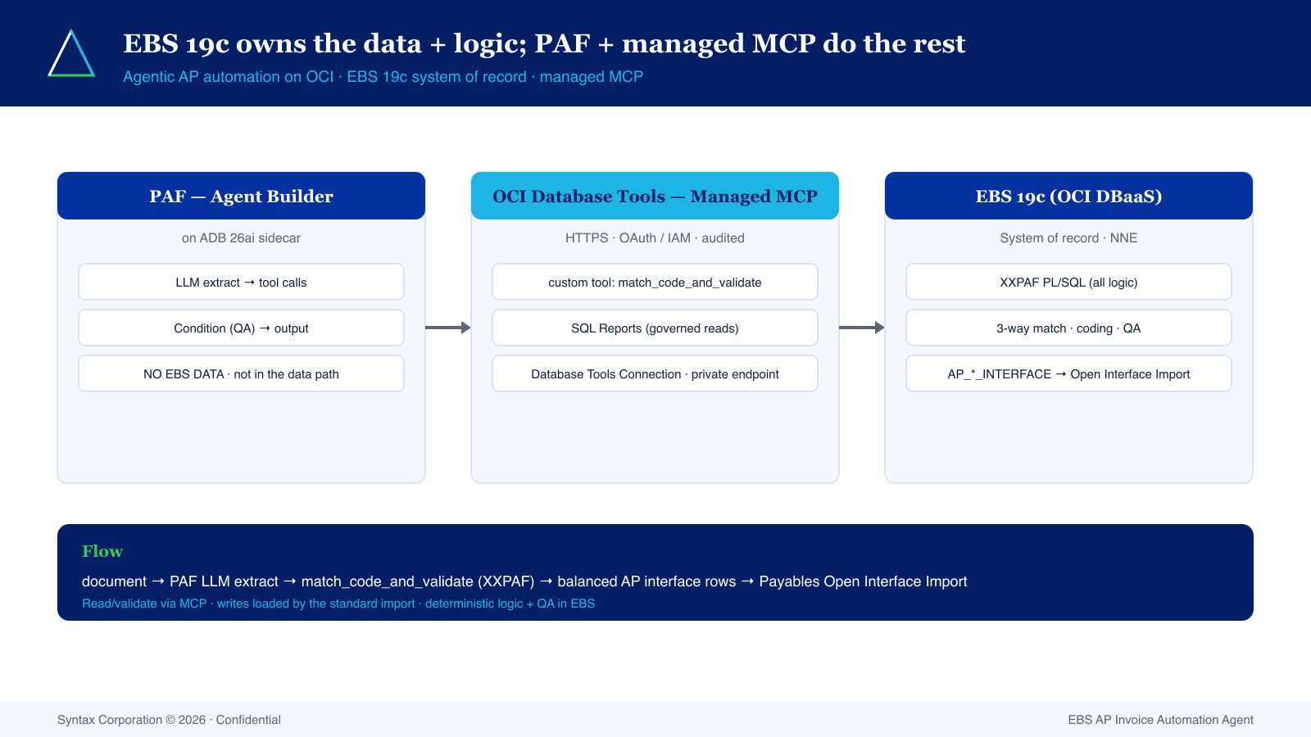
3. Deliverables
- XXPAF PL/SQL package deployed to EBS 19c
- PAF agent (.paf import + canvas) + managed-MCP tool registration
- QA pack (tests + QA_REPORT) and technical design document
- Go-live support and knowledge transfer
4. Responsibilities (RACI summary)
Activity | Syntax | Customer
EBS access / Database Tools Connection | C | R
XXPAF deployment | R | A
PAF agent build + import | R | C
UAT & acceptance | C | R

5. Pricing
Implementation (fixed fee, blended $95/hr, 320 hrs):
Item | Amount
Implementation (~320 hrs @ $95 blended) | $30,400

Managed services (per month, by commitment term — medium tier):
Term | Monthly | Discount
12 months | $8,957 | —
24 months | $8,061 | 10%
36 months | $7,165 | 20%

Estimated first-year net savings ~ $822,520; payback ~ 1.4 months. See the ROI calculator and OCI BOM for detail.
6. Acceptance & signatures
Acceptance: a green live golden test plus a balanced interface load in customer UAT. This generic SOW shell is subject to the parties' MSA; have counsel review before use.

For Customer | For Syntax Corporation
Name: | Name:
Title: | Title:
Signature / Date: | Signature / Date:

Syntax Corporation © 2026 · Confidential

