EBS AP Invoice Automation Agent — Technical Design
AP invoice automation · Oracle Private Agent Factory
Architecture
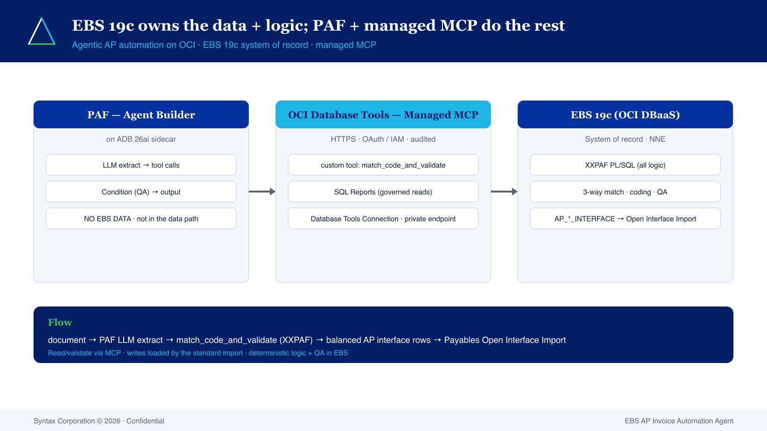
EBS 19c (OCI DBaaS/Exadata) is the system of record and the home of all logic — the XXPAF_AP_AGENT PL/SQL package. PAF runs on an ADB 26ai sidecar holding zero EBS data and is not in the data path. The OCI Database Tools Managed MCP (HTTPS + OAuth/IAM) exposes XXPAF as a governed custom tool + SQL Reports over a Database Tools Connection — no broker, no DB link, no thick-mode in production.
Processing
- Extraction in the PAF LLM node → invoice JSON
- match_code_and_validate (XXPAF): supplier resolve, duplicate check, 3-way match (dual %/$ tolerance), GL/tax coding, QA gate
- Balanced AP interface rows (header = Σ lines incl. TAX line)
- Load via the standard Payables Open Interface Import (writes off the MCP path)
Interface contract
Item | Value
Header table | AP_INVOICES_INTERFACE
Lines table | AP_INVOICE_LINES_INTERFACE
Import program | Payables Open Interface Import
Tolerances | price 2% & $25 · qty 5% & $25 (dual gate)

Assurance
Deterministic logic in PL/SQL; the Python reference engine is the test oracle (parity test asserts Python == PL/SQL on golden PO 3495 → balanced $632,500.00, QA PASS).
Syntax Corporation © 2026 · Confidential

