Оглавление
- Introduction
- Background
- Model Architecture
- Experiments
- Conclusion

Introduction
Recurrent neural networks, long short-term memory networks, and gated recurrent neural networks in particular, have been firmly established as state of the art approaches in sequence modeling and transduction problems. The inherently sequential nature precludes parallelization within training examples, which becomes critical at longer sequence lengths, as memory constraints limit batching across examples.
The attention mechanism has become an integral part of compelling sequence modeling and transduction models, allowing modeling of dependencies without regard to their distance in the input or output sequences.

Background
The goal of reducing sequential computation also forms the foundation of the Extended Neural GPU, ByteNet, and ConvS2S, all of which use convolutional neural networks as basic building blocks, computing hidden representations in parallel for all input and output positions.
Self-attention, sometimes called intra-attention, is an attention mechanism relating different positions of a single sequence in order to compute a representation of the sequence.

Model Architecture
Most competitive neural sequence transduction models have an encoder-decoder structure. The encoder maps an input sequence of symbol representations $(x_{1},...,x_{n})$ to a sequence of continuous representations $z=(z_{1},...,z_{n})$. Given $z$, the decoder then generates an output sequence $(y_{1},...,y_{m})$ of symbols one element at a time.
The Transformer follows this overall architecture using stacked self-attention and point-wise, fully connected layers for both the encoder and decoder, shown in Figure .
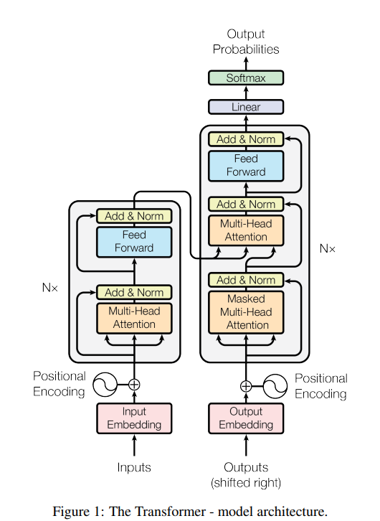
Архитектура Transformer

Encoder and Decoder Stacks
Encoder: The encoder is composed of a stack of $N=6$ identical layers. Each layer has two sub-layers. The first is a multi-head self-attention mechanism, and the second is a simple, position-wise fully connected feed-forward network.
Decoder: The decoder is also composed of a stack of $N=6$ identical layers. In addition to the two sub-layers in each encoder layer, the decoder inserts a third sub-layer, which performs multi-head attention over the output of the encoder stack.

Attention
An attention function can be described as mapping a query and a set of key-value pairs to an output, where the query, keys, values, and output are all vectors. The output is computed as a weighted sum of the values, where the weight assigned to each value is computed by a compatibility function of the query with the corresponding key.

Scaled Dot-Product Attention
We call our particular attention “Scaled Dot-Product Attention” (Figure ). The input consists of queries and keys of dimension $d_{k}$, and values of dimension $d_{v}$. We compute the dot products of the query with all keys, divide each by $\sqrt{d_{k}}$, and apply a softmax function to obtain the weights on the values.
$$\text{Attention}(Q,K,V)=\text{softmax}\left(\frac{QK^{T}}{\sqrt{d_{k}}}\right)V$$

Multi-Head Attention
Instead of performing a single attention function with $d_{\text{model}}$-dimensional keys, values and queries, we found it beneficial to linearly project the queries, keys and values $h$ times with different, learned linear projections to $d_{k}$, $d_{k}$ and $d_{v}$ dimensions, respectively.
Multi-head attention allows the model to jointly attend to information from different representation subspaces at different positions:
$$\begin{aligned}\text{MultiHead}(Q,K,V)&=\text{Concat}({\text{head}}_{1},...,{\text{head}}_{h})W^{O} \\ {\text{where head}}_{i}&=\text{Attention}(QW_{i}^{Q},KW_{i}^{K},VW_{i}^{V})\end{aligned}$$
Where the projections are parameter matrices: $W_{i}^{Q}∈R^{d_{\text{model}}×d_{k}}$, $W_{i}^{K}∈R^{d_{\text{model}}×d_{k}}$, $W_{i}^{V}∈R^{d_{\text{model}}×d_{v}}$ and $W^{O}∈R^{hd_{v}×d_{\text{model}}}$.
[(left) Scaled Dot-Product Attention. (right) Multi-Head Attention consists of several attention layers running in parallel.] (рисунок attention.png не найден)

Position-wise Feed-Forward Networks
Each layer in our encoder and decoder contains a fully connected feed-forward network, which is applied to each position separately and identically. This consists of two linear transformations with a ReLU activation in between:
$$\text{FFN}(x)=max(0,xW_{1}+b_{1})W_{2}+b_{2}$$

Positional Encoding
Since our model contains no recurrence and no convolution, in order for the model to make use of the order of the sequence, we must inject some information about the relative or absolute position of the tokens in the sequence. We use sine and cosine functions of different frequencies:
$$\begin{aligned}PE_{(pos,2i)}&=sin\left(\frac{pos}{{10000}^{2i/d_{\text{model}}}}\right) \\ PE_{(pos,2i+1)}&=cos\left(\frac{pos}{{10000}^{2i/d_{\text{model}}}}\right)\end{aligned}$$
where $pos$ is the position and $i$ is the dimension.

Experiments

Training Data and Benchmarking
We trained on the standard WMT 2014 English-German dataset consisting of about 4.5 million sentence pairs. Sentences were encoded using byte-pair encoding. For English-French, we used the significantly larger WMT 2014 English-French dataset consisting of 36M sentences.

Results
On the WMT 2014 English-to-German translation task, the Transformer achieves a BLEU score of 28.4, outperforming all previously published models. The results are shown in Table .
Model | BLEU | Training Cost (FLOPs)
English-to-German
Transformer (base) | 27.3 | $3.3×{10}^{18}$
Transformer (big) | 28.4 | $2.3×{10}^{19}$
English-to-French
Transformer (base) | 38.1 | $3.3×{10}^{18}$
Transformer (big) | 41.8 | $2.3×{10}^{19}$

Model | F1 Score
Transformer (4 layers) | 91.3
Transformer (8 layers) | 91.7

Conclusion
We have presented the Transformer, the first sequence transduction model based entirely on attention, replacing the recurrent layers most commonly used in encoder-decoder architectures with multi-headed self-attention.
For translation tasks, the Transformer can be trained significantly faster than architectures based on recurrent or convolutional layers. We achieve a new state of the art on the WMT 2014 English-to-German and English-to-French translation tasks.
We are excited about the future of attention-based models and plan to apply them to other tasks. The Transformer is particularly suitable for tasks involving large inputs and outputs, and we plan to continue its development.

