Attention Is All You Need
Ashish Vaswani, Noam Shazeer, Niki Parmar, Jakob Uszkoreit, Llion Jones, Aidan N. Gomez, Lukasz Kaiser, Illia Polosukhin

Оглавление
- Abstract
- Introduction
- Model Architecture
- Conclusion

Abstract
The dominant sequence transduction models are based on complex recurrent or convolutional neural networks that include an encoder and a decoder. The best performing models also connect the encoder and decoder through an attention mechanism. We propose a new simple network architecture, the Transformer, based solely on attention mechanisms, dispensing with recurrence and convolutions entirely.

Introduction
Recurrent neural networks [1], long short-term memory networks [2], and gated recurrent neural networks in particular, have been firmly established as state of the art approaches in sequence modeling and transduction problems.
The attention mechanism has become an integral part of compelling sequence modeling and transduction models [3], allowing modeling of dependencies without regard to their distance.

Model Architecture
Most competitive neural sequence transduction models have an encoder-decoder structure.
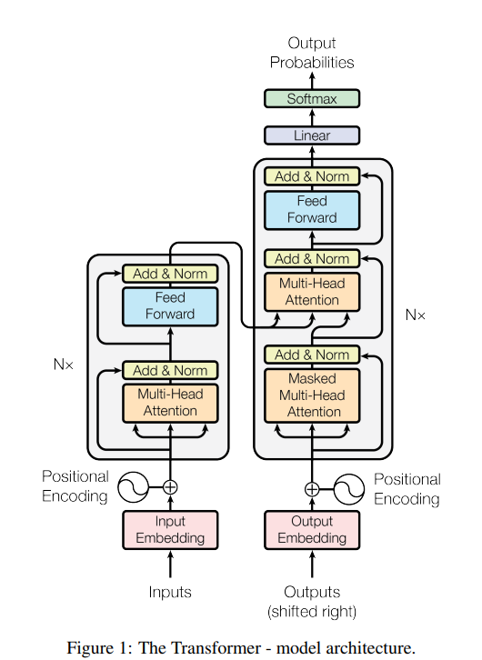
Архитектура Transformer

Encoder and Decoder Stacks
Encoder: The encoder is composed of a stack of $N=6$ identical layers. Each layer has two sub-layers.
Decoder: The decoder is also composed of a stack of $N=6$ identical layers.

Attention
An attention function can be described as mapping a query and a set of key-value pairs to an output.

Scaled Dot-Product Attention
We call our particular attention “Scaled Dot-Product Attention”:
$$\text{Attention}(Q,K,V)=\text{softmax}\left(\frac{QK^{T}}{\sqrt{d_{k}}}\right)V$$

Multi-Head Attention
Multi-head attention allows the model to jointly attend to information:
$$\begin{aligned}\text{MultiHead}(Q,K,V)&=\text{Concat}({\text{head}}_{1},...,{\text{head}}_{h})W^{O} \\ {\text{where head}}_{i}&=\text{Attention}(QW_{i}^{Q},KW_{i}^{K},VW_{i}^{V})\end{aligned}$$
Multi-Head Attention
Multi-Head Attention

Results
Model | BLEU | Training Cost (FLOPs)
Transformer (base) | 27.3 | $3.3×{10}^{18}$
Transformer (big) | 28.4 | $2.3×{10}^{19}$

Conclusion
We have presented the Transformer [4], the first sequence transduction model based entirely on attention.

Список литературы
- sutskever2014sequence
- hochreiter1997long
- bahdanau2014neural
- vaswani2017attention

