Market Warrior
Admin Panel, Dashboard & Community Requirements


Prepared for developer • 2025-12-16

1. Executive summary
Goal: keep the exact look/feel of the provided HTML templates (1:1), but make every admin/dashboard/community feature fully functional with database + APIs + Stripe + Resend.
Non‑negotiables:
- UI must remain 1:1 with the templates (no redesigns).
- Admin tools must actually work (not UI-only).
- Stripe billing (price switching + promo codes) should be managed from the Admin Panel.
- The 30-day course content must be editable via Admin Panel and stored in the DB.
- Community forum must be implemented according to the attached guide/preview and be fully functional.

2. Current codebase status (what is working vs gaps)
Based on the latest ZIP provided by the developer ("marketwarrior_final_with_updates.zip"), the following items are confirmed:
✅ Build issues were addressed (imports fixed, webhook no longer depends on micro).
✅ Stripe price is stored in DB (app_settings.stripe_price_id) and the webhook/checkout are intended to read from the same source (with env fallback).
✅ A rerunnable migration exists for app_settings.
✅ A placeholder logo exists at public/logo.png (will be replaced with our actual logo).
✅ Day pages are implemented as a single dynamic route (/day/[day]) and content is fetched from the database (course_content, quiz_questions, etc.).
However, several functional gaps remain and must be addressed in the next milestone:
⚠️ Admin page gate is not usable: current /admin uses getServerSideProps expecting an x-admin-password header, which normal browsers do not send. Admin should be accessible via login + admin role and then prompt for admin password inside the UI (or use cookie-based session).
⚠️ SSR auth risk: protected pages that rely on Authorization headers during SSR will redirect/loop unless SSR auth is implemented properly (cookie-based Supabase SSR helpers) or SSR gates are removed and handled client-side.
⚠️ Community route is not implemented yet (dashboard links to /community, but the page/API/db tables must exist).
⚠️ Course day content is not included as files (no Day1–Day30 HTML files). Content must be seeded into DB or created via Admin Content Editor.

3. Required assets
Logo: use the official Market Warrior logo (attached). Replace the placeholder at public/logo.png with this file.

4. Dashboard requirements
The dashboard must match the template and be functional.
Functional requirements:
- Show accurate Current Day, Days Completed, Avg Quiz Score, and Affiliate Earnings (real data).
- Action cards must navigate correctly:
- • Continue Learning → first unlocked / incomplete day
- • Trading Journal → /journal
- • Community → /community (forum)
- • Refer & Earn → scroll to affiliate panel and show the user’s unique referral link
- Affiliate link must be generated once per user and remain stable unless changed by Admin (User Management).

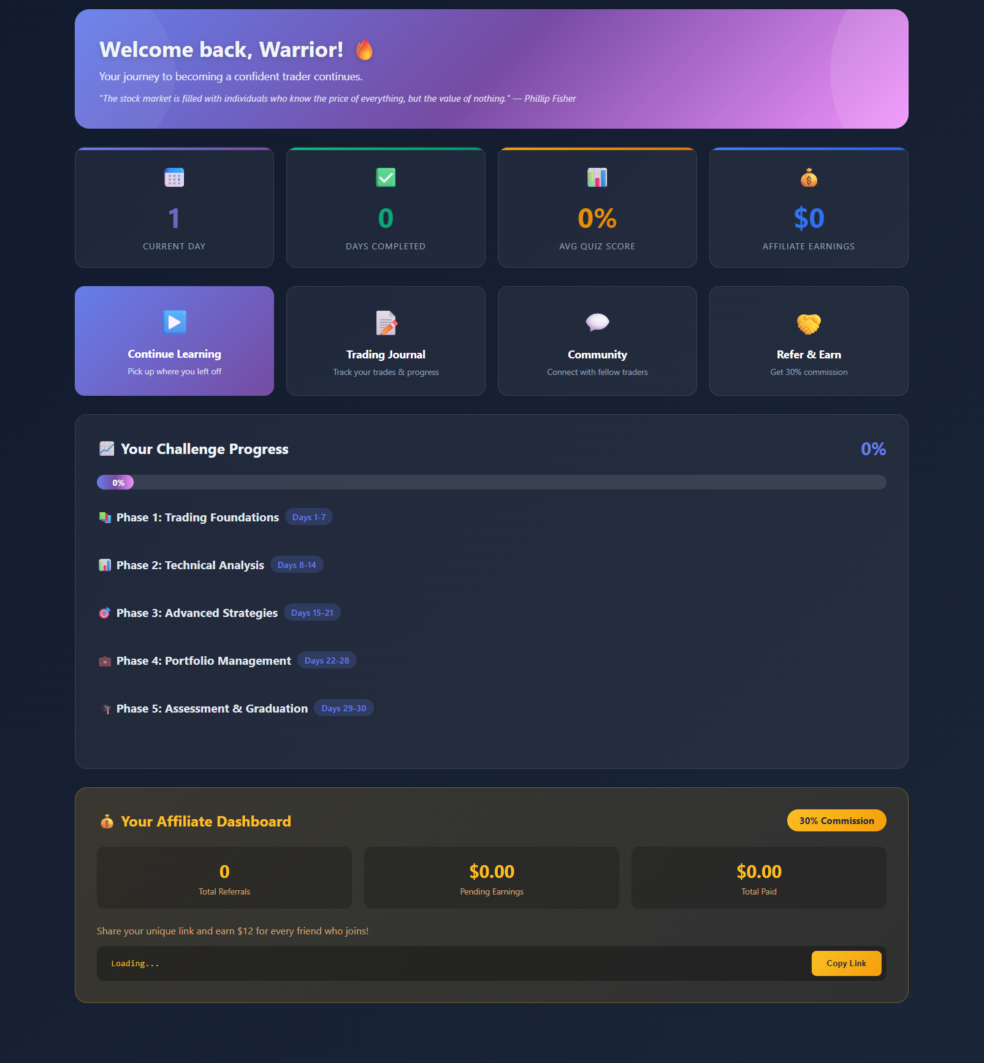
Dashboard template screenshot (expected layout + progress + affiliate panel).

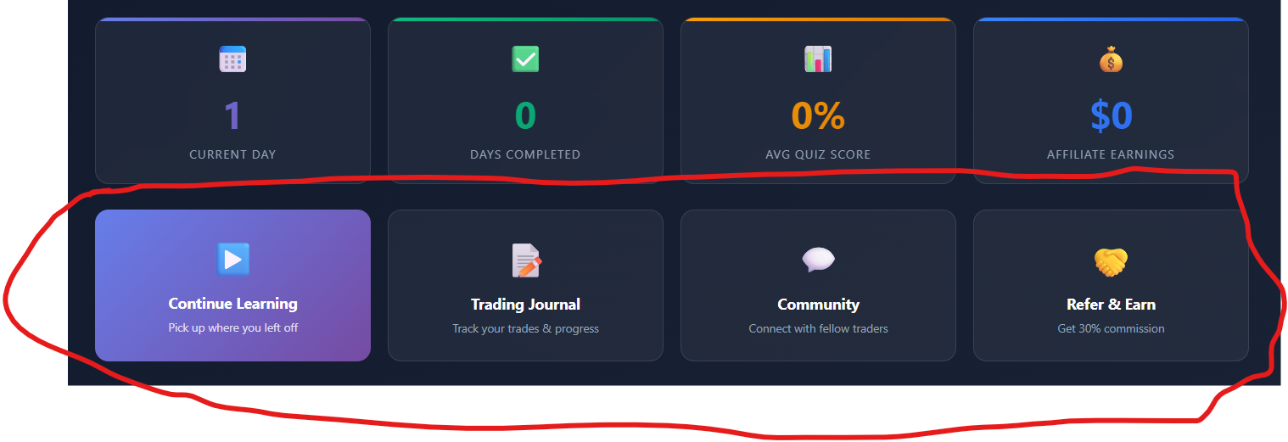
Dashboard action cards – each card must route correctly (Continue, Journal, Community, Refer & Earn).

5. Admin Panel requirements (must be fully functional)
The master Admin Panel must provide real management tools (not UI-only). The design must remain 1:1 with the admin template.
5.1 Dashboard & Analytics
- Total Revenue: All time / This month / Daily
- Conversion rate (visitors → purchases)
- Active users (e.g., last 7/30 days)
- Completion rate (users completing Day 30)
- Affiliate sales + payouts
- Recent activity feed (signups, purchases, quiz pass/fail, task submissions, refunds, admin changes)
5.2 Settings (must affect Stripe + website)
- Change course price from Admin Panel:
- • Stripe price amounts cannot be edited; admin must create a NEW Price in Stripe and set it as the active price (store its price_… id in app_settings).
- • Landing page price display must update from DB (app_settings).
- Create/manage promo codes from Admin Panel:
- • Create Coupons + Promotion Codes in Stripe (percent or fixed).
- • Optionally store promo-code metadata in DB for reporting.
- Update logo/site title/support email
- Access duration (currently 120 days) and maximum devices per user (enforced)
5.3 Content Editor (Day 1–30)
- Select a day (1…30) and edit: title, YouTube URL, and main lesson content.
- Lesson editor should support HTML and common tools (headings, paragraph, bold, lists, links, image, table, preview).
- Quiz management per day: add/edit/delete questions + answers + correct answer(s).
- Task management per day: add/edit task instructions, allow file upload if required, and view user submissions.
5.4 User Management
- Search users by email/name.
- View: profile details, status (paid/free), progress, quiz scores, task submissions, devices, join date, access expiry, affiliate link + earnings.
- Actions: unlock all days, issue certificate, reset/remove a device, extend access duration, refund (Stripe), disable user, delete user.
5.5 Promo Codes (if separate section)
- Optional: keep promo code management as a dedicated section instead of under Settings.
5.6 Affiliate Management
- Create affiliate for a specific email address and generate a unique URL (stable).
- Set base affiliate percentage (default 25% or 30%).
- Track: clicks, signups, purchases, commissions owed/paid.
- Payout workflow: mark paid, export report, and optionally trigger payout email via Resend.
5.7 Email Campaigns (Resend)
- Create campaign, select audience (users/leads/segment), write content, send test, send live.
- Store campaign + delivery logs in DB (sent, bounced, failed).
- Admin UI must match template 1:1.
5.8 Community Forum
Implement community forum exactly as per the attached Community Forum Guide and preview ZIP. This requires new DB tables + APIs + UI pages.
5.9 Live Feed bar
A top-of-page announcement bar (admin create/update/delete). Users can hide/unhide. Stored in DB.
5.10 Certificate Management
- Issue certificate to a user (and optional manual issue for friends/family).
- Upload/change certificate layout/template.
- Track issued certificates in DB and allow user download.

6. Community Forum guide (as provided)
Below is the text from the provided Community Forum Guide. The developer should implement the forum to match this behaviour and UI.
Market Warrior Community Forum
Developer Implementation Guide
Project: Market Warrior 30-Day Trading Challenge
Feature: Community Forum
Date: December 2025
1. Overview
We need a Facebook-style community forum where users can: - Create posts in different categories - Like and comment on posts - Discuss specific days of the 30-day challenge
The admin (Mike) needs a separate panel to moderate content.
2. Categories
The forum has 4 fixed categories (users cannot create new ones):
Special: Days 1-30 Subcategory
When a user selects “Days 1-30 Challenge” category, a second dropdown appears asking them to select which specific day (1-30) they want to discuss.
This is stored as day_number (integer 1-30) on the post.
3. User Features
3.1 View Posts
Users see a feed of posts (newest first)
Pinned posts always appear at the top
Posts show: author name, category, day number (if applicable), title, preview of content, likes count, comments count, time ago
Users can filter by category using the sidebar
3.2 Create Post
When clicking “Create Post”, user sees a modal with:
Name / Nickname (required)
Text input
User enters how they want to be displayed
This is stored with the post (not their account name)
Category (required)
Dropdown with 4 options: General, Days 1-30, Trading Journal, Other
Day Number (conditional - only if “Days 1-30” selected)
Dropdown showing Day 1 through Day 30
Each option shows: “Day X: [Title]”
See Section 8 for full list of day titles
Title (required)
Text input for post title
Content (required)
Textarea for post body
3.3 Like Posts
Users can like/unlike posts
Each user can only like a post once
Like count updates in real-time
3.4 Comment on Posts
Click on a post to view full content and comments
Users can add comments
Comments show: author name, content, time ago, like count
Users can like comments too
3.5 View Single Post
Full post content displayed
All comments listed below
View count increments when post is opened
4. Page Routes
5. Sidebar Navigation
The left sidebar shows:
📁 CATEGORIES
├── 🏠 All Posts
├── 💬 General Discussion
├── 📚 Days 1-30 Challenge ▼
│ ├── All Days
│ ├── Day 1 - Introduction to Trading...
│ ├── Day 2 - Setting Up Demo Account...
│ ├── Day 3 - Trading Terms...
│ └── ... (expandable list)
├── 📊 Trading Journal
└── 📁 Other
Clicking “Days 1-30 Challenge” expands to show individual day filters.
6. Admin Features
6.1 Access Control
Only users with is_admin = true can see the admin panel
Regular users should NOT see any admin link or access /admin/forum
If a non-admin tries to access /admin/forum, show “Access Denied”
6.2 Admin Panel Layout
The admin panel shows a table of all posts with columns:
6.3 Post Status
Posts can have 4 statuses:
Admin can change status via dropdown in the table.
6.4 Admin Actions
6.5 Admin Filters
Admin can filter the table by: - Status (All, Published, Hidden, Flagged, Deleted) - Search (searches post title, content, author name)
6.6 Stats Summary
At top of admin panel, show counts: - Published: X - Hidden: X - Flagged: X - Deleted: X
7. Post Card Design
Each post in the feed shows:
┌─────────────────────────────────────────────────────┐
│ 📌 Pinned (only if pinned) │
├─────────────────────────────────────────────────────┤
│ [Avatar] AuthorName [⋮ Menu] │
│ 💬 General • 3h ago │
│ (or: 📚 Days 1-30 | Day 15 • 3h ago) │
├─────────────────────────────────────────────────────┤
│ Post Title Here │
│ │
│ Post content preview text goes here, truncated │
│ if too long... │
├─────────────────────────────────────────────────────┤
│ ❤️ 12 💬 8 comments 👁️ 89 views │
├─────────────────────────────────────────────────────┤
│ [🤍 Like] [💬 Comment] [🔗 Share] │
└─────────────────────────────────────────────────────┘
The ⋮ menu shows for post author (to edit/delete own post) or admin
Avatar shows first letter of author name if no image
Day tag (green badge) only shows for Days 1-30 category posts
8. Day Titles Reference
When user selects “Days 1-30 Challenge”, show this dropdown:
Display format in dropdown: Day 1: Introduction to Trading and Types of Financial Markets
9. Data Requirements
Post Object
id
user_id (who created it)
category_id
author_name (display name entered by user)
title
content
day_number (1-30, nullable - only for Days 1-30 category)
likes_count
comments_count
views_count
status (published/hidden/deleted/flagged)
is_pinned (boolean)
is_locked (boolean)
created_at
updated_at
Comment Object
id
post_id
user_id
author_name
content
likes_count
status
created_at
User Profile
id
display_name
avatar_url
is_admin (boolean)
is_moderator (boolean)
posts_count
comments_count
10. Tech Stack
Frontend: Next.js 14 (App Router)
Backend: Supabase (PostgreSQL + Auth)
Authentication: Supabase Auth (already set up)
11. Key Behaviors
Pinned posts always appear first in the feed, then sorted by newest
View count increments when a user opens the full post view
Like/unlike is a toggle - clicking again removes the like
Locked posts show all existing comments but hide the comment input
Hidden/deleted/flagged posts are invisible to regular users
Admin sees all posts regardless of status in the admin panel
Day number is only saved/shown for “Days 1-30 Challenge” category
12. Visual Reference
See the HTML preview file (community_forum_preview.html) for: - Forum layout and styling - Post card design - Create post modal with day selector - Admin panel table layout
Summary Checklist
☐ Forum page with posts feed
☐ Category sidebar with expandable Days 1-30
☐ Create post modal with name, category, day selector, title, content
☐ Like functionality for posts and comments
☐ Comment section on single post view
☐ Admin panel at /admin/forum (restricted access)
☐ Admin can: pin, lock, edit, hide, delete posts
☐ Admin can filter by status and search
☐ Responsive design for mobile
Questions? Contact Mike.
© 2025 Market Warrior™

7. Acceptance criteria & deliverables
The milestone is considered complete only when:
- Admin Panel modules listed above are functional end-to-end (DB + API + UI) and follow template UI.
- Dashboard shows real values and all action cards route correctly.
- Course days can be fully managed through Admin Content Editor and saved in DB (no manual SQL required).
- Promo codes can be created/managed via Admin (Stripe) and used at checkout.
- Community forum works per guide and persists posts/replies in DB.
- A rerunnable migration file is included for any new tables/policies (safe on an existing Supabase project).
- README is updated to match the real setup and includes a step-by-step deployment checklist.
Attachments to include when sending this spec:
- This Word document (requirements).
- community_forum_preview.zip (UI preview asset).
- Official logo image (to replace public/logo.png).

Appendix A. Admin template screenshots
Reference screenshots extracted from Admin Panel.docx:
A1.
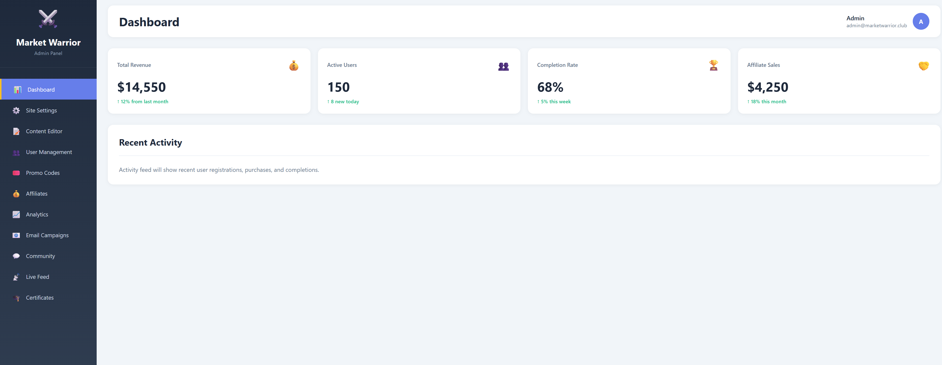
A2.
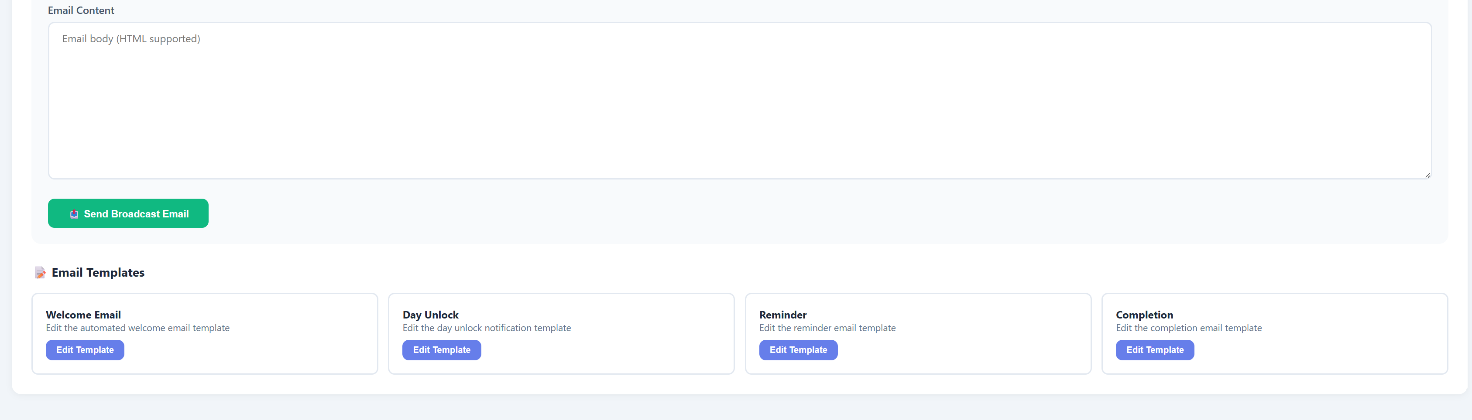
A3.
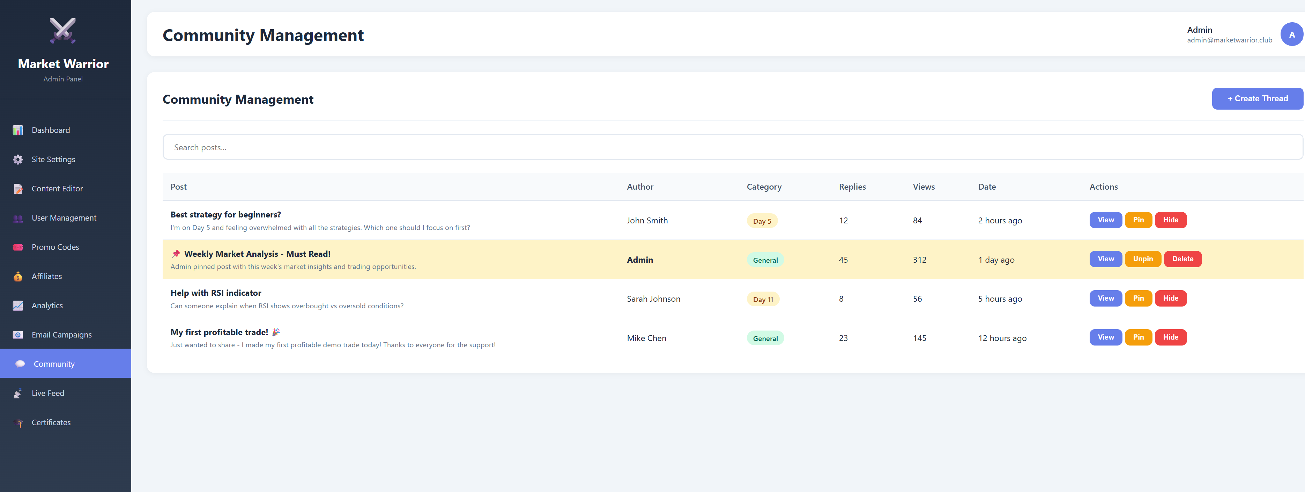
A4.
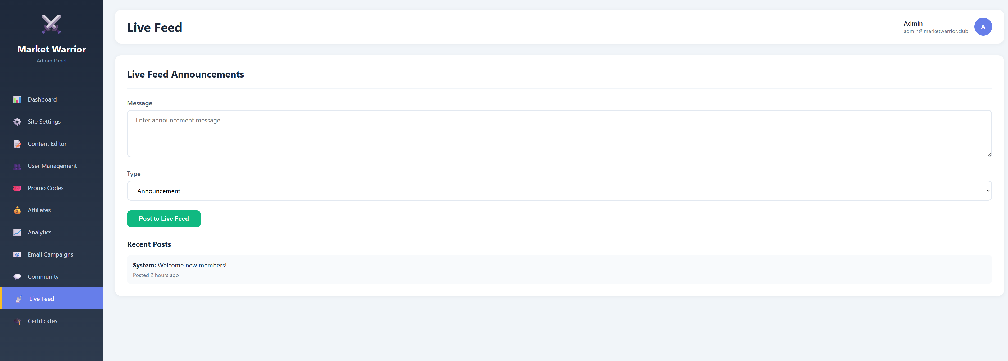
A5.
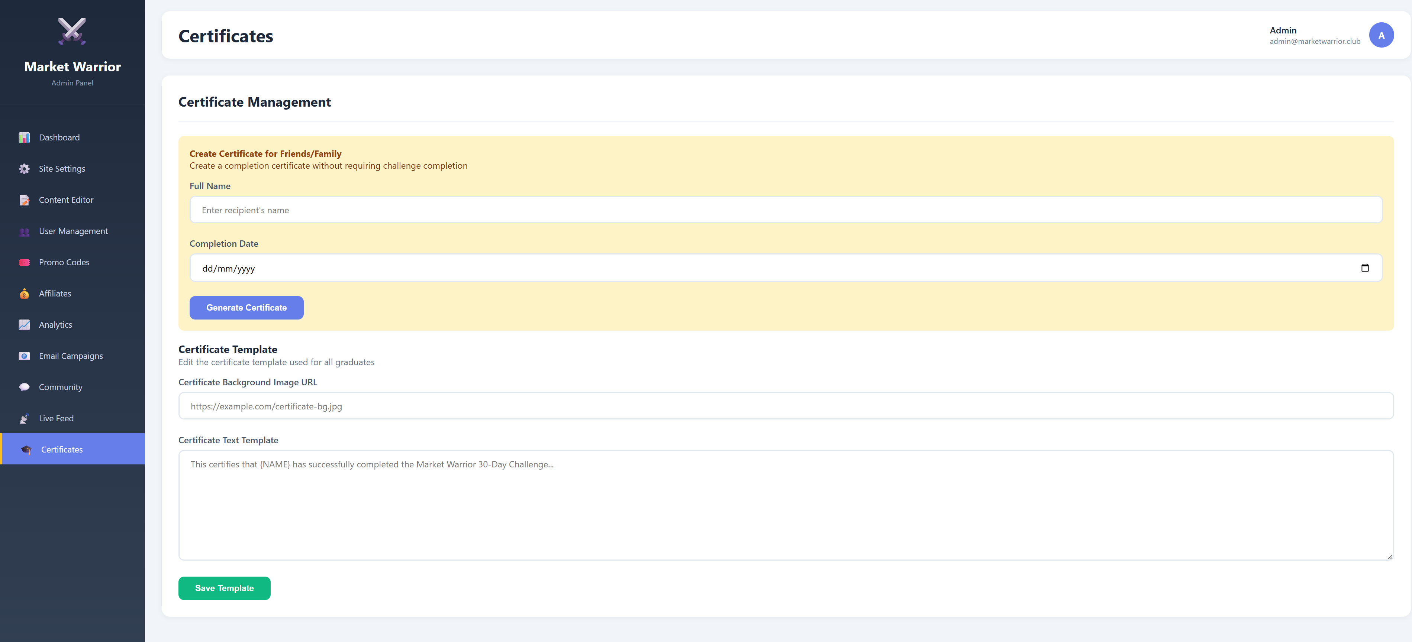
A6.
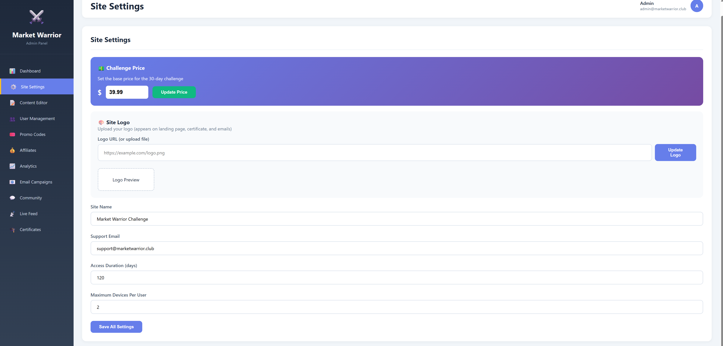
A7.
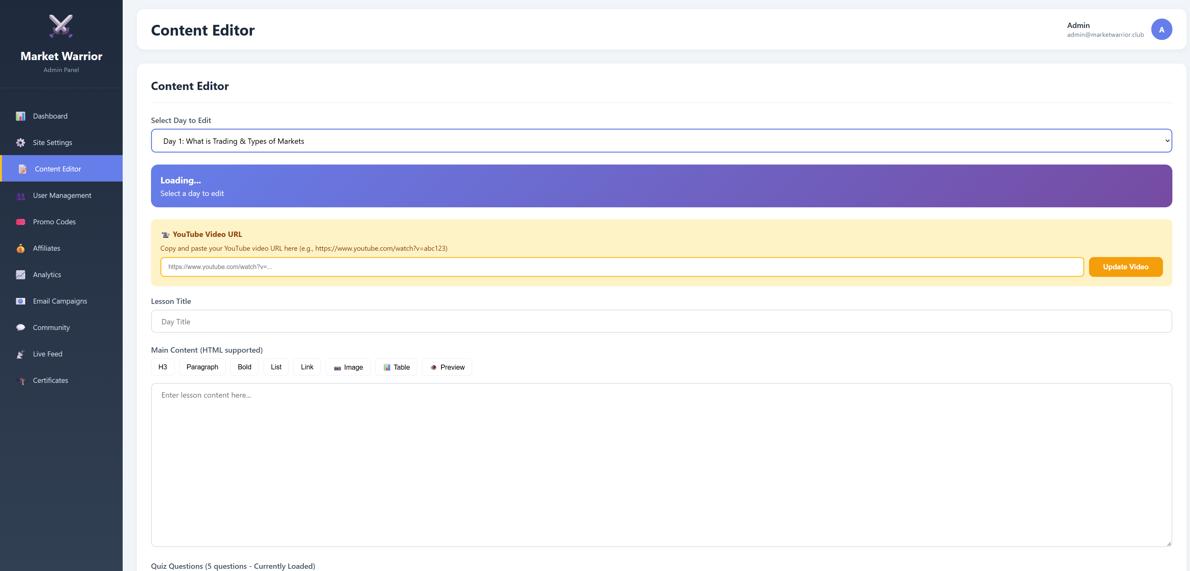
A8.
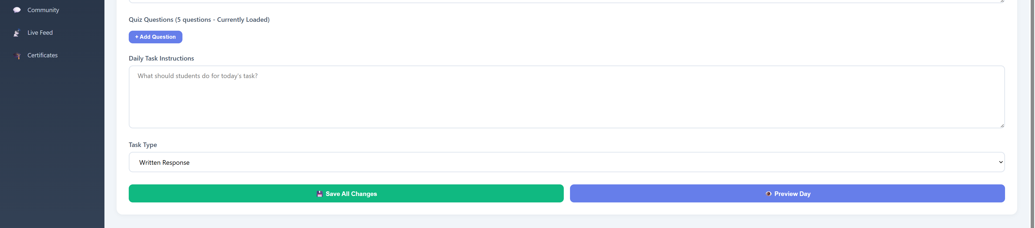
A9.
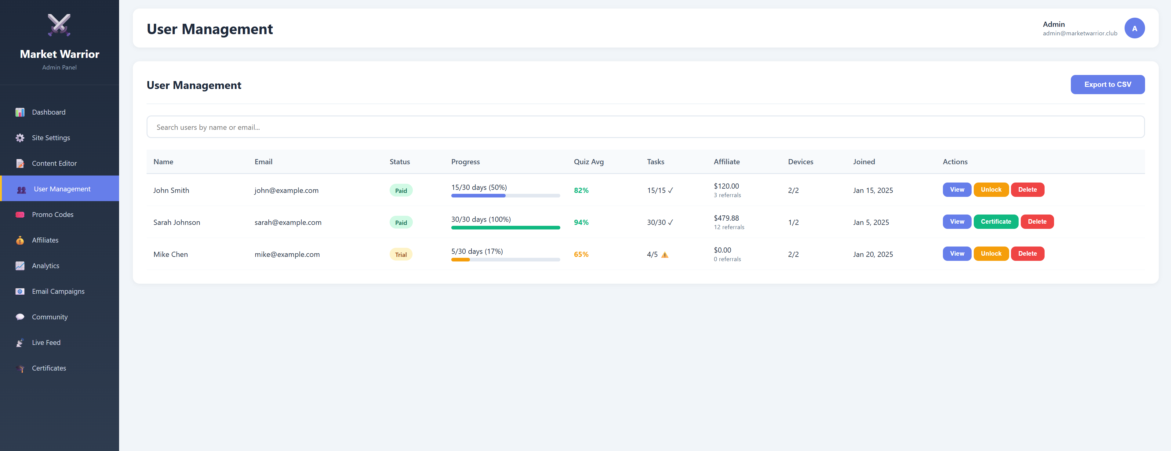
A10.
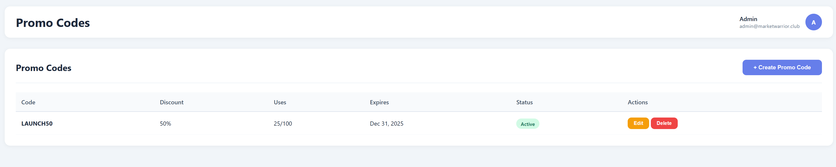
A11.
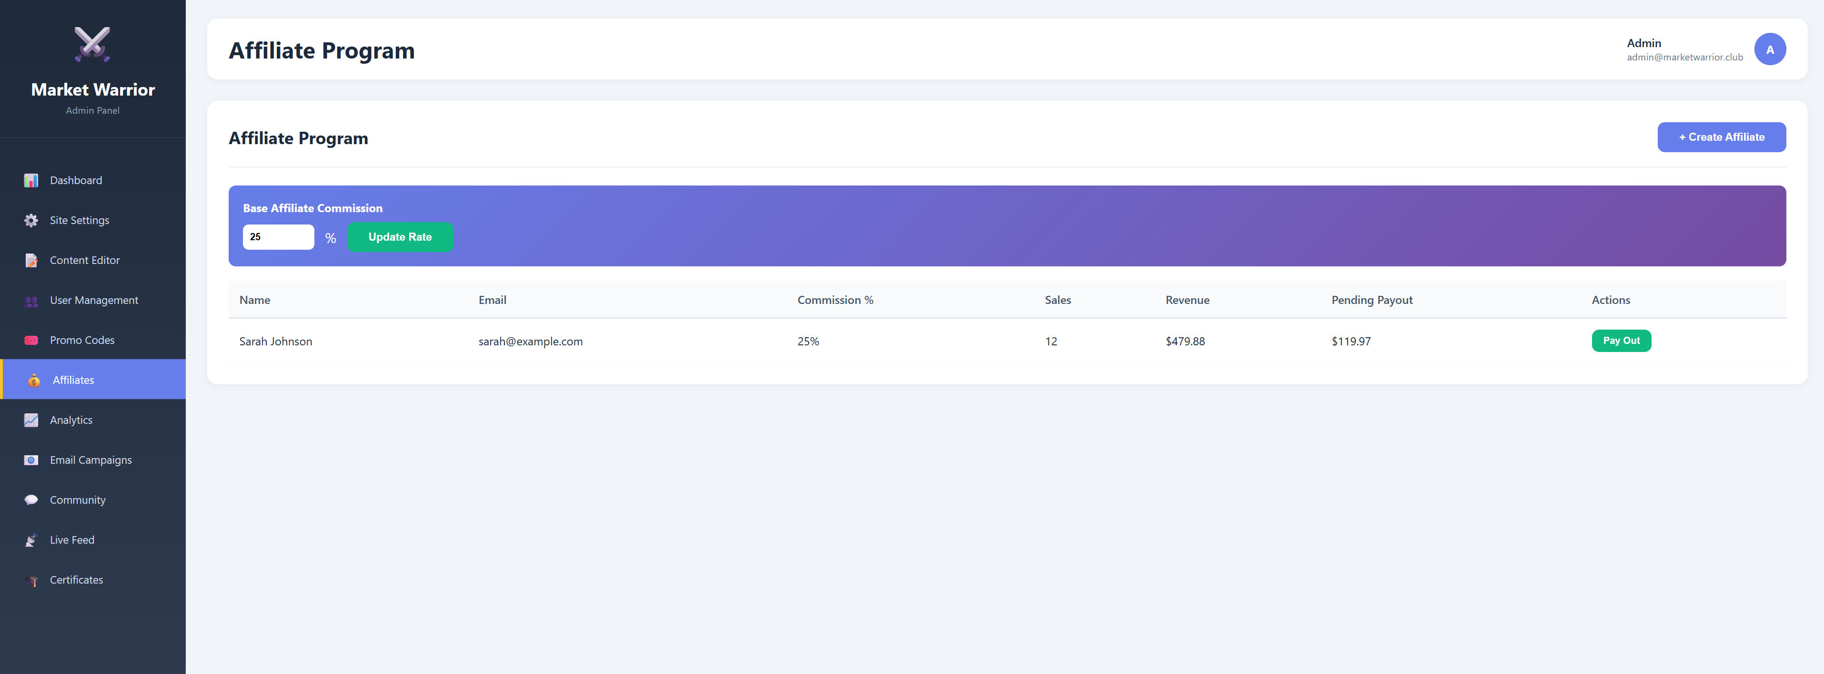
A12.
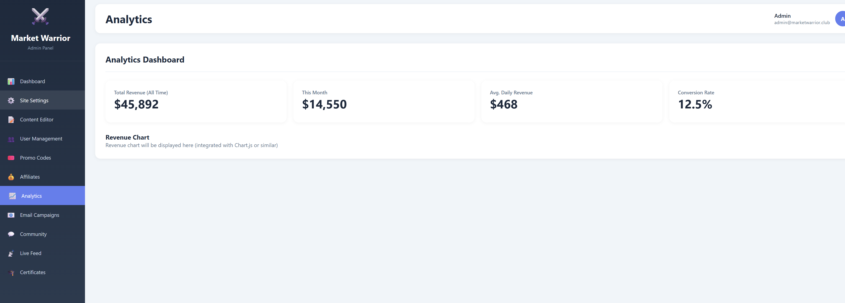
A13.
