WSL2

**Red Hat Guest OS**

*Red Hat needs to install on a VMware ESXi Guest VM first before install it on Windows 10 machine. RHEL needs to be install, compressed, exported, then imported to Windows 10 WSL2.*

1. Install Red Hat Guest OS. (*Any version*).
   1. Make you sure install the OS as minimal as possible.
2. Terminal Commands. (*sudo*)
   1. Unregister Red Hat Product.
      1. “subscription-manager remove –all”
      2. “subscription-manager unregister”
      3. “subscription-manager clean”
   2. Tarball compression. (*sudo*)
      1. “cd /”
      2. “tar cvfzp rhel#.tar.gz bin dev etc home lib lib64 media opt run root sbin srv tmp usr var”
         1. The “#” in the above command is replaced with the version of Red Hat you are using.
3. WinSCP on Windows Client.
   1. Download/Install WinSCP onto a remote Windows 10 client.
   2. Transfer compressed Red Hat OS.
      1. Input your Red Hat ip address, username or root, and password.

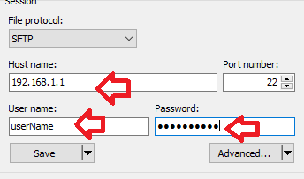

* + 1. Transfer the rhel compressed tarball file to your Windows 10.

**Windows 10 Client**

*This is your remote Windows 10 client computer that you will be install WSL2 and side loading Red Hat OS/Kernel.*

1. Requirements for Windows 10.
   1. For x64 systems: Microsoft Windows 10 version 1903 or higher, with Build 18362 or higher.
   2. Windows Terminal (*Optional*)
   3. VMWare ESXi VM Settings are set!
   4. Enable the “Windows Subsystem for Linux” Windows optional feature.
   5. Enable the “Virtual Machine Platform” Windows optional feature.
   6. Download the Linux kernel update package. ([Link](https://wslstorestorage.blob.core.windows.net/wslblob/wsl_update_x64.msi))
2. Windows Terminal (*Optional*)
   1. Download from Github (*preferred way*). ([Link](https://github.com/microsoft/terminal/releases))
      1. Download the “msixbundle” file.
3. VMware ESXi VM – Windows 10 (*Must have VM powered off*)
   1. On the Windows 10 VM your are using WSL2, ensure you enable these features.
      1. Ensure it is “EFI’ on the BIOS.

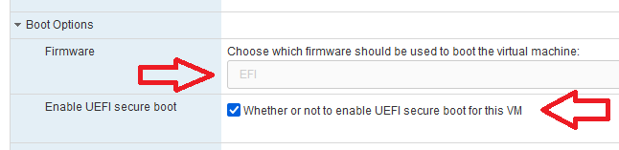

* + 1. Ensure CPU settings is set!

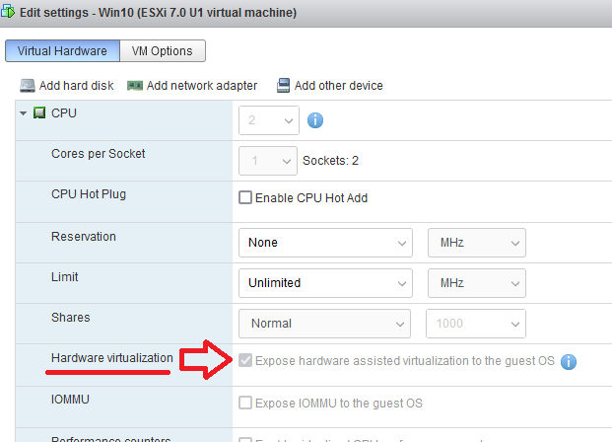

1. Windows optional feature.
   1. Mount your Windows 10 iso file. (*Latest*)
   2. “Windows Subsystem for Linux”
      1. CMD/PowerShell (*As Admin*).
         1. Go to the your mounted ISO and run these cmd’s.



* + - 1. Ensure these Windows features are enabled by going to your Windows search bar and typing in “Windows Features”.

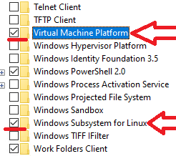

* 1. Download/Install the “Linux kernel update package” at Microsoft’s website.
  2. Reboot your computer!!!

1. Windows WSL2 check & make version default!
   1. CMD/PowerShell/Windows Terminal (*As Admin*)
      1. “wsl.exe –l”
         1. Currently you should have no distributions.
      2. “wsl --set-default-version 2”
         1. This will set to make sure you will be using version WSL2/

**WSL2 – Red Hat Side Loading**

1. Windows 10 client.
   1. CMD/PowerShell (*As Admin*)
      1. Change directories to where you are holding the Red Hat tarball compress file.
      2. Create a folder to hold your Red Hat kernel on C drive or secondary drive.
         1. Example: “Mkdir C:\rhel79”
      3. WSL2 syntax structure.
         1. “Wsl.exe –import distroName C:\locationOfOS\ .\rhelTarballFile.tar.gz”

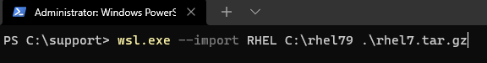

1. Check WSL2 and your distro!
   1. “wsl.exe –l -v”
2. Change “root” user account as the default.
   1. You'll notice it starts as the root user. If you would like to change this, you can go to “HKCU\Software\Microsoft\Windows\CurrentVersion\Lxss” and change the Decimal value of DefaultUid for your distro to whatever you want.
      1. Typically, this would be 1000 for the first user created (including the user you created during the setup process).