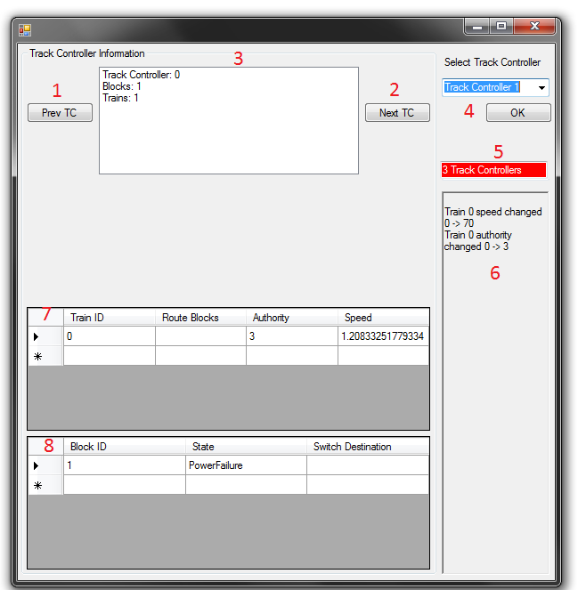

1. Previous TC Button
   1. Allows the user to select the previous Track Controller, if any, adjacent to the current Track Controller
2. Next TC Button
   1. Allows the user to select the next Track Controller, if any, adjacent to the current Track Controller
3. Track Controller Information Box
   1. Lists the following information about the current Track Controller:
      1. Track Controller ID
      2. Track Controller block count
      3. Track Controller train count
4. Track Controller ComboBox
   1. Allows the user to select a Track Controller to display via a drop down ComboBox
   2. The user must then select OK to switch to the selected Track Controller
5. Track Controller Line Count
   1. Shows the number of track controllers on the current line
      1. A Red background indicates that this Track Controller is on the Red line
      2. A Green background indicates that this Track Controller is on the Green line
6. Track Controller Messages
   1. Messages indicating status changes are displayed here
7. Train Information
   1. The following information is listed for each train in a Track Controller’s area of control:
      1. Train ID
      2. Train Route blocks (if assigned)
      3. Train Authority
      4. Current speed of the train
8. Block Information
   1. The following information is listed for each block in a Track Controller’s area of control:
      1. Block ID
      2. Block State (Health, Failure, etc.)
      3. The switch destination Block ID of the current Block