**CODE:**

Program main

implicit none

character(50)::filename1, filename2

integer :: size1, size2, size3

real, allocatable :: array1(:), array2(:), array3(:)

!ask for 1st file

print *, "First Array"

call read_file(filename1,array1,size1)

call write_array(array1,size1)

print *," "

print *," "

print *," "

!ask for 2nd file

print *, "Second Array"

call read_file(filename2,array2,size2)

call write_array(array2,size2)

print *," "

print *," "

print *," "

!merge 2 arrays and output

print *, "Merged Array"

call merge_array(array1,size1,array2,size2,array3,size3)

call write_array(array3,size3)

contains

!subroutine to read file

Subroutine read_file(filename, array, size)

implicit none

!declare variables

real, allocatable :: array(:)

integer :: size, i, iostat

character(50)::filename

!ask for file name

print *, "What is the name of the data file? "

read *, filename

!open filename on unit 10

open (unit=10, file = filename,iostat = iostat)

!check if the input output is nonzero

if(iostat /= 0) stop 'Error opening file'

size = 0

!read file, check error, increase size

do

read (10, *, iostat = iostat)

if (iostat /= 0) exit

size = size + 1

end do

rewind(10)

!read data into array

allocate (array(size))

do i = 1, size

read(10,*)array(i)

end do

close(10)

end subroutine

! subroutine to write contents of array

subroutine write_array (array, array_size)

implicit none

integer :: array_size, i

real, allocatable :: array(:)

print *, array_size, " Elements in this array: "

!print *, array

do i =1, array_size

write(*,'(F7.3,$)') array(i)

end do

end subroutine write_array

!subroutine to merge 2 arrays

subroutine merge_array(array1,size1,array2,size2,array3,size3)

implicit none

integer :: size1, size2, size3, i1,i2,i3

real, allocatable :: array1(:), array2(:), array3(:)

i1 = 1

i2 = 1

i3 = 1

size3 = size1+ size2

allocate(array3(size3))

!compare each element in both array and move on until reach the end

do while (i1 <= size 1 .and. i2<= size2)

if (array1(i1) <= array2(i2)) then

array3(i3) = array1(i1)

i1 = i1+1

else

array3(i3) = array2(i2)

i2 = i2 +1

end if

i3= i3 +1

end do

!copy the rest of the other array to third array

if (i1 > size1) then

do i2 = i2, size2

array3(i3) = array2(i2)

i3 = i3 + 1

end do

else

do i1 = i1, size1

array3(i3) = array1(i1)

i3 = i3 + 1

end do

end if

end subroutine

End program main

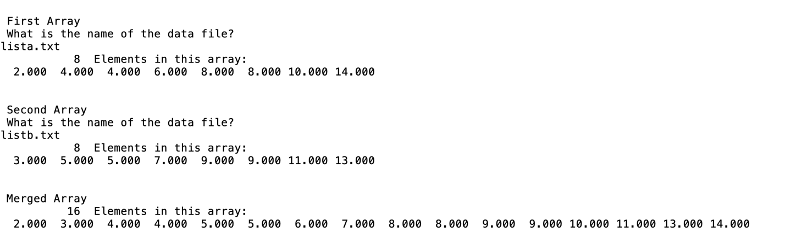**OUTPUT SCREENSHOT:**

