This folder contains the code and data needed to replicate the analysis in the main body of the paper “Consumer Consent and Firm Targeting after GDPR: The Case of a Large Telecom Provider”

The data and code are provided as is.

Comments about the dataset:

The original dataset is subject to a non-disclosure agreement that limits the form and amount of data we can release.

To allow the replication of our analysis, we provide a synthetic dataset as well as the R code that we used with the original data.

The synthetic dataset derives from our industry partner's proprietary information, but it is not the actual confidential data that we obtained. Therefore, the replication script results are qualitative and quantitively similar to those in the main paper, but they are not pointwise equivalent.

The following are the key differences from the original dataset:

  - The synthetic dataset includes 10,000 synthetic households instead of the original 33,629 (this means that all regressions have higher variance);

  - The synthetic dataset includes only the variables that were used in the regression tables in the main body of the paper;

  - Compared with the original variables, the variables in the synthetic dataset include cross-sectional white noise. The white noise changes the variance of the original distributions, but not the overtime trends or the cross sectional means in the original dataset.

The dataset allows replicating all tables and figures in main body of the paper except for the panels in figure 3 that pertain to variables which are not used in the regression analysis.

Comments about the code:

The code Is provided as an R markdown file. It corresponds to the actual code that we used to generate the main body of the paper. To generate the results in the actual manuscript, we just replace these synthetic data with our industry partner’s proprietary data.

To run the replication code, you need to install R and RStudio. We recommend that you use https://cran.rstudio.com/ as your main mirror for package installation.

The replication code was successfully run on the environment listed below. We provide the output of the replication script as an html file together with the replication kit.

R Environment

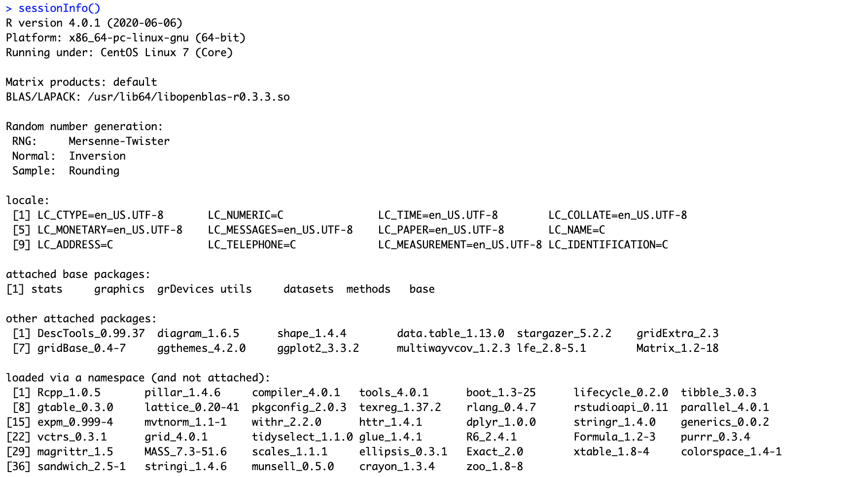

Hardware Environment

