CS 1632 – DELIVERABLE 4: Performance Testing Using VisualVM

Nick Taglianetti, Michael Oles

Summary

The following field can be deleted from the MonkeySim.java source code since it will be unused after the proper changes are made to the MonkeySim.stringifyResults method.

public static final int HEADER = 50000;

For the summary, describe how you profiled the application and determined the methods to refactor, and why you changed what you did. The summary should not be more than a few paragraphs - definitely less than a page. if you come across an error and fix it - no points will be taken off as long as you note it in your summary.

Some of the VisualVM screenshots were taken before the MonkeySim program completed running.

Screenshots of VisualVM and Runtime

Before modifying MonkeySim.getFirstMonkey():

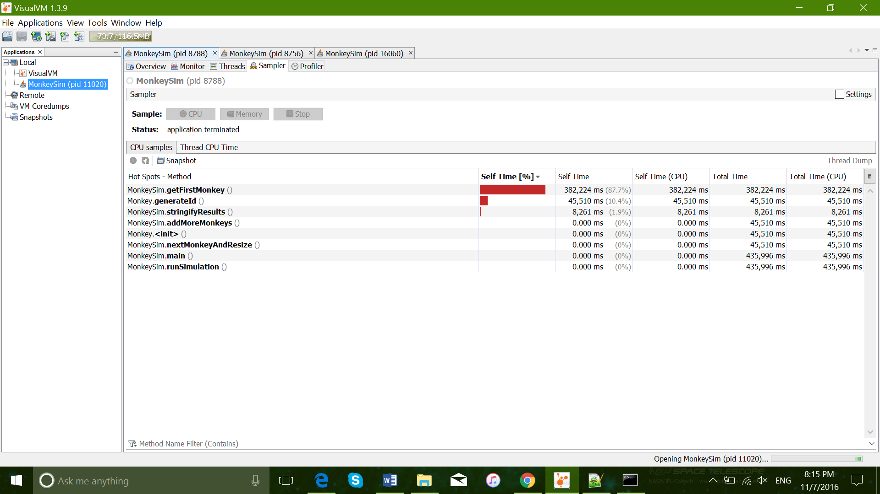

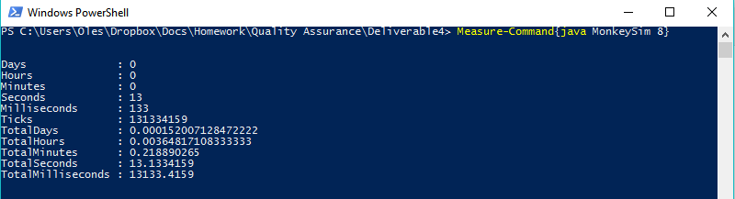

After modifying MonkeySim.getFirstMonkey(), before modifying Monkey.generateId():

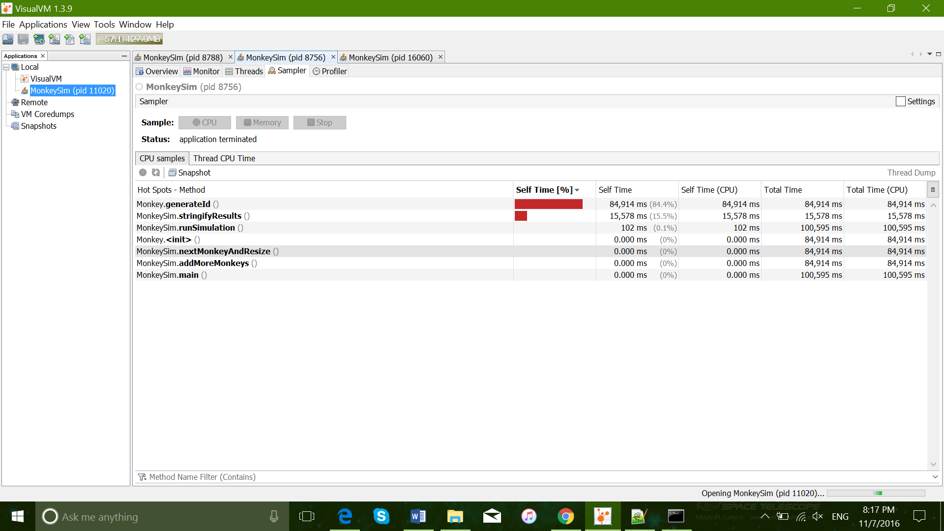

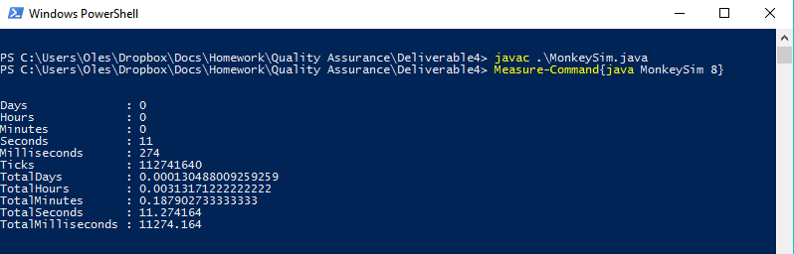

After modifying Monkey.generateId(), before modifying MonkeySim.stringifyResults():

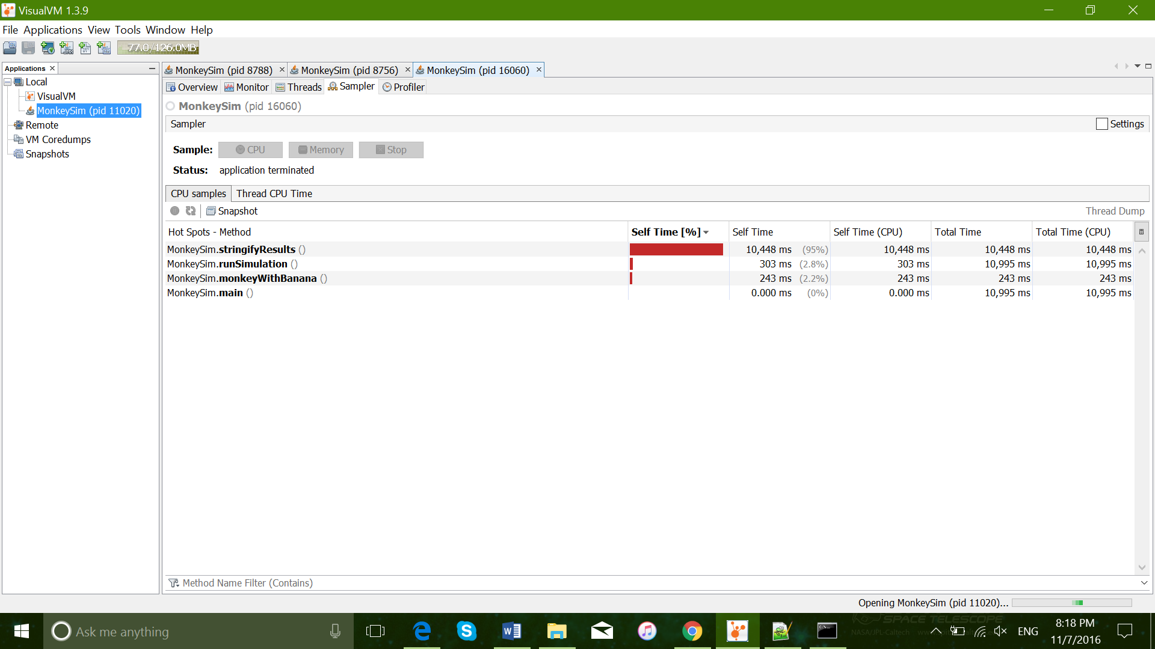

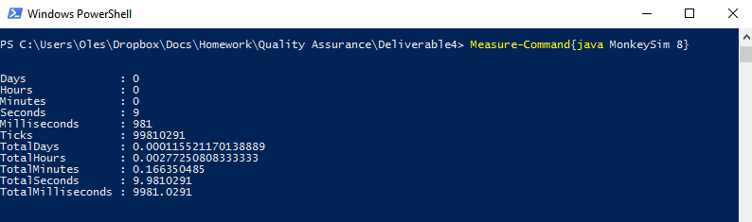

After modifying stringifyResults()

