CS 1632 – DELIVERABLE 5: Static Analysis

Nick Taglianetti, Michael Oles

<https://github.com/mikeoles/Deliverable5.git>

Summary

Before adding the code for prime monkey pass, we ran checkstyle and Findbugs on the existing code. By fixing the issues found by these static analysis tools before modifying the functionality of the code, we hoped to minimize confusion and engineering effort of fixing such issues after the prime monkey pass was to be added. One issue we encountered when running checkstyle involved WhiteSpaceAround warnings. These seemed to be violations of the style guide with respect to white space around brackets ({}) or operators (=, &&)—violations which we found to be ambiguous and difficult to correct. One way we were able to solve this issue was to run the Format command in NetBeans IDE, which also fixed some more minor stylistic infractions, such as indentation, not necessarily included explicitly in the style guide. When running Findbugs, we were getting the warning that the Monkey constructor was writing to a static field when incrementing monkeyNum. We initially just made monkeyNum not static; however, this caused MonkeySim to crash and our Unit Tests to fail. We finally solved the issue by creating a static void incrementMonkeyNum() mutator method which would be called in the Monkey constructor to increment monkeyNum.

We then added the method to pass the prime monkey. Since almost everything was the same as the previous simulation, we tried to avoid rewriting code and used the same runSimulation() method with an added flag for to differentiate between which method the monkeys were using to pass the banana. Then in Monkey.class we added a method to pass to the next prime monkey. This method just looks at all numbers lower than the current monkey num and uses the isPrime() method to figure out when one is prime and then returns that monkeys number. When writing the tests, we made sure to test the edge cases like 1 and 2 because they’re dealt with differently when determining if a number is prime or not. We also refactored the code to make _monkeyList a non-static variable.

Screenshots of Final Findbugs and Checkstyle Output

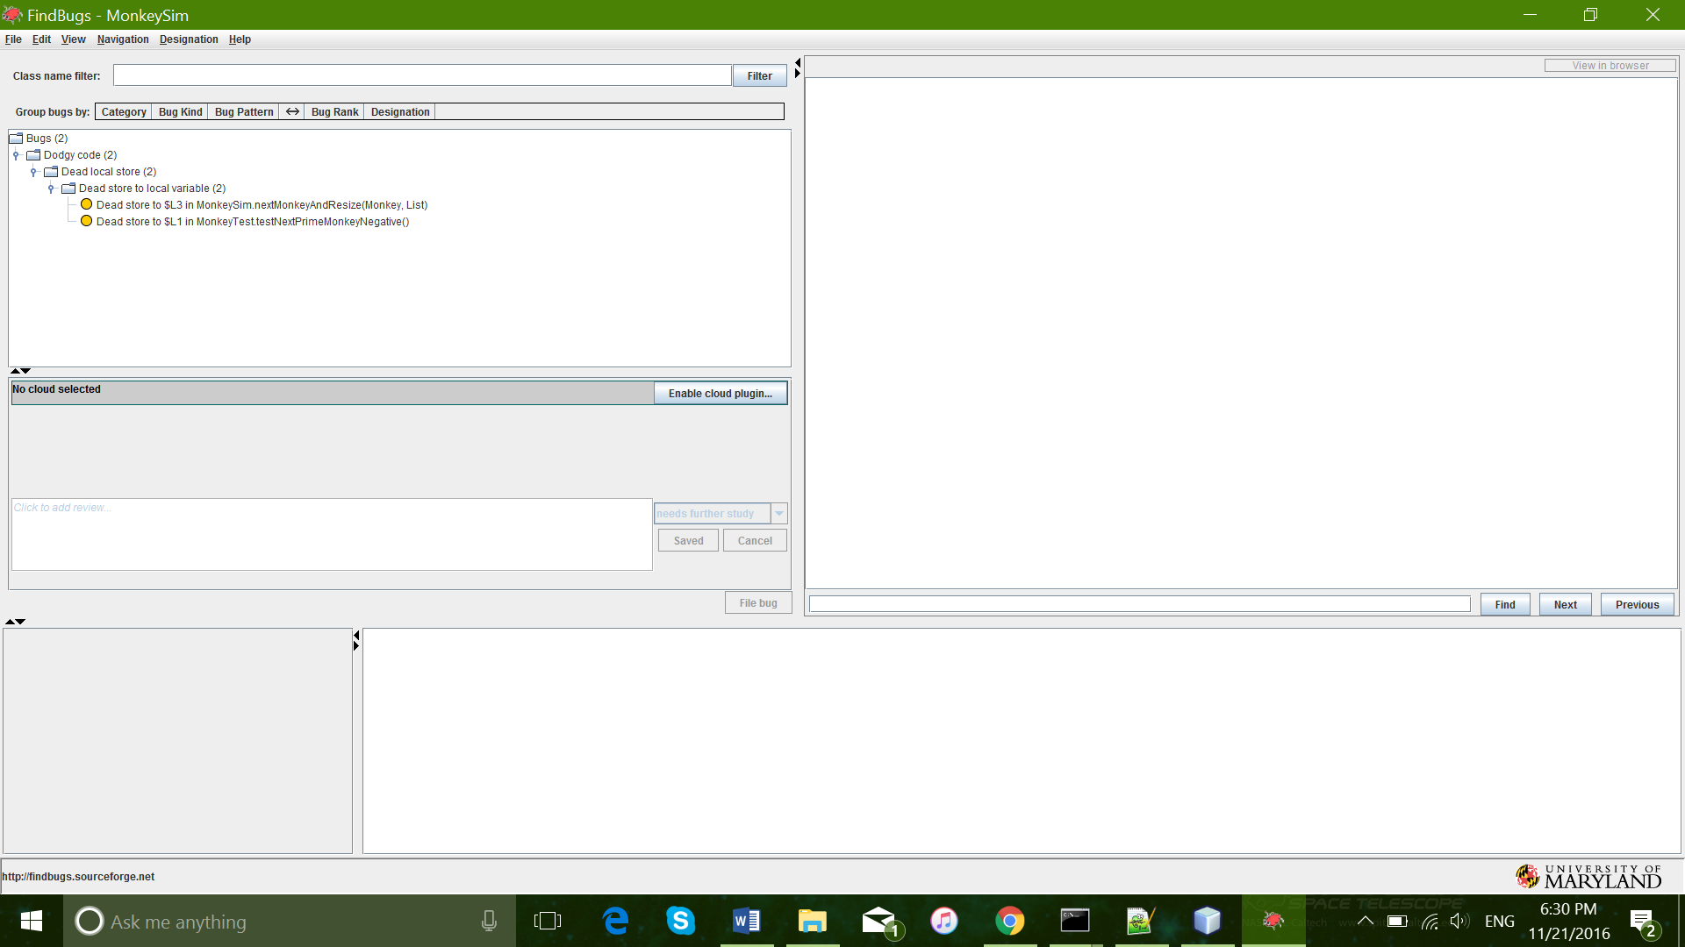

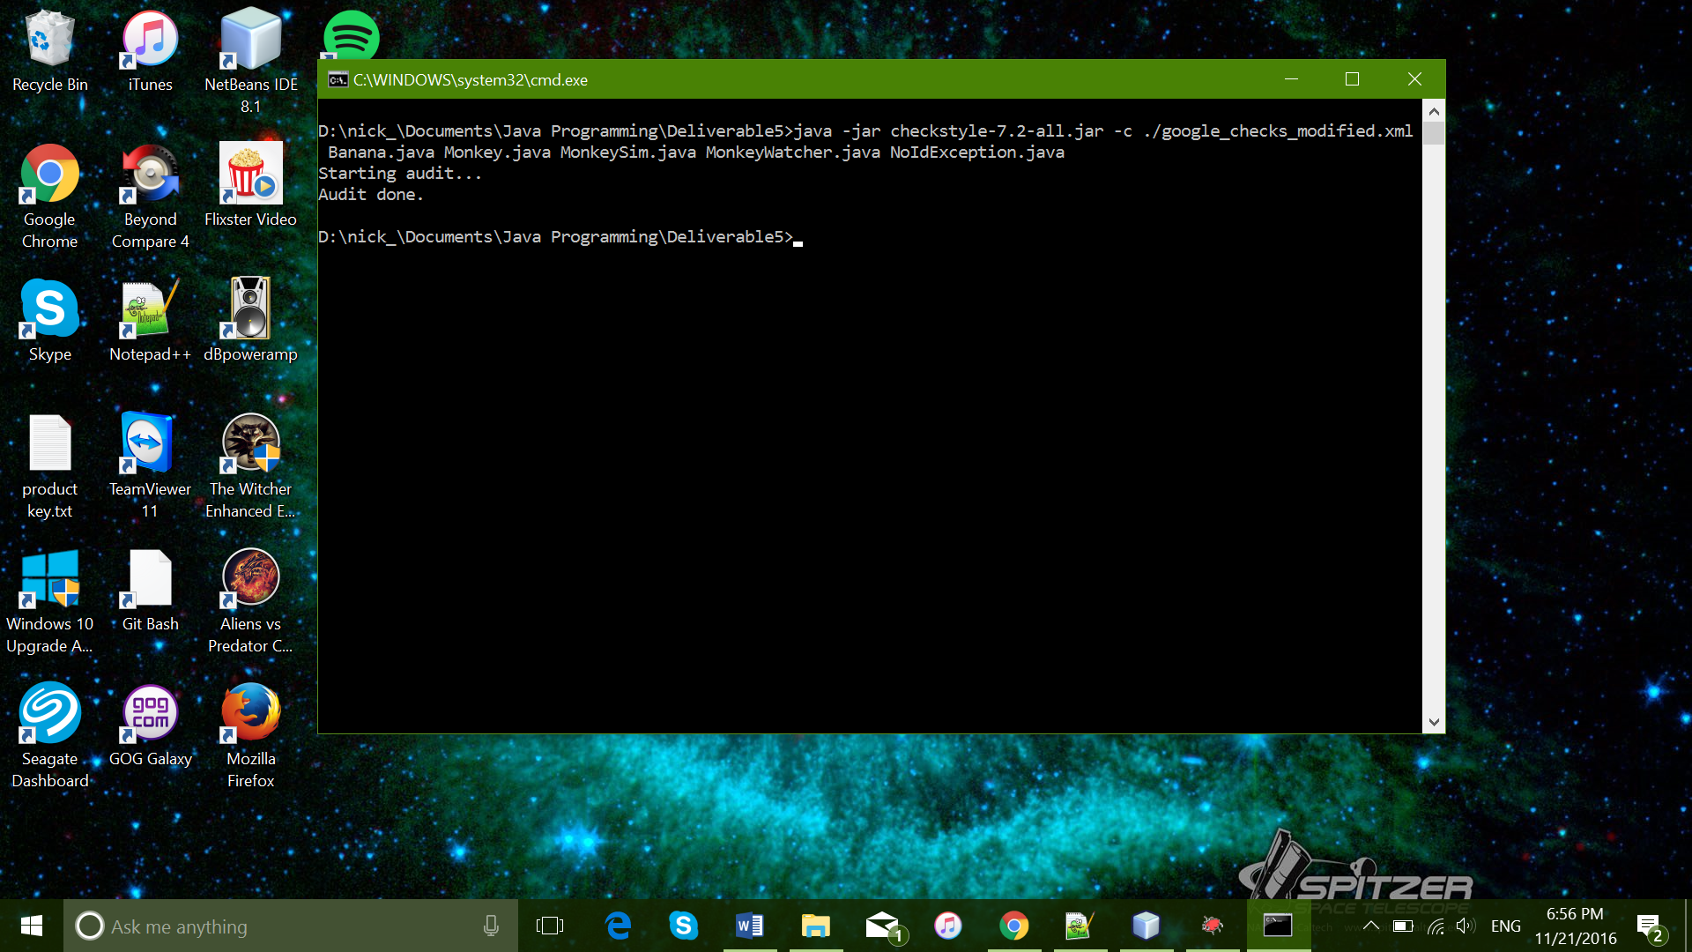

Screenshot of Passed Unit Tests

