Enterprise DSAR Management & Consumer Rights Operations
BDC-OPS-001 | Consolidated case study v3.0 | 12 November 2026
Prepared by Olumuyiwa Michael, CIPP/US, CIPP/EU, CIPM, AIGP, CompTIA Security+
Published by BloomDale Capital LLC • Fictional enterprise: Meridian Digital Holdings • Data snapshot: 11 November 2026
SIMULATION DISCLOSURE All organizations, systems, people, request records and metrics are fictional. Interface images are original illustrations, not OneTrust screenshots. This is a portfolio demonstration, not an employer implementation or legal advice. Legal references were reviewed as of 12 November 2026. OneTrust is a trademark of its owner; no affiliation, sponsorship or endorsement is implied.

1. Executive overview
Meridian Digital Holdings (MDH) is a fictional group with Digital Platforms, Digital Learning, Financial Services and Healthcare Technology businesses. Its privacy requests arrived through scattered channels, with inconsistent evidence and no shared view of deadlines. This case study designs a centralized consumer rights operation: one procedure, one register, law-specific deadline rules and management reporting, with OneTrust Privacy Rights Automation as the proposed case-management platform.
The synthetic register of 12 requests shows why the reporting design matters. Every closed request met its statutory deadline, yet only three of eight met Meridian’s own internal target, and two open requests were already past their legal deadline on the snapshot date.
Measure (as of 11 November 2026) | Result | What it shows
Requests in the register | 12 (8 closed, 4 open) | Synthetic data across six regimes
Closed within statutory deadline | 8 of 8 (100%) | Covers closed cases only
Closed within internal target | 3 of 8 (37.5%) | Operations run close to the legal limit
Open past statutory deadline | 2 (MDH-26008, MDH-26010) | Reported separately from the closed-case rate
Average days to close | 24.4 (30.0 excluding opt-outs) | Fast opt-outs flatter the overall average

The main design decision follows from this: closed-case timeliness, open-case deadline exposure and internal-target performance are always reported side by side, so a 100% figure cannot hide overdue work.

2. Enterprise context and scope
Meridian is the same fictional enterprise assessed in case study BDC-PRIV-001, and this study follows its applicability screening. The regimes in scope are the CCPA/CPRA (California), the Connecticut Data Privacy Act (in scope since 1 July 2026), the Texas Data Privacy and Security Act, the EU GDPR and the UK GDPR. Meridian HealthTech handles health requests as a HIPAA business associate. Residents of other states are served under a voluntary baseline policy with a 45-day internal standard; those states are monitored and added to the deadline rules if Meridian crosses their thresholds.
Business unit | Typical requests | Routing rule
Digital Platforms | Access, erasure, opt-out of sale/sharing and targeted advertising | Consumer privacy law of the requester’s jurisdiction; EU and UK users under GDPR
Digital Learning | Access, deletion, portability | As above; EU and UK learners under GDPR
Financial Services | Access, deletion, correction | GLBA-covered account data is exempt at data level under the CCPA and CTDPA; the unit is entity-exempt under the TDPSA
Healthcare Technology | Access to and amendment of PHI | Business associate: forward to the covered entity under the BAA and support fulfillment; the covered entity decides

3. Governance and control ownership
Control area | Accountable / responsible | Evidence
Intake and case ownership | Privacy Operations Lead / analyst | Receipt timestamp, intake channel, case ID
Applicable law and exceptions | Legal accountable; Privacy Operations responsible | Jurisdiction decision, denial or retention rationale
Identity and secure delivery | Privacy Operations; Security consulted | Verification outcome, secure response method
Discovery and fulfillment | IT, business system owners and processors | Assigned tasks, completion attestations
Business associate requests | Health Privacy; covered entity decides | Forwarding record, BAA timeline, fulfillment support
Monitoring and escalation | Privacy Operations Lead | Aging report, deadline alerts, escalation record

4. Standard operating procedure
- Intake and register. Accept requests through the web form, privacy inbox, support escalation and authorized agents. Record the original receipt date (the clock starts that day, even on a weekend), request type, business unit, channel and case ID. Check for duplicates and send any required acknowledgment (CCPA: within 10 business days).
- Classify and set the deadline. Identify the applicable law, Meridian’s role (controller, business or business associate), exemptions and the right requested. Record the statutory due date, the internal target and the last date to send an extension notice. Calendar-month and calendar-day rules are calculated separately.
- Verify where appropriate. Use existing account authentication where possible and avoid collecting new government ID. Do not verify opt-out requests. Follow up by day 10. An unverified request then goes to a decision gate (day 35 for 45-day regimes; day 20 for GDPR, UK GDPR and HIPAA): deny as unverifiable, or send an extension notice where the law allows one.
- Discover and assign. Use the data inventory and vendor register to assign tasks to CRM, LMS, marketing, payment, cloud and processor owners, each with a due date and an evidence requirement.
- Fulfill and review exceptions. Process access, correction, deletion, portability and opt-out actions. Legal reviews retention duties, legal holds, security exceptions, third-party data and partial denials. Suppression is tracked separately from deletion.
- Validate and respond. QA reconciles task outcomes, checks redaction and secure delivery, confirms suppression reached downstream systems and approves the response, including appeal or complaint information where the law requires it.
- Close and report. Close only after QA sign-off. Retain minimum evidence under the retention schedule and feed the case into SLA, aging, exception and vendor-performance reporting.

5. Lifecycle and decision points
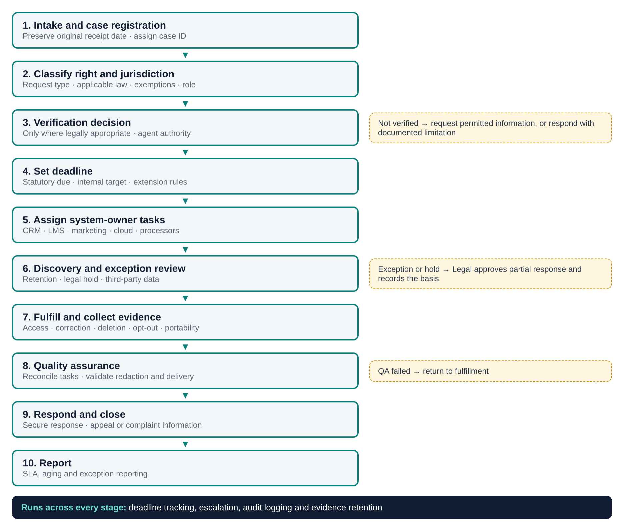
Figure 1. DSAR lifecycle with decision branches. Original illustration.
Decision point | Required response
Verification required? | Apply proportionate verification only where lawful; never for opt-out requests.
Verified? | Request additional information as permitted; record the follow-up and its effect on the deadline.
Request within scope? | Identify the controlling law and exemptions; Legal approves any denial or partial response.
Retention or legal hold? | Document the preservation basis, fulfill the remainder and consider restriction or suppression.
QA passed? | Reassign incomplete tasks; do not close without evidence and an approved response.

6. Regulatory rights and deadline matrix
Response rules for the regimes in scope, reviewed as of 12 November 2026. Deadlines run from receipt and assume no extension; they drive the register’s Statutory Due field.
Regime | Response deadline | Extension | Verification and special rules | Appeal or redress
EU GDPR | One calendar month from receipt (Art. 12(3)) | Up to two further months if complex or numerous; notify within the first month | Extra information only where there is reasonable doubt about identity (Art. 12(6)) | Complaint to a supervisory authority; judicial remedy
UK GDPR | One calendar month; if that date is a weekend or bank holiday, the next working day (ICO) | As EU GDPR | The month runs from the latest of receipt, receipt of identity information requested under Art. 12(6), or any fee; it pauses while awaiting clarification reasonably required (Art. 12A, in force 5 February 2026) | Complaint to Meridian under its complaints procedure (required since 19 June 2026; acknowledge within 30 days); complaint to the ICO; judicial remedy
CCPA/CPRA | 45 calendar days for know, delete and correct, from receipt regardless of verification time; confirm receipt within 10 business days | One 45-day extension with notice and reason inside the first 45 days | Opt-out of sale/sharing and limit-use requests: no verification; act within 15 business days | No statutory appeal
Connecticut (CTDPA) | 45 days | One 45-day extension when reasonably necessary, with notice inside the first 45 days | Honor opt-out preference signals; authenticate other requests with commercially reasonable efforts | Appeal decided within 60 days; if denied, provide the Attorney General complaint route
Texas (TDPSA) | 45 days | One 45-day extension when reasonably necessary, with notice and reason inside the first 45 days | Authenticate requests with commercially reasonable methods; honor universal opt-out signals | Appeal decided within 60 days; if denied, provide the Attorney General complaint route
HIPAA (Meridian as business associate) | Covered entity acts on access within 30 days and amendment within 60 days (45 CFR 164.524, 164.526) | One 30-day extension each, with written notice | Meridian forwards the request within the BAA timeframe and supports fulfillment | Covered entity handles denials; complaints to HHS OCR
GLBA / Regulation P | No access, deletion or correction right | Not applicable | Privacy notices; opt-out of certain sharing with nonaffiliated third parties | GLBA-covered data exempt from state requests at data level (CCPA, CTDPA) or entity level (TDPSA)

7. OneTrust operating model
Each lifecycle stage maps to a proposed use of OneTrust Privacy Rights Automation and to the register field that evidences it.
Lifecycle stage | Proposed OneTrust use | Register field and evidence | Owner
Intake and registration | Request intake form and case record; manual case creation for email and phone | Columns A to E; receipt timestamp | Privacy Operations
Verification | Verification as a workflow task, skipped for opt-outs | Column H; verification log | Privacy Operations
Classification and deadline | Request type, jurisdiction and deadline rules | Columns C, D, F and G | Privacy Operations; Legal
Fulfillment | Subtasks for system owners and processors; integrations where licensed | Columns J and O; task evidence | System owners
Exceptions | Legal approval step with recorded rationale | Column K | Privacy Legal
Response and closure | Approved templates, secure delivery, QA sign-off | Columns L to N and Q | Privacy Operations
Reporting | Volume, aging and SLA reports reconciled to the register | Dashboard workbook | Privacy Operations Lead

The table describes a proposed design. Stage names are not verified OneTrust menu names or default features, and no live OneTrust tenant was configured. Product capabilities should be confirmed in OneTrust’s documentation (see References).

8. Illustrative interfaces
Figures 2 to 5 are original illustrations built from the synthetic register to show how the operating model would look in daily use. They are not OneTrust screenshots and do not reproduce OneTrust’s interface.
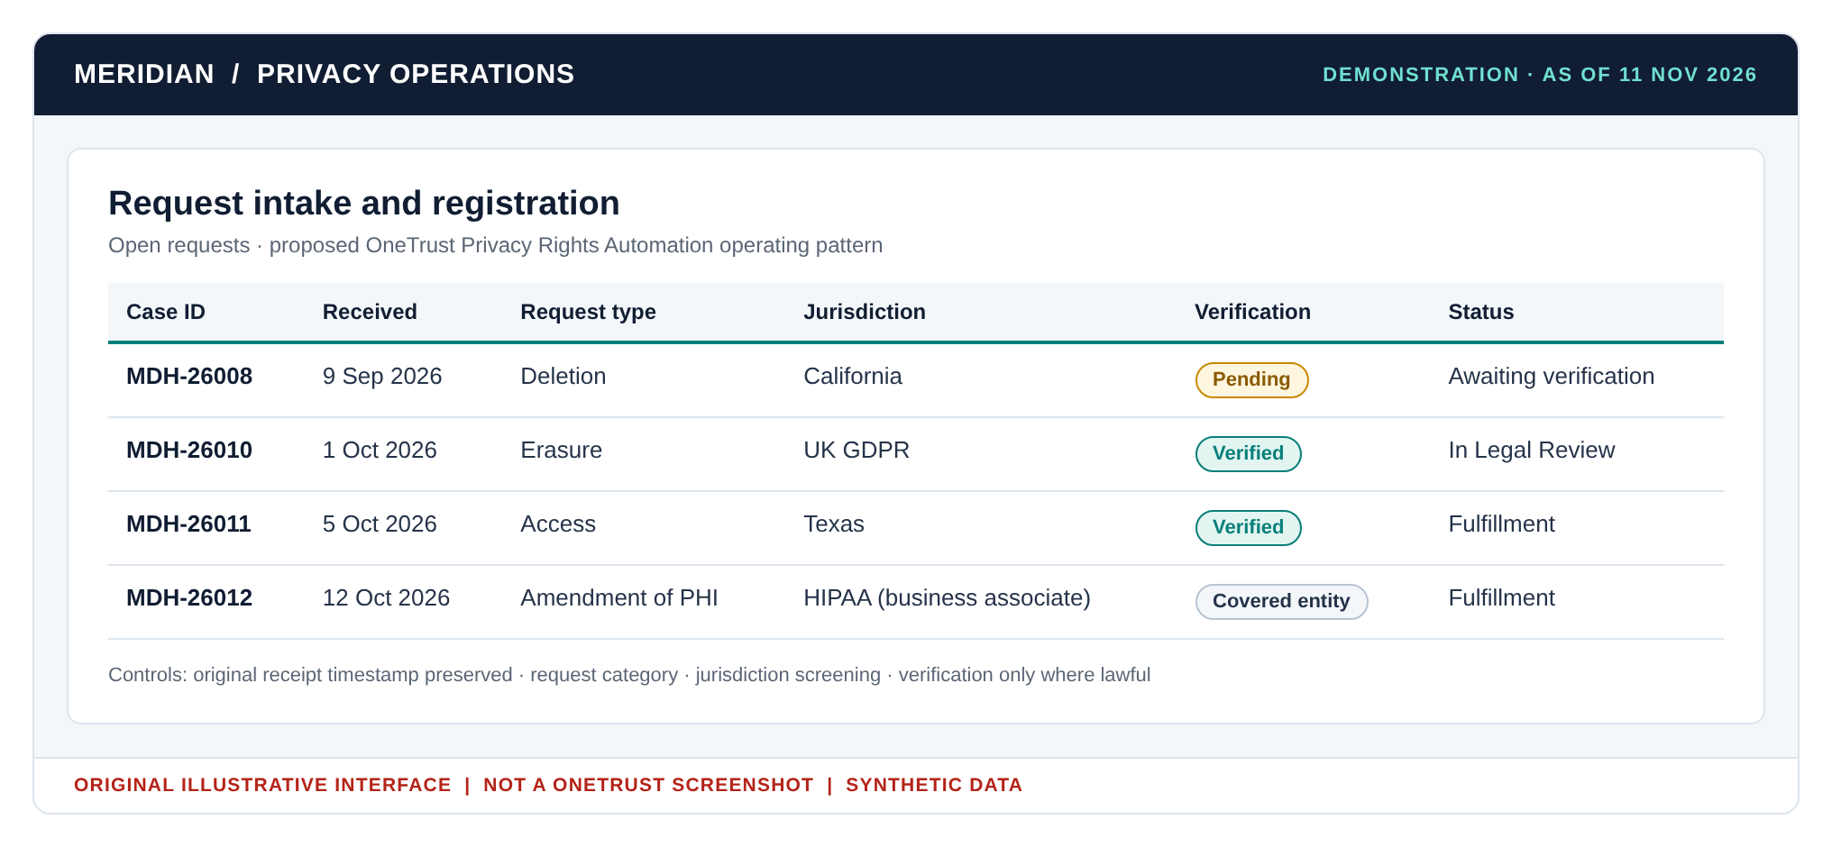
Figure 2. Intake queue for the four open requests, with conditional verification; the HIPAA request has been forwarded to the covered entity.
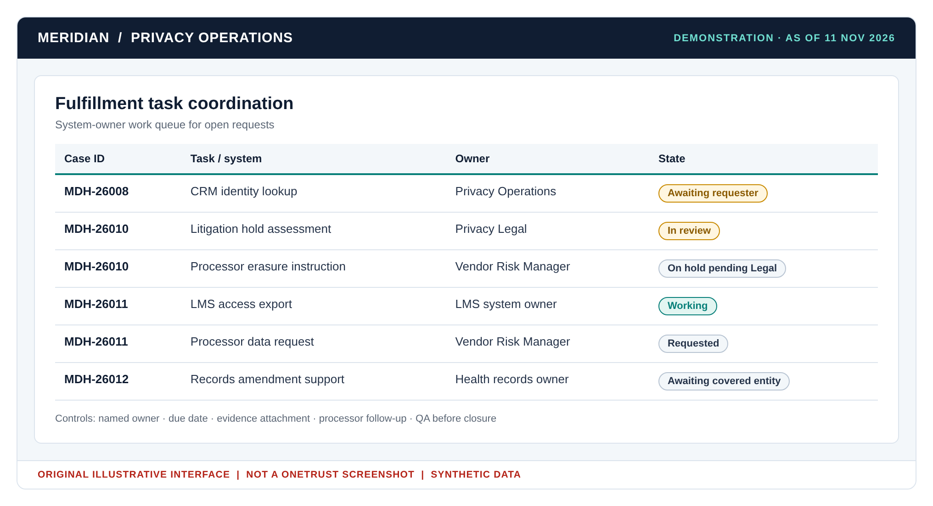
Figure 3. Task coordination across Privacy Operations, Legal, system owners and processors.
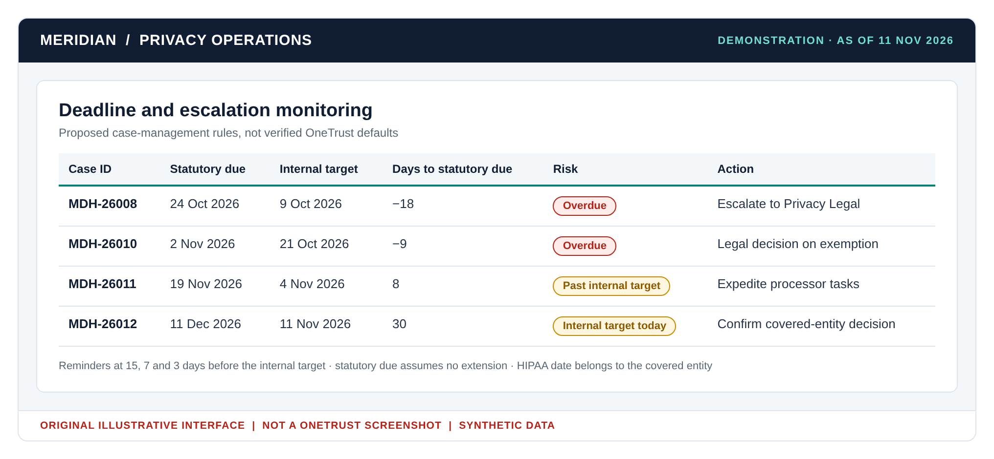
Figure 4. Deadline monitoring as of 11 November 2026: two overdue cases, one past its internal target and one at its internal target today.
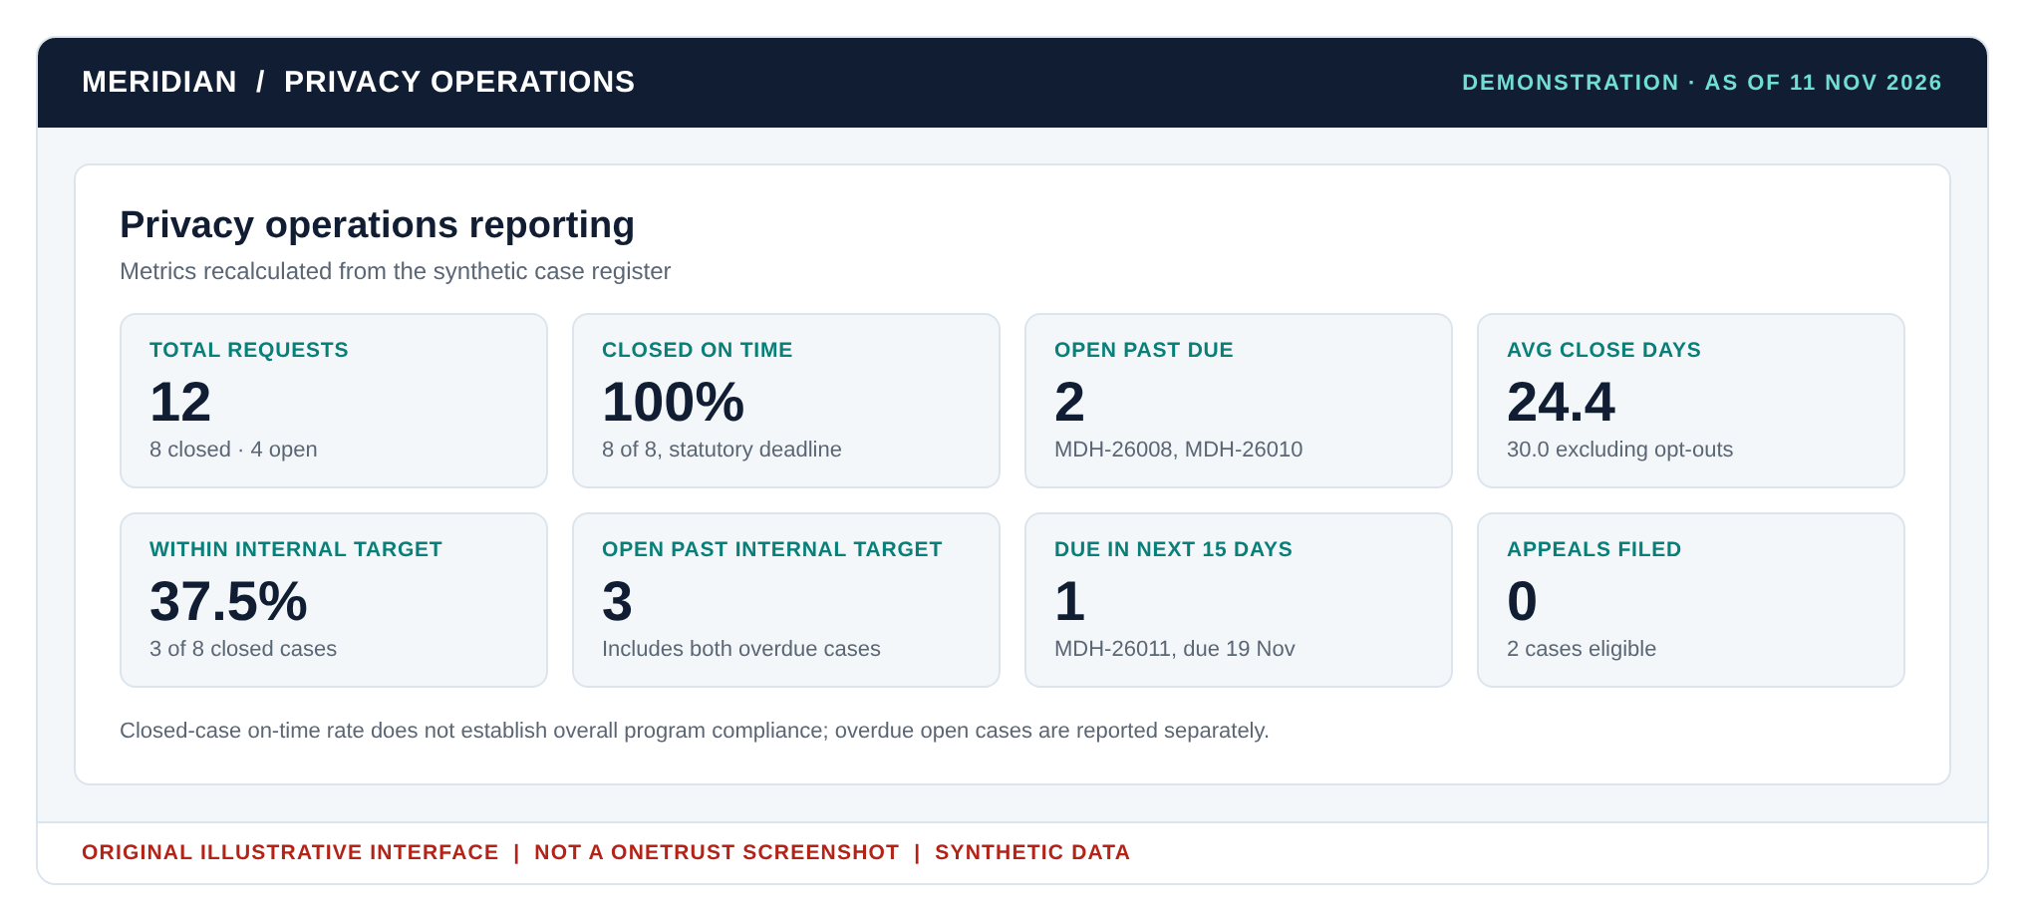
Figure 5. Management reporting recalculated from the register.

9. Case register and dashboard results
All figures are recalculated from the 12 rows of the synthetic case register as of 11 November 2026 and match the companion dashboard workbook; the appeals tile in Figure 5 is counted from the register’s Appeal column.
Metric | Definition | Result
Closed on time (statutory) | Closed cases with closure date on or before Statutory Due, divided by closed cases | 8 of 8 (100%)
Open past statutory due | Open cases whose Statutory Due is before the snapshot date | 2
Closed within internal target | Closed cases with closure date on or before Internal Target, divided by closed cases | 3 of 8 (37.5%)
Open past internal target | Open cases whose Internal Target is before the snapshot date | 3
Average days to close | Calendar days from receipt to closure, closed cases | 24.4
Average days to close, excluding opt-outs | As above, rights requests only | 30.0
Due in next 15 days | Open cases due within 15 days of the snapshot date | 1 (MDH-26011)
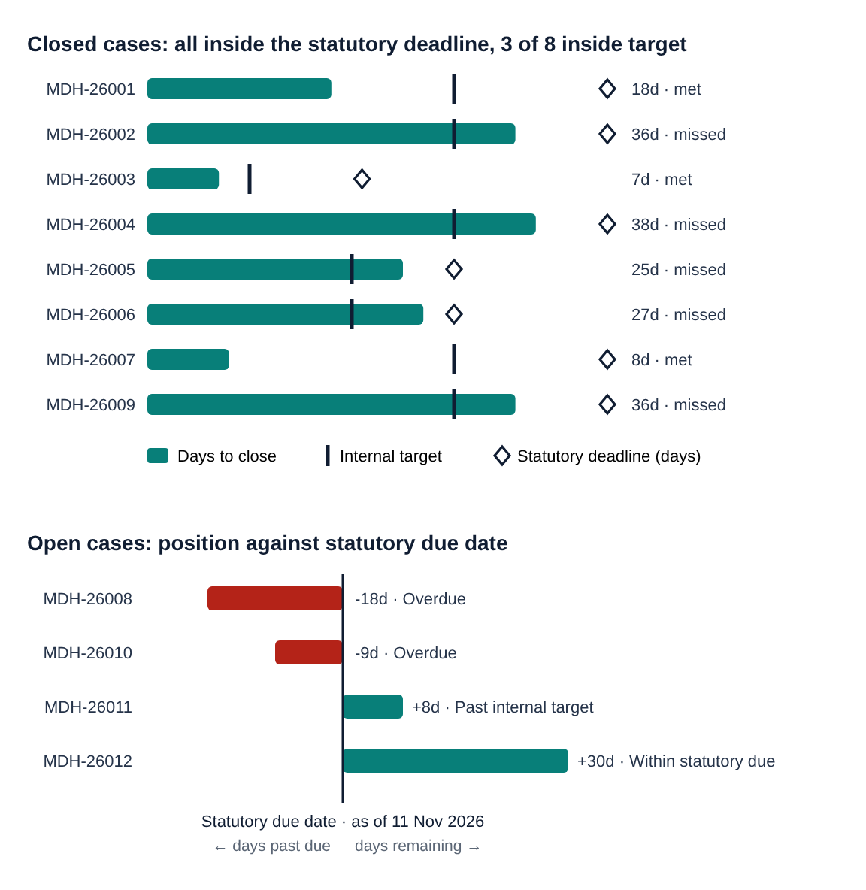
Figure 6. Closed-case cycle time against targets (top) and open-case position against the statutory due date (bottom).
- All eight closed requests met the legal deadline, but five missed the internal target: MDH-26002, 26004, 26005, 26006 and 26009. Each involved Legal review, several systems or a third party.
- The overall average of 24.4 days rises to 30.0 days once two opt-outs, closed in 7 and 8 days, are excluded; 30.0 is the more representative measure of rights-request handling.
- Two open requests are past their legal deadline. A closed-case rate of 100% must never be presented as overall compliance.

10. Worked case: MDH-26002
A Texas learner asks Digital Learning to delete their data. The case shows a lawful partial deletion that met the legal deadline but missed the internal target.
Date (2026) | Day | Step
5 August | 0 | Request received through the privacy web form; case created. Statutory due 19 September (45 days); internal target 4 September.
6 August | 1 | Identity verified through existing learner-account authentication.
7 August | 2 | Deletion tasks assigned to LMS, CRM, marketing and billing owners.
21 August | 16 | LMS, CRM and marketing confirm deletion; billing flags invoices needed for tax records.
1 September | 27 | Legal approves retaining invoice records for the tax retention period; all other data deleted.
10 September | 36 | QA sign-off. The response explains what was deleted, what was kept and why, and how to appeal. Case closed.

Outcome: closed nine days before the statutory deadline but six days after the internal target, because the Legal exception review took 11 days.
Improvement: pre-approved retention rules for standard record types (tax, fraud, legal hold), so Legal reviews only new kinds of exception.

11. Overdue and at-risk cases

MDH-26008: California deletion, Financial Services (due 24 October 2026, 18 days overdue)
Status: verification request sent; no reply.
Why it is late: the CCPA’s 45-day period runs from receipt regardless of verification time. No extension notice was sent, and no rule forced a decision on an unverified request.
Action now: respond that identity could not be verified and the deletion request is denied (11 CCR 7022(a)), explaining the basis, including that GLBA-covered account data is exempt in any case (7022(f)). If Meridian sells or shares this person’s data and they have not opted out, ask whether they want to opt out of sale/sharing and include the opt-out notice or a link to it (7022(g)); an opt-out needs no verification. Record the late response.
Control fix: verification follow-up on day 10 and a decision gate on day 35 for 45-day regimes (verify, deny as unverifiable, or extend with notice).

MDH-26010: UK GDPR erasure, Digital Platforms (due 2 November 2026, 9 days overdue)
Status: litigation hold under Legal review.
Why it is late: Legal review had no time limit and no extension notice went out within the first month. An internal review does not pause the clock; under Article 12A only a request for information reasonably required does.
Action now: decide whether the Article 17(3)(e) exemption covers data needed for legal claims; erase or restrict the rest; instruct processors; tell the person what was and was not erased, why, and how to complain to Meridian and to the ICO.
Control fix: a 10-day limit on Legal decisions and an extension decision by day 20 of the month.

MDH-26011: Texas access, Digital Learning (due 19 November 2026, past internal target)
Status: processor tasks outstanding.
Action now: escalate through the Vendor Risk Manager; if processors cannot deliver in time, send the TDPSA extension notice, stating the reason, no later than 19 November.
Control fix: contractual processor response times, tracked as a vendor KPI.

12. Controls and assurance
Risk | Control | Test evidence
Missed legal deadline | Deadline rules by regime, reminders, day-35 decision gate, escalation | Deadline sample test; overdue exception review
Unauthorized disclosure | Proportionate verification and secure delivery | Access controls and delivery validation
Incomplete deletion | Inventory-driven task assignment and reconciliation | System-owner evidence and QA sign-off
Unlawful deletion | Legal retention and legal-hold checkpoint | Approved exception rationale
Processor gap | Processor task ownership and contractual response times | Vendor attestation and exception tracking
Business associate routing error | BAA-based routing rule; Health Privacy review | Sample of forwarding records
Misleading reporting | Closed-case, open-case and internal-target metrics reported together | Reconciliation of dashboard to register

13. Limitations
- All organizations, records and metrics are synthetic. Dates, owners and outcomes illustrate the operating model and are not performance evidence.
- The regulatory matrix is a screening reference as of 12 November 2026, not legal advice. Weekend roll-forward is applied to EU and UK GDPR deadlines; public holidays are not modeled, and no register deadline falls on one. No extensions are applied in the register.
- OneTrust is referenced as an example platform. The study does not represent a configured tenant, an endorsement or an affiliation.
- HIPAA handling assumes Meridian HealthTech acts as a business associate, consistent with BDC-PRIV-001, and conservatively runs the covered entity’s deadline from Meridian’s receipt.

14. Companion files
- BDC-OPS-001_Synthetic_DSAR_Case_Register_v1.1.xlsx: master case register with field guide and KPI snapshot.
- BDC-OPS-001_DSAR_SLA_Dashboard_v1.1.xlsx: executive dashboard with charts; holds a copy of the register for its formulas.
- BDC-PRIV-001: the enterprise privacy assessment that sets Meridian’s profile and applicability screening.

About the author
Olumuyiwa Michael, CIPP/US, CIPP/EU, CIPM, AIGP, CompTIA Security+
Privacy and compliance professional with more than seven years of experience in privacy operations, privacy impact assessments, data subject rights, incident management and regulatory compliance, and a technical background in database administration and information security.
This case study is part of the BloomDale Capital LLC Data Privacy & AI Governance Portfolio: https://mikeolu700-gif.github.io/bloomdale-privacy-ai-governance/

References
Reviewed as of 12 November 2026.
- EU GDPR, Regulation (EU) 2016/679: https://eur-lex.europa.eu/eli/reg/2016/679/oj
- ICO, Right of access: responding to a request: https://ico.org.uk/for-organisations/uk-gdpr-guidance-and-resources/individual-rights/right-of-access/what-should-we-consider-when-responding-to-a-request/
- Data (Use and Access) Act 2025: https://www.legislation.gov.uk/ukpga/2025/18
- CCPA regulations, 11 CCR §7021 (response timelines): https://www.law.cornell.edu/regulations/california/11-CCR-7021
- CCPA regulations, 11 CCR §7022 (requests to delete): https://www.law.cornell.edu/regulations/california/11-CCR-7022
- California Privacy Protection Agency regulations: https://cppa.ca.gov/regulations/
- Connecticut Attorney General (CTDPA): https://portal.ct.gov/ag
- Texas Data Privacy and Security Act, Tex. Bus. & Com. Code §541.052 (responses and extensions): https://texas.public.law/statutes/tex._bus._&_com._code_section_541.052
- HIPAA Privacy Rule, 45 CFR Parts 160 and 164: https://www.ecfr.gov/current/title-45/subtitle-A/subchapter-C
- CFPB Regulation P, 12 CFR Part 1016: https://www.ecfr.gov/current/title-12/chapter-X/part-1016
- OneTrust Privacy Rights Automation (product page): https://www.onetrust.com/products/privacy-rights-automation/
- OneTrust documentation: https://docs.onetrust.com/

